WP2: Hardware-backed cryptographic Identity & Medical sensors
D2.4 Physical biometric smart card (Credit card form factor) - This includes : Offline Private Keys / Privacy-Centric Fingerprint / Biometrics / NFC Connectivity / Battery less / FIDO2 Certified

Due date of deliverable: (DD-MM-YYYY)
Actual submission date: (DD-MM-YYYY)

Dissemination level
PU | Public | 
PP | Restricted to other programme participants (including the Commission Service
RE | Restricted to a group specified by the consortium (including the Commission Services)
CO | Confidential, only for members of the consortium (excluding the Commission Services)

DOCUMENT INFO
Author

Author | Company | E-mail
Alexandre Peyrot | Kelvin Zero | a.peyrot@kzero.com

Documents history

Document version # | Date | Change
V1 | 17/01/25 | Final (To be reviewed if necessary)

Contents
Context 3
1. First part 3
1.1. Sub-part 3

Context
This deliverable is about the Multi-Pass cards that allows the most efficient and secure way to authenticate to a system. It has been demonstrated thanks to the different integration we have done with partners from the consortium.
- Documention
At a high level, FIDO2 (Fast Identity Online 2) is a set of standards for strong, passwordless authentication designed to provide a more secure and user-friendly way to verify identity online. It uses public-key cryptography to authenticate users, eliminating the need for passwords. Here's a breakdown of how it works:
- Registration (Enroll) Process:
User Interaction: The user begins by registering an authenticator (e.g., a hardware device like a USB security key, or a biometric device like a fingerprint scanner) with a service (e.g., a website or application).
Key Pair Generation: During registration, the authenticator generates a pair of cryptographic keys:
Private Key: Kept securely on the authenticator and never shared.
Public Key: Sent to the service (server) and stored there. This public key will be used to verify the authenticity of future authentication attempts.Metadata Stored by the Service: Along with the public key, the service may store other metadata like the type of authenticator, and a unique identifier for the key pair.
No Passwords: At this point, there is no password involved. The authenticator is now associated with the user’s account.
- Authentication (Login) Process:
Challenge Issued by the Service: When the user tries to log in to the service, the service generates a challenge (a random string of data) and sends it to the authenticator via the user’s device (browser, app, etc.).
User Verification: The authenticator prompts the user to authenticate (e.g., via biometric authentication, PIN entry, or simply touching the security key).
Signature Creation: Once the user is verified, the authenticator uses the private key (which it has securely stored) to sign the challenge sent by the service. This signature is unique to that session and challenge.
Response Sent to the Service: The signed challenge (along with some additional data) is sent back to the service.
- Verification by the Service:
Public Key Check: The service uses the stored public key (from the registration step) to verify the signature. If the signature matches the challenge and the public key, the user is authenticated successfully.
Authentication Successful: If the service successfully verifies the signature, the user is granted access.
Key Points:
- No Passwords: FIDO2 authentication doesn't rely on passwords, reducing the risk of phishing, brute-force attacks, and password reuse vulnerabilities.
- Public-Key Cryptography: FIDO2 uses public-key cryptography (a public and a private key pair) for authentication, which is much more secure than password-based systems.
- Secure and User-Friendly: The user interacts with the authenticator (e.g., touching a key, scanning a fingerprint, or entering a PIN) to authenticate, which is more secure and user-friendly than traditional passwords.

- Summary:
Registration: The user enrolls an authenticator, which generates a key pair (public/private). The public key is stored by the service.Authentication: During login, the service challenges the authenticator, the user verifies their identity, and the authenticator signs the challenge with its private key.Verification: The service verifies the signed challenge using the stored public key. If valid, the user is authenticated.By using FIDO2, authentication becomes highly secure, with no password vulnerabilities, and much easier for users, as they can rely on secure methods like biometrics or hardware security keys.

- Video tape / Screenshots
The videos are too heavy to be uploaded into this document and published on ITEA portal. Screenshots
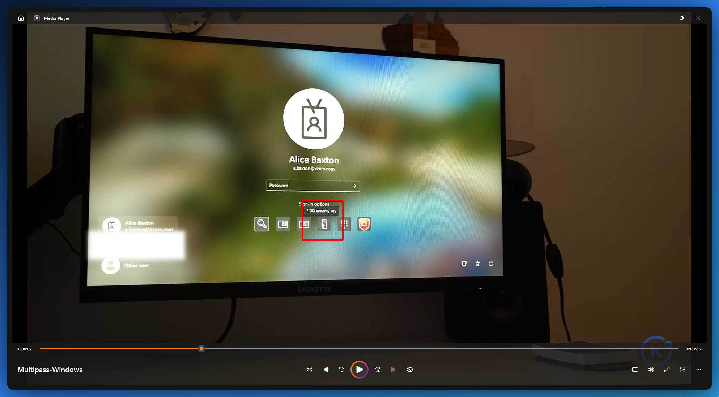
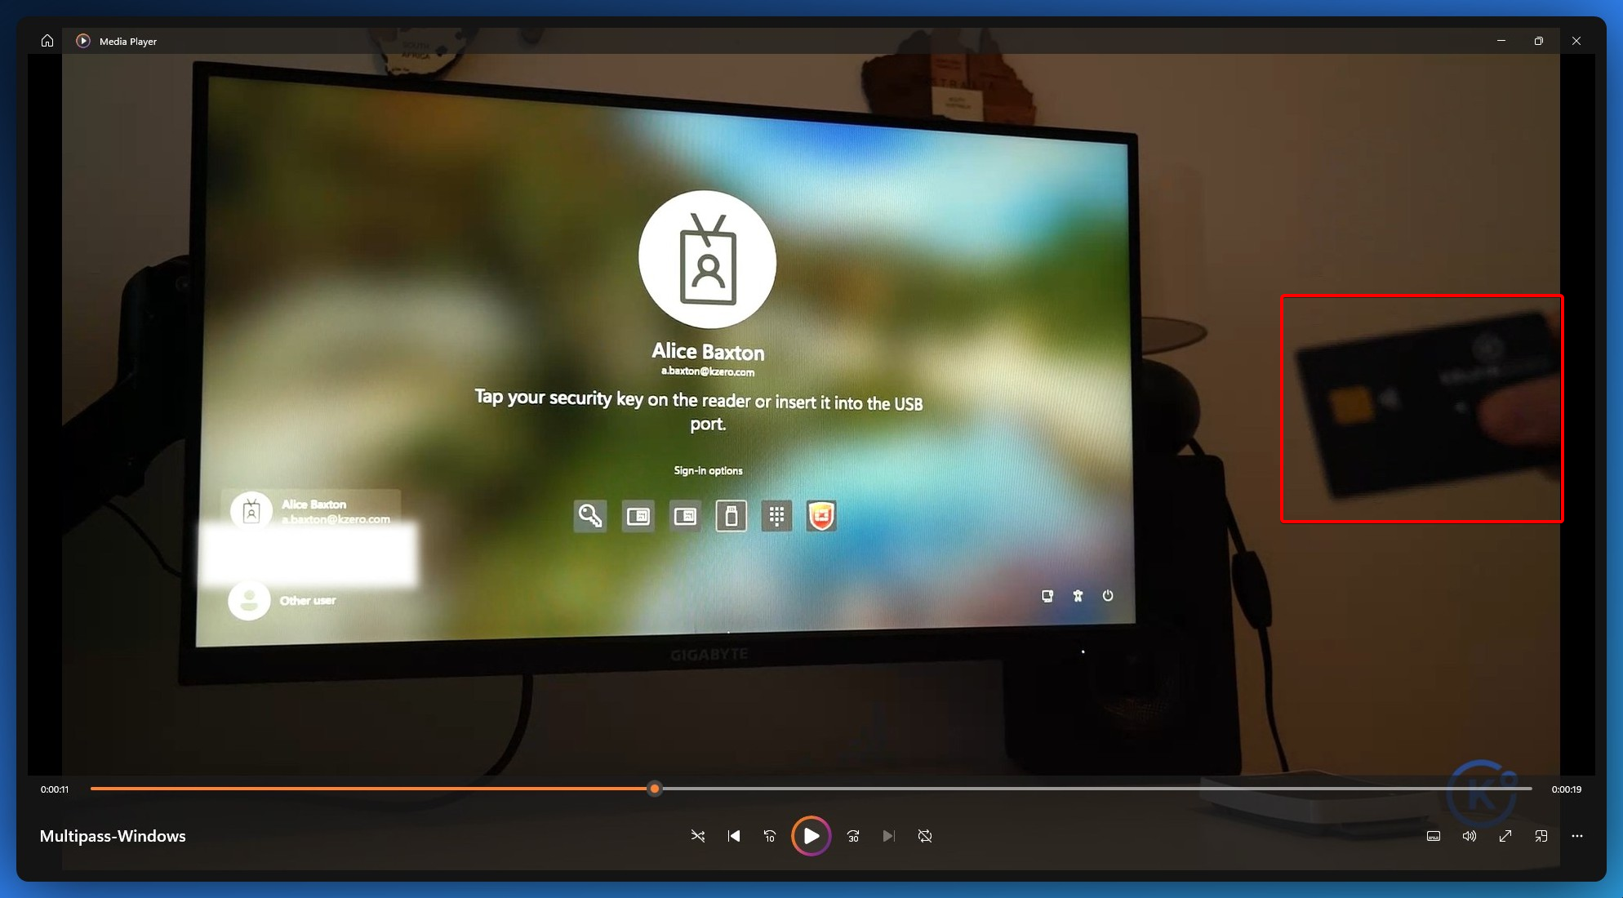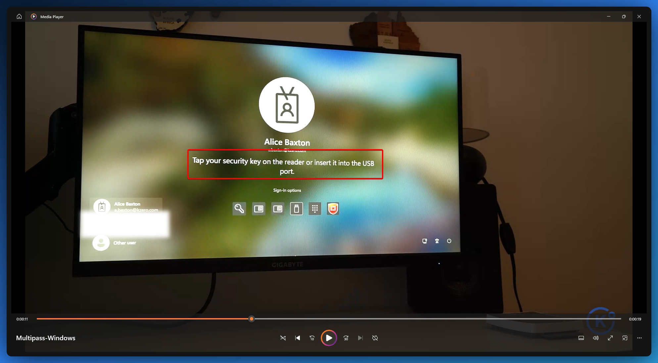
Put your thumb on the black spot of your Multi-Pass card then press it on your NFC reader that can be external to your laptop or directly integrated.
