
TREAT
Transforming Healthcare Through Semantic Interoperability and Self-Efficacy
Labeled in ITEA4, a EUREKA cluster, Call 2022
ITEA4 Project Number 22022
D5.1 – Public Project Web Page
Due date of deliverable: March 2024
Actual date of submission: January 2025
Start date of project: |  |  | Duration:
Organisation name of lead contractor for this deliverable: |  |  | ARD GROUP
Author(s): | ARD GROUP
Status: | Final
Version number: | V1.0
Submission Date: | 27-January-2024
Doc reference: | TREAT_Deliverable_D5.1._Public_Project_Web_Page
Work Pack./ Task: | WP5 / Task 5.1
Description:  (max 5 lines) | This deliverable provides an overview of the TREAT Project web page, detailing its purpose, structure, and functionality. It explains how the web page serves as a communication tool to engage, disseminate project updates, and facilitate collaboration among partners and the public.
Nature: | R=Report
Dissemination Level: | PU | Public |  | x
Dissemination Level: | PP | Restricted to other programme participants
Dissemination Level: | RE | Restricted to a group specified by the consortium
Dissemination Level: | CO | Confidential, only for members of the consortium
DOCUMENT HISTORY
Release | Date | Reason of change | Status | Distribution
V0.5 | 20/12/2024 | Initial version | Draft | WP5
V1.0 | 27/01/2025 | Approved by PMT, to be submitted to ITEA4 | Final | WP5

Table of Contents
Executive Summary 4
1. Introduction 5
2. Homepage 6
3. About 8
4. Consortium 10
5. Event 11
6. Dissemination 12
7. Contact 13

Executive Summary
This deliverable document outlines the development and deployment of the TREAT Project web page, designed to serve as a central platform for disseminating information about the project’s mission, activities, and progress. The site, accessible at https://treatprojects.com supports the project's outreach, stakeholder engagement, and public communication efforts.

The report details the structure of the web page, including key sections such as the Homepage, Consortium, Dissemination, and Contact. The homepage provides an overview of TREAT Project’s mission, while the Consortium section introduces partner organizations contributing to the project's success. The Dissemination section highlights ongoing efforts to share research and project updates, ensuring transparency and fostering collaboration.

The web page is designed with user experience in mind, enabling visitors to easily navigate through content. It will be regularly updated with new information, publications, and announcements to keep stakeholders engaged and informed.

Introduction
The TREAT Project web page is an important tool for the project's communication strategy, aimed at promoting personalized care and health through innovative technologies and research. The web page’s development aligns with the project's objective of making research outcomes accessible to a wide range of audiences, including academics, industry partners, and the public.

The web page reflects the collaborative nature of the project, emphasizing transparency, research progress, and partner engagement. Its design supports seamless navigation, clear content presentation, and regular updates on project developments.

Key design considerations included:
- Clarity and Usability: Ensuring easy navigation and intuitive content presentation.
- Accessibility: Providing open access to relevant project updates, reports, and contacts.
- Engagement: Creating dynamic content, including event updates.

The web page includes five main sections: Homepage, Consortium, Dissemination, Events, and Contact. These sections provide comprehensive information about the project, its partners, and its ongoing research efforts. News updates and announcements ensure that visitors stay informed about the latest developments, while the thoughtfully structured content allows users to explore the project’s details with ease.

This deliverable ensures that the web page effectively communicates the project’s goals and
achievements, while also serving as a platform for ongoing engagement with the broader community.
New sections and content will be added on the web page if necessary.

Homepage
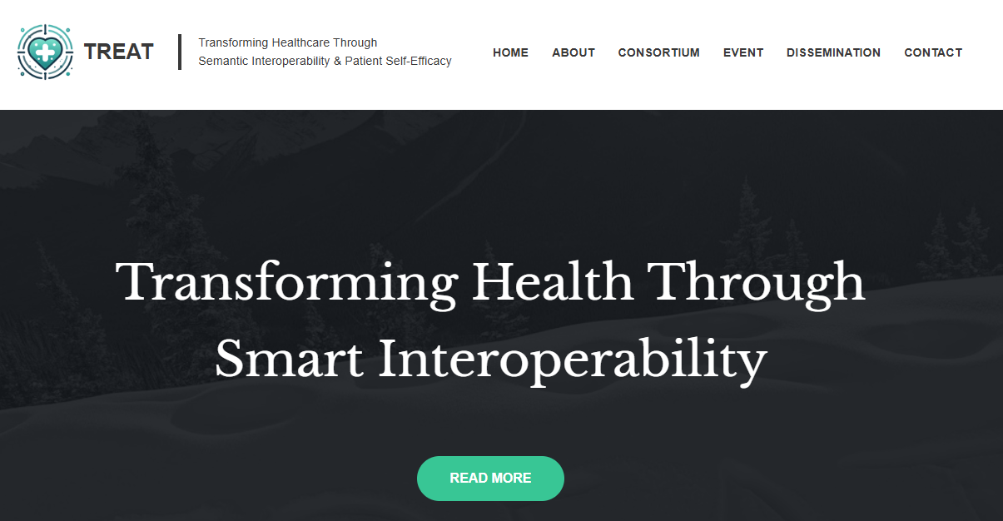
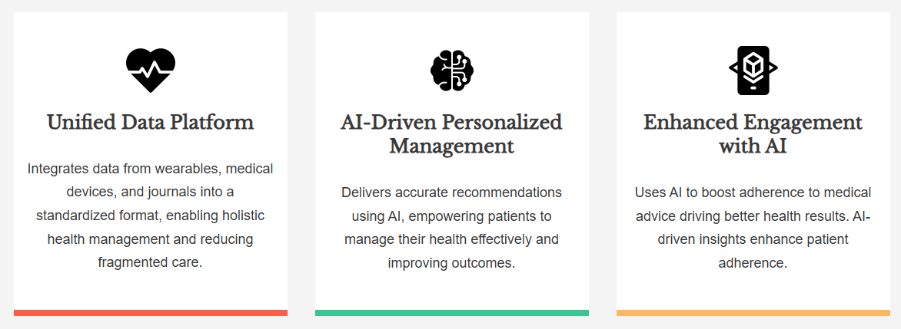
The Homepage introduces the TREAT Project, emphasizing its mission to change healthcare through semantic interoperability and patient self-efficacy. It highlights the project’s focus on transforming fragmented care processes into a unified system, empowering patients to manage their health effectively.

Key features such as the Unified Data Platform, AI-Driven Personalized Management, and Enhanced Engagement with AI are briefly showcased, illustrating how TREAT leverages advanced technologies to improve health outcomes and adherence to treatment plans. Additionally, the homepage outlines the project’s commitment to addressing the global burden of non-communicable diseases (NCDs), promoting self-management, and contributing to sustainable healthcare systems.

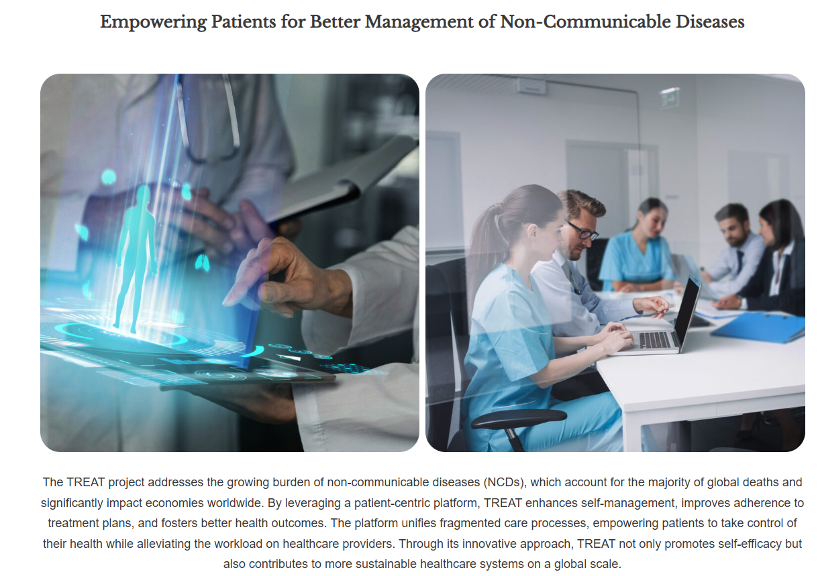

About
The About section introduces the TREAT Project, focusing on its mission to address the global challenge of managing non-communicable diseases (NCDs). It highlights the project’s aim to empower patients through a unified, patient-centric platform that enhances self-management and health outcomes while reducing the burden on healthcare providers.

This section outlines the project’s key objectives and references a visual representation of the TREAT solution concept, providing visitors with a clear understanding of its innovative approach and goals.
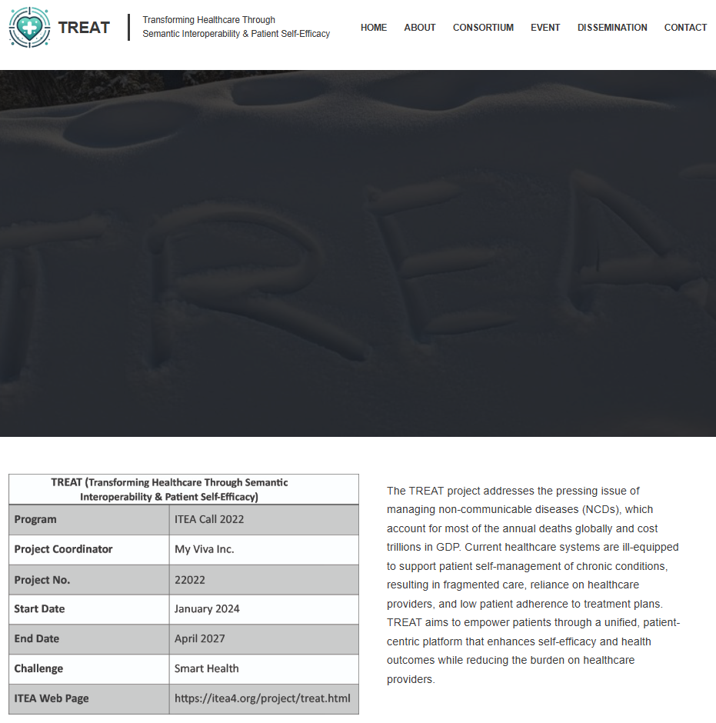
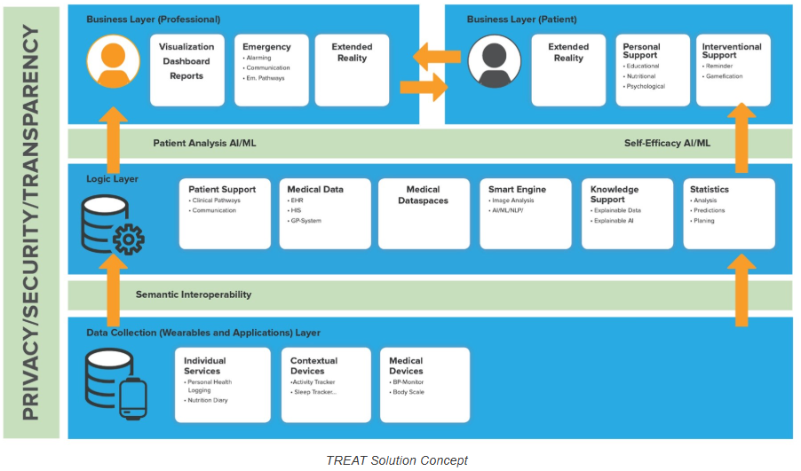

Consortium
The consortium section introduces all sub-consortia and project partners in the project.
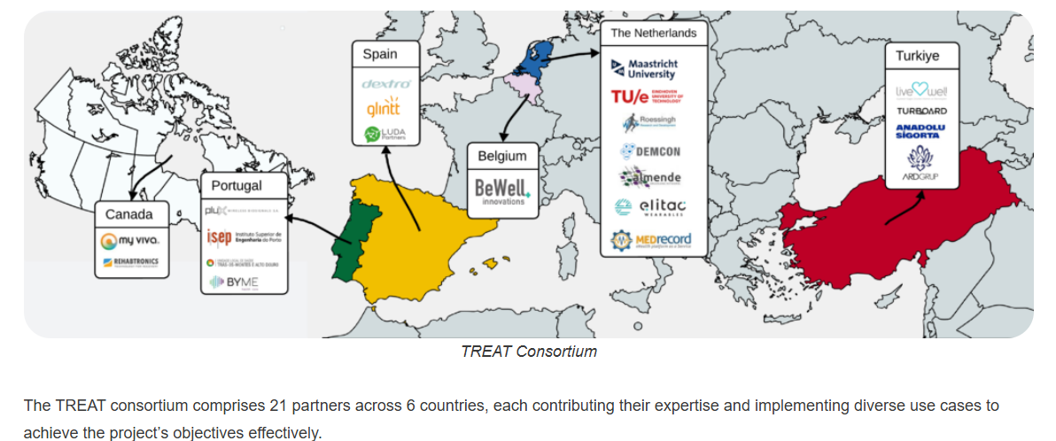

Event
The Event section highlights key activities for the TREAT Project, such as kick-off meetings, workshops, and other collaborative sessions. It serves as a hub for visitors to stay updated on project-related events, fostering collaboration and engagement.



Dissemination
It will be updated when the deliverables with public-access and dissemination activities are completed.
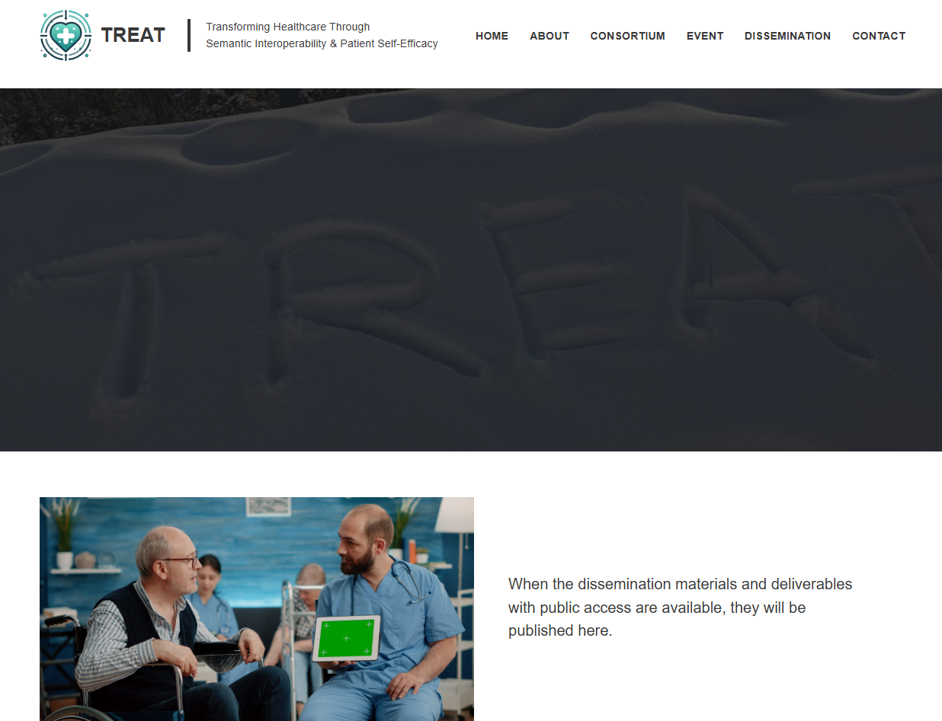

Contact
