



Innovating Sales and Planning of Complex Industrial Products
Exploiting Artificial Intelligence

Deliverable 4.6

Connectors to existing IT systems and external data

sources: Implementation and test

Deliverable type: | Software
Deliverable reference number: | ITEA 20054 | D4.6
Related Work Package: | WP 4
Due date: | 2024-10-31
Actual submission date: | 2024-12-31
Responsible organisation: | IFAK
Editor: | Mario Thron
Dissemination level: | Confidential
Revision: | Final | Version 1.0
Abstract: | This document provides descriptions of service implementations for data connectors and integration services of the InnoSale architecture.
Keywords: | service-oriented architecture (SOA), service implementation

Table_head | SAG | ADESSO | Approval date (1 / 2)
Approval at WP level | Frank Werner | Ahmet Emin Ünal  Şafak Karagenç | 13.01.2025 / 03.01.2025
Veto Review by All Partners

Editor
Mario Thron (IFAK)

Contributors
Mario Thron (IFAK)
Klaus Hanisch (tarakos)
Yazmin Andrea Pabon Guerrero (Panel)

Executive Summary
This report outlines the development of a technology stack for the InnoSale platform, including multiple services designed to enhance data analysis, visualization, and decision-making processes. The stack comprises six key components:

- BigMacIndexProvider: Calculates the Big Mac Index and provides valuable economic insights for comparing currencies and purchasing power across different countries.
- PurchasingPowerParityProvider: Offers a convenient way to compare purchasing power parity (PPP) values, facilitating strategic planning for international sales and procurement activities.
- StockQuoteProvider: Delivers real-time stock data analysis through an interface with Yahoo Finance, supporting accurate financial forecasting and decision-making for companies involved in the sale of industrial goods.
- FactoryLoadProvider: Simplifies access to aggregated factory load data, enabling production planning, capacity management, and resource optimization in the manufacturing sector.
- Crawler: Automates the process of identifying and collecting relevant digital products from open repositories using customizable search criteria, saving time and effort for users.
- TaraXchange: Provides a versatile data transformation tool that consolidates and reformats data from diverse sources to meet specific InnoSale requirements.

These services collectively contribute to the platform by offering a comprehensive suite of data-driven functionalities. The technology stack described here can be adapted or extended based on specific project requirements, ensuring compliance with conceptual requirements and authentication/authorization standards.

Table of Content
1 Introduction 1
2 Technology 1
2.1 Overview 1
2.2 Usage of the example technology stack 1
2.2.1 Preparing SSO and JWT token-based authentication 1
2.2.2 Configuration of Keycloak 3
2.2.3 Backend Application 3
2.2.4 Frontend Application 4
3 Data connector service implementations 5
3.1 BigMacIndexProvider 5
3.1.1 Use case 5
3.1.2 Inputs / Outputs 5
3.1.3 Business logic 6
3.1.4 Available Functions, APIs, User Interactions 7
3.2 PurchasingPowerParityProvider 10
3.2.1 Use case 10
3.2.2 Inputs / Outputs 10
3.2.3 Business logic 10
3.2.4 Available Functions, APIs, User Interactions 10
3.3 StockQuoteProvider 11
3.3.1 Use case 11
3.3.2 Inputs / Outputs 11
3.3.3 Business logic 11
3.3.4 Available Functions, APIs, User Interactions 12
3.4 FactoryLoadProvider 12
3.4.1 Use case 12
3.4.2 Inputs / Outputs 13
3.4.3 Business logic 13
3.4.4 Available Functions, APIs, User Interactions 13
3.5 Crawler 14
3.5.1 Use case 14
3.5.2 Inputs / Outputs 15
3.5.3 Business logic 15
3.5.4 Available Functions, APIs, User Interactions 15
3.6 TaraXchange 16
3.6.1 Use case 16
3.6.2 Inputs / Outputs 16
3.6.3 Business logic 16
3.6.4 Available Functions, APIs, User Interactions 17
4 Conclusion 18
5 Abbreviations 19
6 References 20

Figures
Figure 1: GUI taraXchange Rule-Editor 17

Tables
No table of figures entries found.

Introduction
This report provides a comprehensive overview of the technology stack employed for implementing InnoSale data connector services, along with detailed descriptions of each component's usage and practical implementation examples. Although the specified technology stack serves as a blueprint for service development, this document also highlights that other compatible technology stacks may be used, provided they meet conceptual requirements and support Keycloak's authentication and authorization system.
Section 2 describes the chosen technology stack, focusing on setting up Single Sign-On (SSO) and JSON Web Token (JWT)-based authentication using Keycloak. The section offers a hands-on guide for configuring Keycloak with Python scripts to manage realms, users, groups, roles, clients, and other related entities. Subsequently, the report showcases the creation of a backend application utilizing OAuth2.0 protocol for secure authentication and authorization, adhering to best practices such as context managers and secure configuration storage. Additionally, this document presents frontend application examples that seamlessly integrate with Keycloak's OAuth2.0 authorization flow while serving static files using FastAPI.
In section 3, it introduces several data connector services designed to provide valuable insights for various use cases, including BigMacIndexProvider, PurchasingPowerParityProvider, StockQuoteProvider, FactoryLoadProvider, Crawler, and TaraXchange.
Each service offers unique functionalities adapted to specific needs, such as currency valuation comparisons, purchasing power parity analysis, stock quote data retrieval, factory load forecasting, and digital product discovery. Section 3 comprehensively describes each service's use case, inputs/outputs, business logic, and available functions and APIs, enabling a thorough understanding of their capabilities.

Technology

Overview
In deliverable D4.5 we described a technology stack for implementation of InnoSale data connector services. In the following section we describe the usage of this stack and provide code examples for implementation of an InnoSale service. It can be used as a blueprint for other service implementations.
However, as we described in D4.5, this application stack is not mandatory. Every other technology stack may be used as long as the conceptual requirements (D4.5 section 2.2) are met and the system for authentication and authorization (D4.5, section 2.3.4, Keycloak) is supported.

Usage of the example technology stack

Preparing SSO and JWT token-based authentication
The Keycloak Web site provides a guide for getting started with Keycloak on Docker. The main steps are as follows.

Run the following command in a terminal:
docker run -p 8080:8080 \
-e KEYCLOAK_ADMIN=admin \
-e KEYCLOAK_ADMIN_PASSWORD=admin quay.io/keycloak/keycloak:21.1.1 \
start-dev
This command starts Keycloak exposed on the local port 8080 and creates an initial admin user with the username "admin" and password "admin".
You could use now the Keycloak admin console ("http://localhost:8080/admin") to enter a graphical user interface for administration of users and applications. But describing it would involve a huge number of graphics that would be difficult to describe verbally. Thus, in the following, we will use some Python scripts and the Keycloak Admin API for the initial setup of user and application information.
First let’s describe some basic concepts of the Keycloak SSO system:
- Realm: A realm in Keycloak represents a security domain where users, groups, and client applications are managed. It acts as an isolated container for managing authentication, authorization, and user data. Each realm has its own set of users, roles, and configuration settings.
- User: A user in Keycloak represents an individual who can authenticate and access the applications within a realm. Users have attributes like username, password, email, and additional custom attributes. They can be assigned to roles, participate in group memberships, and have specific authentication and authorization settings.
- Group: A group in Keycloak is a logical collection of users within a realm. It simplifies user management by allowing users to be organized based on common characteristics, roles, or access requirements. Groups provide a way to manage permissions and access control on a group level rather than individually for each user.
- Client: A client in Keycloak represents an application or service that requests authentication and authorization from Keycloak. It can be a web application, mobile app, or backend service. Clients are registered within a realm and are assigned various settings, such as redirect URIs, access policies, and protocol configurations.
- Role: A role in Keycloak defines a set of permissions or privileges within a realm. Roles can be assigned to users or groups, allowing fine-grained access control. Clients can use roles to enforce authorization decisions and restrict access to certain functionalities or resources.
- Authentication Flow: An authentication flow in Keycloak represents the sequence of steps or processes involved in authenticating a user. Keycloak provides various built-in authentication flows, such as username/password, social login, multi-factor authentication, and more. Custom authentication flows can also be created to accommodate specific requirements.
- Client Scopes: Client scopes in Keycloak define sets of attributes and permissions that can be requested and granted to client applications during the authentication process. They allow for standardized and consistent sharing of user attributes and access permissions across multiple clients within a realm.
The configuration of the technology stack example setup will be as follows:
- Realm: We will introduce the "InnoSaleDemo" realm. Thus, the project partner’s company could maintain other realms, which are securely split from our demo setup.
- User: We will create several users per group.
- Group: Beside the "admin", we will introduce the groups "sales" and "customer".
- Client: We will introduce the very simple services demonstrating how to develop an InnoSale data connector. Later-on, those connectors but also maybe the Knowledgebase will be clients.
- Role: We will consider "sales" and "customer" as roles, which are in scope of Keycloak groups. But for our InnoSale demo, we don’t want a more complex and fine-granular access-right management.
- Authentication flow: We will use the username/password flow.
- Client Scopes: For the technology example, we will not use this feature. Nevertheless, for more complex demonstration scenarios in WP6, it might be necessary to use this feature.
In the following, we will describe how to use Python scripts to configure the Keycloak SSO system and how to get a simple application running based on that infrastructure.

Configuration of Keycloak
We developed a Python script, which serves as an automated administrator for Keycloak. It leverages the Keycloak REST API to efficiently manage. This script automates the often time-consuming task of setting up a Keycloak environment from scratch, demonstrating best practices for managing users, roles, and permissions in a programmatic way. It uses or respectively provides:
- Authentication: Uses Keycloak's authentication mechanism via an administrator token obtained during initialization.
- REST API Interaction: The script relies heavily on the `requests` library to communicate with the Keycloak REST API for creating, updating, and managing resources.
- Data Structures: Defines key data structures (e.g., dictionaries) to represent entities like users, groups, roles, realms, and clients according to Keycloak's API specifications.
- Error Handling: Includes robust error handling using `try-except` blocks to gracefully manage potential exceptions raised during API interactions.
For later experiments, we used the script functionality to configure following Keycloak related items:
- Realms: The script creates a new Keycloak realm named "InnoSale" which acts as a distinct environment for managing users, groups, roles, and clients.
- Users: Defines two sample users ("john" and "eva") with attributes like name, email, mobile number, and password credentials.
- Groups: Establishes two user groups: "sales" and "customer".
- Roles: Creates a custom role "can_access_internal_data" to control access permissions within the realm.
- User-Group Assignments: Adds users to specific groups (e.g., "john" to "sales").
- Role-Group Assignments: Maps the "can_access_internal_data" role to the "sales" group, granting group members access to designated internal data.
- Clients: Registers a new client application named "ExampleFrontend" with configurated redirect URIs and web origins.

Backend Application
For demonstration, we chose to provide a backend and a frontend application. This section here is about the backend application. It uses the OAuth2.0 protocol for secure authentication, which is a widely-adopted standard with clear benefits in terms of security and ease of use for users. The backend code follows best practices such as using context managers (“OAuth2Scheme”) to handle authentication and authorization checks, as well as storing configuration details securely in the “config.py” file. The application has a single endpoint (/get_data) that accepts a JSON payload as input and returns a response with additional information based on the user's roles. The application ensures that only authorized users can access certain internal data by checking if they have the role “can_access_internal_data”.
Here are descriptions of the 4 main modules of the program:
1. auth.py
This file configures and handles authentication using the OAuth2.0 OpenID protocol, a widely-adopted standard for secure user authentication. It uses following key abstractions:
- “OAuth2AuthorizationCodeBearer”: A decorator that implements the OAuth2.0 authorization code flow as a context manager.
- “KeycloakOpenID”: A wrapper around the Keycloak OpenID server to interact with it via its REST API for creating, managing, and verifying tokens.
The script defines several data structures:
- “User” (model) to represent a user entity with attributes like `id`, `username`, `email`, and `first_name`.
- “authConfiguration” (model) to hold configuration details for the Keycloak server, such as the realm name and client ID.
The script provides a way to obtain a public key for token verification. It sets up an OAuth2.0 authorization code flow with the configured server URL and client credentials (client ID and secret).
2. config.py
This file sets up default configuration values for the application, such as the server URL, realm name, client ID, and secret. It uses these configuration values to initialize an “authConfiguration” object, which is then passed to the “get_server_url” method.
3. models.py
This file defines a model class “User” for representing a user entity in the system with attributes like “id”, “username”, “email”, and “first_name”. It uses this model to define the structure of the payload returned by the authentication server.
4. main.py
This file sets up a FastAPI application with a single endpoint (/get_data) that accepts a JSON payload as input and returns a response with a message containing the user's authorized services based on their roles. The script integrates “FastAPI” and uses the “get_user_info” function to authenticate users and retrieve additional information about them, ensuring they have access to specific services.
The script includes a simple endpoint (/get_data) that accepts a JSON payload as input and checks if the user has access to certain internal data based on their roles. If the user has the role “can_access_internal_data”, the script prints out the user's details and their authorized services.

Frontend Application
The frontend code provides a seamless OAuth2.0 authorization flow integrated with Keycloak, allowing users to authenticate and access protected resources via a simple web application. The use of FastAPI for serving static files and Axios for making HTTP requests ensures a robust and scalable solution.
It separates the concerns of serving static files from the main application, which is useful for keeping things organized and modular. Further-on, it uses the URLSearchParams library to parse any query parameters from the current URL and extract the code parameter, which is required for exchanging tokens with the Keycloak server. The script uses the axios.post() method to exchange a code for a token with the configured OpenID server. This demonstrates how to use AJAX requests to interact with external services and process data in a more structured way within the application.
The two main components are as follows:
1. server.py
This file sets up a basic FastAPI web application to serve static files (HTML, CSS, JavaScript) located in the static directory. It exposes these files at http://127.0.0.1:8087/static/*. The server is started using uvicorn, a popular ASGI server for FastAPI applications.
2. static/login.html
This HTML file acts as the login page of the application. It utilizes JavaScript to handle user authentication with Keycloak and subsequent data retrieval from a backend API. The script utilizes the axios library (loaded from a CDN) for making HTTP requests to the backend API. It provides several functional elements:
- Authentication Flow: The HTML file checks for an authorization code in its query parameters (URL). If present, it exchanges this code for an access token using the Keycloak token endpoint (/protocol/openid-connect/token). It then sends a GET request to the backend API at /get_data with the obtained access token in the Authorization header.
- Displaying Data: The response from the backend is displayed on the HTML page within an element with the ID dataDisplay.
- Error Handling: It includes error handling for both token retrieval and data fetching, displaying appropriate messages to the user.

Data connector service implementations

BigMacIndexProvider

Use case
The BMIProvider service is an API designed to calculate and provide the Big Mac Index (BMI) for various currencies. The Big Mac Index, developed by The Economist in 1986, is a simple way to compare the purchasing power of different currencies using the price of a Big Mac as a reference point. The service uses data from the Big Mac Index dataset to provide real-time and historical valuations of different currencies.

Inputs / Outputs
See API description in section 3.1.4.

Business logic
Basic Understading of BMI
The Big Mac Index is a light-hearted way to compare the purchasing power of different currencies. It was created by The Economist magazine in 1986 and uses the price of a McDonald's Big Mac hamburger as a benchmark for comparison.
The basic idea behind the Big Mac Index is this: The ingredients and the size of each part of a Big Mac are standardized. So, it should cost the same all over the world: if you convert the money that a Big Mac costs in the U.S. in U.S. dollars into the currency of another country using the official dollar exchange rates, then the Big Mac in that country should cost exactly that amount in local currency. But it usually doesn't, which means that the official exchange rate needs to be corrected.
The Economist magazine provides the necessary correction values as a valuation against several major currencies. They publish the data in a GitHub repository and we will have a look into "https://github.com/TheEconomist/big-mac-data/blob/master/output-data/big-mac-full-index.csv. Therein, following variables (columns) are available among others:
- local_price: the price of a Big Mac in local currency
- dollar_ex: the official exchange rate from the U.S. dollar to the local currency
- dollar_price: the price of a Big Mac in U.S. dollars (dollar_price = local_price / dollar_ex)
- USD_raw: the raw value for the valuation against the U.S. dollar (dollar_price(local) - dollar_price(USA)) / dollar_price(USA)
Let's take data for Australia in relation to USA in 2000-04-01 as base:
- local_price(AUS) = 2.59 AUD
- dollar_ex(AUS) = 1.68 AUD/USD
- dollar_price(AUS) = 2.59 AUD / 1.68 AUD/USD = 1.541667 USD
- dollar_price(USA) = local_price(USA) = 2.24 USD
- USD_raw(AUS) = (dollar_price(AUS) - dollar_price(USA)) / dollar_price(USA) = (1.541667 - 2.24) / 2.24 = -0.311755
Thus, the AUD was around 31% undervalued (USD_raw(AUS) was negative) against the USD in 2000-04-01.
Transfer to other main currencies
Let's say, we want to compute the valuation against another 3rd currency, e.g. Euro (EUR). We can use the following formula:
- EUR_raw: the raw value for the valuation against the Euro (dollar_price(local) - dollar_price(EUR)) / dollar_price(EUR)
Now, we can compute that value based on the given CSV table for entries 2000-04-01 for AUS and EUZ:
- EUR_raw(AUS) = (dollar_price(AUS) - dollar_price(EUZ)) / dollar_price(EUZ) = (1.541667 - 2.3808) / 2.3808 = -0.35246
And thus, the AUD was around 35% undervalued (EUR_raw(AUS) was negative) against the EUR in 2000-04-01.
Typical adjustments
The adj_price in the Big Mac Index represents the adjusted price of a Big Mac after accounting for differences in economic factors like income levels (e.g., GDP per capita), cost of living, and other local economic conditions. It provides a more nuanced view than the dollar_price, which simply reflects the price of a Big Mac in U.S. dollars based on the exchange rate.
In our implementation, we will stick with the raw value, due to its better understanding for non-economists.
Implications for under and overvalued currencies
We assume, we produce a product which we would sell in the USA for 100 USD. But we sell it in a country, where the local currency is 50% undervalued against the USD according to the BigMac Index. Then the question is whether the product is considered cheap or expensive in that country, when we want 100 USD as product price.
The answer is that the product would be considered expensive in that country when we price it at the equivalent of 100 USD using the nominal exchange rate. A simple heuristic is: if the BigMac dollar price in that country is lower than the price in the USA, then also other products should be cheaper. There is a reason, why McDonalds sells its Big Mac for less in that country than in the USA.
Here is a more detailed answer:
- Undervaluation of Local Currency: A currency that is 50% undervalued according to the Big Mac Index means that, in terms of purchasing power parity (PPP), local prices are generally lower than what the nominal exchange rate suggests. Specifically, goods and services in the local market cost less when compared to their prices in the U.S., after adjusting for exchange rates.
- Actual vs. PPP Exchange Rates: The nominal exchange rate doesn't reflect the true purchasing power of the local currency. For example, if the nominal exchange rate is 10 local currency units (LC) per USD, the PPP exchange rate implied by the Big Mac Index would be 5 LC per USD due to the 50% undervaluation.
- Price Comparison: When you price your product at 1,000 LC (100 USD × 10 LC/USD), local consumers perceive this price based on their purchasing power, which is effectively double the local price level. In PPP terms, 1,000 LC equates to 200 USD (1,000 LC ÷ 5 LC/USD), making your product twice as expensive relative to local goods.
- Local Perception: Since local consumers can generally buy more with their money due to the undervalued currency, your product appears significantly more expensive compared to similar products in the local market.
Thus, by pricing our product at the equivalent of 100 USD using the nominal exchange rate, we set a price that is high relative to local purchasing power, making it expensive in the eyes of local consumers.
We can generalize the findings for any other main currency like EUR, JPY, GBP, etc.

Available Functions, APIs, User Interactions
After starting the service, the following API endpoints will be available:
- /bigmacindex: Fetch the current Big Mac Index for two currencies.
  - Inputs
    - ProducerCurrency (character string): Three-letter ISO currency code (ISO 4217) for the country producing the product.
    - QuoteCurrency (character string): Desired quote currency for the BigMacIndex (ISO 4217 format), the selling target country.
  - Output
    - The current BigMacIndex (valuation) of the quote currency with respect to the producer currency.
- /bigmacindexhistory: Fetch historical Big Mac Index data over several years.
  - Inputs
    - ProducerCurrency (character string): Three-letter ISO currency code (ISO 4217) for the country producing the product.
    - Years (integer): Number of years to look back in history.
    - QuoteCurrency (character string): Desired quote currency for the BigMacIndex (ISO 4217 format), the selling target country.
  - Output
    - List of historical (date, BMI) entries, with BMI as the valuation of the quote currency with respect to the producer currency.
- /bigmacindextrend: Predict the BMI trend for a future period.
  - Inputs
    - ProducerCurrency (character string): Three-letter ISO currency code (ISO 4217) for the country producing the product.
    - Months (integer): Number of months to look into the future.
    - QuoteCurrency (character string): Desired quote currency for the BigMacIndex (ISO 4217 format), the selling target country.
  - Output
    - List of predicted (date, BMI) entries, with BMI as the valuation of the quote currency with respect to the producer currency.

A GUI for API access is available at <host:port>/docs, where host is the IP address of the computer running the BMIProvider and port is the IP port. We can let it run on localhost and get following GUI:

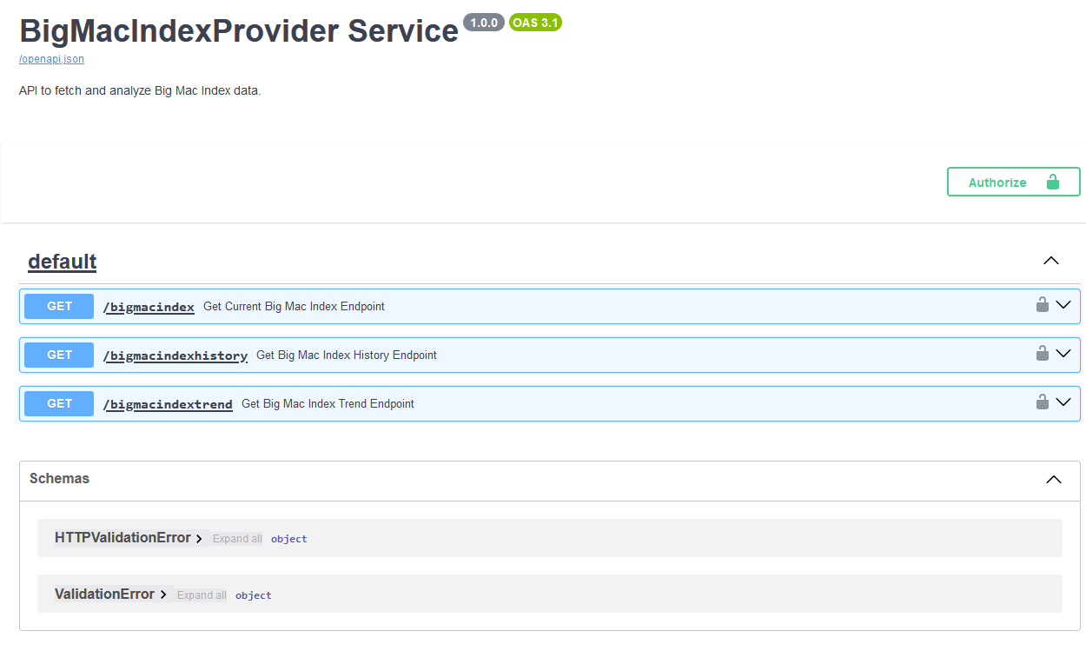

You can try out providing parameters and getting a response by clicking on one of the service endpoints. Here is a screenshot of endpoint “/bigmacindex”:
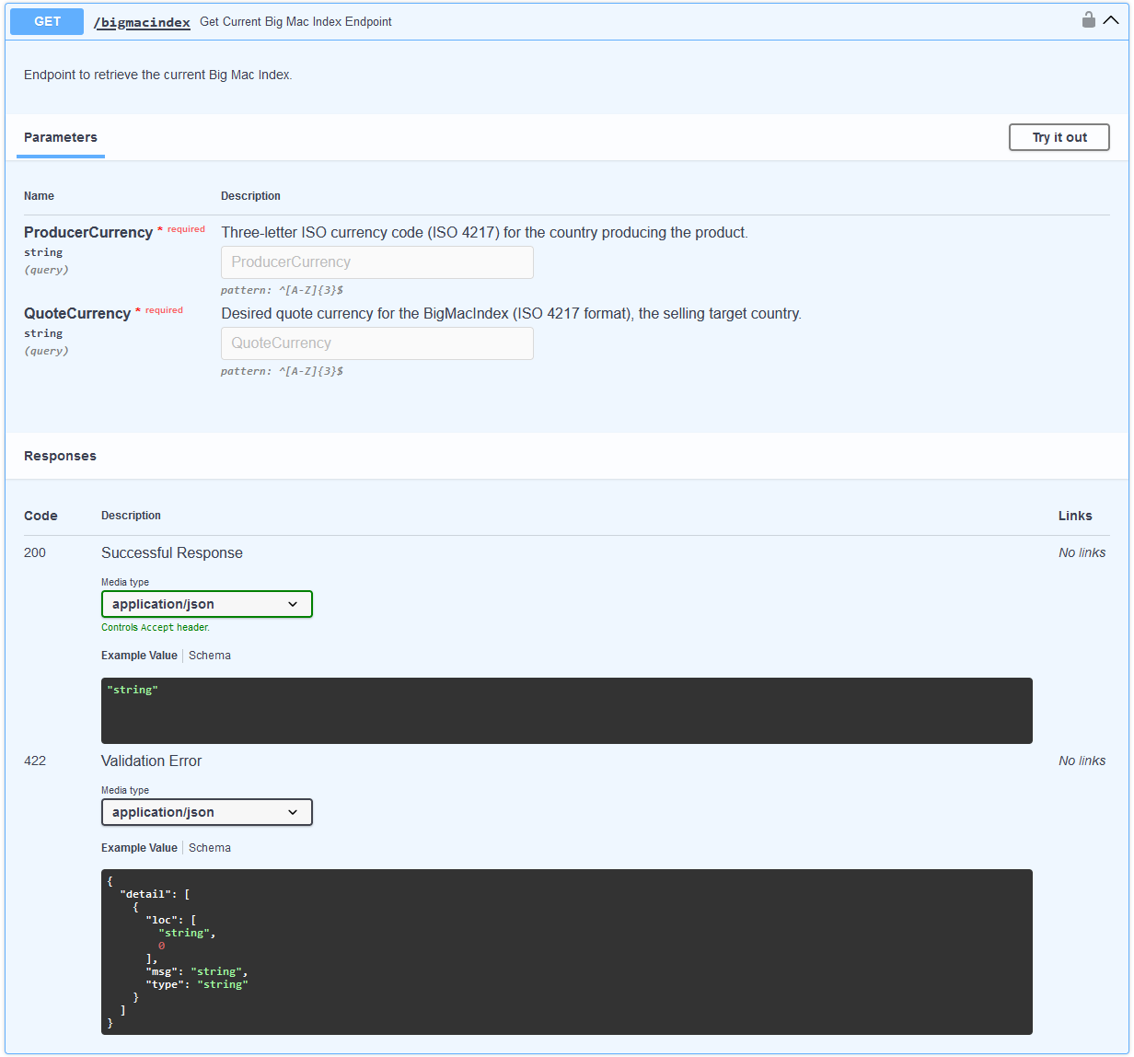

PurchasingPowerParityProvider

Use case
This service provides a convenient way to obtain Purchasing Power Parity (PPP) data from a centralized data source. It enables users to retrieve relative PPP values by specifying a country and a year, helping them compare economic metrics across regions and over time. Businesses and researchers can utilize these values to benchmark costs, analyse economic conditions, and facilitate international market comparisons. By integrating easily into existing workflows, this service supports data-driven decision-making and insight generation. Ultimately, it streamlines PPP data access and computations, saving time and effort for its users.

Inputs / Outputs
For details on the inputs (query parameters) and outputs (JSON responses), please refer to the section "Available Functions, APIs, User Interactions".

Business logic
The service reads a CSV file containing comprehensive PPP data provided by the OECD, filtered by country, year, and certain "TRANSACTION" types. It extracts the exchange rate ("EXC_A") and absolute PPP values ("PPP_B1GQ") from the relevant data rows. Using these values, the service computes the relative PPP as the ratio of the absolute PPP to the corresponding exchange rate. This logic ensures that a straightforward, numeric indicator of purchasing power parity is returned. If no valid data is found for the requested country and year, an error is raised.

Available Functions, APIs, User Interactions
The actual implementation provides a single endpoint:
- GET /ppp:
  - Query Parameters:
    - Country (ISO 3166-1 alpha-3 code, e.g. "FRA")
    - Year (integer, e.g. 2022)
  - Description: Retrieves the computed relative PPP for the specified country and year.
  - Authentication:
    - By default, the endpoint requires Keycloak OAuth2 authentication.
    - If the service is started with --simple, no authentication is required.
  - Response: Returns a JSON object containing the "PPP" value.
  - Error Cases:
    - 404 Not Found if no matching data is available.
    - 400 Bad Request for invalid parameter values.
    - 500 Internal Server Error for unexpected internal errors.
For more details, please see the on-line documentation. When running the service, it will be available at the "/docs" endpoint (by default: "http://127.0.0.1:8088/docs").

StockQuoteProvider

Use case
The Stock Quote Provider service is an API designed to fetch and compute intermediate stock quote values, offering critical insights into real-time, historical, and forecasted stock trends. This information is essential for estimating a company's performance—whether it shows a positive or downward trend. By analysing these trends, one can better predict whether a company, acting as a customer of industrial goods, would pay a high price or only a low price. The service uses cached data from Yahoo Finance to improve response times and accuracy, making it invaluable for financial applications that require up-to-date stock data.

Inputs / Outputs
This API operates as an intermediary, transforming raw stock data into actionable insights for users interested in financial trends.
Inputs:

- User Requests: The API receives requests from users specifying parameters like ticker symbols (e.g., "AAPL"), dates (YYYY-MM-DD format), date ranges, and the desired type of analysis (stock value, historical data, trend prediction).
- External Data Source (Yahoo Finance): The API relies on Yahoo Finance as its primary source for raw stock quote data. It accesses this data through their public API. Users deploying the StockQuoteProvider must agree to the usage terms of service and access rules set by Yahoo.
Outputs:
- Stock Quote Data: For /stock_quote, the API returns the specific stock value corresponding to the requested ticker symbol and date.
- Historical Stock Data: The /stock_quote_history endpoint provides a time-series dataset of stock quotes for the specified ticker within the given date range, enabling users to analyse past performance fluctuations.
- Predicted Annual Growth Rate: /stock_quote_trend produces a numerical estimate of the anticipated annual growth rate for the requested ticker based on historical data extending back days_back. This output aids in forecasting future stock behaviour.

Business logic
This API acts as a sophisticated stock data manager, combining real-time fetching from an external source (Yahoo Finance) with efficient local caching in SQLite for faster response times. Here's the abstract business logic:
Initialization:
- The API initializes an SQLite database to store cached stock prices efficiently.
Data Update Mechanism:
- We implemented methods to update stock data for requested tickers (update_ticker_data and update_multiple_ticker_data).
- For existing tickers, they fetch data from Yahoo Finance starting either from the latest cached date or two years prior to the requested end date (whichever is more recent).
- For new tickers, they automatically fetch historical data covering the last two years.
- Updates are triggered based on user requests and ensure continuous data availability.
Data Retrieval Endpoints:
- get_stock_quote(ticker_name, date): Retrieves the stock price for a specific ticker on a given date. It uses caching to serve requests rapidly. For future dates, it employs linear regression (based on recent cached data) to predict prices.
- get_stock_quote_history(ticker_name, start, end): Fetches historical stock quotes for a requested ticker within a defined date range.
- get_annual_growth_rate_percent(ticker_name, days_back): Predicts the annualized growth rate of a stock based on its price trend over the last days_back days using linear regression.
Caching Strategy:
- The API caches fetched data in SQLite for performance optimization.
- Updates are incremental, ensuring only new or updated data is stored while retaining historical context.
Error Handling:
- Robust error handling ensures the API gracefully handles missing data, invalid requests, and potential issues with external data sources (Yahoo Finance).

Available Functions, APIs, User Interactions
/stock_quote: Fetch the stock value for a specific ticker on a given date. Query Parameters:
- ticker (string, e.g., "AAPL")
- date (YYYY-MM-DD format, e.g., 2024-03-01)
/stock_quote_history: Retrieve historical stock values for a specific ticker over a date range. Query Parameters:
- ticker (string, e.g., "MSFT")
- start_date (YYYY-MM-DD, e.g., 2024-01-01)
- end_date (YYYY-MM-DD, e.g., 2024-12-01)
/stock_quote_trend: Predict the annual growth rate for a specific ticker based on past data. Query Parameters:
- ticker (string, e.g., "GOOGL")
- days_back (integer, e.g., 365)

FactoryLoadProvider

Use case
This service provides computed information about expected factory load for a future date, based on historical load data. It allows consumers, such as production planners or forecast applications, to quickly retrieve the mean factory load covering a specific date range from the current day to a given target date. By querying the service, stakeholders can make informed decisions about scheduling, capacity planning, or adjusting production lines. The service simplifies data retrieval and presents output as aggregated load values over time, reducing manual calculations. Its secure integration with OAuth2 ensures that only authorized users can access the full functionality.

Inputs / Outputs
For details on the available input parameters, output formats, and interaction methods, please refer to the section "Available Functions, APIs, User Interactions".

Business logic
The service reads a CSV file containing weekly production load values, identified by columns "Week" and "Load". Given a target date, the system determines all weeks between the current date and this target date, extracting the corresponding weekly load values. It then calculates how many days within these weeks fall into the requested date range, sums up their load contributions, and finally computes a mean load value over all those included days. Internally, the logic involves parsing the CSV file, validating week formats (YYYY/W), converting these weeks into concrete calendar days, and aggregating load data for all relevant weeks up to the target date.

Available Functions, APIs, User Interactions
All interactions with the service occur through the published REST endpoints defined in the endpoint.py module. Users and client applications make HTTP requests to these endpoints, optionally providing query parameters, to retrieve factory load data.

1. GET /hello_world
Purpose:
- A simple health-check and connectivity test endpoint.
Authentication:
- If the service is started in normal mode (authentication enabled), this endpoint requires a valid OAuth2 access token with the appropriate user role (`innosale_user`), provided in the `Authorization: Bearer <token>` header.
- If the service is started with the `--simple` flag, no authentication token is required.
Example Request:
GET /hello_world
Authorization: Bearer <your_token>
Example Response:
"hello world"

2. GET /factoryload
Purpose:
- Retrieves the calculated mean factory load for a specified future date.
- Inputs:
  - Query Parameter `Date` (required):
    - Format: `YYYY-MM-DD`
    - Example: `2024-12-31`
    - This parameter indicates the target date for which the mean load should be calculated, considering all weeks from the current day up to and including that date.
Authentication:
- In normal mode, a valid OAuth2 access token with the "innosale_user" role is required in the "Authorization: Bearer <token>" header.
- In "--simple" mode, no authentication is needed.
Processing Steps:
- The service reads the factory load CSV file (as configured by "--file-path" or the default location).
- It identifies all weeks covering the date range from today up to the requested target date.
- For each relevant week, it retrieves the weekly load value and determines how many days of that week fall within the date range.
- It sums these daily loads and divides by the number of days considered to produce a mean factory load.
Response:
- Returns a JSON object with:
  - date: The requested target date.
  - load: The computed mean load value (an integer representing the average load percentage).
Example Request:
GET /factoryload?Date=2024-12-31
Authorization: Bearer <your_token> (if required)
Example Response:
{
"date": "2024-12-31",
"load": 85
}

Common Error Responses:
- 400 Bad Request: If the provided "Date" is invalid or cannot be parsed.
- 401 Unauthorized: If authentication is enabled and no valid token is provided.
- 403 Forbidden: If the provided token does not contain the required role.
- 404 Not Found: If no data is available for the given date range.
- 500 Internal Server Error: If an unexpected error occurs during processing.

API Documentation:
A full, automatically generated OpenAPI documentation, including detailed schemas and parameter descriptions, is available once the service is running at "<host:port>/docs", where host is the IP address of the computer running the StockQuoteProvider and port is the IP port.

Crawler

Use case
The crawler component is designed to integrate new products from various open repositories. It identifies and collects information about web applications, mobile applications, libraries, software components, and other digital solutions that could be of interest to InnoSale. Through a web application, users can configure the search criteria. The crawler performs an intelligent search across the specified repositories, extracts the relevant information and presents the results for review.

Inputs / Outputs
Required Inputs: The crawler requires access to open repositories such as GitHub, GitLab, etc, and the search criteria configured by the user (search terms, technologies, repositories to be searched, inclusion criteria).
Outputs: The crawler will produce a list of digital products that match the specified search criteria. The output will be provided in a JSON format, containing details about each product (name, description, URL, technology/framework, license, relevant metadata.

Business logic
The crawler reads the search parameters and other settings from a configuration file and stablishes secure connections to the specified open-source repositories to access the project data. The crawler performs an intelligent, multi-faceted search across the target repositories using the configured search parameters. The crawler extracts the relevant information for the projects that match the search criteria. This data is normalised, structured and formatted, ready for consumption by other systems or presentation to users.

Available Functions, APIs, User Interactions
Endpoints:
- /start-crawl: Initiate a new crawling process
  - Method: POST
  - Inputs:
    - search_terms (array of strings): Keywords or phrases to search for
    - technologies (array of strings): Programming languages or frameworks to filter by
    - repositories (array of URLs): List of repository URLs to crawl
  - Outputs:
    - message: Confirmation message
    - status: Current status of the crawler ("started")
- crawl-status: Check the current status of the crawler
  - Method: GET
  - Inputs
    - None required
  - Output
    - status: Current state of the crawler ("started", "in_progress", "completed", "stopped")
- /results: Retrieve results from the last completed crawl
  - Method: GET
  - Inputs
    - None required
  - Output
    - Array of digital products, each containing:
      - name: Product name
      - description: Product description
      - url: Repository URL
      - technology: Main technology/framework
      - license: License type
      - repository: Source repository
      - discovered_at: Discovery timestamp
- /stop-crawl: Stop the current crawling process
  - Method: POST
  - Inputs
    - None required
  - Output
    - message: Confirmation message
    - status: Updated crawler status ("stopped")
- /health: Check API health status
  - Method: GET
  - Inputs
    - None required
  - Output
status: Health status of the API ("healthy")

TaraXchange

Use case
The software module is designed to consolidate and transform data from various sources to provide it in a compatible and usable format for the target system and has been adapted for InnoSale purposes. It imports data from different sources, processes it, and converts it to the desired target format using transformation rules. Through a graphical user interface, users can customize and create these transformation rules, allowing for adaptability to specific data formats and requirements.

Inputs / Outputs
Required Inputs: The tool requires access to data sources, which can be connected via APIs. Alternatively, data can be imported as files in various formats (e.g., JSON, XML, CSV). It is also possible to extract data directly from the source tools if a direct interface is available.
Outputs: The software performs rule-based data conversion to the specified target format and makes the processed data available for downstream systems. The converted data can either be transferred to a target tool via an API interface or exported as a file (e.g., JSON, XML, CSV) in a format suitable for the target system.
This software solution has been adapted in InnoSale to enable the transfer of data from product configurators and guided selling tools for the automatic generation of 3D simulation models and VR presentations.

Business logic
The software uses a combination of parsers and conversion algorithms to load data from various sources. Based on the defined transformation rules, the data is then converted. Users can create and adjust transformation rules through the graphical editor, enhancing flexibility. The rule processing runs in a specific runtime component that is integrated once the rules are created and saved. This runtime component then automatically applies the rules and provides the results.

taraXchange Main Modules
1. Sourcedata reader
The reader reads data from various source tools such or via web APIs. Formats such as AutomationML, XML, JSON, SQL, XLSX and many more are supported.
2. Graphical user interface for creating data mappings
The graphical user interface allows to create rules for data conversion without having to programme. The logical blocks can be linked simply by drag-and-drop.
3. runtime component
The runtime executes the data conversion rules created in the editor so that your data is automatically prepared and transferred to the appropriate format.
4. Target data writer
The writer saves the converted data in the appropriate format for the target tool

Available Functions, APIs, User Interactions
Users can define mapping and transformation rules through a graphical editor in the GUI. These rules are saved in a specific syntax that is processed by the runtime component. The runtime component executes these rules in real time as soon as data is imported via the connected APIs.
- Available APIs / Functions: The software provides an API for importing and exporting data. Parameters like source and target formats, as well as specific conversion settings, can be adjusted.
- Using the GUI: Through the graphical user interface, users can define data formats and create and adjust rules using drag-and-drop, making it easy to use even without programming skills.

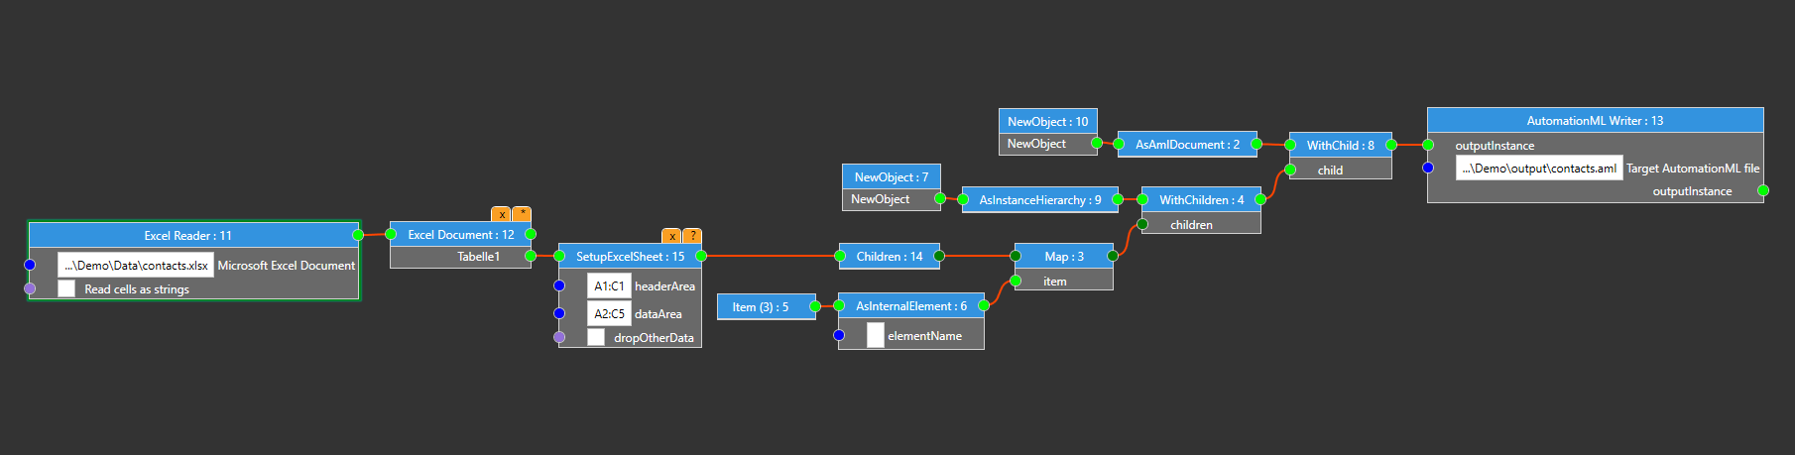
Figure 1: GUI taraXchange Rule-Editor

Conclusion
This report has detailed the InnoSale technology stack and its implementation using various services, including BigMacIndexProvider, PurchasingPowerParityProvider, StockQuoteProvider, FactoryLoadProvider, Crawler, and TaraXchange. Each service serves a unique purpose in enhancing the InnoSale platform's capabilities, enabling better data analysis, visualization, and decision-making processes for users.
The BigMacIndexProvider and PurchasingPowerParityProvider services provide valuable economic insights by calculating the Big Mac Index and PPP values, respectively. These tools offer a convenient way to compare currencies and purchasing power across different countries and time periods, which can be instrumental in strategic planning for international sales and procurement activities.
The StockQuoteProvider service delivers real-time stock data analysis through an interface with Yahoo Finance, facilitating more accurate financial forecasting and decision-making for companies involved in the sale of industrial goods. By integrating cached data from a reputable external source, this service enhances response times and ensures accuracy.
The FactoryLoadProvider service simplifies access to aggregated factory load data by producing mean load values for specified future dates. This functionality supports production planning, capacity management, and resource optimization in the manufacturing sector.
The Crawler component is designed to automate the process of identifying and collecting relevant digital products from open repositories using customizable search criteria. This service saves time and effort by intelligently searching through numerous repositories, extracting valuable information, and presenting results for review.
TaraXchange serves as a versatile data transformation tool that consolidates and reformats data from diverse sources to meet specific InnoSale requirements. By offering a graphical interface for creating data mappings, this software allows users to customize transformations effortlessly without needing programming skills. This capability supports seamless integration with product configurators and guided selling tools for generating 3D simulation models and VR presentations.
The discussed InnoSale services contribute significantly to the platform by providing a comprehensive suite of data-driven functionalities that enable enhanced decision-making in various aspects of sales and production planning processes. The technology stack described here can be adapted or extended based on specific project requirements while ensuring compliance with conceptual requirements and authentication/authorization standards.

Abbreviations
Abbreviation | Description
ABAC | Attribute-Based Access Control
API | Application Programming Interface
CMMS | Computerized Maintenance Management System
CRM | Customer Relationship Management
CSV | Comma-Separated Values
DOM | Document Object Model
EDI | Electronic Data Interchange
ERP | Enterprise Resource Planning
ESB | Enterprise Service Bus
GUI | Graphical User Interface
HTTPS | Hypertext Transfer Protocol Secure
HTTP | Hypertext Transfer Protocol
JSON | JavaScript Object Notation
JWT | JSON Web Token
MOM | Message-Oriented Middleware
RBAC | Role-Based Access Control
REST | Representational State Transfer
SAML | Security Assertion Markup Language
SSO | Single Sign-On
SSL | Secure Sockets Layer
SOA | Service-Oriented Architecture
TLS | Transport Layer Security
XML | eXtensible Markup Language
YAML | YAML Ain't Markup Language

References
[Bazaz2016] | Tayibia Bazaz; Aqeel Khalique: A Review on Single Sign on Enabling Technologies and Protocols. International Journal of Computer Applications, vol. 151 – No. 11, October 2016. Retrieved 2023-04-13 from https://www.researchgate.net/publication/309225903_A_Review_on_Single_Sign_on_Enabling_Technologies_and_Protocols.
[Erl2017] | Erl, Thomas. Service-Oriented Architecture: Analysis and Design for Services and Microservices. Prentice Hall, 2017.
[FastAPI] | Tiangolo (Sebastián Ramírez): FastAPI. Retrieved 2023-02-14, from https://fastapi.tiangolo.com/lo/
[Fielding2000] | Fielding, R. T. (2000). Architectural Styles and the Design of Network-based Software Architectures (Doctoral dissertation). University of California, Irvine. Retrieved 2023-05-10 from https://www.ics.uci.edu/~fielding/pubs/dissertation/fielding_dissertation.pdf.
[Hohpe2003] | Gregor Hohpe and Bobby Woolf. "Enterprise Integration Patterns: Designing, Building, and Deploying Messaging Solutions". Addison-Wesley Professional, October 2003.
[HTTP1.1] | R. Fielding, Ed.: Hypertext Transfer Protocol (HTTP/1.1): Semantics and Content, RFC 7231. Internet Engineering Task Force (IETF), June 2014. Retrieved 2023-04-28 from https://datatracker.ietf.org/doc/html/rfc7231.
[HTTPS] | Rescorla, E.: HTTP Over TLS, RFC 2818. Internet Engineering Task Force (IETF), May 2000. Retrieved 2023-01-11 from https://datatracker.ietf.org/doc/html/rfc2818
[JWT] | Jones, M., Bradley, J., & Sakimura, N.:. JSON Web Token (JWT), RFC 7519. Internet Engineering Task Force (IETF), May 2015. Retrieved 2022-12-12 from https://datatracker.ietf.org/doc/html/rfc7519
[Keycloak] | Keycloak. Retrieved 2023-04-11 from https://www.keycloak.org/.
[OpenAPI] | OpenAPI Initiative. OpenAPI specification (version 3.1.0). February 2021. Retrieved 2023-04-28 from https://spec.openapis.org/oas/v3.1.0.
[Python] | Python Software Foundation: Python.org. Retrieved 2023-05-02, from https://www.python.org/
[PyPi] | Python-Community: PyPI - the Python Package Index. Retrieved 2023-03-23, from https://pypi.org/
[RBAC] | Serban I. Gavrila: Formal Specification for Role Based Access Control User/Role and Role/Role Relationship Management. National Institute of Standards and Tech., 1998. Retrieved 2023-02-16 from https://dl.acm.org/doi/10.1145/286884.286902
[Sandhu1996] | R. Sandhu et al, Role-Based Access Control Models, IEEE Computer, 29(2):38-47, Feb. 1996, Retrieved 2023-02-16 from https://profsandhu.com/journals/computer/i94rbac(org).pdf
[Xin2012] | Xin Jin, Ram Krishnan and Ravi Sandhu: A Unified Attribute-Based Access Control Model Covering DAC, MAC and RBAC. In Proceedings 26th Annual IFIP WG 11.3 Working Conference on Data and Applications Security and Privacy (DBSec 2012), Paris, France, July 11-13, 2012, pages 41-55.
[Hu2013] | Vincent C. Hu et. al.: Guide to Attribute Based Access Control (ABAC) Definition and Considerations (Draft). National Institute of Standards and Technology, April 2013. 2023-02-16 from https://citeseerx.ist.psu.edu/document?repid=rep1&type=pdf&doi=cab698a5b0949aa7acd0858b55352c5df0a2c2fb

https://www.keycloak.org/getting-started/getting-started-docker
https://data-explorer.oecd.org/vis?lc=en&fs[0]=Topic%2C1%7CEconomy%23ECO%23%7CNational%20accounts%23ECO_NAD%23&fs[1]=Topic%2C2%7CEconomy%23ECO%23%7CNational%20accounts%23ECO_NAD%23%7CGDP%20and%20non-financial%20accounts%23ECO_NAD_GNF%23&pg=0&fc=Topic&snb=53&df[ds]=dsDisseminateFinalDMZ&df[id]=DSD_NAMAIN10%40DF_TABLE4&df[ag]=OECD.SDD.NAD&df[vs]=1.0&pd=%2C&dq=A....PPP_B1GQ.......&ly[cl]=TIME_PERIOD&ly[rw]=COMBINED_UNIT_MEASURE%2CREF_AREA&to[TIME_PERIOD]=false&vw=ov

