CAPE
Project Management Plan
Project Code: 22017 (ITEA Call 2022)
V1.1
Revision Table:
Version | Date | By | Changes
1.0 | April, 2024 | INOSENS | Initial Version
1.1 | May, 2024 | INOSENS | Reviewed all sections

Contents:
Executive Summary 2
Project Scope 3
Project Organization and Communication Management Plan 4
Project Deliverables 6
Project Schedule 8
Project Resources 9
Risk and Issue Management Plan 10

Executive Summary
Cognitively Smart Assistant in Phygital Environment (CAPE) project management plan (PMP) describes the project management organization and processes, which are meant to facilitate teamwork within the consortium and assure the quality of the work carried out. The PMP will ease the collaborative work of the partners, and it may therefore be considered key for the overall success of the CAPE project. In addition, it will ensure that the consortium meets all the requirements related to the contract with the European Commission (EC).
Project Scope
This document is the Management Plan for the CAPE project. Its purpose is to establish the project management organization, processes, and standards that will be followed throughout the project life cycle with regard to project management.
The CAPE project has focused on this PMP from the beginning of the project, with the whole consortium working on its definition. The project management plan is a living document that will be updated during the course of the project.
The document is composed of 5 sections. Each section can contain a description of a set of operations or processes or links to additional internal documents where the topic is developed in more detail.
The sections are organized as follows:
― CAPE Project Organization and Communication Management Plan
― CAPE Project Deliverables
― CAPE Project Schedule
― CAPE Project Resources
― CAPE Risk and Issue Management Plan

Project Organization and Communication Management Plan
The project work is divided into five work packages and the work package structure is shown in figure below.

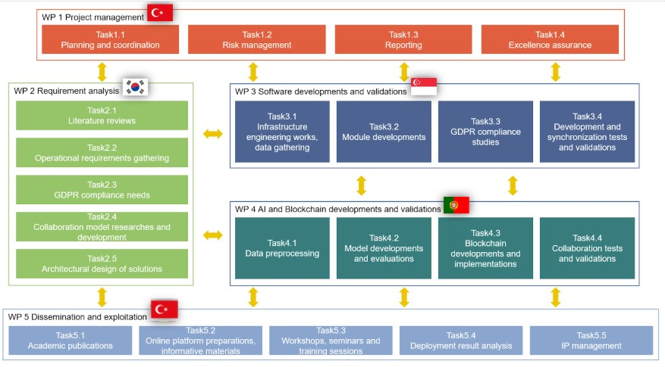

WP1, work package, undertakes overall project management and coordination to ensure that the project objectives are achieved. A project management plan will be established and all activities will be managed within this framework. The work package also includes important functions such as risk management and reporting.

WP2 analyzes the requirements of the web-based communication and support management application. Determining operational requirements, assessing GDPR compliance, exploring collaboration models and designing the architecture are the focal points of this work package.

WP3 develops and integrates the technical solutions of the project. Activities such as infrastructure engineering studies, module developments and GDPR compliance studies are carried out under this work package. In addition, synchronization tests and verification of the developed infrastructure, hardware and software are also part of this work package.

WP4 focuses on the development of the project's cutting-edge research projects. Data pre-processing, model development and evaluation, blockchain development and implementation, and collaboration testing and validation are the sub-tasks of this work package. Each task aims for the project to achieve a specific outcome.

WP5 focuses on dissemination and commercialization of the project results. Academic publications, creation of informative materials, organization of training sessions, analysis of results and management of intellectual property rights are the activities of this work package. This work package ensures that the results of the project are disseminated to a wide audience and commercial opportunities are exploited.
The management structure of the CAPE project is shown in the figure below. This organization focuses on the complexity of an international collaborative research and development project.
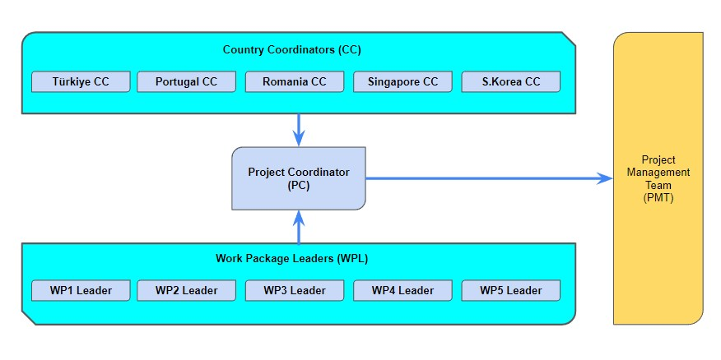
The project management team (PMT) is in charge of project overall continuous executive management. The PMT consists of the project administrative coordinator (PC), work package leaders (WPL), Country Coordinators (CC) and representatives of each partner. The project administrative coordination is executed by PC. WPL role is to lead the referred work package. CC's role is to coordinate the interaction with the local public authority. The PMT may also invite external technical advisers to take part in the PMT meetings. The key roles are shortly described in the following.
The project co-ordinator (PC) is responsible for the overall administrative coordination of the project. He/she is in charge of the following issues: performance and progress of the project agreement with the project cost plan; communication and interaction between the ITEA and the project consortium; reporting to the ITEA office, organization of general and regular meetings, review meetings and events.
Work package leaders (WPL) are responsible for coordination, planning and monitoring of the work package in agreement with the overall work plan, co-operating with task leaders and reporting to the PC.
The internal functioning of the project will be further set in a detailed Consortium Agreement that all partners will need to sign.
Project Deliverables
The project management process includes two main deliverables: documents, and software. They have been clarified and confirmed in the kick-off meeting and will be reviewed iteratively along the project process.
These deliverables are outcomes of a 36 monthly process within the CAPE Project to deliver the following.

Del. No. | Name of Deliverable (Dx.x) or Milestone (Mx.x) | Type (report, software) | Dissem.  level | Delivery month
D1.1 | Project Management Plan | Document | PU | M6
D1.2 | Risk Management Plan | Document | PU | M7
D1.3 | Term Report | Document | PU | M12
D1.4 | Final Project Report | Document | PU | M36
D2.1 | Literature Review Report | Document | PU | M9
D2.2 | Operational Requirements Report | Document | PU | M6
D2.3 | GDPR Compliance Report | Document | PU | M9
D2.4 | Collaboration Model Report | Document | PU | M9
D2.5 | Solution Architecture Document | Document | PU | M9
D2.6 | Technical Specifications Report | Document | PU | M9
D3.1 | Initial CAPE software Platform | Software | CO | M33
D3.2 | Final CAPE software Platform | Software | CO | M33
D3.3 | Infrastructure Design and Implementation Report | Document | CO | M33
D3.4 | Security and Privacy Report | Document | PU | M33
D3.5 | Engineering Activities Test Results and Validations | Document | PU | M33
D4.1 | Data Preprocessing Report | Document | CO | M15
D4.2 | Model Development and Evaluation Report | Document | CO | M33
D4.3 | Blockchain Development and Evaluation Report | Document | CO | M33
D4.4 | Deployment and Feedback Report | Document | CO | M33
D5.1 | CAPE Website and social media accounts | Other | PU | M3
D5.2 | CAPE Newsletter #1 | Other | PU
D5.3 | CAPE Newsletter #2 | Other | PU
D5.4 | CAPE Newsletter #3 | Other | PU
D5.5 | Use Case Demonstrations Videos | Other | PU | M33
D5.6 | Solution Brochures, Presentations and Whitepapers | Document | PU
D5.7 | Final Project Report | Document | PU | M36

Project Schedule
The project’s duration is 3 years. ITEA reviews are planned at approximately 1 year intervals. The more detailed schedule is illustrated in the Gantt chart below.
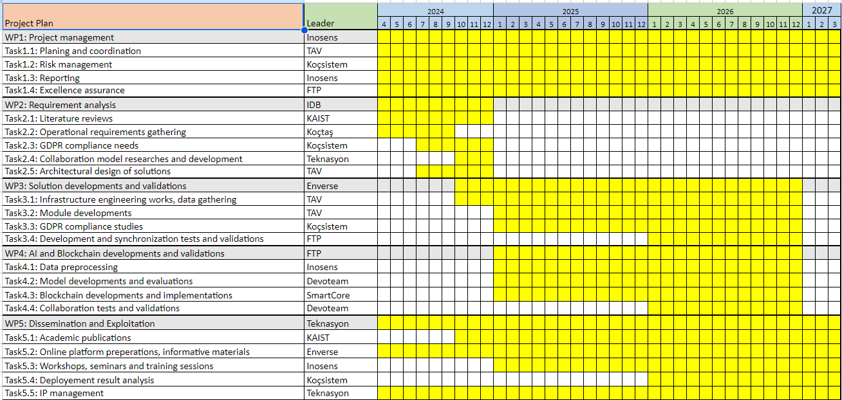
Project Resources

Effort and Budget for the project | Total | 2024 | 2025 | 2026 | 2027 and later
Project budget (kEUR)
Effort in
Person Years (PY)

Total budget allocations per country are following
(Figures in kEuro)
Country | 2024 | 2025 | 2026 | 2027 (+) | Total
Turkey
S.Korea
Portugal
Romania

Total effort allocations per country
(Figures in person year (PY))
Country | 2024 | 2025 | 2026 | 2027 (+) | Total
Turkey
S.Korea
Portugal
Romania

Risk and Issue Management Plan
The Risk Management Plan defines the approach that the CAPE Team will take to identify, assess, and manage project risks from inception through closure.
The following are the objectives of the Risk Management Plan:
- To establish a structured, repeatable risk management process to minimize the negative impact and maximize any benefits of risks to a project
- To verify risks are communicated to management and other project stakeholders in a timely manner
This plan is being handled in the D1.2 Risk Management Plan document.

