WP 2 Deliverable 2.5:
Architectures and Standardization
WP2: Requirement Analysis

Project Name: 22017 CAPE
Status: v1.0

Reviewers
Names | Organization
Gokhan Koc | TAV Technologies
Ilyoung Chong | KAIST

Document History
Version | Date | Author | Changes
v0.1 - Initial Version | 14.01.2025 | Gokhan Koc (TAV Technologies)  Gozde Sayin (TAV Technologies)
V0.2
v0.9 | 12.03.2025 | Isabel Ribeiro (FTP)
v1.0 –Final Version | 13.03,2025 | Bernard Min (IDB),  Ilyoung Chong (KAIST)
Contents
1 Table of Figures 5
2 USE CASE 1 AND USE CASE 5 7
2.1 Overall Communication and Platform Architecture 7
2.1.1 Independent architecture for different clients 8
2.1.2 Deployment of partner servers/systems 8
2.1.3 Robot architecture (details are shared in other sections) 8
2.1.4 Bidirectional communication between robots and partner servers 9
2.1.5 Integration with retail and external data sources 9
2.1.6 Data standardization and centralized monitoring 9
2.1.7 Access control mechanism 10
2.1.8 Configuration management and data aggregation 10
2.1.9 Future enhancements for commercialization 10
2.2 Data Standardization 11
2.2.1 Customer interaction data (streaming) 12
2.2.2 Employee data (streaming) 14
2.2.3 Robot data (streaming) 15
2.3 Robot Architecture 16
3 USE CASE 4 19
3.1 Overall Communication Architecture 19
3.2 Data Standardization 20
3.2.1 Fire detection (P11) 20
3.2.2 Accident detection (P12) 21
3.2.3 Disaster detection(P13) 21
3.2.4 AI reliability analysis(P2) 22
3.2.5 Generative AI user conversation (P31) 22
3.2.6 Alerting & Dashboard service (P32) 23
3.3 Detail of Data Standardization of each data structure 23
3.3.1 Vibration Sensor(S11) 23
3.3.2 Electrical monitoring sensor(S12) 24
3.3.3 Gas Sensor(S13) 24
3.3.4 Environmental Sensor(S14) 24
3.3.5 Noise Sensor(S15) 24
3.3.6 Thermal data from Thermal Camera (S16) 25
3.3.7 CCTV camera (S21) 25
3.3.8 Audio Sensor (S22) 25
3.3.9 SOP Info (S81) 25
3.3.10 SOP Node (S82) 25
3.3.11 SOP Edge (S83) 25
3.3.12 SOP Assign (S84) 26
3.3.13 AI Analysis result (O1) 26
3.3.14 Reliability Assessment (O21) 26
3.3.15 AI Model Management (O22) 26
3.3.16 User Assistant Service (O31) 27
3.3.17 Dashboard Data (O32) 27
4 USE CASE 2 28
4.1 Overview 28
4.2 Components and communication 29
4.3 Data Standardization 30

Table of Figures

Figure 1 – Cape platform and system level architecture for UC1 and UC5 7
Figure 2 - UC1, UC5 customer data streaming format 12
Figure 3 - UC1, UC5 employee data streaming format 15
Figure 4 - UC1, UC5 robot data streaming format 16
Figure 5 – UC 4, Solution Architecture of AI-DSP(AIoT powered Intelligent Disaster Safety Platform) of Use case 4 17
Figure 6 – UC4 process base data standardization of AI-DSP 18
Figure 7 – UC 4, data flow at Fire detection process 18
Figure 8 - UC4 data flow at Accident detection process 19
Figure 9 – UC 4 data flow at Disaster detection process 19
Figure 10 – UC 4 data flow at AI reliability process 20
Figure 11 – UC4, data flow at Generative AI user conversation process 20
Figure 12 – UC4, data flow at Alert & Dashboard service process 21
Figure 13 – UC4, detail of Data Standardization for Vibration Sensor 21
Figure 14 – UC4, detail of Data Standardization for Electrical monitoring Sensor. 22
Figure 15 – UC4, detail of Data Standardization for Gas Sensor. 22
Figure 16 – UC4, detail of Data Standardization for Environmental Sensor. 22
Figure 17 – UC4, detail of Data Standardization for Noise Sensor. 22
Figure 18 UC4, detail of Data Standardization for Thermal data from Thermal Camera. 23
Figure 19 – UC4, detail of Data Standardization for CCTV camera. 23
Figure 20 – UC4, detail of Data Standardization for Audio Sensor. 23
Figure 21 – UC4, detail of Data Standardization for SOP Info. 23
Figure 22 – UC4, detail of Data Standardization for SOP Node. 23
Figure 23 – UC4, detail of Data Standardization for SOP Edge. 23
Figure 24 – UC4, detail of Data Standardization for SOP Assign. 24
Figure 25 – UC4, detail of Data Standardization for AI Analysis result. 24
Figure 26 – UC4, detail of Data Standardization for Reliability Assessment. 24
Figure 27 – UC4, etail of Data Standardization for AI Model Management. 24
Figure 28 – UC4, detail of Data Standardization for User Assistant Service. 25
Figure 29 – UC4, detail of Data Standardization for Dashboard Data. 25
Figure 30 – UC2 Communication architecture 26

USE CASE 1 AND USE CASE 5

Overall Communication and Platform Architecture
System architecture developed under Use Case 1 and Use Case 5, supports multi-store capabilities, allowing edge devices such as kiosks, robots, and mobile interfaces to collect and transmit data to central partner servers. These partner systems will standardize and forward data to the CAPE Central Monitoring Platform, where AI-driven analytics will provide real-time insights. The architecture will ensure secure, GDPR-compliant data exchange, unidirectional data flow, and configurable access controls through VPN-based authentication. With a modular structure supporting cloud, on-premise, and data center deployment options, the platform will enable seamless integration with retail store systems, external public data sources, and AI-powered recommendation engines. validation will further strengthen the system’s efficiency and security.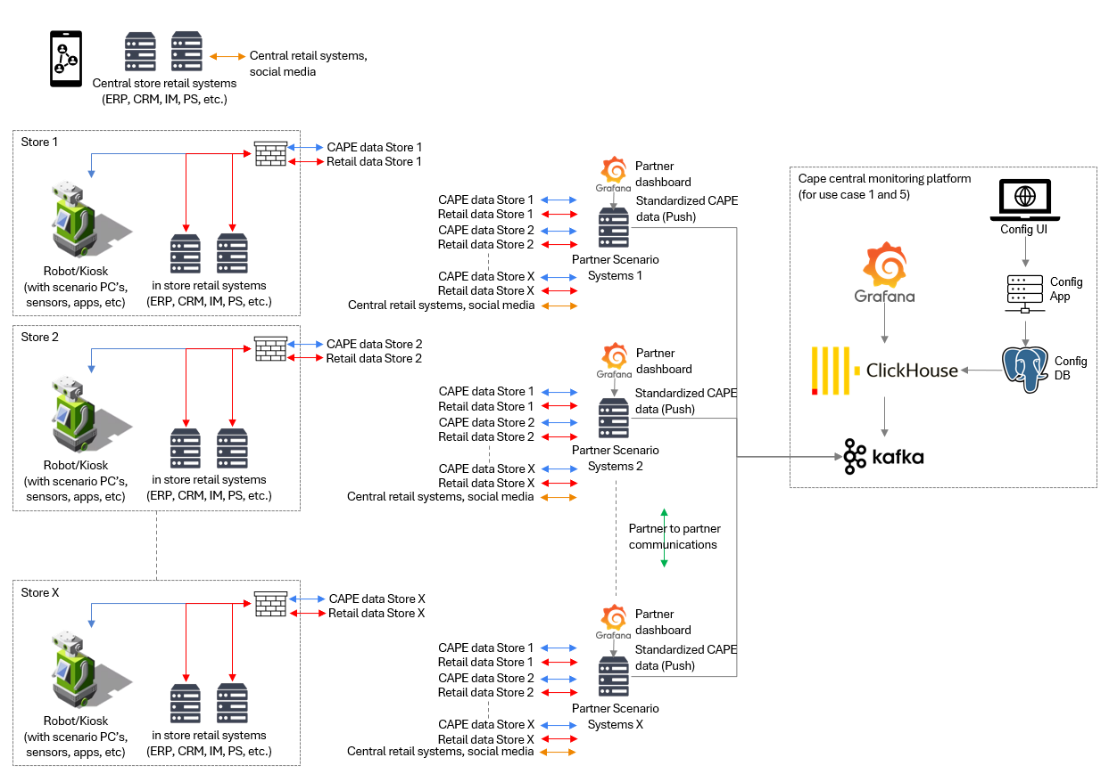
Figure 1 – Cape platform and system level architecture for UC1 and UC5

Independent architecture for different clients
The scenarios developed under Use Case 1 and Use Case 5 will be designed for a single type of customer at a time. As the project moves toward commercialization, the system will be implemented as independent architectures tailored to different clients, such as Koçtaş, DeFacto, and TAV Store. However, the system will be built with multi-store capability, meaning that edge systems deployed in different store locations will transmit their data to central partner servers. These partner servers will then send standardized data to the CAPE Central Monitoring Platform for further analysis and visualization.

Deployment of partner servers/systems
The location and deployment strategy for partner servers will be determined through discussions with clients during the project or commercialization phase. There will be three potential deployment models: cloud-based hosting for scalability and centralized management, on-premise deployment within the client’s network at a designated central point, or private data center hosting managed by partner organizations. Since the development phase will focus on a single-store environment, these deployment details will not be critical in the early stages. However, during demonstration phases, partners will coordinate with store IT teams to ensure compliance with their network security policies.

Robot architecture (details are shared in other sections)
The architecture of the robot, kiosk, VR glass, and smartphone system will be structured into multiple layers, ensuring seamless data collection, processing, communication, and actuation.
At the data collection and sensing layer of robot, various input devices such as cameras, microphones, RFID readers, and environmental sensors will collect real-time data. The processing layer will use edge computing systems to handle hardware control, movement management, actuation functions, and environmental monitoring. Multiple Edge App Services will be responsible for AI-powered data processing, real-time decision-making, and hardware configuration.
The actuation layer of robot will include motors, servos, and mechanical components that enable physical actions based on AI-driven decision-making. The communication layer will ensure data exchange through secure network protocols, including TCP/IP, Modbus, Wi-Fi, and cellular networks (3G/4G/5G/6G). Data security and privacy compliance will be ensured through GDPR-aligned mechanisms. This modular structure will allow the system to function as an autonomous AI-driven platform, adaptable to different retail environments as a self-service kiosk, a robotic assistant, or an interactive customer support system.

Bidirectional communication between robots and partner servers
The system will require two-way communication between robots/kiosks and partner servers/systems. For example, AI models will be deployed from partner servers to robots/kiosks, while real-time external data sources, such as promotions and inventory updates, will be pushed to robots. In return, for example, robots/kiosks will transmit sensor data, AI processing outputs, and service requests to partner servers.
Network bandwidth limitations will be considered in the design phase to ensure efficient data exchange. Additionally, personal data such as customer and employee information will not be transferred to partner servers without explicit consent from users.

Integration with retail and external data sources
Partner servers will integrate data from multiple sources. Retail store systems, including ERP, CRM, and IM, will provide data related to inventory, promotions, employee schedules, and operational metrics. Partner systems will be able to communicate with each other when necessary, enabling cross-functional scenarios. Additionally, external public data, such as social media trends, weather conditions, and city traffic data, will be incorporated to enhance AI-driven insights.

Data standardization and centralized monitoring
While the architecture of partner systems and their data input configurations will vary based on the specific use case requirements, all data transmitted to the CAPE Central Monitoring Platform will follow a standardized format to ensure compatibility across all partner systems.

A unidirectional data flow will be maintained, where partner servers will push data to the CAPE platform, while the CAPE platform will not send data back to partner servers. This will ensure a secure and controlled data environment.

Access control mechanism
A two-level access control system will be implemented:
- Retail clients will access monitoring dashboards only from authorized devices. Access will be restricted through a Client-to-Site VPN, requiring users to connect via VPN before accessing Grafana dashboards. Authentication will be enforced through unique usernames and passwords.
- For partner system communication with CAPE, partner servers will only push data via Site-to-Site VPN. Kafka topics will be configured to control which data streams each partner can send. Data validation and standardization will be handled on the partner servers before transmission.

Configuration management and data aggregation
The CAPE platform will include several components to ensure flexibility and scalability. A Configuration UI and application will be developed to manage store-specific metadata, systems, and configurations, with configuration data stored in PostgreSQL.
A real-time data processing pipeline will be implemented, where scenario data from partner servers will be aggregated with configuration metadata and stored in ClickHouse. The stored data will be queried and monitored via Grafana. This method will allow users to view raw queries, but since data transformation will occur on the client side, performance may be impacted. As the project is an R&D initiative, this method will be used during the development phase.

Future enhancements for commercialization
As the system moves toward commercialization, additional improvements will be implemented. A GraphQL-based API gateway will be introduced between ClickHouse and Grafana, enhancing security by preventing direct database queries from being exposed to users. The access control mechanism will be strengthened by integrating a Keycloak-like authentication system.
Currently, partner servers are responsible for data validation before transmission to CAPE. In the future, data validation and standardization will be performed within CAPE itself, improving data consistency and security.

Data Standardization
Partners will transmit data in a structured event-driven format to ensure compatibility with the CAPE system. Each partner system, including customer interaction sources, employee tracking tools, and robots, will push event data to three predefined Kafka topics: Customer Interaction Data, Employee Data, and Robot Data. These events will be formatted as JSON objects following the predefined schema for each data category. The CAPE system will process and validate these events before storing them for analytics and monitoring.
Each event will contain all necessary fields based on the standardized schema, but some fields may remain null depending on the functionalities of the partner system. For example, if a partner system does not track campaign-related interactions, the related_campaign_id field will be null. Similarly, if an employee tracking system does not support facial emotion detection, it will not send values for employee_sentiment_detection_method. CAPE’s data validation process will allow such optional fields to remain empty without rejecting the entire event.
Partners will format their data as JSON payloads before sending them to Kafka topics. Below are examples of how partners will structure their event data.
Partners will have access to a JSON schema document and validation services to test their event formats before full integration. CAPE’s real-time data pipeline will process valid events and make them available for AI-driven analytics and operational monitoring.

Customer interaction data (streaming)
The diagram represents a relational database schema designed to standardize and manage customer interactions, employee activities, and store operations within the CAPE system. It defines key entities such as stores, employees, customer interactions, products, campaigns, and sentiment analysis, ensuring structured data flow between different components while linking them through unique identifiers and relationships.
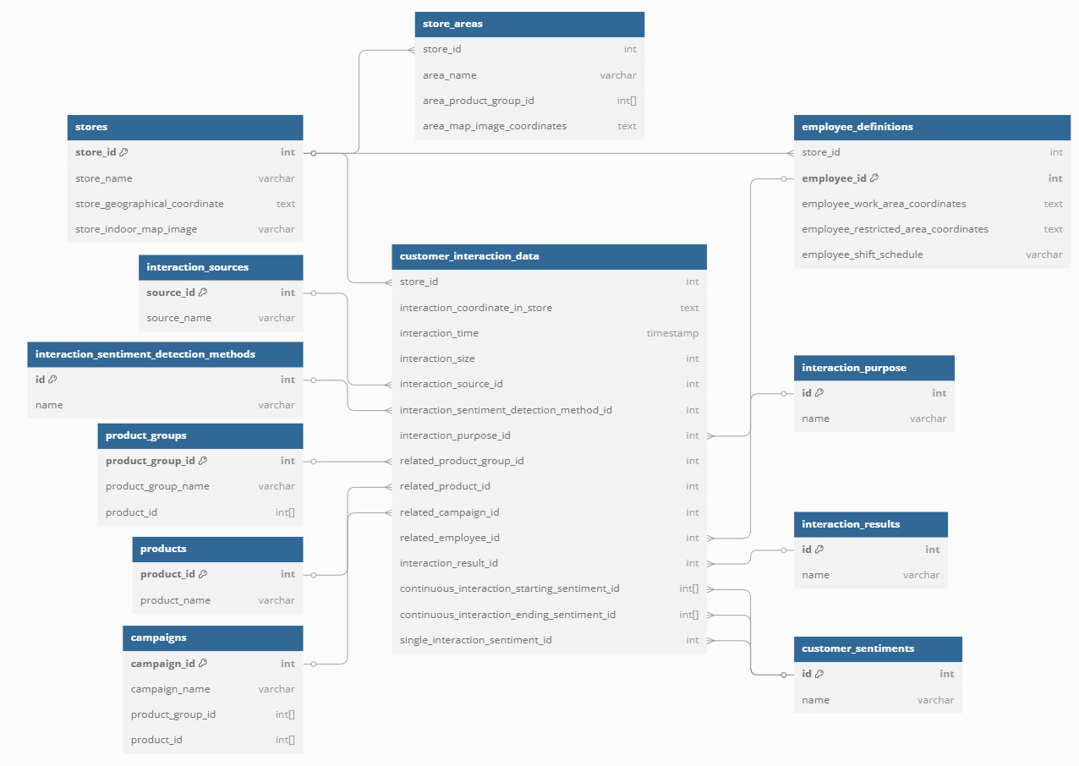
Figure 2 - UC1, UC5 customer data streaming format
The store_id field is an integer that uniquely identifies the store where the interaction took place.
The interaction_coordinate_in_store field is a text value that represents the spatial coordinates of the interaction within the store layout. The values will be formatted in GeoJSON, but they will not reference image-based x,y coordinates.
The interaction_time field is a timestamp indicating the exact time when the customer interaction occurred.
The interaction_size field is an integer that represents the dialogue length between customers and systems. The value will be counted as the number of characters in the interaction.
The interaction_source_id field is an integer that references the source of the interaction. The value corresponds to specific partner systems, such as partner system 1, partner system 2, ... , partner system X.
The interaction_sentiment_detection_method_id field is an integer referencing the method used for detecting customer sentiment. The possible values include:
- Speech
- Text
- Body language
- Facial emotion
The interaction_purpose_id field is an integer referencing the purpose of the interaction. The possible values include:
- Product inquiry
- Recommendation request
- Navigation assistance
- Promotion inquiry
- Complaint
- General information request
- Employee support request
The related_product_group_id field is an array that references the product groups related to the interaction.
The related_product_id field is an array that references the specific products involved in the interaction.
The related_campaign_id field is an array that references the campaigns related to the customer interaction.
The related_employee_id field is an array that references the employees involved in the interaction.
The interaction_result_id field is an integer that references the result of the interaction. The possible values include:
- Successful interaction
- Partially successful
- Failed interaction
- Escalation
- Feedback collected
The continuous_interaction_starting_sentiment_id field is an array that stores the sentiments detected at the start of a continuous interaction.
The continuous_interaction_ending_sentiment_id field is an array that stores the sentiments detected at the end of a continuous interaction.
The single_interaction_sentiment_id field is an integer that represents the overall sentiment of a single interaction session.

Employee data (streaming)
This database schema represents the standardized structure for employee-related data within the CAPE system, ensuring a consistent way to store and process employee activities, emotions, and work-related details. The employee_data table logs key details such as the employee's location within a store, recorded emotions, sentiment sources, detection methods, and timestamps of events. It is linked to employee_definitions, which stores additional details such as work area coordinates, restricted zones, and shift schedules. The schema also includes employee_emotions and interaction_sentiment_detection_methods, which define sentiment categories and detection techniques used in employee interactions. Additionally, interaction_sources identify different sources of employee-related data, while stores provide contextual information about the store location. This structure allows real-time employee monitoring, sentiment analysis, and operational insights to enhance workforce efficiency and experience in retail environments.
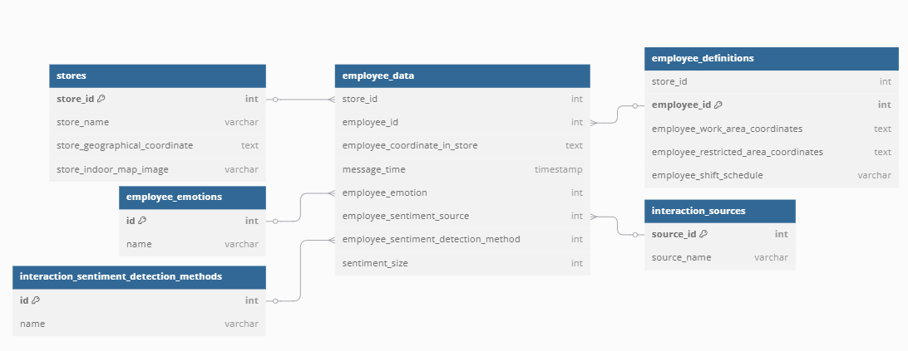
Figure 3 - UC1, UC5 employee data streaming format

Robot data (streaming)
This database schema is designed to manage and standardize robot-related data within the CAPE system. The robot_data table records key operational metrics of robots deployed in stores, including their location coordinates, battery levels, temperatures, CPU and memory usage, disk space availability, and overall health status. It also includes shock detection, allowing the system to identify potential damage or impact events. The robots table stores general information about each robot, such as its name, type, manufacturer, firmware version, and last maintenance date, ensuring that maintenance schedules and system updates can be tracked effectively. The stores table links robot data to a specific store by storing details such as store name, geographical coordinates, and an indoor map image. By structuring robot data in this way, the CAPE system ensures real-time monitoring of robot performance, predictive maintenance, and seamless integration into store operations for enhanced automation and efficiency.
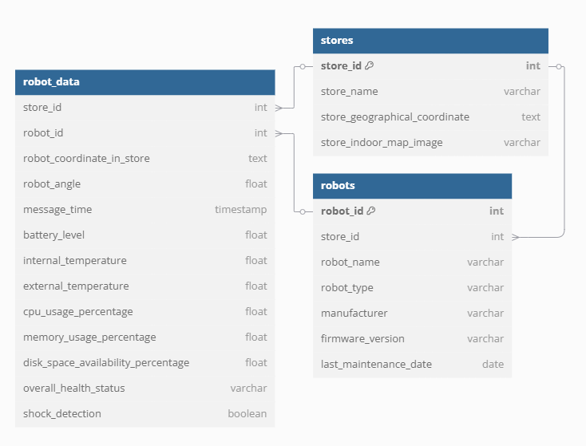
Figure 4 - UC1, UC5 robot data streaming format

Robot Architecture
The robot and kiosk architecture is illustrated in Figure 5. As shown, there is no direct interaction between the robot and the use cases. Instead, a third hardware module will be created to integrate the use cases, enabling human interaction on the robot. This module will allow the robot to perform various tasks and interact with users.
The robot architecture consists of the following key components:
Robot
The robot is equipped with various sensors and actuators to perform its tasks. It collects data from its environment and interacts with users through the hardware module.
Firewall
The robot communicates with the database (DB) through a firewall, ensuring secure data transmission. This connection allows continuous data sharing and enables the robot to receive actions, such as changing its position, directly from the DB.
Database (DB)
The database stores all the necessary data for the robot's operations. It receives data from the robot and provides the required information for the robot to perform its tasks. Also, it stores usecases usage and summary to perform analysis in the future.
Hardware Module
The hardware module is responsible for integrating the use cases with the robot. It acts as an intermediary, facilitating human interaction with the robot. This module’s only direct connection between robot is to get power from pover supply. This modules ensures that the robot sustains itself as a platform for different usacases.
Server
The server hosts the use cases and communicates with the hardware module. It implements the solution on robot via the hardware module without intervention to the robot. It processes the data received from the DB that belongs to the robot and sends the necessary commands back to the robot through the DB. It also summarizes and stores usage details of the solution in the DB.
Note: The mongo DB is stores all information about solutions such as conversations, user_id’s etc. This DB will be placed on the host partner servers because of the security.
Kiosk
Similar to the robot, the kiosk collects data and interacts with users. However, unlike the robot, the kiosk does not perform physical actions. It communicates with the server and the hardware module to provide the necessary services.
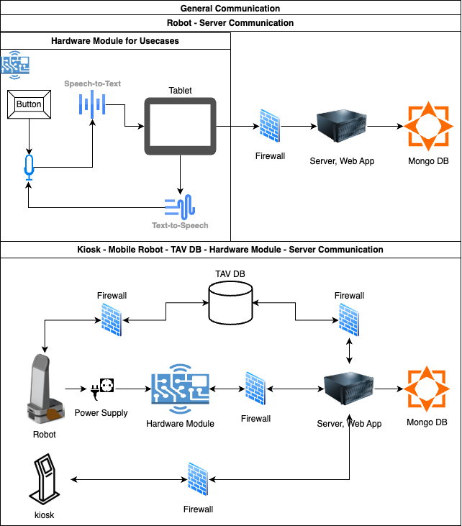
Figure 5 Robot - Kiosk - Server - DB Communication

USE CASE 4

Overall Communication Architecture
The safety & hazardous protection system in the smart workplace is designed to support worker safety through AI-based data analysis based on integrated monitoring utilizing Internet of Things (IoT). Based on detection of abnormal situations such as disaster in the workspace, abnormal behavior of workers, etc., the system sends notifications to supervisor or surrounding workers when the abnormal situation occurs. The system supports accurate and quick responses to worker’s requests regarding the abnormal situation.
The platform of AI-DSP(AIoT powered Intelligent Disaster Safety Platform) supports the functional capabilities of safety & hazardous protection in accordance with trustworthy IoT environment in the smart workplace as shown in the following figure.
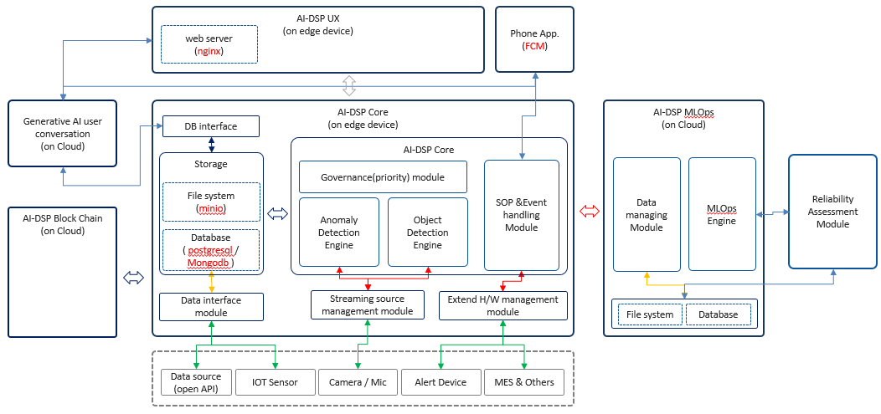
Figure 5 – UC 4, Solution Architecture of AI-DSP(AIoT powered Intelligent Disaster Safety Platform) of Use case 4

Data Standardization
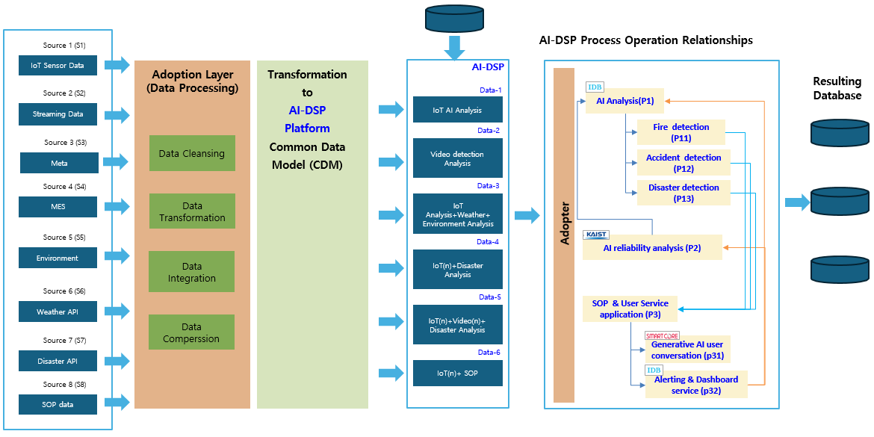
Figure 6 – UC4 process base data standardization of AI-DSP

Fire detection (P11)
Predicts and detects fire occurrence through streaming data, IoT sensor data, and other information.
- Detection contents: Flame, smoke, temperature abnormality, harmful gas abnormality, explosion sound.
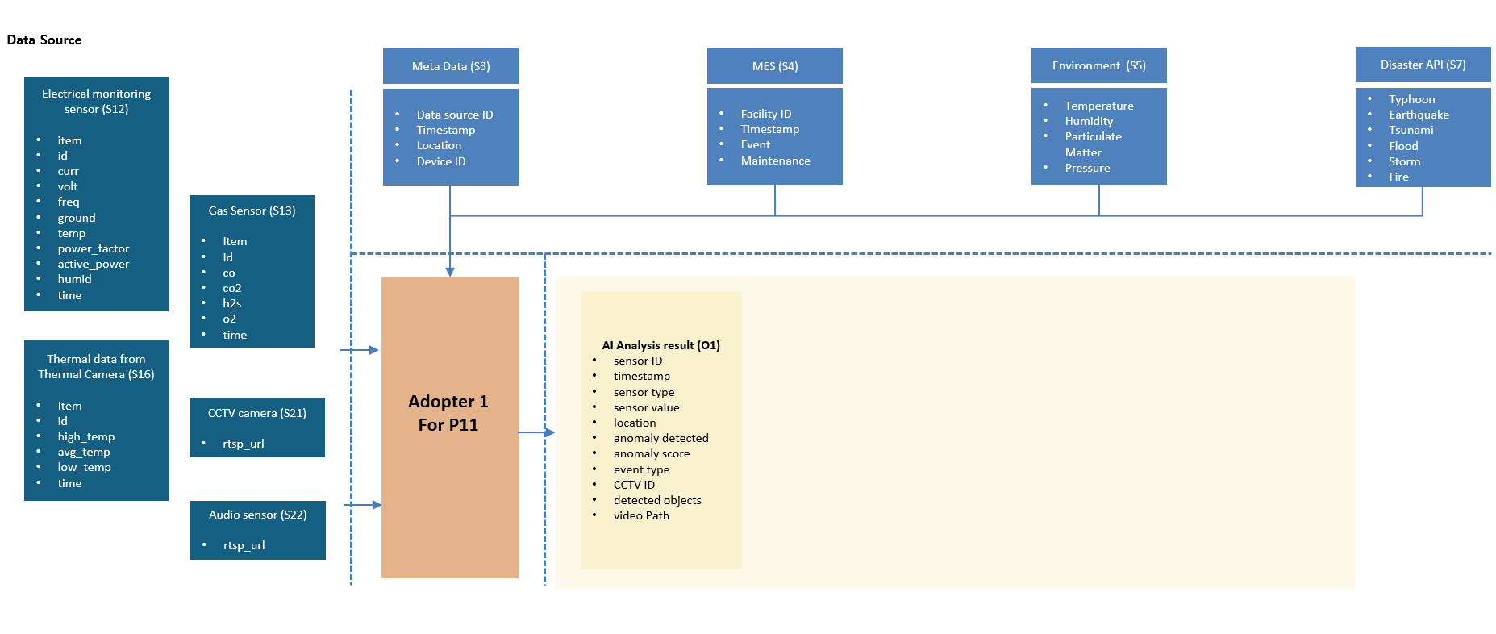
Figure 7 – UC 4, data flow at Fire detection process

Accident detection (P12)
Predicts and detects accidents through streaming data, IoT sensor data, and other information.
- Detection contents: Falling, not wearing safety equipment, trespassing in dangerous areas, harmful gas abnormality, approaching to vehicles and construction equipment, screams, and verbal notifications of dangerous situations.
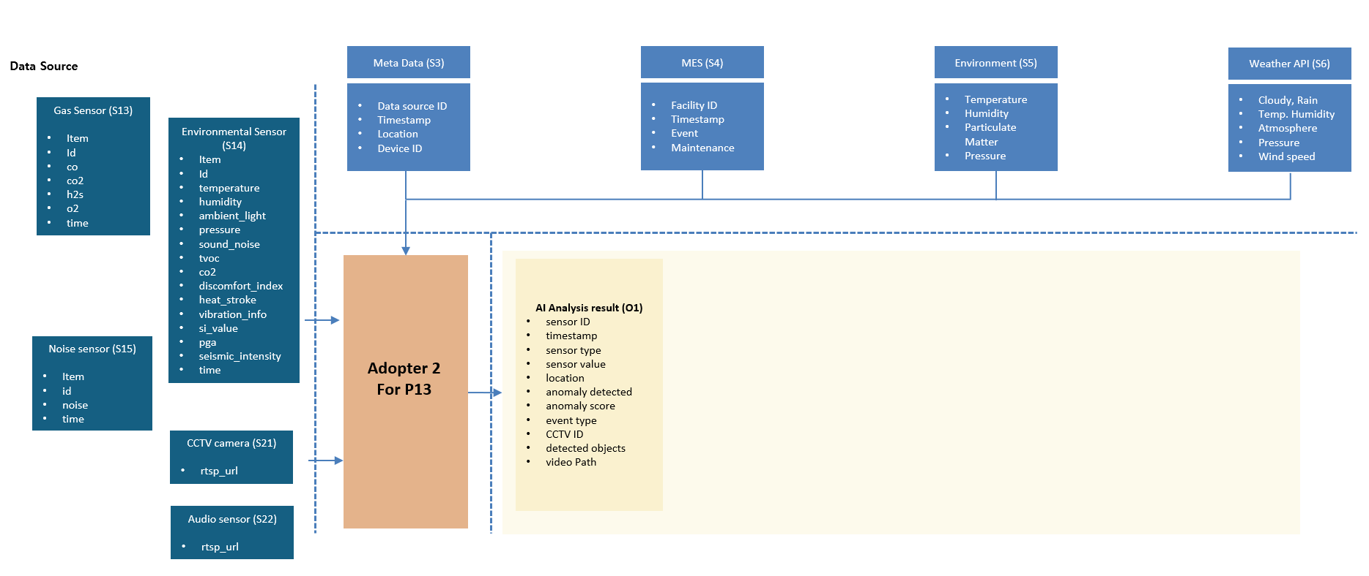
Figure 8 - UC4 data flow at Accident detection process

Disaster detection(P13)
Predicts and detects disasters through streaming data, IoT sensor data, and other information.
- Detection contents: Earthquake, typhoon, flood, landslide, large-scale fire, temperature abnormality, humidity abnormality, large-scale vibration abnormality.
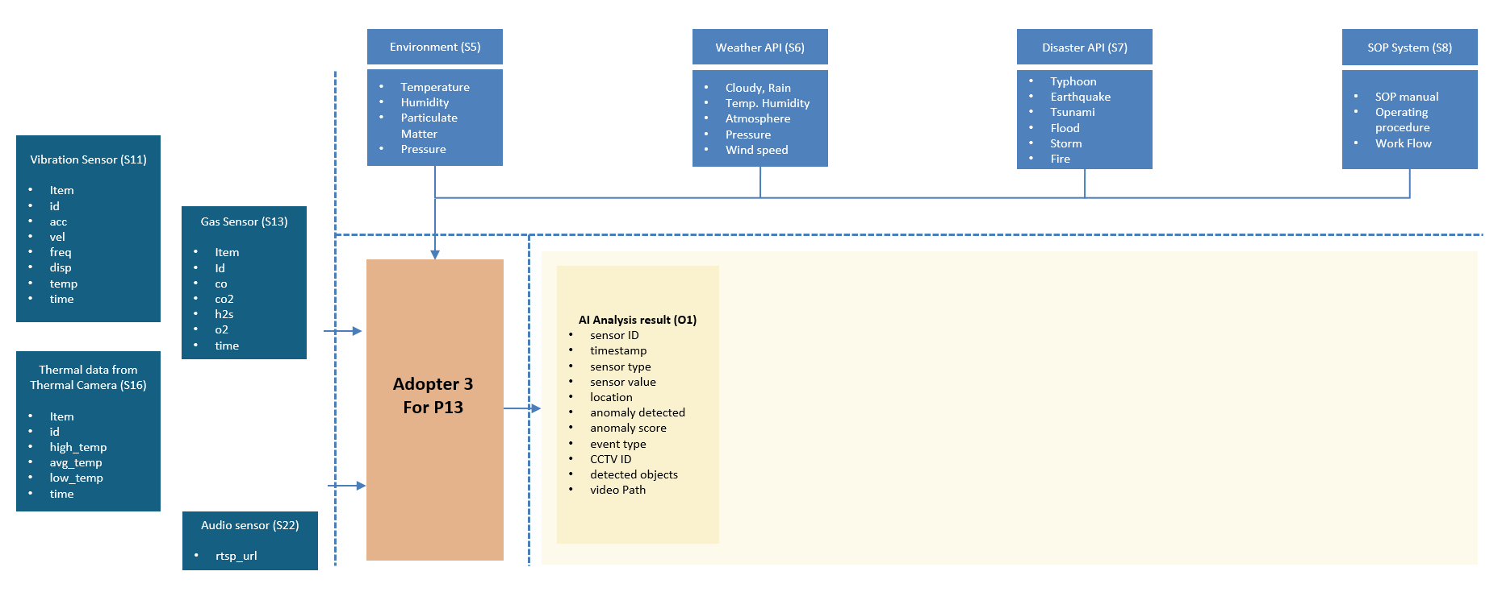
Figure 9 – UC 4 data flow at Disaster detection process

AI reliability analysis(P2)
Analyze sensor data for training AI models to identify performance degradation factors, extract reliability based on these results, and apply performance improvement methods to improve the model.
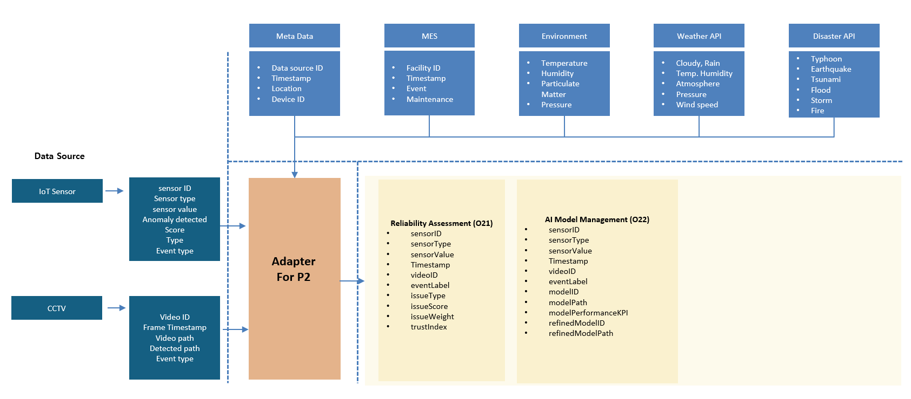
Figure 10 – UC 4 data flow at AI reliability process

Generative AI user conversation (P31)
Learn the contents of SOP and response scenarios and provide users with interactive notifications and information on the optimal action plan for detected content.
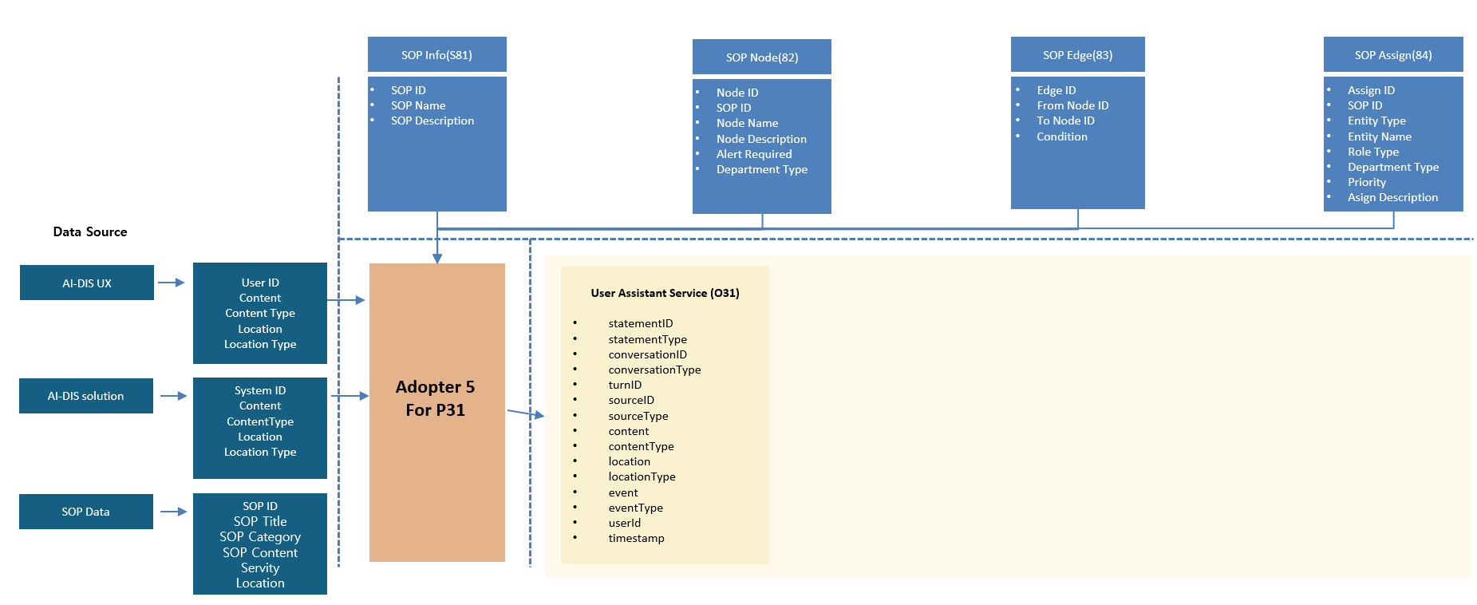
Figure 11 – UC4, data flow at Generative AI user conversation process

Alerting & Dashboard service (P32)
Provides visualization of detection data and links detected and predicted information to dashboards and various devices to enable actions based on risk factors.
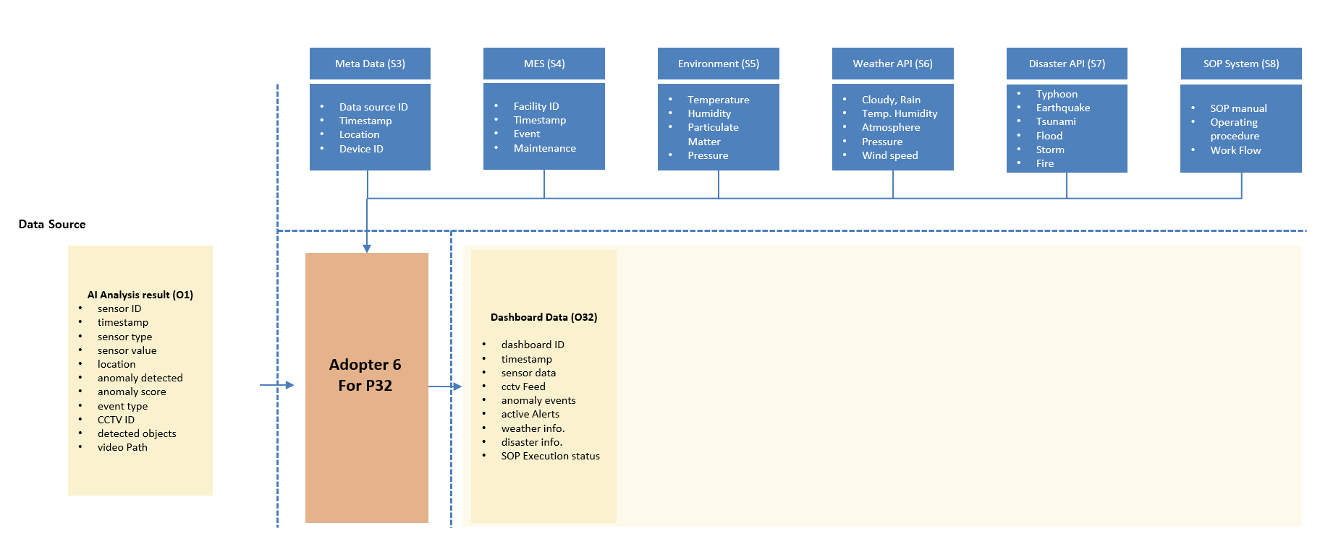
Figure 12 – UC4, data flow at Alert & Dashboard service process

Detail of Data Standardization of each data structure

Vibration Sensor(S11)
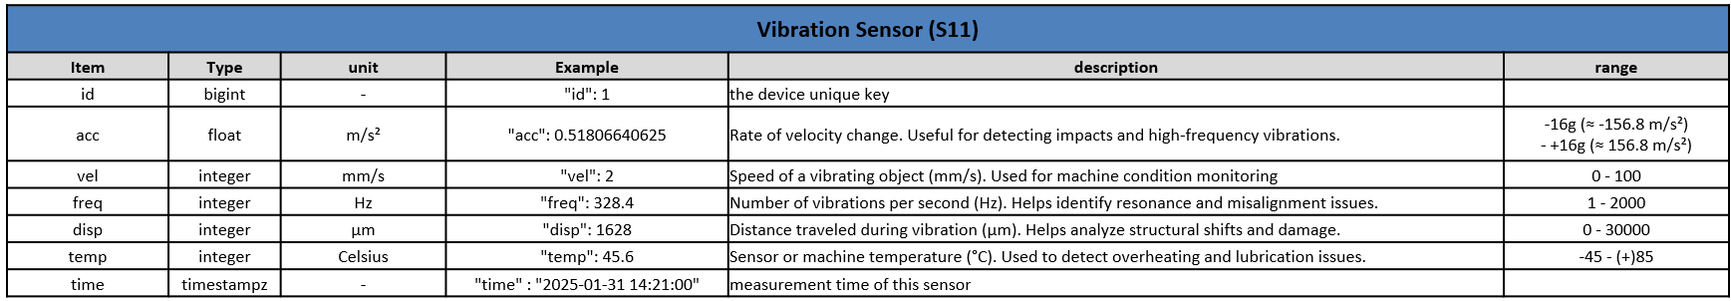
Figure 13 – UC4, detail of Data Standardization for Vibration Sensor

Electrical monitoring sensor(S12)
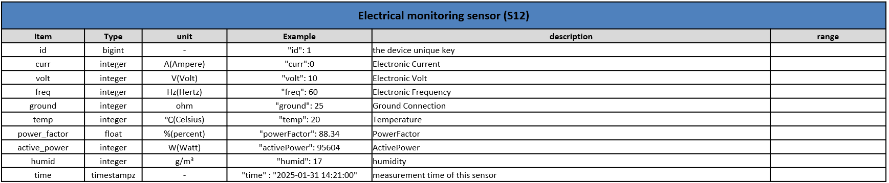
Figure 14 – UC4, detail of Data Standardization for Electrical monitoring Sensor.

Gas Sensor(S13)
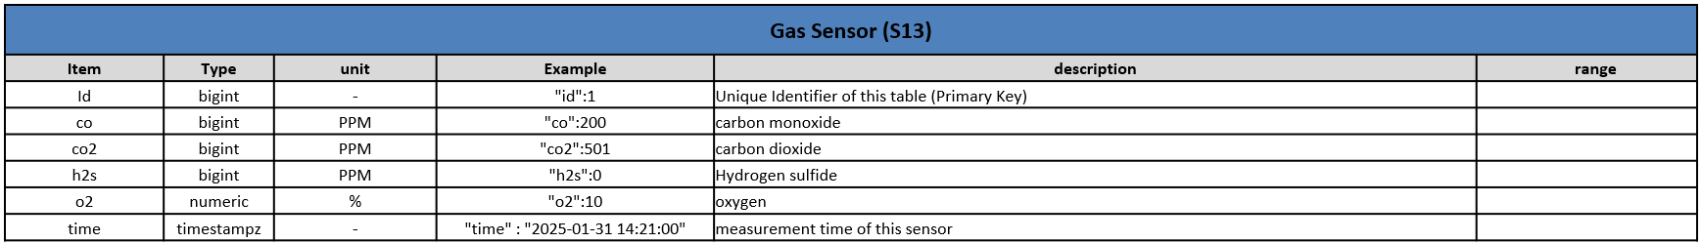
Figure 15 – UC4, detail of Data Standardization for Gas Sensor.

Environmental Sensor(S14)
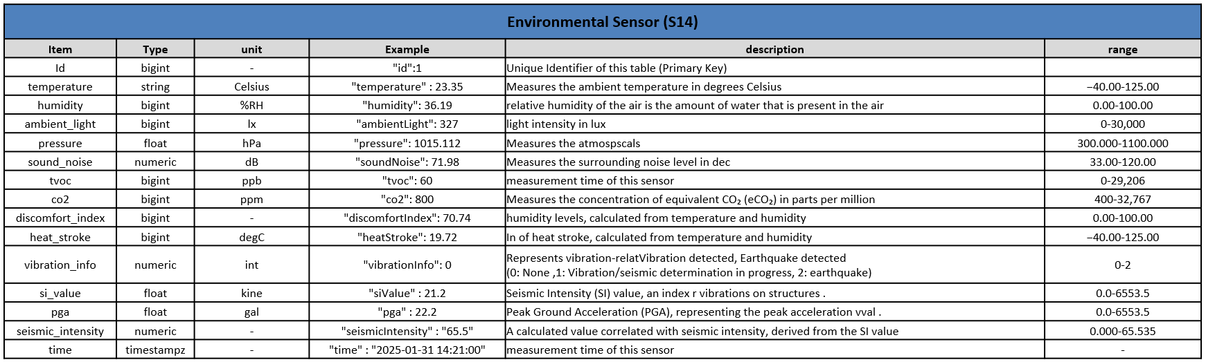
Figure 16 – UC4, detail of Data Standardization for Environmental Sensor.

Noise Sensor(S15)
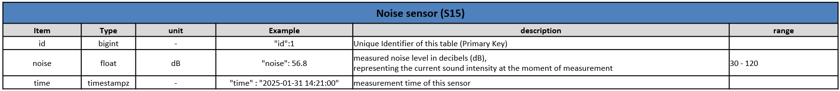
Figure 17 – UC4, detail of Data Standardization for Noise Sensor.

Thermal data from Thermal Camera (S16)
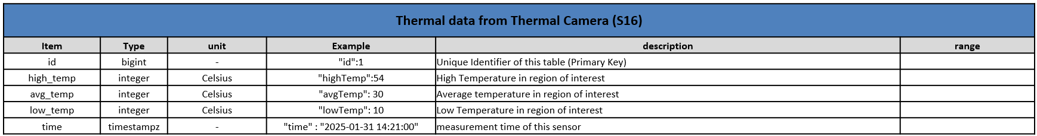
Figure 18 UC4, detail of Data Standardization for Thermal data from Thermal Camera.

CCTV camera (S21)
Figure 19 – UC4, detail of Data Standardization for CCTV camera.

Audio Sensor (S22)
Figure 20 – UC4, detail of Data Standardization for Audio Sensor.

SOP Info (S81)
Figure 21 – UC4, detail of Data Standardization for SOP Info.

SOP Node (S82)
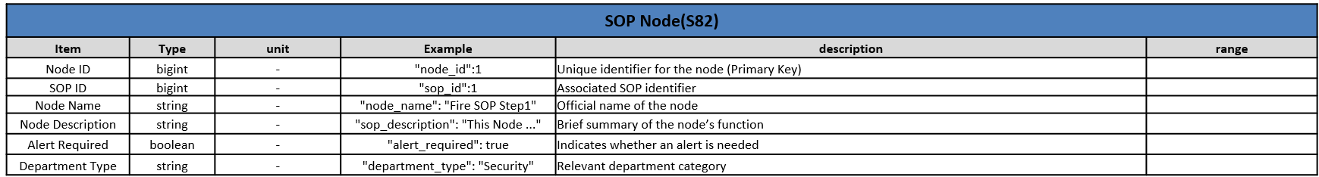
Figure 22 – UC4, detail of Data Standardization for SOP Node.

SOP Edge (S83)
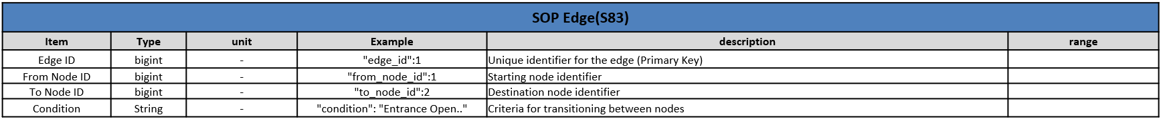
Figure 23 – UC4, detail of Data Standardization for SOP Edge.

SOP Assign (S84)
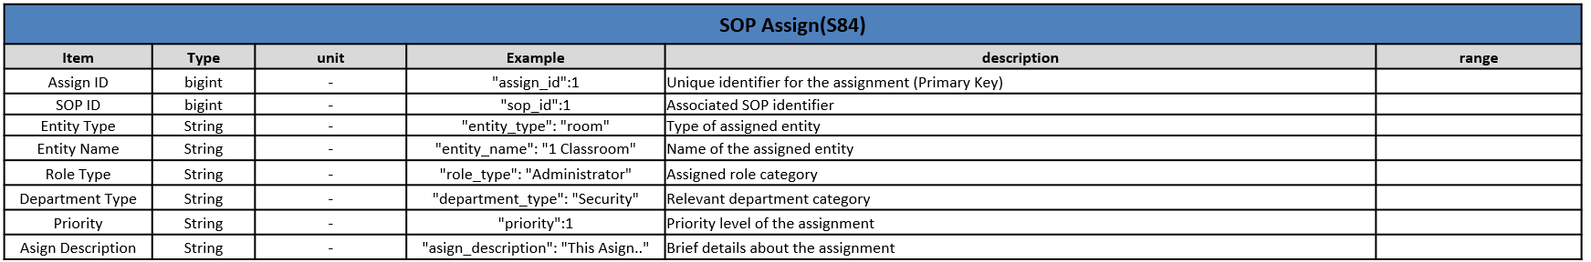
Figure 24 – UC4, detail of Data Standardization for SOP Assign.

AI Analysis result (O1)
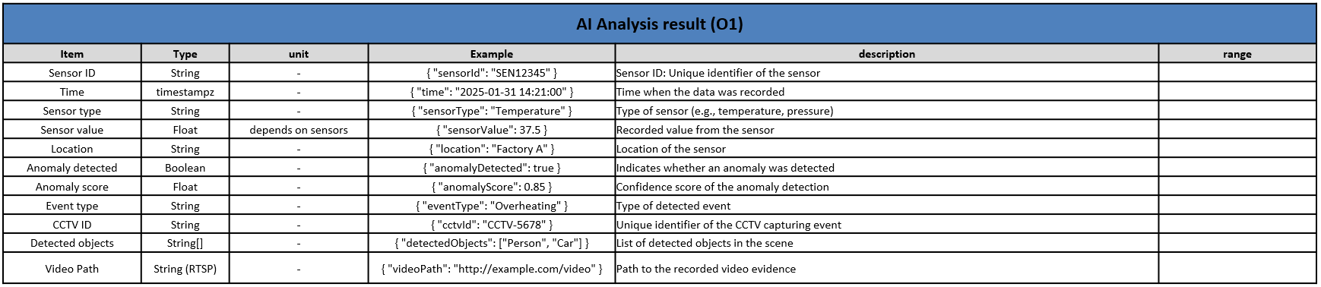
Figure 25 – UC4, detail of Data Standardization for AI Analysis result.

Reliability Assessment (O21)
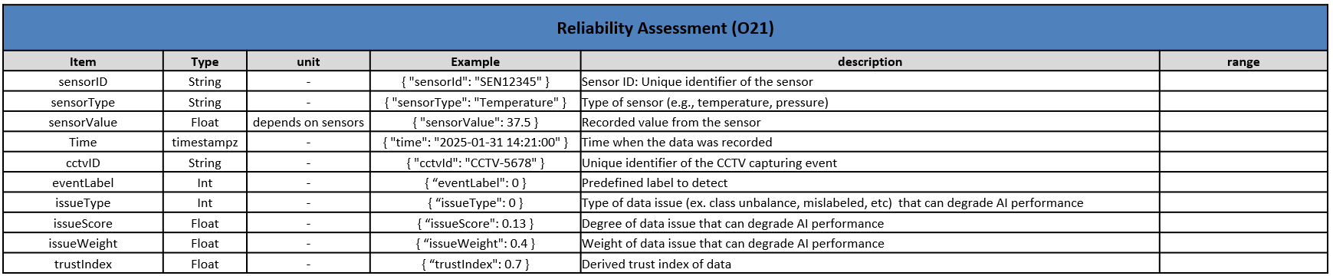
Figure 26 – UC4, detail of Data Standardization for Reliability Assessment.

AI Model Management (O22)
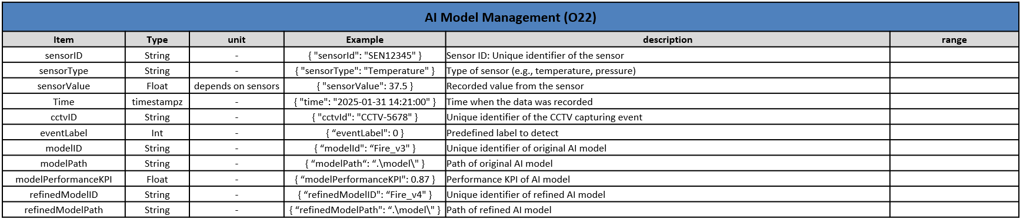
Figure 27 – UC4, etail of Data Standardization for AI Model Management.

User Assistant Service (O31)
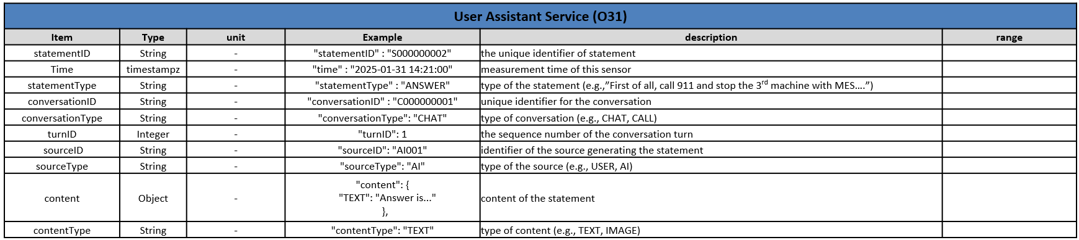
Figure 28 – UC4, detail of Data Standardization for User Assistant Service.

Dashboard Data (O32)
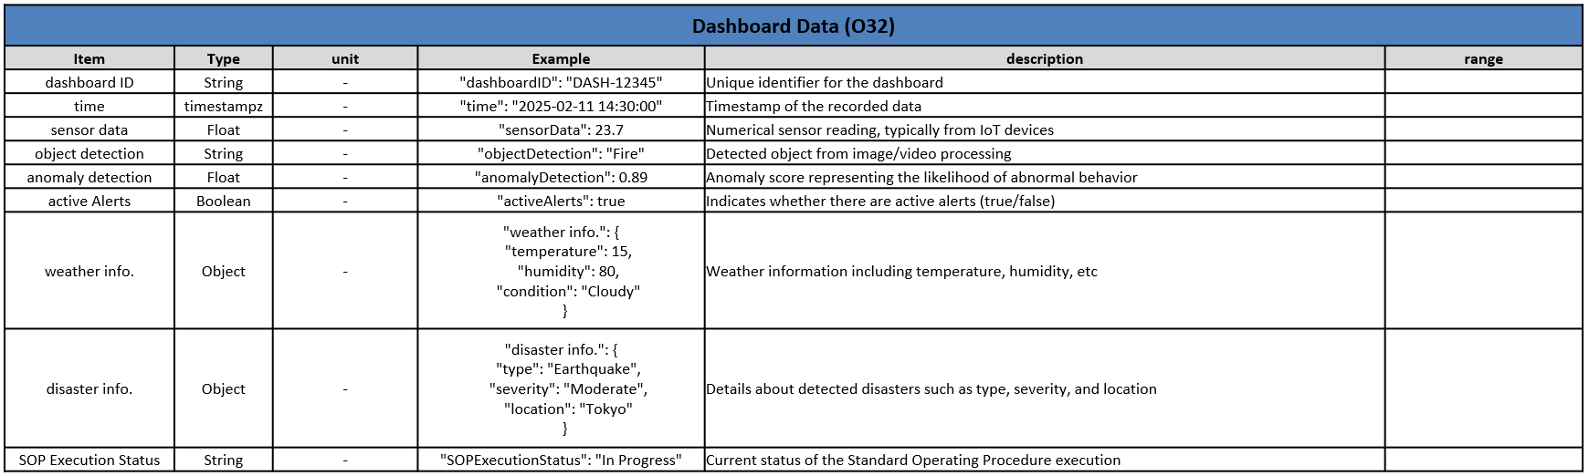
Figure 29 – UC4, detail of Data Standardization for Dashboard Data.

USE CASE 2

Overview
This use case focuses on helping customers navigate extensive purchase options and combinations using advanced technologies like Recommendation Systems, Natural Language Processing and Facial Recognition. The goal is to develop an innovative solution for a more interactive and satisfying customer experience for the retail sector, specifically designed for physical sales environments.
The Customer Interaction Layer (Virtual Assistant) provides an interactive user interface through a chatbot, and visual suggestions and recommendations based on the customer’s profile and similar purchase experiences.
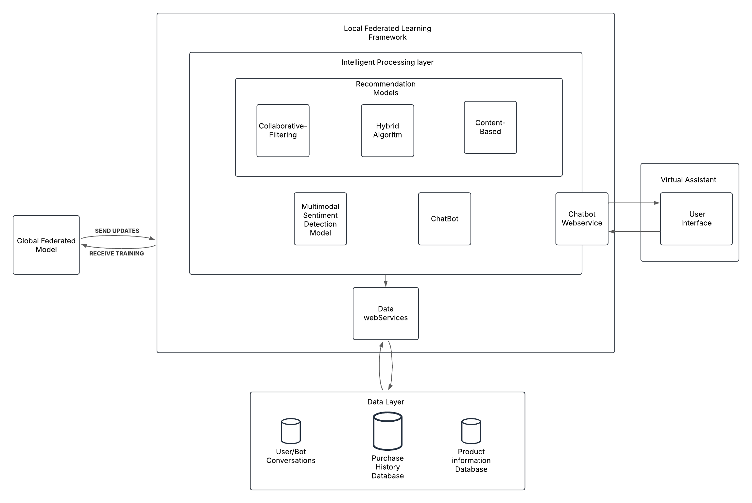
Figure 30 – UC2 Communication architecture
The Local Federated Learning Framework consists of two key components. The Intelligent Processing Layer handles customer interactions, including the multimodal sentiment analysis model that is composed by the NLP and facial recognition components for identification of the user sentiments, user feedback on recommendations, communication API, and chatbot functionality. It also manages the local training of the model, which contributes to a globally standardized model. The Recommendation Models Layer uses hybrid recommendation algorithms to analyze user behavior and provide personalized suggestions.
The Global Federated Model serves as the central system, aggregating multiple local models and distributing the refined model back to all participants, ensuring standardization across nodes.
The Data Layer stores product information and user interaction history with the virtual assistant. Since the model is trained locally using a federated learning approach, data remains within the store’s device, ensuring compliance with data privacy regulations.

Components and communication
The Local Federated Learning Framework contains the Intelligent Processing layer, which contains the Recommendation Layer Models, Multimodal Sentiment Detection Model and the Chatbot.
The Recommendation Models Layer features three types of recommendation models: Collaborative Filtering, which suggests products based on purchases made by users with similar profiles; Content-Based Filtering, which suggests products similar to those the user has previously interacted with; and a Hybrid Algorithm, which combines both methods to improve recommendation accuracy. The recommendation models are accessible through web services, with an API responsible for providing recommendations to the virtual assistant.
The remainder of the Intelligent Processing Layer includes a chatbot that interacts with users through natural language to understand their preferences. A Multimodal Sentiment Detection Model analyzes user feedback while communicating with the virtual assistant by running NLP models to extract product characteristics and gauge user sentiment. This model also analyzes users’ facial expressions utilizing the Enkman’s Emotions model, which are widely used in Facial Emotion Recognition models, with the addition of the “neutral” emotion, to assess their reactions to suggested products. An API connects the user interface with internal processing and recommendation services.

The Global Federated Model serves as the central control system, responsible for running periodic commands to collect model parameters from different nodes. These parameters contribute to creating a unified global model, which is then distributed to update all nodes.
The Virtual Assistant acts as the primary interface for customer interaction with the system.
The Data Layer consists of a database that stores user and assistant conversations for training purposes, a database that stores the relationship between purchases in store and a database with product information, including descriptions, titles, and prices. Data web services provide an API to manage the flow of data between different system modules.

Data Standardization
As previously mentioned in the deliverable D2.3, for this use case, the Data Standardization will utilize two JSON files, where one is focused in the sessions and user-machine interaction and the other contains the information of the Federated AI processes. The complete session JSON represents the aggregated information from the session, where results and additional technical information are included. Single interaction data will be associated with the respective sessions and will summarize sentiment analysis with emotion distribution action from the user in that specific moment. A session can be composed of several interactions. The JSON of the Federated AI will represent the data associated with the participating components and the results obtained by the process.
The collected data is based on captured audio and video during interaction sessions between the end user (store client) and the virtual agent of the multimedia kiosks that are physically available inside the store. The captured audio and video will be processed, and the results will be resumed in JSON data for Data Standardization.
It’s important to note that some fields represent information that can be considered specific for the use case.
The following list represents the JSON fields of a full session as well as the interaction between user-machine:
Session Information:
session_id: Unique identifier of the complete session.
session_date_hour: Date and hour of the session start.
session_duration_seconds: Duration of the session in seconds.
cliente_gender: Interpreted gender based on captured results.
cliente_age_range: Interpreted age range based on captured results.
main_result: Result interpreted by the system based on the client reaction.

Unit: Information about the device identifiers and location
store_id: Unique identifier of the store
kiosk_device_id: Unique identifier of the device
kiosk_device_location: Location of the device on the store

Interaction: Interaction with the virtual assistant and the client associated emotion
- interaction_id: Interaction identifier
- cliente_response: Overall evaluation (negative, neutral or positive)
- emotions_data: Emotion detect during the interaction
  - dominant_emotion: The main emotion based on all interaction
  - action_detected: Client expressions captured in vídeo during the interaction
  - sentence: Textual representation of the cliente statements
  - emotion_distribuition: Level of client emotions based on Ekman emotions
    - happiness
    - neutral
    - surprise
    - fear
    - sad
    - disgust
    - angry
- Technical: This section details the technical aspects of the interaction.
  - algorithm_technique: Methodology used to extract feelings.
  - processing_duration_seconds: Seconds analyzed to extract sentiments
  - processed_video_BSON: video to analyze, converted on a binary object
  - processed_audio_BSON: audio to analyze, converted on a binary object

Technical:
Capture-specifications: This section details the technical aspects of video and audio capture
video_capture_dimension: Specifies the video capture resolution
video_bit_depth_per_channel: Represents the bit depth per channel in the video
audio_sampling_rate_hz: Represents the audio sampling rate in Hertz
audio_bit_depth: Represents the bit depth of the audio
audio_signal_to_noise_ratio_db: Represents the audio signal-to-noise ratio in decibels
video_BSON: Video data codified in BSON format
audio_BSON: Audio data codified in BSON format

The following description represents the JSON data associated with the Federated Framework:
federated_request_unique_id: unique identifier of the request session.
federated_date_hour: Date and hour of the federated data submission.
federated_training_time: duration of the training process.

Unit: Information about the device identifiers and location
store_id: Unique identifier of the store
kiosk_device_id: Unique identifier of the device
kiosk_device_location: Location of the device on the store
federated_model_weights: The weights values of the machine learning model.
federated_num_examples: Total data samples analyzed for training and validation.
federated_training_metrics: Metric results of the training and validation of the model

