WP2 Deliverable 2.6:
Technical Specification Report
WP2: Requirements Analysis

Project Name: 22017 CAPE
Status: Draft (v1.0)
Contributors
Names | Organization
Ilyoung Chong | KAIST
Bernard Min | IDB
Ismail Uzun | Inosens
Aylin Yorulmaz | KoçSistem (27.01.2025)
Ali Osman Baykuş | Inosens(29.01.2025)

Reviewers
Names | Organization
Ismail Uzun | INOSENS
Ilyoung Chong | KAIST

Document History
Version | Date | Author | Changes
v0.1 - Initial Version | 10.12.2024
v1.0 - Final Version | 28.02.2025
Table of Contents

1. Introduction 3
2. Technical Capabilities of CAPE Project 4
3. Technical Specifications of Five Use Cases in CAPE 7
3.1 Use Case 1: Intelligent Shopping Assistance and Recommendation System 7
3.1.1 System Overview 7
3.1.2 Functional Requirements of Use Case 1 9
3.1.3 Non-Functional Requirements of Use Case 1 9
3.1.4 Technical Implementation Considerations 10
3.1.5 Deployment and Maintenance 10
3.2 Use Case 2: Using Facial Emotion Recognition and User Profiles to Generate In-Store Product Recommendations 11
3.2.1 System Overview 11
3.2.2 Functional Requirements of Use Case 2 12
3.2.3 Non-Functional Requirements of Use Case 2 13
3.2.4 Technical Implementation Considerations 13
3.2.5 Deployment and Maintenance 14
3.3 Use Case 4: Trust Enabling IoT Environment and Smart Working Area 15
3.3.1 System Overview of AI-DSP (AI enabled Disaster Safety Platform) 15
3.3.2 Functional Requirements of AI-DSP in Use Case 4 16
3.3.3 Non-Functional Requirements of AI-DSP in Use Case 4 16
3.3.4 Technical Considerations to Implement AI-DSP 17
3.3.5 Deployment and Maintenance 17
3.4 Use Case 5: Enhancing Employee and Customer Experience Through AI-Powered Monitoring and Analysis 20
3.4.1 System Overview 20
3.4.2 Functional Requirements of Use Case 5 21
3.4.3 Non-Functional Requirements of Use Case 5 23
3.4.4 Technical Implementation Considerations 25
3.4.5 Deployment and Maintenance 26
3.4.6 Conclusions on Use Case 5 28
4 Conclusions 29

Introduction
This document outlines the technical specifications for the CAPE project. It serves as a comprehensive guide for the design, development, and implementation of challenges of providing better shopping experiences and work environments for employees. The specifications detailed herein are intended to develop personal experiences, improve the health and performance of robots/kiosks, and offer alternative opportunities and technologies not widely available in the market. Paricularly, this document specifies the technical specification to support the solutions on three major problems and fourteen minor challenges related to resource and movement management, employee identification and tracking, privacy and trustworthiness, customer engagement, intelligent search, communication (HCI), and mood recognition and facial expressions.
As shown in Figure 1, four use cases described in the project and involve the use of various technical descriptions such as artificial intelligence, deep learning, blockchain, and the Internet of Things to improve the shopping experience, generate personalised product recommendations, enhance employee and customer satisfaction, create a trustworthy IoT environment for smart manufacturing, and monitor and analyse customer and employee feedback.
This report encompasses the following key areas for four use cases:
- System Architecture: A high-level overview of the system, including its major components and their interactions of four use cases.
- Functional Requirements: Detailed descriptions of the system's functionalities and expected behaviors.
- Non-Functional Requirements: Specifications for performance, security, reliability, and other quality attributes.
- Interface Specifications: Definitions of interfaces between different system components and external systems.
- Data Model: Description of the data structures, formats, and relationships used within the system.
- Technology Stack: Specification of the programming languages, frameworks, libraries, and tools employed.
The innovative features of each use case involve specific technologies and systems such as smart dialogue systems, facial emotion recognition, IoT-based recommendation systems, trust management and control technology, customer communication platform, and employee tracking through passenger flow management cameras and biometric functionality kiosks/robots.
Based on Figure 1 deliverable D2.6 includes technical specifications related to the main technologies, applications, and main directions applied in the four use cases performed in the CAPE project.
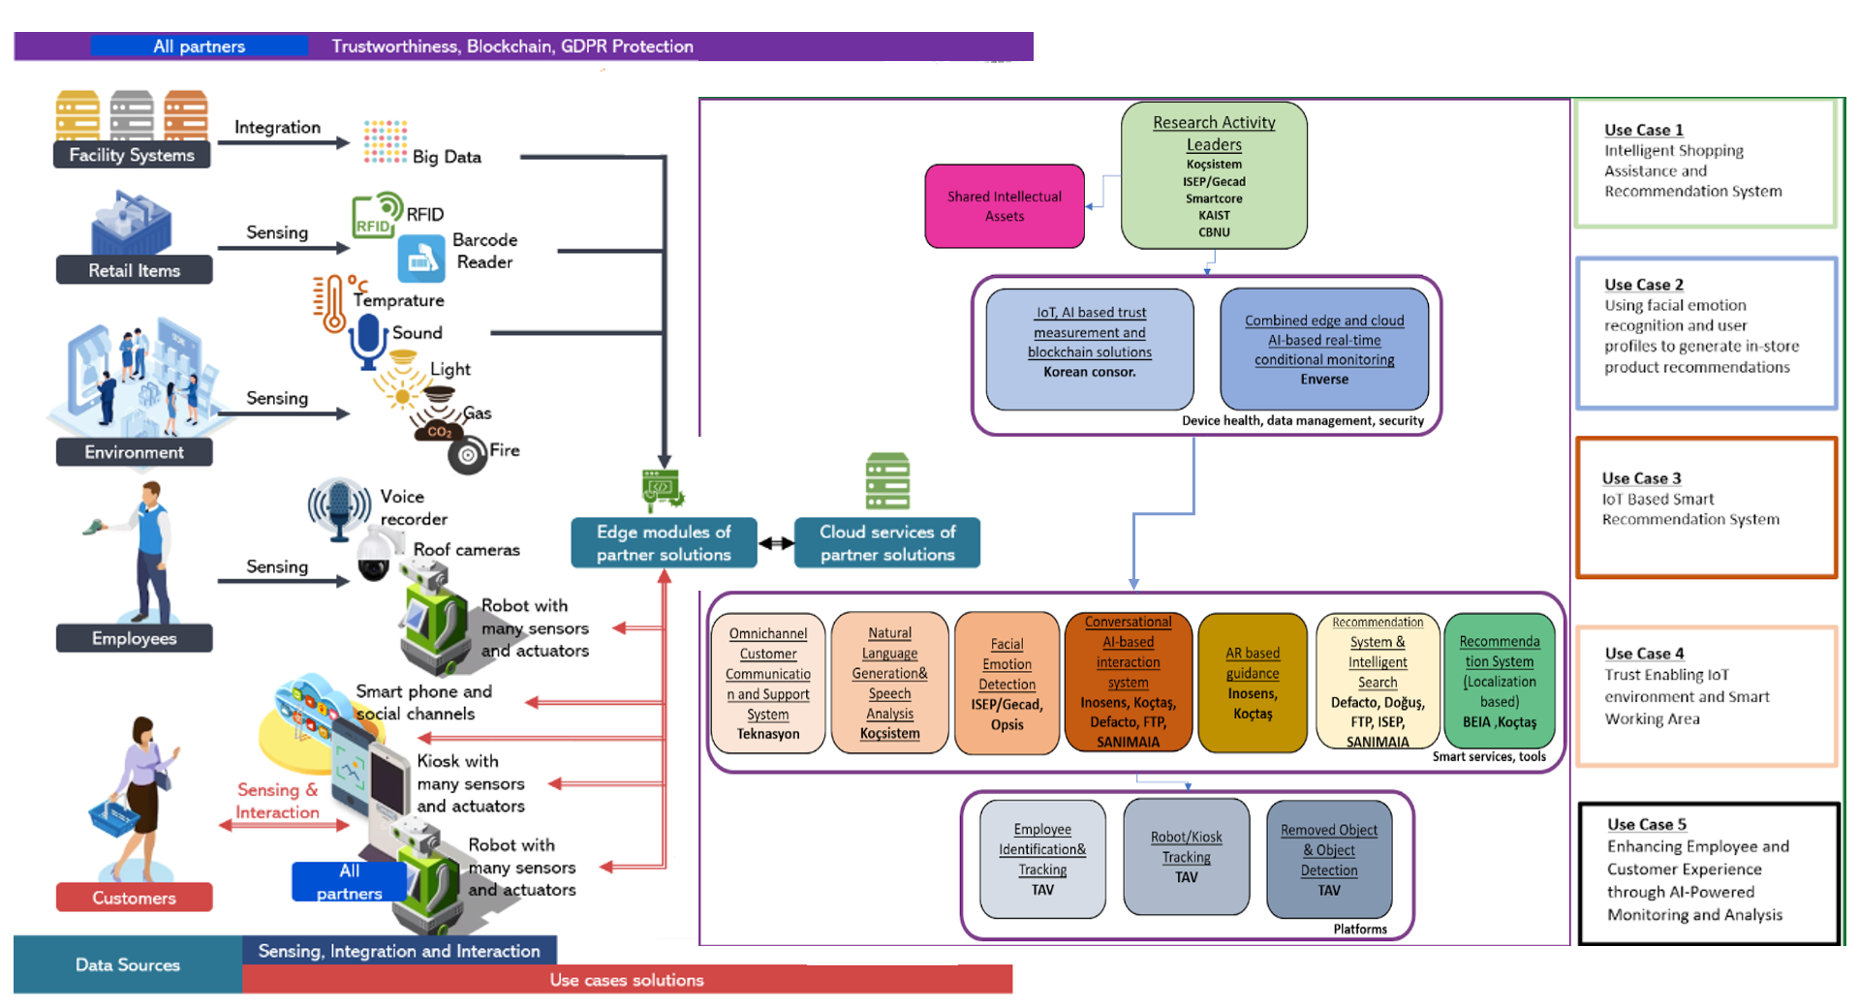
Figure 1 High level CAPE solotion structure

Technical Capabilities of CAPE Project
In the description of technical specification of CAPE, the following technical capabilities as shown in the below are incated through the development of 5 use cases.
- Functioning Robots/Kiosks with Hardware and Software layers:
These robots/kiosks will be built with five significant functionalities: sensing, actuation, communication, cognition, and multi-functionality. Also, standards for data exchange between robots/kiosks with open online services, other retail store systems, and services will be developed by partners within the project scope.
- Functioning Integrations:
These are focused to develop fucntioning integrations between facility systems and sensors such as RFID, microphone, cameras, barcode reader, accelerometer, gyroscope, compass, LIDAR, ultra-sonic, temperature, gas, encoder, touch screen sensors, so that robots and kiosks can interact with customers, employees, and the environment at the highest level.
- Cybersecurity assurance and trustworthy data management system:
The system aims to deliver trusted conditions for testing, assessing, reporting, and certifying IoT security robustness, in line with the European Union Cybersecurity Act certification assurance levels “basic,” “substantial,” and “high” for IoTs that range from consumer IoTs to a range of IoTs supporting safety and trustworthy function for its customers or IoTs designed as to support mission-critical working areas.
- Smart Dialogue System:
The system will use voice interaction for kiosks and hybrid voice and visual interaction for mobile robots.
- Smart Recommendation System (SRS):
The SRS will also provide customers with information about the in-store location of the recommended products.
- Deep Learning-Based Embedding Model for Recommendations:
This will enable accurate recommendations for new users and items by linking them to latent factors based on their attributes. Also, in a model to enable transparency, this will provide explanations in a way that humans can understand and foster trust.
- IoT Trustworthiness Provisioning Platform:
An IoT platform provides trust management and control, trust-based IoT data management, and trust-based IoT ecosystem resource operation management. This platform will be developed by the IoT trust enabler.
- Trustworthiness Estimation Technology:
This technology will be developed to maximise the performance of operational actions based on collected IoT data and devices. This technology will be developed by the task responsible for checking the feasibility and versatility of implementation technology.
- IoT Artificial Intelligence Data Processing, Analysis and Modelling:
This algorithm will take into consideration stakeholders' expectations in the IoT ecosystem and provide an integrated trustworthiness of IoT data. This output will be developed by the task responsible for deriving IoT data trustworthiness.
- Employee Tracking System:
It supports passenger flow management (PFM) cameras and biometric functionality kiosks/robots to track employee movements and identify them. It will use computer vision and image processing techniques, biometric data such as facial recognition, and PFM cameras to identify the employee's position and identity.
- Text-based Analytics Algorithms:
It will support to analyse chat conversations coming from social media and instant messaging channels. The algorithms will be integrated to web-based Communication and Support Application and give insightful reports on customer feedback.
- Anomaly Detection Algorithms for Robotic Operation:
This will be developed using machine learning and deep learning techniques such as neural networks and LSTMs. It will monitor key parameters such as battery health forecasting, building ventilation monitoring, kiosk/robot motion anomaly detection, and robot vibration/noise anomaly detection.
- Acoustic Analysis:
This will be developed tol involve analysing the pitch, loudness, and duration of speech to identify changes that may indicate stress. It will also include prosodic analysis to create features about the rhythm, intonation, and stress patterns of the speech and linguistic analysis to analyse the content of speech.
- Human-computer interaction through dialogue considering Users Intentions:
This will support a software solution that encompasses human-computer interaction and a recommendation system with intelligent search. Furthermore, it provides a methodology for combining text-based input with facial emotional detection software in order to obtain insights about user intention and expand existing user profiles will be developed.
- Localization based Recommendation System:
This is a system which robots serve with voice using localization information provided by store mapping combined with planogram. The customers will be informed by voice about recent campaigns for a specific aisle which they are getting closer to by robots. The robot will be able to tell customers about the recent campaigns for the aisles they are standing by.

Technical Specifications of Four Use Cases in CAPE
This technical specification is a crucial blueprint for the system of use cases in CAPE project. It outlines the technical requirements, design, and implementation details to ensure a uase case target solution. Here's a breakdown of four use cases.

3.1 Use Case 1: Intelligent Shopping Assistance and Recommendation System

System Overview
3.1.1.1 Purpose:
The objective of this Technical Specification is to define the system requirements and architectural framework for Use Case 1. The system aims to enhance the in-store customer experience in Koçtaş and Defacto retail stores through Smart Dialogue Systems (SDS), a Smart Recommendation System (SRS) and Location Based Campaigning (LBC). It will enable efficient product inquiries and navigation via kiosks and mobile robots, as well as provide personalized product recommendations and capaignings based on customer behavior, inventory data and indoor location.

3.1.1.2 Description:
The proposed system consists of two main components:
- Smart Dialogue System (SDS): Enables customers to ask questions about products through kiosks and mobile robots. The kiosks will use voice-based and text-based interaction, while mobile robots will support hybrid voice and visual interactions.
- Smart Recommendation System (SRS): Provides customers with personalised recommendations for matching and complementary products based on their selected items, available inventory, customer purchase history, and seasonality. It will also guide customers to the location of recommended products in the store.
- Location Based Campaigning (LBC): Provides visual and audio campaignings based on indoor location.

3.1.1.3 Architecture
The system follows a modular architecture, comprising
- Client-side: Kiosks and mobile robots equipped with speech recognition, NLP, NLU and visual interaction modules.
- Server-side: A centralized backend that processes customer queries, manages recommendations, and communicates with store databases.
- APIs: Integration between SDS, SRS,LBC and store inventory systems via RESTful APIs.

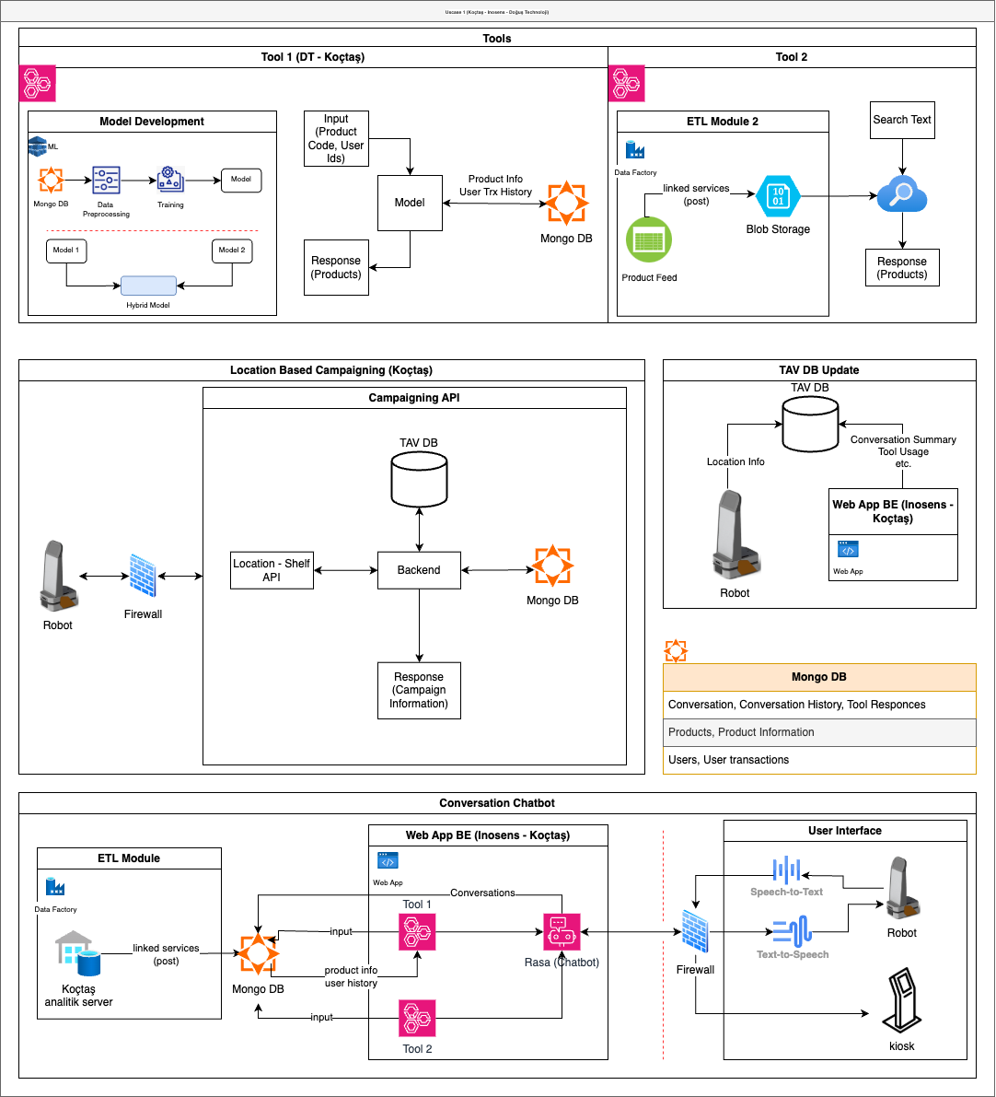

Figure 1: Koçtaş – Inosens – Doğuş Technology SDS, SRS and LBC System Architectural Design

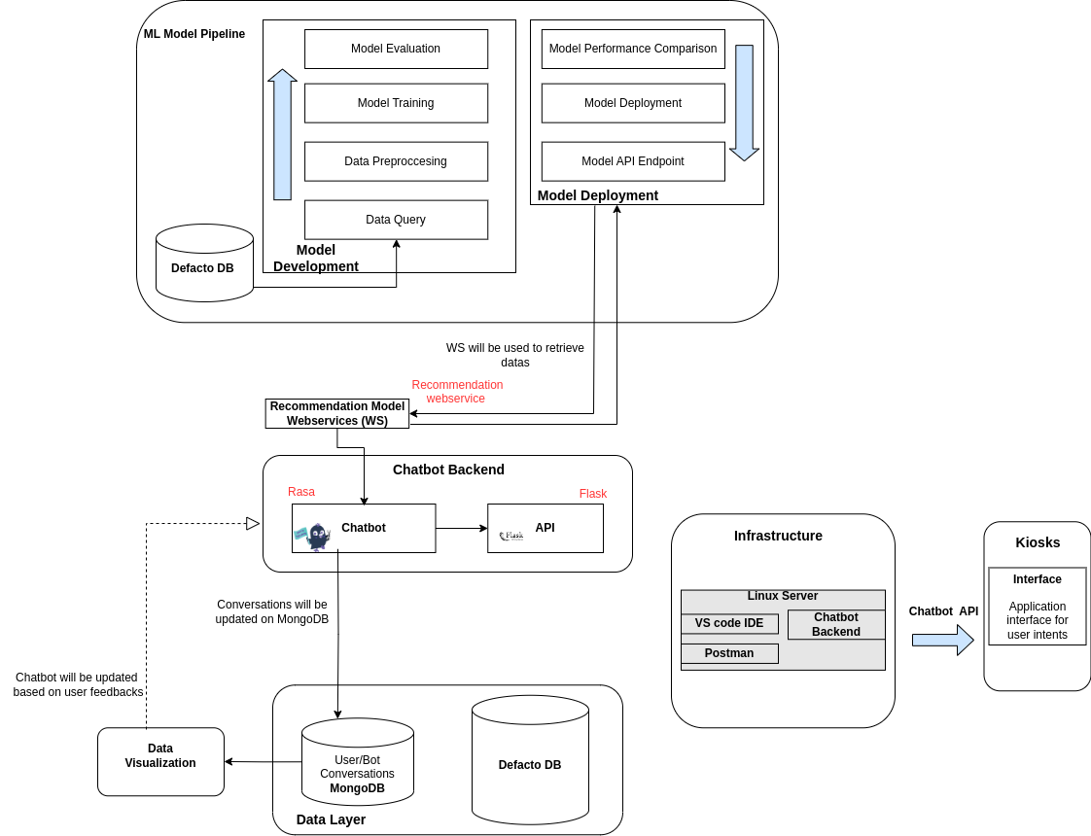
Figure 2: Inosens & Defacto SDS and SRS System Architectural Design

Functional Requirements of Use Case 1
- Customers should be able to interact with kiosks and robots using natural language.
- Kiosks must support visual interaction, voice-based and text-based interaction; robots must support both voice and visual interaction.
- The system should process customer queries and retrieve product-related information.
- The SRS should generate recommendations based on selected products, inventory, and customer behavior.
- The system must fetch and display real-time inventory data.

Non-Functional Requirements of Use Case 1
- Performance: The system should process customer queries within seconds and provide product recommendations within seconds
- Scalability: Must support concurrent interactions in multiple store locations without performance degradation
- Security: Customer interactions and data must be protected using encryption and authentication mechanisms.
- Usability: Kiosks and robots should offer intuitive and user-friendly interfaces for seamless interaction
- Reliability: The system must ensure robust fault tolerance.
- Maintainability: Modular components and well-documented code for easy updates and troubleshooting
- Portability: The system should be deployable on Windows based kiosks and mobile robot platforms

Technical Implementation Considerations
- Technologies:
  - Programming Languages: Python (for NLU, NLP and ML models), JavaScript (for UI components
  - Frameworks & Libraries: Rasa (for chatbot development), TensorFlow/PyTorch (for ML models), Flask/FastAPI (for backend API)
  - Tools: MongoDB (for storing conversations)
- Coding Standards:
  - Follow PEP 8 for Python-based development
  - Use REST API best practices for backend services
- Testing Requirements:
  - Unit Tests for SDS and SRS modules.
  - Integration tests for API communication.
System Tests to validate the entire workflow from customer interaction to recommendation display.

Deployment and Maintenance
- Deployment Environment:
  - Hardware: Kiosks, mobile robots with speech processing units.
  - Software: on-premises-based backend, store database servers.
  - Network: Secure Wi-Fi and internal communication protocols for seamless data transfer.
- Deployment Process:
  - Set up local servers for SDS and SRS processing.
  - Install software components on kiosks and robots.
  - Conduct deployment tests before live usage.
- Maintenance Plan:
  - Regular software updates to improve SDS accuracy and recommendation quality.
  - Performance monitoring to ensure optimal response times.
  - Customer feedback integration for continuous system enhancement.

3.2 Use Case 2: Using Facial Emotion Recognition and User Profiles to Generate In-Store Product Recommendations

3.2.1 System Overview

3.2.1.1 Purpose
The objective of this Technical Specification is to define the system requirements and architectural framework for Use Case 2. The system aims to enhance the in-store customer experience in Portuguese clothing and accessories retail stores through a Virtual Assistant with a multimodal sentiment analysis powered by Facial Emotion Recognition and NLP and a Smart Recommendation System. It will enable personalized product recommendations based on customer emotions, behavior, and profile, as well as facilitate efficient product discovery through interactive digital kiosks. By integrating NLP, facial recognition and intelligent search, the system will provide real-time feedback on customer reactions to recommendations, ensuring a more engaging and customized shopping experience.

3.2.1.2 Description
The proposed system consists of three main components:
1. Recommendation Layer: Responsible for generating personal recommendations for users based on different recommendation models.
2. Intelligent Processing Layer: Acts as an intermediary between the recommendation models and the user interface. It includes a chatbot for direct interactions, a multimodal sentiment detection model to understand user emotions, and an API to facilitate integration with other systems.
3. Virtual Assistant and Data Layer: The virtual assistant interacts directly with users through an intuitive interface, providing responses and personalized suggestions. The data layer stores essential information, such as user-bot conversations and a product information database. Communication between these layers occurs through web services, ensuring efficient data exchange.

3.2.1.3 Architecture
The system follows a modular architecture, comprising:
1. Client-side: A virtual assistant with a user-friendly interface that interacts with users through chatbot conversations and multimodal sentiment detection, enhancing engagement via natural language processing (NLP) and emotion recognition.
2. Server-side: A centralized intelligent processing layer that handles user queries, processes recommendations using collaborative filtering, hybrid algorithms, and content-based models, and integrates with local and global federated learning frameworks.
3. APIs: Seamless integration between the intelligent processing layer, recommendation models, and data services via web-based APIs, ensuring efficient communication with user-bot conversations, product databases, and external federated learning systems.
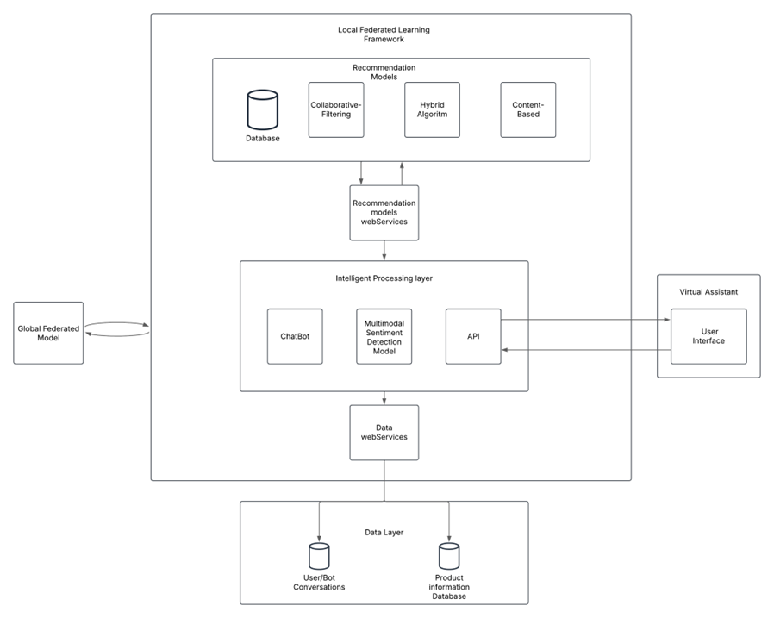

Functional Requirements of Use Case 2
- Customers should be able to interact with virtual assistants using natural language.
- Virtual Assistants must support voice-based and text-based interaction.
- Generate personalized product suggestions based on customer profile and inventory.
- Detect and analyze customer facial expressions to assess emotional reactions to product recommendations, adapting recommendations based on detected emotions.

Non-Functional Requirements of Use Case 2
• Performance: The system should process customer queries and provide product recommendations within seconds
• Scalability: Must support concurrent interactions without performance degradation
• Security: Customer interactions and data must be protected using encryption and authentication mechanisms. The use of Federated Learning contributes to this, in addition to ensuring compliance with the AI Act and GDPR.
• Usability: Virtual Assistants should offer intuitive and user-friendly interfaces for seamless interaction
• Reliability: The system must ensure robust fault tolerance.
• Maintainability: Well-documented code and modular components to facilitate updates and troubleshooting.
• Portability: The system should be deployable on store hardware.

Technical Implementation Considerations
• Technologies:
- Programming Language: C# for real-time engine logic and 3D environment interface, Python (for NLU, NLP and ML models).
- Frameworks & Libraries: Laravel framework for API development, Rasa (Chatbot Development), Tensorflow/Pytorch (for ML models), FLower (for FL logic), Unity real-time engine (3D Graphics and Virtual Environment).
- Tools: MongoDB (for storing conversations)
• Coding Standards:
- Follow PEP 8 for Python-based development
- Use REST API best practices for backend services
• Testing Requirements:
- Unit Tests for the Recommendation models and the intelligent Processing Layer modules.
- Integration tests for API communication.
Tests to validate the complete workflow, from customer interaction to recommendation display.

Deployment and Maintenance
• Deployment Environment:
- Hardware: Kiosks, with speech and image processing units
- Sofware: on-premises-based backend, store database servers, FL communication
- Network: Secure Wi-Fi and internal communication protocols for seamless data transfer and a special channel for FL updates with a centralized global model
• Deployment Process:
- Set up local servers for SDS, SRS and FL processing.
- Install software components on Kiosks.
- Conduct deployment test before live usage
• Maintenance Plan:
- Regular software updates to improve SDS accuracy and recommendation quality.
- Performance monitoring to ensure optimal response times.
Customer feedback integration for continuous system enhancement.

3.3 Use Case 4: Trust Enabling IoT Environment and Smart Working Area

3.3.1 System Overview of AI-DSP (AI enabled Disaster Safety Platform)

3.3.1.1 Purpose
AI-DSP(AIoT powered Intelligent Disaster Safety Platform) system that integrates IoT sensors to prevent safety accidents and manage disasters at manufacturing facilities, along with a generative AI-powered assistant service for real-time user support
Advanced IoT sensor systems for complex manufacturing and disaster safety. Reliable AI delivering accurate disaster safety services by evaluating and operating trusted data. Rapid user support through a disaster safety service that responds in real-time to user requests.
3.3.1.2 Architecture of AI-DSP
The system architecture is organized into five modules as shown below.
- AI-DSP UX module: The module to support user experiences in AI enabled Disaster Safety Platform (AI-DSP).
- AI-DSP Solution module: The module performed the following functions.
- DB Interface
- File System
- Data Interface
- SOP & Event Handling
- Anormaly Dtetection
- Object Detection
- Video Source Management
- Extended Hardware Management
- Priority Governancing

- AI-DSP MLOps (Machine Learning Operations) Capabilities to support the set of processes and automation for managing data, code and models to improve performance stability and long-term efficiency in ML systems.
- Data Managing capability
- MLOps Engine
- File System
- Database
- Reliability Assessment
- Data Sources for AI-DSP
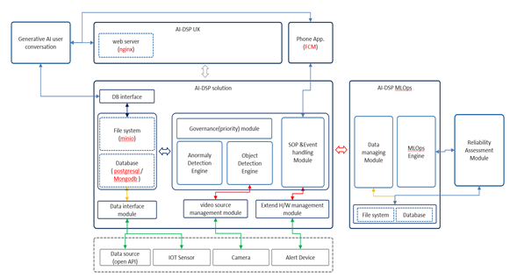
Figure 3: AI-DSP System Architecture

3.3.2 Functional Requirements of AI-DSP in Use Case 4
The functional requirements to support the disaster safety provisioning capability in AI-DSP are as follows
• Context-driven IoT sensor deployment for safety.
• IoT sensor operation technology depending on the situation
• Selective use of IoT sensors to solve safety issues
• Enhancing AI model efficacy by assessing and utilizing data reliability.
• Real-time generative AI user support service development.

3.3.3 Non-Functional Requirements of AI-DSP in Use Case 4
The non-functional requirements to support the disaster safety provisioning capability in AI-DSP are as follows
• Performance: The system should alert to user within seconds
• Scalability: Must support concurrent interactions in multiple iot sensors and edge devices without performance degradation
• Security: AI-DIS system should interactions and data must be protected using encryption and authentication mechanisms.
• Usability: AI-DIS UX should offer intuitive and user-friendly interfaces for seamless interaction
• Reliability: The system must ensure robust fault tolerance
• Maintainability: Modular components and well-documented code for easy updates and troubleshooting
• Portability: The system should be deployable on ubuntu based edge device

3.3.4 Technical Considerations to Implement AI-DSP
The technical considerations to implement AI-DSP in Use Case 4 are as follows.
• Technologies
1. Programing language : Python, Typescript, Javascript, Golang
2. Front-end library : react, axios, react-query, react-table, react-flow, react-konva, react-apexcharts, hls.js, etc.
3. AI/ML framework : PyTorch, OpenCV, ONNX, Ultralytics
4. Backend framework : gin-gonic, Nestjs, FastAPI
5. Database : PostgreSQL, InfluxDB, MongoDB
6. Security & authentication : OAuth 2.0, JWT

• Coding Standards
1. coding conventions : Prettier, ESLint
2. Python coding : PEP 8
3. API type : RESTful API
• Testing Requirements
1. Unit Test: AI model, API, data processing verification
- Verification of input and output accuracy at the individual function or method level
2. Integration Test: IoT device, database, backend linkage test
- Verification of whether two or more components interact correctly
- Database linkage, REST API response verification, data flow verification between modules
3. System Test: Overall process verification and performance test
- Verification of whether multiple servers and modules operate normally in an integrated environment
- Check the interaction between servers and modules
- verification of data flow and consistency within the platform

3.3.5 Deployment and Maintenance
• Deployment Environment
1. Hardware environment
- CPU: Intel Core i5 / Jetson Orin 16G
- Memory: 32GB RAM / 16GB RAM
- Storage: 500GB SSD (minimum specifications)
- All servers are physical servers connected to a LAN (Local Area Network)
2. Software environment
- Each server runs applications in an environment where a container engine (Docker Engine) is running.
- Operating system: Linux-based (Ubuntu) server environment
- Docker and Docker Compose are used to run containerized applications
- Application execution environment:
i. Backend: Go (Gin framework), NestJS
ii. Database: MongoDB, PostgreSQL (separate operation from the application server(or edge device))
3. Network environment
- All servers are connected to a wired LAN, and Docker Network is applied within the same server to manage communication between containers.
- Accurate host information and network settings are required for database connection.
- If necessary, use a reverse proxy (such as Nginx) or load balancer to efficiently distribute traffic.
• Deployment Process
1. Code development and testing
- Work is done on the development branch in GitHub, and all changes are merged into the main branch after testing is complete.
2. CI/CD pipeline execution
- Builds and tests are automatically executed using CI/CD tools such as GitHub Actions or Jenkins.
- If the test passes, build the container image and push it to the container registry (such as Docker Hub, AWS ECR).
3. Deployment
- Pull the latest container image from the server and run it.
- Run multiple containers at once using Docker Compose.
- Use PM2 to continuously manage the application within the deployed container.
4. Network and database connections
- Deployed containers are configured to communicate with each other in a pre-configured network environment.
- Ensure that each container runs with accurate database (MongoDB, PostgreSQL) information.
5. Monitoring and Log Management
- Monitor application status in real time using PM2 log management function.
- Analyze container and application performance using tools such as Grafana and Prometheus.
• Maintenance Plan
1. Bug fixes and security patches
- When deploying a new version, minimize downtime by using blue-green deployment or rolling update strategy.
2. Logs and Monitoring
- Manage logs using PM2 and central log system and respond quickly when errors occur.
- Monitor performance and resource usage using Prometheus and Grafana.
3. Container and Database Management
- Apply automatic recovery settings (PM2 and Docker Restart Policy) to prevent containers from terminating abnormally.
- Perform periodic backups of databases (MongoDB, PostgreSQL) and prepare for quick recovery in case of failure.
4. Continuous Improvement
- Improve CI/CD pipeline to increase deployment speed and improve test accuracy.
- Improve the performance and stability of the system by introducing new technologies as needed.

3.4 Use Case 5: Enhancing Employee and Customer Experience Through AI-Powered Monitoring and Analysis

3.4.1 System Overview
The primary objective of this technical specification is to define the requirements and architecture of a system designed for Use Case 5, focusing on enhancing customer experiences and employee well-being. The system leverages advanced analytics and real-time insights derived from large-scale data processing and deep learning-based NLP models. It aims to deliver actionable feedback by analyzing customer interactions, detecting stress patterns, and providing real-time interventions.

The system is a comprehensive solution built to process vast amounts of structured and unstructured data, enabling real-time analytics and insights. Its primary functions include:
1. Real-Time Data Processing: Capturing and analyzing customer interaction data for immediate insights.
2. NLP-Driven Insights: Employing advanced deep learning models such as BERT, CNN, and LSTM to perform sentiment analysis, stress detection, and contextual understanding.
3. Scalable and Secure Architecture: Supporting high-throughput operations, maintaining data privacy through encryption and anonymization, and scaling dynamically to handle increased workloads.
4. APIs for Interaction: Providing RESTful APIs for external systems to collect, analyze, and act upon customer and employee data.
The system is tailored to operate in a resource-intensive environment, requiring high-performance hardware, low-latency networks, and robust security mechanisms. It integrates with existing enterprise systems to deliver meaningful insights and improve operational efficiency.

3.4.1.1 Architecture
The system adopts a modular, microservices-based architecture, ensuring flexibility, maintainability, and scalability. Key architectural components include:
1.Data Ingestion Layer:
- Collects real-time and batch data from multiple sources, such as in-store devices, surveys, and feedback forms.
- Uses tools like Apache Kafka for streaming data and RabbitMQ for event-driven data handling.
2.Processing Layer:
- Performs real-time analytics using big data frameworks like Apache Spark or Apache Flink.
- Implements deep learning models (BERT, CNN, LSTM) for sentiment analysis, stress detection, and contextual analysis.
- Integrates with GPU-accelerated processing for efficient model execution.
3.Database Layer:
- Combines NoSQL databases (e.g., MongoDB, Cassandra) for unstructured data with ACID-compliant relational databases (e.g., PostgreSQL) for structured data.
- Ensures encrypted data storage and supports dynamic scaling.
4.API Layer:
- Provides RESTful APIs for system interactions, including data analysis, real-time feedback, and anonymization.
- Features OAuth 2.0 authentication, role-based access control, and secure data transmission protocols.
5.Orchestration and Deployment:
- Uses containerization (Docker) and orchestration (Kubernetes) for consistent, scalable deployments.
- Supports both on-premises and cloud environments for flexible infrastructure utilization.
6.Monitoring and Security:
- Includes centralized logging systems (e.g., ELK stack) and monitoring tools (Prometheus, Grafana) for performance tracking.
- Employs advanced encryption and anonymization techniques to ensure data privacy and regulatory compliance.

3.4.2 Functional Requirements of Use Case 5
The requirements below outline the technical and infrastructure requirements for deploying a robust system designed to process large datasets, enable real-time analytics, and facilitate deep learning-based NLP models. The key components include high-performance hardware (CPU, GPU, RAM, and SSD storage), scalable network capacities, advanced transaction management, and secure, flexible platforms for application development. The use case for TAV and KoçSistem's solution is focused on improving customer experience and employee well-being through advanced analytics and real-time insights. Key requirements for use case are:
3.4.2.1 Hardware Requirements
- Processor (CPU): A 16-core or higher processor is recommended for processing large datasets. Server-grade processors like Intel Xeon or AMD EPYC are preferred.
- RAM: High memory capacity is essential. A minimum of 128 GB RAM is recommended as NLP tasks and deep learning model training can be memory intensive.
- GPU: GPU acceleration is required for deep learning models (e.g., BERT, CNN, LSTM). High-performance GPUs like NVIDIA Tesla V100 or A100 are recommended.
- Storage: SSD storage is preferred, with at least 1 TB capacity to ensure quick access to large volumes of data (e.g., complaints, interactions, model output).
- Multi-Core Processors: Processors with 16 or more cores are required for parallel processing of NLP and deep learning algorithms. High clock speeds (at least 3 GHz) are also important for faster data processing.
- Processor Speed: A minimum speed of 3.5 GHz is essential for handling large data volumes and model training.
3.4.2.2 Network Capacity
- Bandwidth: At least 1 Gbps internet connection is required for fast transfer of large datasets. A 10 Gbps connection is recommended for extremely large data workloads.
- Low Latency: Network latency should be kept under 50 ms for real-time analysis and interventions, especially for rapid customer interaction feedback.
3.4.2.3 Transaction Management
- NoSQL Databases: Due to the complexity of complaint and customer interaction data, flexible and scalable NoSQL databases (e.g., MongoDB, Cassandra) are recommended.
- Data Streams: Real-time data flow systems like Apache Kafka or RabbitMQ are required for efficient data collection and processing.
- Data Integrity and Security: ACID-compliant databases should be used to maintain data integrity. Additionally, encrypted connections via SSL/TLS protocols are necessary to ensure customer data security.
3.4.2.4 Platform Requirements
- Server-Side OS: Linux-based systems (Ubuntu, CentOS) are preferred for their stability, security, and performance.
- Software Frameworks:
  - Python is the primary language for NLP and machine learning applications, leveraging libraries such as TensorFlow, PyTorch, and Scikit-learn.
  - Tools like Docker/Kubernetes are essential for containerization and orchestration to ensure portability and scalability.
  - Big data processing and real-time analytics platforms like Apache Spark or Apache Flink are recommended.
  - RESTful APIs should be created to collect customer interaction data (e.g., from in-store devices, surveys, and feedback forms).
  - APIs should process NLP models (e.g., BERT, LSTM) for sentiment analysis, location detection, and stress analysis.
  - APIs must enable real-time detection of negative interactions and facilitate immediate intervention using CNN and LSTM models.
  - Special APIs for anonymizing customer and employee data must be implemented.
  - All customer and employee data in databases and networks should be encrypted.
3.4.2.5 API Requirements
- Data Analysis APIs: APIs must run NLP models (e.g., BERT, LSTM) to analyze customer interactions, perform sentiment analysis, detect locations, and assess stress levels.
- Real-Time Feedback APIs: These APIs should detect negative customer interactions and enable immediate intervention, integrated with CNN and LSTM models.
- Data Anonymization APIs: Dedicated APIs must anonymize customer and employee data to allow secure analysis while protecting personal information.
3.4.2.6 Data Privacy and Anonymity
- Data Encryption: All customer and employee data must be encrypted in databases and during network transmission. End-to-end encryption is essential.
- Anonymization Techniques: Models like BERT and LSTM should operate on anonymized data using algorithms like k-anonymity and L-diversity.
3.4.2.7 Machine Learning Model Requirements
- BERT (Bidirectional Encoder Representations from Transformers): Used for sentiment analysis and context understanding from customer complaints.
- CNN (Convolutional Neural Networks): Suitable for fast classification of complaints.
- LSTM (Long Short-Term Memory): Applied to time-series data and long-term context tracking, especially for stress and workload analysis.
- Real-Time Analysis: These models require appropriate parallelization and GPU support for timely analysis.

3.4.3 Non-Functional Requirements of Use Case 5
The non-functional requirements (NFRs) derived from the given technical requirements, categorized by key aspects are presented as follow:
3.4.3.1 Performance
- Response Times:
  - Real-time analysis APIs must respond within 50 milliseconds to ensure timely interventions during customer interactions.
  - Data anonymization and NLP model execution (e.g., BERT, LSTM) should not exceed a processing time of 1 second per request.
- Throughput:
  - The system must handle at least 10,000 API requests per second to support large-scale customer interactions and data streams.
  - The data pipeline (e.g., Kafka) should process and deliver 1 GB of data per minute without delays.
3.4.3.2 Scalability
- Handling Increased Load:
  - The architecture must support horizontal scaling to handle increased traffic, ensuring that additional servers or GPUs can be added without downtime.
  - NoSQL databases (e.g., MongoDB, Cassandra) should dynamically scale to manage surges in data, supporting 50% growth in data volume annually.
- Future Growth:
  - The system must accommodate additional features (e.g., more NLP models or new APIs) without requiring major architectural changes.
3.4.3.3 Security
- Authentication:
  - All APIs must implement OAuth 2.0 or equivalent protocols to authenticate users and applications securely.
- Authorization:
  - Role-based access control (RBAC) must be implemented to restrict sensitive operations (e.g., data decryption) to authorized personnel only.
- Data Security:
  - All data in transit and at rest must be encrypted using AES-256.
  - Sensitive customer and employee data must be anonymized before processing using industry-standard techniques like k-anonymity and L-diversity.
- Compliance:
  - The system must comply with data privacy regulations such as GDPR and CCPA, ensuring customer rights to data protection and access.
3.4.3.4 Usability
- Ease of Use:
  - The APIs must have intuitive and well-documented interfaces, enabling developers to integrate them with minimal effort.
- Accessibility:
  - Provide comprehensive monitoring dashboards and real-time alerts for system administrators to track performance and resolve issues quickly.
  - The user interface (UI) for API management tools should support multiple languages for global accessibility.
3.4.3.5 Reliability
- Uptime:
  - Ensure 99.99% system availability, allowing a maximum downtime of approximately 52 minutes per year.
- Fault Tolerance:
  - Implement redundancy for all critical components (e.g., servers, GPUs, databases) to avoid single points of failure.
  - The system must automatically failover to backup servers or data centers during hardware or network failures.
3.4.3.6 Maintainability
- Modularity:
  - The system should follow a microservices architecture, where each API or function operates independently to simplify debugging and updates.
- Code Clarity:
  - All code must adhere to industry best practices, with sufficient inline documentation and version control.
- Update Management:
  - Deploy changes using CI/CD pipelines to automate testing and deployment, reducing manual intervention and downtime.
3.4.3.7 Portability
- Operating Systems: The solution must run seamlessly on Linux-based distributions like Ubuntu and CentOS.
- Hardware Platforms: Support for deployment on both on-premises servers and cloud environments (e.g., AWS, Azure, GCP).
- Containerization: Use container technologies like Docker to ensure applications can run on diverse hardware configurations without reconfiguration.

3.4.4 Technical Implementation Considerations
3.4.4.1 Technologies
- Programming Languages:
  - Python for primary development due to its strong ecosystem for machine learning, NLP, and deep learning (TensorFlow, PyTorch, Scikit-learn).
  - JavaScript/TypeScript for building user-facing interfaces or API integration where needed.
- Frameworks and Libraries:
  - Deep Learning and NLP: TensorFlow, PyTorch, Hugging Face Transformers, and SpaCy for training and deploying NLP models like BERT, CNN, and LSTM.
  - Big Data Processing: Apache Spark or Apache Flink for large-scale data processing and real-time analytics.
  - API Development: Flask or FastAPI for lightweight APIs, with options like GraphQL for more complex data queries.
  - Containerization and Orchestration: Docker for containerization and Kubernetes for managing distributed deployments.
  - Data Streaming: Apache Kafka or RabbitMQ for real-time data processing and event-driven architectures.
- Databases:
  - NoSQL Databases: MongoDB or Cassandra for handling flexible and scalable data.
  - Relational Databases: PostgreSQL with ACID compliance for structured data where needed.
- Security:
  - Libraries for encryption like PyCryptodome (Python) or OpenSSL for database and network data encryption.
3.4.4.2 Coding Standards
- Code Style:
  - Follow PEP 8 (Python) and ESLint/Prettier configurations for JavaScript/TypeScript.
- Documentation:
  - Every module and API endpoint must have inline documentation using tools like Sphinx (Python) or JSDoc (JavaScript).
  - Maintain an updated API documentation using OpenAPI (Swagger) for RESTful APIs.
- Version Control and Branching:
  - Git workflows with a clear branching strategy (e.g., GitFlow) to streamline collaboration and code review.
- Error Handling:
  - Implement structured logging (e.g., Python’s logging library or Logstash for ELK stack) and centralized error reporting through tools like Sentry.
- Code Reviews:
  - Mandatory code reviews for all pull requests to ensure maintainability and adherence to standards.
3.4.4.3 Testing Requirements
- Unit Tests: Test individual functions, modules, and machine learning pipelines using pytest for Python or Jest for JavaScript.
- Integration Tests: Test interactions between components such as APIs, databases, and machine learning models to ensure seamless communication. Tools: Postman, Newman, or Pytest-Django.
- System Tests: Validate the end-to-end functionality of the system, including real-time feedback loops and the scalability of APIs under high traffic.
- Performance Testing: Test the system’s ability to handle large datasets, real-time streaming, and parallel processing using tools like Apache JMeter or Locust.
- Security Testing: Conduct regular vulnerability scans using tools like OWASP ZAP or Nessus.
- Automated Testing: Leverage CI/CD pipelines (e.g., GitHub Actions, Jenkins) to run automated test suites for every code update.

3.4.5 Deployment and Maintenance
3.4.5.1 Deployment Process
- Preparation and Configuration:
  - Set up the hardware environment with required specifications, including servers, GPUs, and network configurations.
  - Install necessary operating systems, libraries, and software frameworks.
- Containerization:
  - Package applications, APIs, and services using Docker for consistent deployment across environments.
- Orchestration:
  - Deploy containers in a Kubernetes cluster to ensure high availability, scalability, and fault tolerance.
- Database Initialization:
  - Configure NoSQL and relational databases, ensuring ACID compliance and encryption for sensitive data.
- Model Deployment:
  - Deploy trained NLP models (e.g., BERT, CNN, LSTM) into the production environment using TensorFlow Serving or TorchServe.
  - Integrate models into APIs for real-time processing.
- Load Testing:
  - Perform stress and performance testing to ensure the system can handle the expected load (e.g., real-time analytics, large datasets).
- Security Validation:
  - Conduct security testing to identify and mitigate vulnerabilities.
- Go Live:
  - Gradually roll out the system using blue-green deployment or canary releases to minimize risks.
- Monitoring and Logging:
  - Implement monitoring tools (e.g., Prometheus, Grafana) and centralized logging systems (e.g., ELK stack) to track system performance and identify issues.
3.4.5.2 Maintenance Plan:
- System Updates:
- Software: Regularly update frameworks, libraries, and operating systems to their latest stable versions.
- Models: Periodically retrain NLP and machine learning models using updated datasets to maintain accuracy.
- Monitoring and Alerts:
- Monitor system health, resource usage, and performance metrics using automated tools.
- Set up alert systems for anomalies (e.g., latency spikes, memory usage thresholds).
- Bug Fixes and Enhancements:
- Use a version control system (e.g., Git) and a ticketing system (e.g., Jira) for tracking bugs and new feature requests.
- Backup and Disaster Recovery:
- Regularly back up databases and critical application components.
- Implement disaster recovery strategies (e.g., hot failover, automated backups, and restore procedures).
- Security Maintenance:
- Conduct regular security audits and patch vulnerabilities promptly.
- Rotate encryption keys periodically and enforce strong authentication protocols.
- User Support and Documentation:
- Provide detailed technical and user documentation for system operators and end-users.
- Maintain a help desk or support team for resolving user issues and queries.
- Scalability Management:
- Regularly assess system performance under increased load and scale hardware or cloud resources as needed.

3.4.6 Conclusions on Use Case 5
The outlined requirements and technical considerations provide a comprehensive framework for deploying and maintaining a robust system capable of processing large datasets, enabling real-time analytics, and supporting advanced deep learning-based NLP models. This solution is tailored to meet the specific use cases of TAV and KoçSistem, focusing on enhancing customer experiences and employee well-being through actionable insights and advanced analytics.
The combination of high-performance hardware, scalable network capacities, secure platforms, and modular software design ensures the system's reliability, maintainability, and adaptability. By leveraging state-of-the-art technologies, including GPU-accelerated deep learning frameworks, containerization tools, and real-time data processing platforms, the system is equipped to handle current operational demands and scale effectively for future growth.
Additionally, the deployment and maintenance strategies emphasize security, scalability, and resilience. From initial configuration to ongoing monitoring and updates, the plan ensures that the system remains secure, performant, and aligned with industry’s best practices. With a strong focus on compliance with data privacy regulations and the integration of cutting-edge anonymization techniques, the system safeguards sensitive information while delivering actionable insights.
In conclusion, the detailed technical, functional, and non-functional requirements presented here provide a solid foundation for deploying a scalable, efficient, and secure system that aligns with the strategic goals of improving customer engagement and operational efficiency.

Conclusions
This document describes technical specification and requirements in terms of specific technologies and system capabilities of each use cases such as smart dialogue systems, facial emotion recognition, trust enabling smart working area in terms of AI-based disater and safety provisioning platform, enhancing employee and customer experience through AI-powered monitoring and analysis.
Thus, this document indicates the directions to develop and implem the technical features related to the main technologies, applications in the four use cases performed in the CAPE project.

