Deliverable | D1.2
Title | Milestone 1 Report & Project Handbook
Date | March. 2025
WP | WP1 – Project Management

Contributor

Table of Contents
Contents
1. Introduction 1
2. Milestone Report 2
2.1 Introduction of MS 1 2
2.2 Report of MS 1 2
2.2.1 The result of the kick-off meeting 2
2.2.2 Captured presentation slides (part of presentation) 3
3. Project Handbook 5
3.1. Project Overview 5
3.2. Purpose of the Handbook 5
3.3 Goals and Objectives 5
3.4 The structure of Work package and roles 7
3.5 Timeline 8
3.6 Project methodologies & collaborating guidelines 10
3.8 Risk Management 11
3.9 Progress monitoring and Reporting 12
3.10 Deliverables 13

1. Introduction
The milestones we described in the FPP are essential checkpoints in the project timeline, ensuring that each phase is completed on time and meets the set objectives. This first milestone involves several critical tasks:
- Kick-off Meeting: A crucial starting point where all key stakeholders and project participants come together to discuss the project scope, objectives, and roles. This meeting sets the tone for the collaboration and synchronization efforts required throughout the project.
- Regular Collaboration Meetings: Scheduled meetings that occur periodically to assess progress, address any issues, and make necessary adjustments. These meetings are vital for maintaining alignment among all team members and ensuring that the project stays on track.
- Project Handbook Creation: This comprehensive document outlines the project's framework, including the methodologies, tools, and processes to be used. It serves as a reference guide for all team members, providing clarity on the project's goals and the steps needed to achieve them.
- Progress Evaluation: An ongoing assessment of the project's advancement towards its goals. This evaluation helps identify any deviations from the planned schedule and outcomes, allowing for timely interventions and corrections.
- Deliverables and Reports: Detailed documentation of the project's outputs and achievements. These reports provide transparency and accountability, ensuring that all stakeholders are informed of the project's status and any significant developments.
By following these structured steps, the project team can ensure a smooth and efficient execution, ultimately leading to the successful completion of the project.

2. Milestone Report

2.1 Introduction of MS 1
MS 1 (Milestone 1) is scheduled six months after the start date of the project and marks the completion of project collaboration and synchronization. The main tasks include a kick-off and regular collaboration meetings among participants. This report summarizes the results of the kick-off meeting and evaluates progress over the past six months.

2.2 Report of MS 1
The MS 1 report reviewed two items outlined in the FPP: the kick-off meeting and the project handbook.

2.2.1 The result of the kick-off meeting
The EXPAI partners introduced company technologies and products, and a coordinator introduced project plan, collaboration tool, and XAI concept to achieve the final objectives.
Date | 25/10/2024
Organized by | Nanosystems (S. Korea)
Participants | All partners (Nanosystems, KIRO, Acd, Accuro, Usyncro, FTP, BEIA, ISEP
Location | Online meeting
Agenda | Project Schedule & Plan Introduction  Outline partner roles and responsibilities in the EXPAI project  Present partner products and capabilities  Review XAI concepts and development plan
Conclusion | Agreed the concepts of XAI framework  Agreed INCOSE Systems Engineering and its methodologies  Agreed to hold a bi-weekly regular meeting

2.2.2 Captured presentation slides (part of presentation)
Partner Introduction
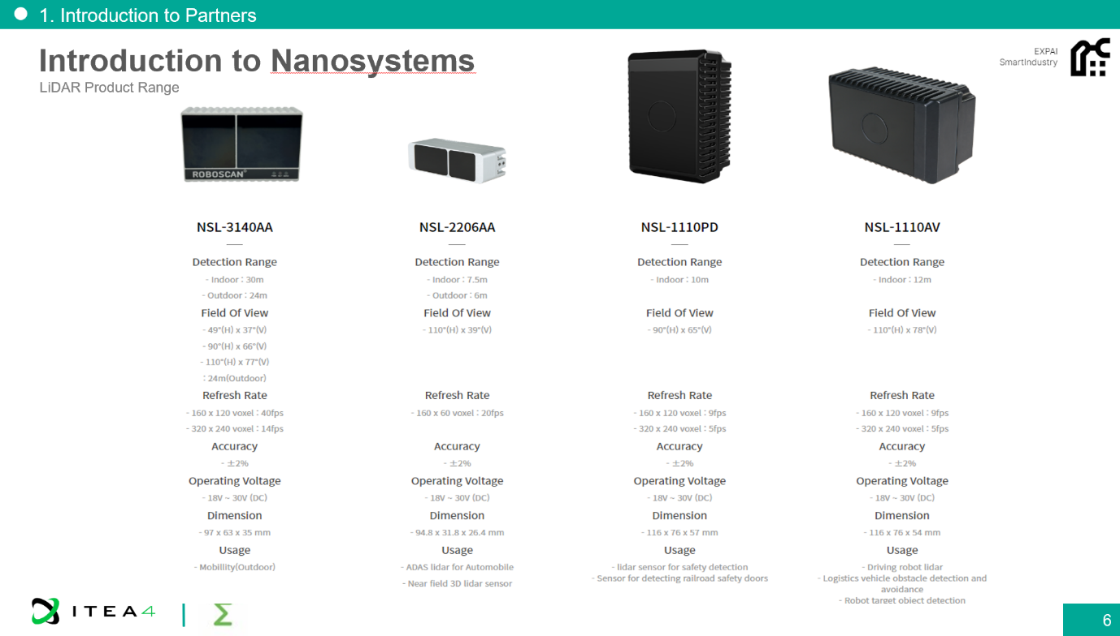
Introduction of development methodologies (Vee model)
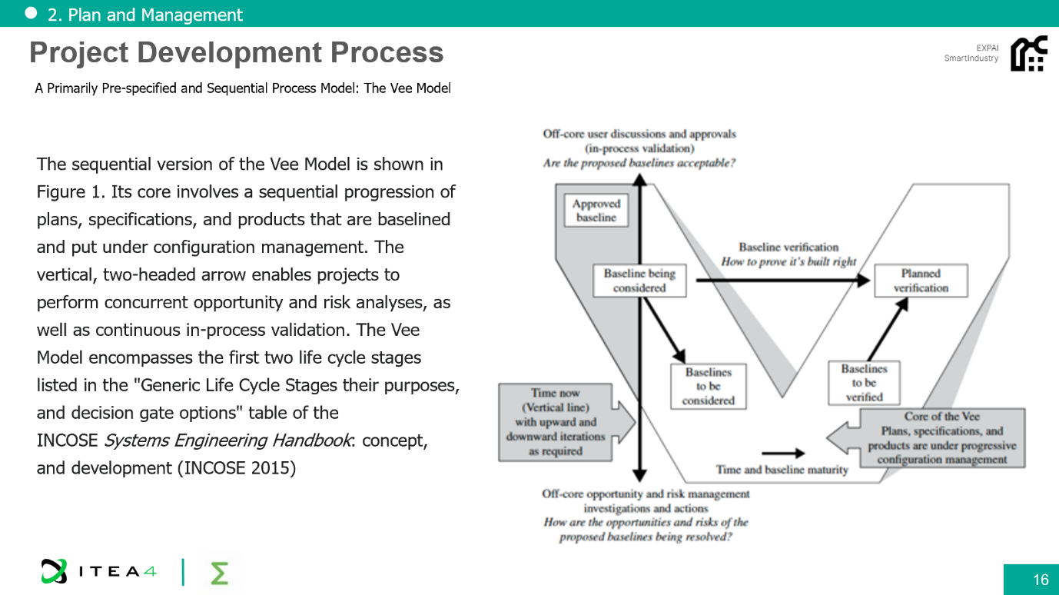
Introduction to XAI techniques and Implementation concept
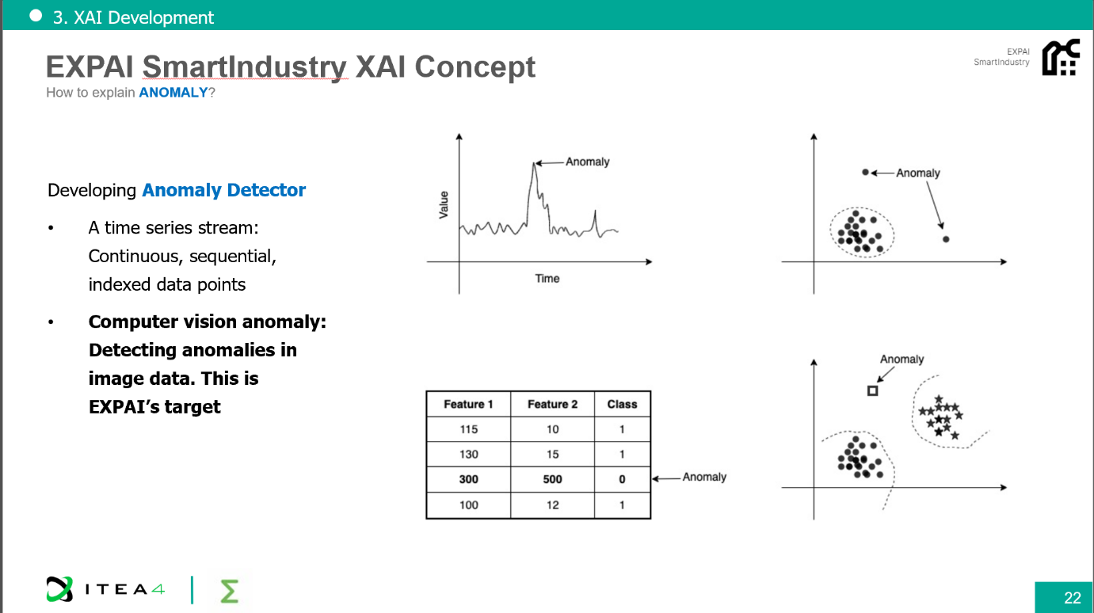
Propose partner contributions for EXPAI SmarIndustry project
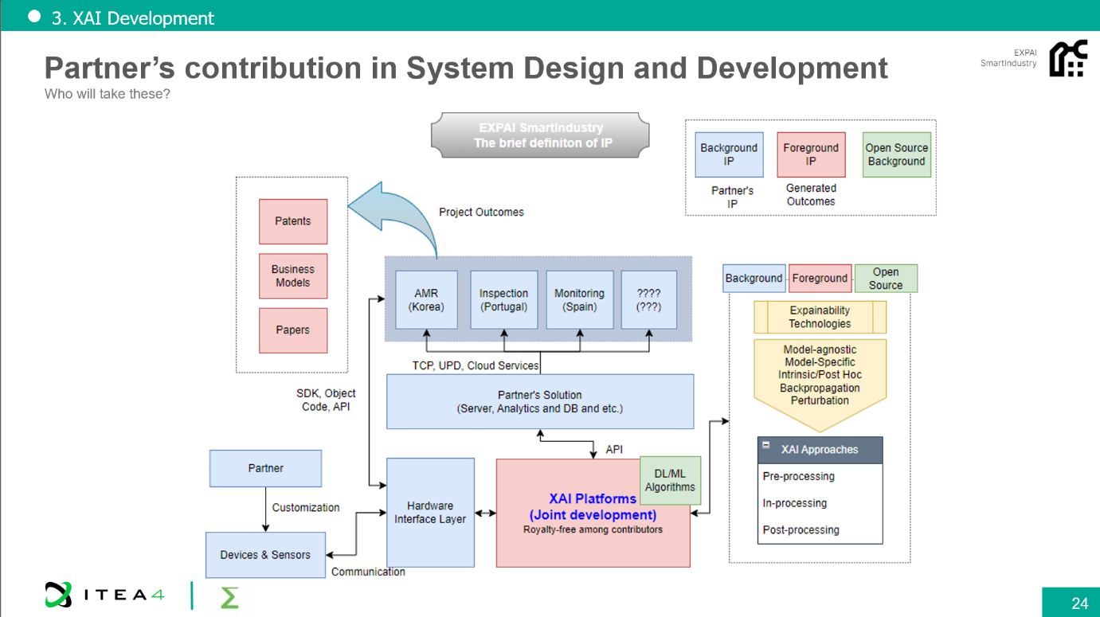

3. Project Handbook

3.1. Project Overview
The fourth evolution of the industrial revolution marks the advent of a new era, presenting opportunities to utilize industrial robots, artificial intelligence, decision support systems, and prognostic technologies. Autonomous Mobile Robots (AMRs) and smart systems will take on more responsibilities and handle critical tasks in industrial processes due to their efficiency in repetitive and demanding tasks. Addressing the complexity of operations, the EXPAI Smart platform is introduced by the EXPAI project as the primary solution. The project proposes three distinct industrial application scenarios with three use cases. In these scenarios, innovative tools, toolchains, and methods will be developed to facilitate simplified, effective, and observable technologies for various industrial processes.
The EXPAI project aims to deliver digital solutions that support explainable AI across three different use cases, ensuring flexibility and efficiency to reduce energy consumption and enhance safety conditions in factories.

3.2. Purpose of the Handbook
The project handbook outlines all aspects of project execution, including development phases, reviews, collaboration, and the processes that partners should follow. It serves as a comprehensive guide, detailing the methodologies and best practices required for successful project management. Partners will use this handbook to navigate through the complexities of the EXPAI SmartIndustry project, ensuring that they have the necessary information to address any issues and problems that may arise. The handbook aims to provide clarity on roles, responsibilities, and the structure of work packages, promoting an organized and efficient workflow.

3.3 Goals and Objectives
The EXPAI project develops a number of technical innovations focused on creating cross-sector tools and components currently underdeveloped in the Industry 4.0. By applying novel approaches such as Machine Learning algorithms, we aim to create significant changes in our four initial use-cases.
- Cross-domain, general platform
- Technological innovations using Robot Smart Analysis
- Technological innovations using intelligent Decision Support Systems
- Technological innovations using Explainable AI
To accomplish these goals, we have defined KPI for evaluation, and it will describe in WP 2.
KPI ID | Performance Indicator | KPI Description | Success Criteria | Responsible Partners
KPI-1 | Enabling energy efficient AI algorithms | Reinforcement Learning, Deep Reinforcement Learning methods will be developed in | Enabling 10% energy efficiency compared to initial conditions in case applications | Nanosystems,
KPI-2 | Autonomous drive with single charge | Mobile robot expected to drive through retail stores without colliding human or objects | > 6 hours | Nanosystems, ACD
KPI-3 | Object Recognition, AI Accuracy | Mobile robot expected to recognise objects lined up in a shelf with Image Processing and AI algorithms  Accuracy in overall applications | with a success of greater than %75 (Koctas)  with a success of greater than %85 (Nanosystems) | Nanosystems,
KPI-4 | Autonomy | operate independently of human operators | >=10h | Nanosystems
KPI-5 | Efficiency gain | Increase the efficiency of the stock management process | Increase stock management and retrieval efficiency by 50% when compared to the previous process (without AI / Optimization algorithms input) | Portuguese Consortium
KPI-6 | Revenue gain | Increase in early revenue due to the implemented innovations | increase revenue by 5% when compared to the previous process (without AI / Optimization algorithms input) | Portuguese Consortium
KPI-7 | Data acquisition time | Sampling rate of LiDAR sensor | > 20 Hz | Nanosystems
KPI-8 | Average accuracy of knowledge extraction models | Cross validation | At least 85% | ACD, Nanosystems
KPI-9 | Average processing time of AI services | Using web application performance units | Under 5s | Nanosystems, ACD
KPI-10 | Capacity of Big Data Management and Analytics Platform | Read and write throughput on different work loads | Under 1s | Nanosystems, ACD
KPI-11 | Up to 30% energy saving in a manufacturing line (at the end of the Project-36 months later) | Measuring the energy consumption by using relevant tools (such as sensors etc.) | Up to 30% | Nanosystems, ACD
KPI-12 | Detection of anomalies in energy using | By using the most relevant Computational Intelligence Techniques (such as Online Clustering and Fuzzy Logic Systems) | Minimum 35% | ACD
KPI-13 | Defect Detection Accuracy | Measures the accuracy of the AI system in detecting cracks, incorrect bends, and surface defects in steel plates. | ≥ 90% detection accuracy. | ACCURO
KPI-14 | Navigation Accuracy of AMRs | Measures the ability of AMRs to navigate the production environment without collisions and correctly identify steel parts. | ≥ 95% navigation accuracy and ≥ 90% object recognition accuracy. | ACCURO

3.4 The structure of Work package and roles
The EXPAI project consists of six work packages that address both technical and managerial aspects. WP1 supervises all other work packages and tracks the progress of technical milestones and administrative tasks. WP2 collects and analyzes the requirements for Explainable AI (XAI) and usage scenarios to define the system architecture. WP3 is responsible for designing and developing XAI techniques and AI algorithms. WP4 integrates applications with the developed XAI framework and software component modules to interface with sensors or external devices. WP5 involves demonstrating the developed systems at the client site. The results from the EXPAI project will be disseminated to facilitate exploitation.
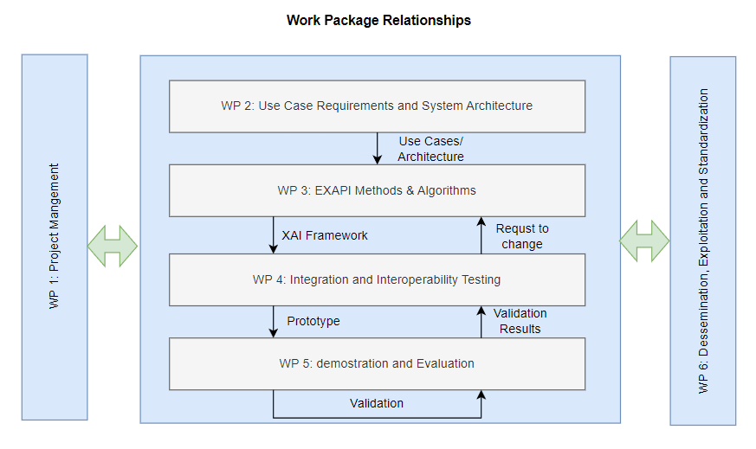

3.5 Timeline
We have outlined a plan that includes five key milestones and six work packages to be completed over a period of 36 months.
The milestones are:
1. Milestone 1: Project Collaboration and Synchronization
Project kick-off collaboration and first project handbook publication is aimed in this period.
2. Milestone 2: validation milestone
In this milestone, it is aimed to finalize all points of use cases and systems architecture and move to main development parts.
3. Milestone 3: Midterm Progress Report
In this milestone, it is aimed to provide first version of module development reports and plans for system integration. It is aimed to define common standards in project to provide have final versions of development for next milestone.
4. Milestone 4: Technology validation milestone
In this milestone it is aimed to have finalized technologies and modules and integrations for EXPAI platform have started. M30 will validate all the technologies and integration concepts of project.
5. Milestone 5: Project Finalization
In this milestone, it is aimed to have final demonstrations of each use cases and validate developments with predefined KPIs of the project. In this phase, EXPAI platform and technologies will be demonstrated in a final shape and future exploitation and dissemination roadmap will be provided.

The timeline of work packages is:
1. Work packages 1: Jan 2024 – Dec 2026, leader: Nanosystems
2. Work packages 2: Jan 2024 – Jul 2026, leader: Accuro
3. Work packages 3: Jun 2024 – Nov 2025, leader: Nanosystems
4. Work packages 4: Jan 2025 – Dec 2026, leader: Nanosystems
5. Work packages 5: Sep 2024 – Dec 2026, leader: Acd
6. Work packages 6: Apr 2024 – Dec 2026, leader: ISEP
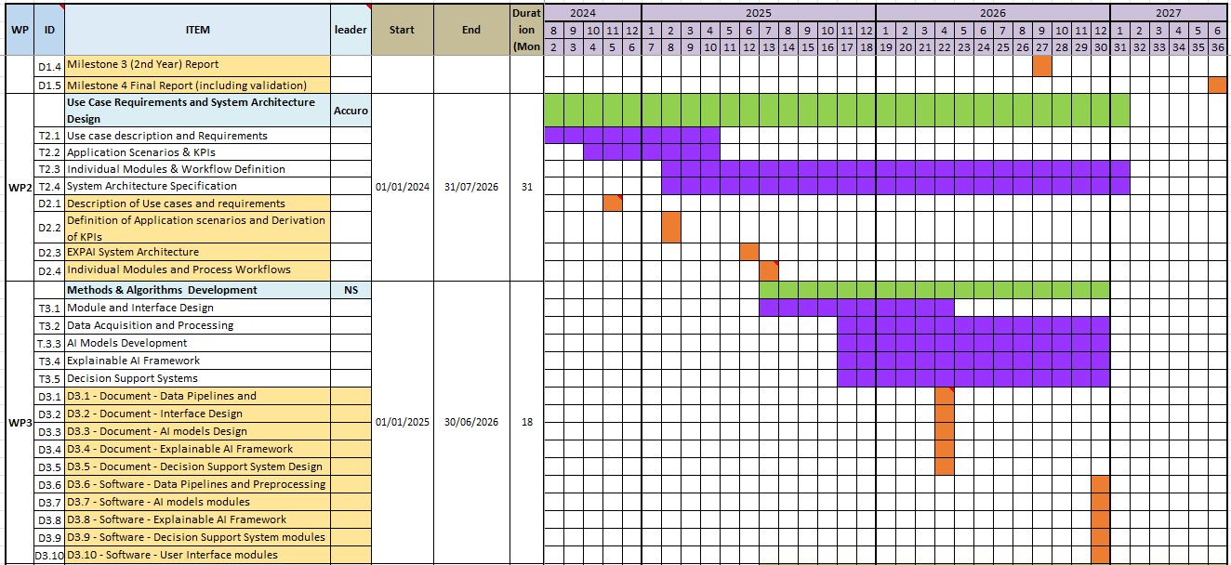
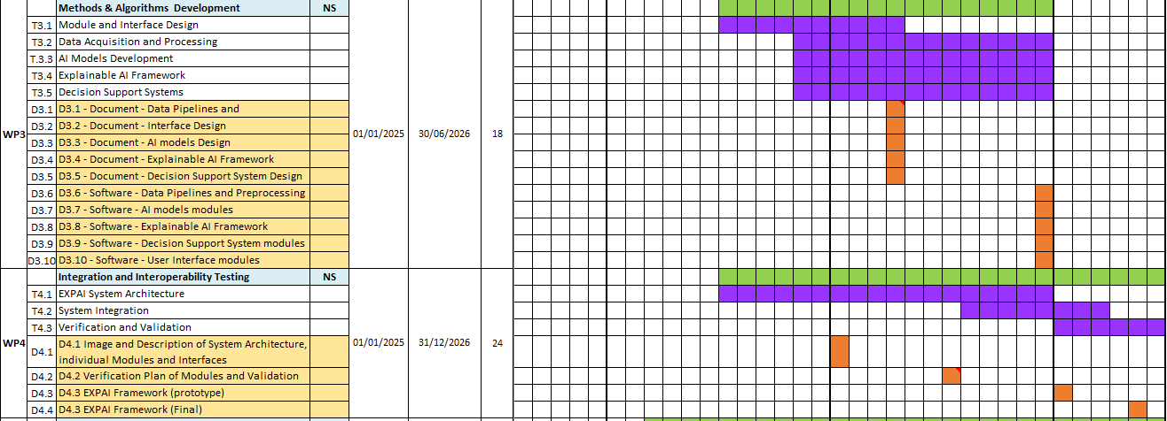

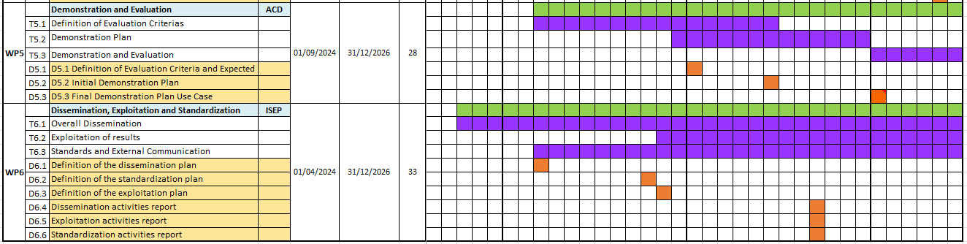

This detailed timeline will provide clarity on the project's progression and ensure all team members are aligned with the project's objectives and deadlines.

3.6 Project methodologies & collaborating guidelines
We will apply the Systems Engineering approach as outlined by INCOSE to define the phases of MCR, SRR, SDR, and others for the EXPAI project. The project's progress will be assessed using a customized version of the INCOSE guidelines.
The International Council on Systems Engineering (INCOSE) is a professional association that promotes the application of systems engineering principles and practices. Systems engineering is an interdisciplinary approach that focuses on designing, integrating, and managing complex systems over their life cycles.
Key Aspects of INCOSE Systems Engineering
- Interdisciplinary Approach: Systems engineering involves collaboration across various disciplines to ensure all aspects of a system are considered and integrated effectively.
- Lifecycle Focus: It covers the entire lifecycle of a system, from initial concept through development, operation, and eventual decommissioning.
- Structured Process: INCOSE provides a structured process that includes defining customer needs and required functionality early in the development cycle, documenting requirements, and proceeding with design synthesis and system validation while considering the complete problem.
- Phases like MCR, SRR, SDR:
  - MCR (Mission Concept Review): Evaluates the mission's feasibility and alignment with strategic goals.
  - SRR (System Requirements Review): Assesses the system requirements to ensure they are complete and feasible.
  - SDR (System Design Review): Reviews the system design to ensure it meets requirements and is ready for development.
- Guidelines and Standards: INCOSE provides guidelines and standards to ensure best practices are followed, enhancing the quality and reliability of the systems developed.

By applying these principles, the EXPAI project can be systematically managed to meet its objectives efficiently and effectively. You can find each phase of EXPAI project by INCOSE definition below.

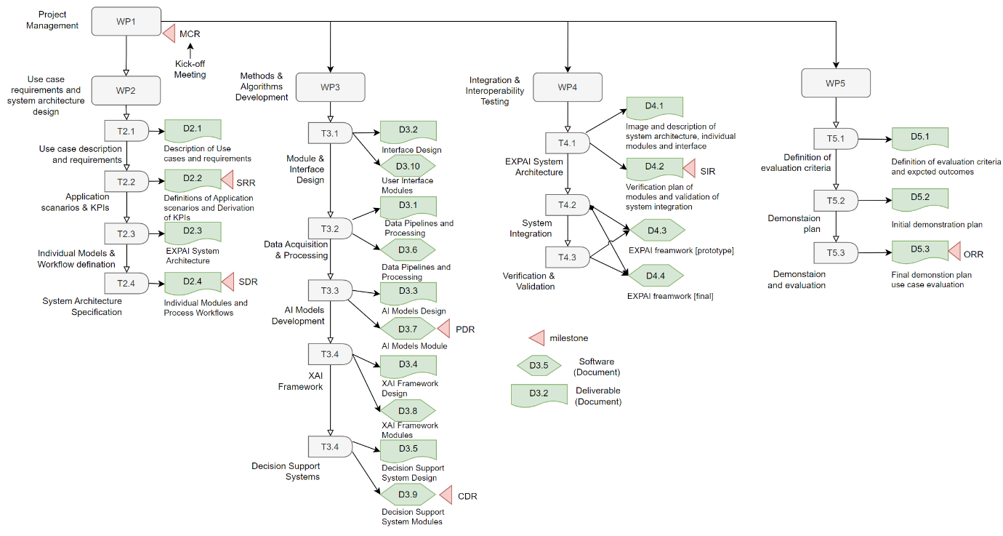
Figure 1 The defined process by INCOSE System Engineering

3.8 Risk Management
How to find and assess it.
Defining risks in the EXPAI project involves identifying potential issues that could negatively impact the project's progress or outcomes. This includes technical risks, such as the failure of AI algorithms to meet performance standards, and managerial risks, such as delays in project timelines or lack of resources. Risks can be assessed by evaluating their likelihood of occurrence and potential impact on the project.
Mitigation strategies for these risks involve proactive planning and continuous monitoring. For technical risks, this could mean implementing rigorous testing and validation processes for AI algorithms and ensuring robust system architecture. For managerial risks, it involves maintaining clear communication channels among all stakeholders, regularly reviewing progress, and being adaptable to changes in project requirements or timelines.
The table below shows categorized risks and mitigate them.
Category | Definition | Examples | Mitigation
Technical risks | Risks associated with technology used in the project, such as new or untested technologies | Software bugs, hardware failures, integration issues | Avoidance: Select a proven technology.  Reduction: Conducting through testing before using it.
Project management risks | Risks related to planning, execution, and control of project | Schedule or funding delay, control of the project | Reduction & Acceptance: Change Request to reflect situation.
External risks | Risks originating from outside the project environment. | Regulatory changes, market situation changes, hardware supply issues | Acceptance: Prepare to manage its impact.  Transfer: Finding external vendor.

3.9 Progress monitoring and Reporting
ITEA requests a progress report every six months to assess the project's progress. However, we will evaluate the progress based on the project phases we defined above.
The ITEA progress report consists of several chapters that need to be entered into the ITEA portal, with descriptions written directly in the provided template.
- Overall Status: Include the top four overall innovations, business impacts, key performance indicators (KPIs), and risks.
- Market Access & Exploitation: Enter this information in the ITEA community portal.
- Project Progress: Document project progress and issues directly in the template, and update the progress of work packages in the ITEA portal.
- Partner Progress: Provide input directly in the template.
The table below outlines the phases we need to review internally to assess our progress.
Phase | Name | EXPAI deliverables
MCR | Mission Concept Review | D1.1, D1.2
SRR | Systems Requirements Review | D2.1, D2.2
SDR | Systems Design Review | D2.3, D2.4
PDR | Preliminary Design Review | D3.1, D3.2, D3.3, D3.6, D3.7, D3.10
CDR | Critical Design Review | D3.4, D3.5, D3.8, D3.9
SIR | System Integration Review | D4.1, D4.2
ORR | Operational Readiness Review | D5.1, D5.2, D5.3

3.10 Deliverables
Here are the deliverables that need to be completed before the deadline.
