

PROFIT
PRocedure Optimization and data-driven eFficiency Improvement in healthcare environmenTs

DELIVERABLE D7.2
Public summary report

Project number: ITEA 22021
Document version: v1.0
Edited by: Dominique Segers, Barco
Date: 30 November 2024

This document and the information contained are the property of the PROFIT Consortium and shall not be copied in any form or disclosed to any party outside the Consortium without the written permission of the Project Coordination Committee, as regulated by the PROFIT Project Consortium Agreement.

HISTORY

Document version # | Date | Remarks
V0.1 | November 3, 2024 | Draft version
V1.0 | November 30, 2024 | Final version

Deliverable review procedure:

- 2 weeks before due date: deliverable owner sends deliverable –approved by WP leader– to Project Manager
- Upfront PM assigns a co-reviewer from the PMT group to cross check the deliverable
- 1 week before due date: co-reviewer provides input to deliverable owner
- Due date: deliverable owner sends the final version of the deliverable to PM and co-reviewer

Table of Contents
Abbreviations 5
Executive summary 6
1. The rationale of the project 7
2. Addressing the challenge: proposed solutions and use cases 7
2.1 Use cases 9
2.2 Project’s results and expected impact 12
3. Innovations 14
4. The PROFIT Consortium 16
4.1 The Belgian Consortium 17
4.1.1 AZ Groeninge 17
4.1.2 BARCO N.V. 17
4.1.3 SIRRIS 17
4.1.4 TELEVIC 17
4.2 The Finnish Consortium 18
4.2.1 MEDICONSULT 18
4.2.2 OIVA HEALTH 18
4.2.3 SOLITA 18
4.2.4 University of Eastern Finland 19
4.2.5 Turku University of Applied Science 19
4.2.6 VTT 19
4.3 The Portuguese Consortium 20
4.3.1 Instituto Superior de Engenharia do Porto (ISEP) 20
4.3.2 Unidade Local de Saúde da Região de Leiria – Centro Hospitalar de Leiria (CHL) 20
4.3.3 University of Porto – Faculty of Medicine 20
4.3.4 Wiseware 21
5. Project structure 21
5.1 Work packages 22
5.2 Gantt chart 24
6. Business opportunities 25

Abbreviations

AI | Artificial Intelligence
AIaMD | AI as Medical Device
CAGR | Compounded Annual Growth Rate
DECT | Digital Enhanced Cordless Telecommunication
EHR | Electronic Health Record
EMR | Electronic Medical Record
GDP | Gross Domestic Product
GenAI | Generative Artificial Intelligence
HC | Healthcare
HIS | Hospital Information System
HW | Hardware
IoT | Internet of Things
IP | Internet Protocol
IT | Information Technology
ML | Machine Learning
PMT | Project Management Team
R&D | Research and Development
RGB | Red Green Blue
RTLS | Real Time Location System
QA | Quality Assurance
SME | Small Medium Enterprise
SW | Software
UC | Use case
WP | Work Package

Executive summary
Chronic diseases affect a third of adults worldwide and are rising due to rapid urbanization, unhealthy lifestyles and ageing populations, while a global shortfall of 13 million nurses is expected by 2030. Meanwhile, healthcare systems are under pressure: in Europe expenditures cost 10% of the average GDP. This calls for smart hospitals, which connect people, data and technologies for better end-to-end care experiences and seamless transitions across care settings. The first challenge on this path is to increase operational efficiency to free up time for patient care.
To optimize workflows and reduce staff burden in healthcare environments, the ITEA project PROFIT (PRocedure optimization and data-driven Operational eFficiency in healthcare environmenTs) will enable smart hospitals via a facilitated and safe deployment of AI and the introduction of innovative solutions for asset management, alarm responses, operational efficiency, and clinical assistance and support to healthcare personnel.
To streamline tasks, improve patient outcomes and reduce human error, PROFIT will introduce novel solutions that optimize and simplify workflows across different areas. For smart asset management, technologies like edge intelligence, IoT and cloud computing will be combined to design smart, real-time location systems and AI to optimize hospital processes. For smart alarm responses and context-aware information management, context-driven information and communication nursing tools will improve resource utilization, work processes and patient care according to the end-user needs. For clinical procedure assistance and workflow efficiency, PROFIT will design a healthcare compute platform and a QA framework facilitating the deployment of AI-based medical algorithms while respecting requirements and regulations. These innovations will be interconnected within and beyond the hospital to address entire patient’s journey. This will include the integration of healthcare, social services and long-term care in a holistic and person-centric approach. Technological innovations will be introduced in various areas and clinical use cases and demonstrators will be built to exemplify and validate how the PROFIT solutions will be used in practice and how they complement each other in the clinical workflow.
PROFIT’s primary outcome will be a holistic solution that can be integrated within the existing healthcare system and with the existing products’ portfolio of the industry partners. Its final goal, however, is firmly on improving quality of care, patient and practitioner experiences, and contributing to the sustainability of the healthcare systems.
PROFIT’s market value chain is also relatively short as the industrial partners have existing sales channels to healthcare providers, enabling them to swiftly exploit new products and expand to new market segments. The market potential is very promising; the global healthcare AI market, for instance, will reach US$ 148 billion by 2029 at an impressive 48% compounded annual growth rate. Additionally, the project will investigate new business models and realize integrated demonstrators and proof-of-concept systems for pre-clinical validation. This makes PROFIT a comprehensive first step towards truly smart hospitals.
The starting date of the PROFIT project is March 2024 and its duration is 40 months (project end: June 2027).
The Consortium includes 16 partners from three national consortia (Belgium, Finland, Portugal). Barco N.V. (Belgium) will be in charge of the project management.

The rationale of the project
Healthcare as we know is on an unsustainable trajectory. Hospitals are already facing acute staff shortages, while the prevalence of chronic diseases will only continue to increase in the next few decades creating a growing human and financial burden that forces to urgently reconsider how and where care has to be delivered.
The numbers paint a clear and sobering picture: chronic diseases such as diabetes, cancer, and heart disease affect one in three adults worldwide today; it is a number that is only set to rise due to rapid urbanization, globalization of unhealthy lifestyles, and ageing populations. As a result, healthcare systems are coming under increased financial pressure, with EU healthcare expenditures taking a chunk of 10% of the average EU gross domestic product. This amounts to more than €1.3 trillion in costs!
Adding to the challenge is that hospitals are not staffed to keep pace with the rising demand for care. Globally, a shortage of 6 million nurses pre-COVID plus 4.7 million set to retire in the next few years has been exacerbated by an exodus from pandemic-related burnout, leading to an estimated shortfall of 13 million nurses by 2030. Taken together, this means healthcare providers find themselves in a perfect storm of having to meet new and growing demands with a limited and increasingly exhausted workforce.
To meet the growing demand for affordable and accessible care, building more hospitals cannot be the only answer. Smart hospitals will be an essential part of the healthcare ecosystem of the future. A smart hospital, as we envision it, connects people, data, and technology in intelligent ways for better end-to-end care experiences and seamless transitions across care settings. Smart hospitals rely on workflow automation and effective personnel management to allocate tasks appropriately and liberate healthcare professionals from repetitive procedures.

Addressing the challenge: proposed solutions and use cases
Healthcare stakeholders should ideally take advantage of information technology to optimise daily activities; newly emerging intelligent systems have a significant impact on several areas of health.
The PROFIT project will develop data-driven applications to guide or automate as much as possible the healthcare worker’s tasks, to optimize tasks allocation among medical personnel and to avoid / reduce their stress. One of the main challenges that hospitals endure on their path towards being a Smart Hospital, is to increase operational efficiency to free up time for patient care. Smart hospitals rely on workflow automation, appropriate personnel management and motivation, data-driven optimization of the procedures to remove waste and inefficiencies from the processes, and support healthcare professionals through advanced technologies (e.g. AI-enabled solutions) thereby enabling them to focus on what drew them to medicine in the first place: taking care of patients.

One of the biggest opportunities afforded by smart technologies such as AI is to automate much of the cumbersome manual work that is wearing down physicians and healthcare staff. By adding intelligence to medical systems and devices, they become easier to use for lesser-qualified staff, making hospitals less dependent on scarce specialists without compromising on quality and patient safety. Sharing data among caregivers and improving workflow efficiency help patients to get treatment on time and treatment outcomes can be improved. AI-aided data summaries will mitigate the risk of data overload and will facilitate a timely and data-driven intervention. The point of such innovations is not to remove clinical and technical staff from the loop. It is to enhance human experience and equip them with actionable intelligence at their fingertips, with solutions that are deeply embedded into their workflows and designed to augment their capabilities. That means less time figuring out equipment settings, and more time interacting with the patient.

The PROFIT project will focus on some relevant healthcare applications:

Real-time asset tracking
A frequent source of frustration and inefficiency that automation can help to address is the lack of real-time insight into asset location and utilization. For example, more than a third of nurses waste up to two hours a shift searching for missing medical equipment such as mobile infusion pumps. Furthermore, in the absence of reliable utilization data, hospitals may unknowingly be procuring more equipment than is needed for one department, while there are structural shortages in other departments. Track-and-trace-like solutions – using tracking based on radiofrequency identification (RFID) or infrared – can help staff to find the nearest equipment more quickly. At the same time, real-time location data can be integrated with other information such as data from Electronic Medical Records to provide hospital administrators with actionable insights that help them to optimize workflows and equipment utilization.

Smart alarming and provision of context-aware information
With an ever-growing list of tasks constantly competing for attention, healthcare staff do not have time to go through large amounts of disparate data. They need timely and contextually relevant insights that they can act on immediately in the critical moments that matter. For example, by pioneering the use of automated early warning scores that pick up on signs of patient deterioration in the general ward, one hospital was able to reduce the number of serious adverse events in patients by 35% and the number of cardiac arrests by 86%.

Facilitating the innovation and delivery on the promise of digital transformation (e.g. AI-based solutions)
In a sector as complex as healthcare, no individual player has all the solutions. Instead, the future of digital healthcare will be built in collaborative ecosystems, with solutions from multiple vendors working in concert on open and interoperable platforms. By combining the strengths of technologies from different vendors, in a way that is easy to access and implement for healthcare providers, we can further accelerate innovation and deliver on the promise of digital transformation. With the rise of AI, many apps are coming from start-ups and universities; hospitals find it hard to put these apps to use if they lack a common underlying platform that is integrated with their workflow at the point of care.
Validation and deployment of AI-based solutions are challenging without a quality assurance (QA) framework capable to verify and continuously monitor their performances and safe and reliable execution. PROFIT aims at bridging these gaps.
By adding intelligence to medical systems and devices, they become easier to use for lesser-qualified staff, making hospitals less dependent on scarce specialists without compromising on quality and patient safety.

Promoting the wellbeing and motivation of the healthcare personnel
There is the need of a better management of the personnel. Appropriate tools for allocation of tasks based on the experience, skills and preferences of the medical staff will enhance their motivation and satisfaction and will reduce stressing situations. Automation will avoid repetitive tasks, AI-enabled support will facilitate the decision process and provide higher confidence to the healthcare personnel.

Expanding the digital healthcare beyond the hospital’s boundaries
Healthcare systems can take advantage by a holistic and person-centred approach targeted not only to the hospital’s setting and integrating digital home care. PROFIT will explore this opportunity by including also a synergic integration and harmonization between healthcare and social care services.

Use cases
In PROFIT some clinical areas and use cases were defined to demonstrate and validate the project innovations, and to address the identified challenges. Project outputs will be integrated and deployed into clinical settings in close collaboration with experts. In each specific use case the validation of the results will also explore the scalability of the solutions and their adaptability to other clinical applications where relevant.

Here below the list of the addressed use cases:
Use case # | Title
UC1 | Smart alarm response and context-aware information management
UC2 | Deployment of AI-enabled solutions into clinical practice
UC3 | Real-time asset tracking and sterilisation management system for the safe reuse of invasive medical diagnostic equipment
UC4 | Digital home care and preventive digital care
UC5 | AI-enabled management of clinical documentation
UC6 | Smart orchestration for optimized customer and care pathways

In the “smart alarm response” use case PROFIT will optimize information management and alarm response for nurses by considering the actual context including information related to patients (easy-to-consult summaries related to health status and care needs, history of alarms, interventions, and care outcomes) and to staff (competences, location, quality of work life). Novel technologies to derive context from multisource information (EHRs, human resource systems, nurse call equipment, sensors, and information from the hospital's information system) will be developed. As a result, operational management of resources will be improved, and tasks will be assigned to the most appropriate professionals. At a second level, this contributes to a more person-centred and safe care for the patients as well as staff empowerment.

In the use case 2 (AI deployment in healthcare) the project will foster the deployment of AI-enabled solutions in healthcare by addressing an important overlooked challenge i.e. the current lack of a dependable, safe, and maintainable healthcare compute platform and an effective QA framework ensuring easy integration and continuous compliance with medical requirements and regulations of the AI-based applications.

In use case 3 (real-time asset tracking) PROFIT will combine AI and novel technologies such as edge intelligence, Internet of Things (IoT) and cloud computing to design smart and real-time location systems to overcome current constraints, and to optimize processes within the hospital. Attention will be devoted to a specific process, the sterilization of invasive medical diagnostic equipment for the safe reuse; it will require real-time tracking and the analysis of the sterilization process by using RGB camera and spectroscopy. The process will include the early prediction of bacterial growth.

The ”digital home care” use case intends to demonstrate how healthcare can be expanded beyond the hospital boundaries by using advanced technologies with the result of the improvement of home-based primary care and prevention. PROFIT will explore new solutions and approaches by using Finland as first test case. Advances are expected in areas such as automated calling and logging (also through the use of Ai-supported natural language processing), integration of multisource information, automation in the treatment and everyday support, healthcare system integration, preventive digital care services.

The use case 5 referring to the clinical documentation in the hospitals will explore how AI-driven tools can transform its management through easy-to-consult data summaries and novel speech-to-text solutions allowing to collect voice-based data and integrate it into EHR system. This approach will facilitate and enforce the decision process of healthcare personnel by predicting the current health status of the patient and its trends in a person-centric way.

Finally the last use case (orchestration of HC services) addresses the lack of orchestration of services and care pathways in the healthcare landscape where currently patients are confronted with fragmented and confusing care pathways leading to inefficiencies and suboptimal outcomes. AI-driven solutions will be developed to enable real time analysis of patient’s journey and intelligent orchestration of the provided srvices.

Project’s results and expected impact

With its newly developed solutions PROFIT will address the four major societal challenges in the healthcare domain.
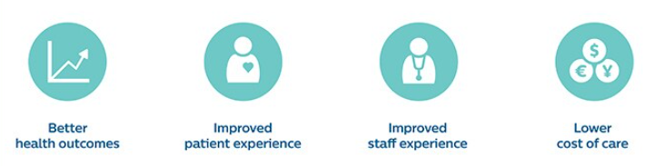
Figure 1 - The Quadruple Aim for healthcare solutions

The new solutions will result in improved staff experience and better health outcomes:
- context-aware alarm responses will streamline nursing calls and consequently also improve the patient experience;
- smart asset management and data-driven operational management will lead to better utilization of resources, less stress for the staff and reduction of care costs;
- AI-based support to medical professionals in their decision process will augment their competences and experience with a better quality of care;
- All the proposed solutions will contribute to cost reduction and to the sustainability of the healthcare systems.

Some of the anticipated tangible project outputs are indicated in the following tables for each of the addressed application areas; for each of them we report the initial and target technology readiness levels

      - Smart asset management
Project output | Initial TRL | Target TRL
A system for automatic real-time collection of location and movements of staff and equipment in the hospital. | 4 | 7
Accurate AI-based engines for the optimization of the process of sterilization and microbiological tests of invasive medical diagnosis equipment. | 3 | 7

      - Smart alarm response and context-aware information management
Project output | Initial TRL | Target TRL
Privacy-preserving algorithms for the collection of multi-modal medical data on patients and caregivers | 2 | 7
Real-time centralized overview of staff, patients, and equipment and provision of information in case of events. | 4 | 7
Automatic, person-centred and context-driven task assignment and scheduling including alarms distribution | 4 | 7
AI-supported system to determine what information (i.e., alarm notification) to- provide to which nurse, at which moment and in which form, based on an assessment of worker’s situational context. | 3 | 6
A system monitoring the carers’ activities and their well-being for improving general and personal workflow. | 3 | 7

      - Data-driven operational efficiency
Project output | Initial TRL | Target TRL
A data-driven resource overview dashboard, which (semi-)automatically manages different care resources. | 3 | 6
AI-enabled microbiological analysis based on the use of hyperspectral sensors and video cameras | 2 | 6
Advanced solutions for speech-to-text | 3 | 7
AI-enabled solutions for the generation of effective data summaries and patients’ documentation summaries | 3 | 6

      - AI-enabled solutions for clinical procedure assistance and automation and novel QA framework for AI algorithms in healthcare
Project output | Initial TRL | Target TRL
Healthcare compute appliance that can be used to deploy a multitude of medical algorithms in a safe and reliable manner and respecting all medical requirements and regulations. | 3 | 7
A QA framework and a set of quality metrics and validation methods that can be used to monitor the reliability and performance of the deployed AI solutions constantly and iteratively (NOTE: the QA framework will be offered as an add on service or as a service layer integrated into a HC compute platform). | 2 | 7
A proposal for a regulatory “adaptive” approach allowing continuous learning of AI algorithms in healthcare through real life data | 3 | 6

Innovations
The table provides an overview of the technological innovation and the identified gaps the PROFIT project plans to introduce:

Research area | Current SotA | Proposed Innovation in PROFIT
Smart asset tracking
Real-time localization of hospital assets | Hardware-oriented solutions aimed at the localisation of tags | Development of advanced prescriptive intelligence aimed at the optimization of routine flow processes
Sensor fusion | Limited use of a combination of technologies with segmented data as a result | Context-aware tracking through AI and advanced analytics
Smart alarm response and context-aware information management
Context representation and detection | Heterogeneous and multi-source data in the healthcare domain | Semi-supervised and adaptive approaches to detect the current context in (near) real-time
Proactive support delivery | Different devices are unaware of each other, resulting in data fragmentation, incomplete user profiles, limited insights, and limited personalization. | Proactive information delivery to healthcare professionals, building upon heterogeneous data acquisition and integration, accurate user profiles, AI aided documentation (including data summaries), context modelling and reasoning
Alarm handling | - No context is associated with an incoming alarm  - Alarms and tasks are routed in a preconfigured way | - Differentiated patient calls and call classification  - Smart routing engine and call prioritization
Task and information management | Alarms, tasks and information are not dynamically scheduled | Planning and scheduling of workflows and tasks based on context
Data-driven operational efficiency
Information exchange | Lack of healthcare architecture models for the integration of AI-based solutions | Development of a platform for AI deployment in clinical practice that integrates multiple solutions, assures quality and compliance and meets the needs of stakeholders. It will also provide a testing environment for new AI algorithms.
Voice-to-text and generation of structured data entries into the EHR systems | Not available even if natural language processing is an area attracting the attention of the research community | Data about patient / customer can be easily collected and enriched by using AI-based solutions for transforming voice data into structured text-data and by creating data summaries. A next step will be advance in text-to-speech techniques such as voice control for EHR and intuitive and innovative user interfaces.
Deployment of AI as a medical device
Interoperability of multivendor AI algorithms | Lack of a HC compute platforms capable to run multivendor medical applications and specifically AI algorithms. Interoperability of these algorithms and devices represents a complex challenge | A novel medical-grade compute framework (HW & SW layers) allowing integration of various 3rd party AI solutions into the hospital ICT infrastructure and to program a cascade of algorithms that sequentially perform multiple and different tasks.
Performance metrics for AI algorithms in healthcare | Very little research has been done with performance modelling and monitoring of AI algorithms mainly in time-critical context and applications requiring low latency | Multiple performance metrics and QA framework for AI algorithms with advanced features such as: a. differentiation on the basis of subgroups of diseases, patients and users; b. definition of confidence intervals for the expected performances; c. detection of subpopulations for which AI was insufficiently trained; d. detection of heterogeneity in real world data.
Regulatory approval for AI algorithms in HC | A “locked approach” based on a limited quantity of data collected on a relatively small patient population and asking for a new approval with a new clinical study protocol in case of retraining of the algorithms | A continuous post-market monitoring in a real life context during the full lifecycle; it will be ensured by the PROFIT QA framework.  Reduction of the need to formally conduct clinical trials in a hospital setting through a “decentralized clinical trial” with the additional benefit of a wider representativeness of the population and a mitigation of the risk of biases.

The PROFIT Consortium
The PROFIT Consortium includes 16 organizations from Belgium (4), Finland (8) and Portugal (4). Two of them, Esko Systems and Inlisol (both from Finland) participate as “in-kind contributors”.
BARCO has the role of Project Lead and will be responsible for the coordination of the international project and for the interfacing with the ITEA Office.
Each national consortium appointed a Country Coordinator (BARCO for Belgium, VTT for FINLAND and Wiseware for Portugal).
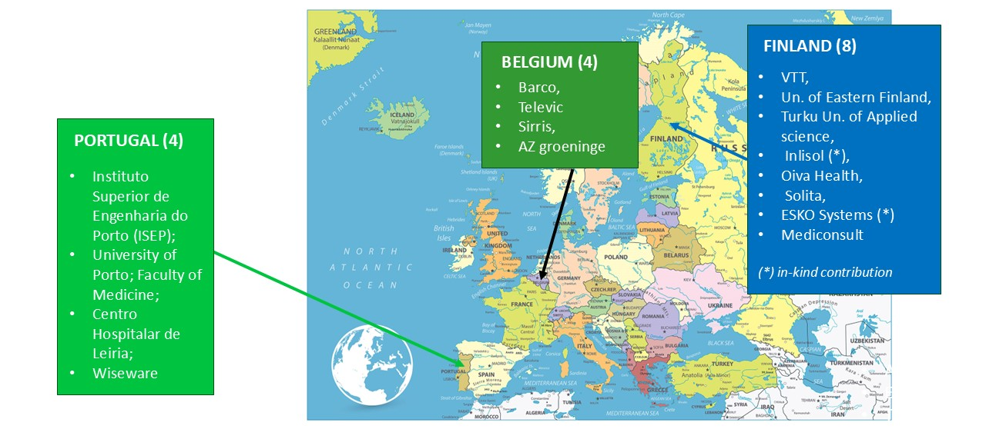

Figure 2 – The PROFIT Consortium

The Consortium includes 3 large industries (BARCO, SOLITA, TELEVIC); 5 SMEs (ESKO SYSTEMS, INLISOL, OIVA HEALTH, MEDICONSULT, WISEWARE); 4 universities (ISEP, TUAS, Univ. Eastern Finland, Univ. Porto); 2 Research Centers (VTT, SIRRIS); 2 medical institutions (AZ Groeninge, Centro Hospitalar of Leiria).
In addition, clinical experts are either partners in the project or linked to the project, and will ensure that end-user needs are appropriately addressed in new products, features, and services.
The PROFIT consortium has a good balance of research-oriented partners, technology suppliers and industrial end-product suppliers.
The demonstrators built for each of the above mentioned use cases will show how the partners’ achievements complement each other in the clinical workflow.
Furthermore, the PROFIT consortium brings together multiple partners capable to commercialize the project’s results in promising market segments and to benefit from the collaboration with knowledge institutes (see section 6).

The Belgian Consortium

AZ Groeninge
Az Groeninge in Kortrijk is one of the oldest and largest hospitals in Belgium, formed from the merger of five hospitals. AZG will be involved in the PROFIT project through its R&D Center, a lab at the heart of Az Groeninge that strives for innovation, R&D, education; its expertise includes the selection of the most promising technologies for healthcare and particularly AI.
AZ Groeninge will play a key role in the definition of the use cases and requirements (including technical, legal, privacy and usability aspects) in terms of workflow enhancement and impact on the staff.

BARCO N.V.
Barco is a global technology company with more than 3,000 employees that designs solutions (hardware, software and services) for three professional markets: entertainment (digital cinema, immersive experience), enterprises (meeting experience, large video walls), healthcare (diagnostic imaging, surgical & modality).
In the PROFIT project the Healthcare BARCO Lab will be involved. It has expertise in HW & SW, imaging, surgical operating room connectivity (the Nexxis audio / video over IP solution), quality assurance and tools for workflow efficiency.
In PROFIT the BARCO involvement is addressed to the deployment of AI-enabled solutions in healthcare and to an innovative platform providing low-latency. The solution includes a QA layer that ensures the safe, highly performant, reliable, privacy preserving and regulatory compliant implementation and operation of AI-based solutions.

SIRRIS
Sirris is the collective centre of the Belgian technology industry and helps companies in the implementation of technological innovations. Two research groups are involved in PROFIT: the ElucoDATA Lab and the Digital Services Lab. The main focus of ElucoDATA Lab is on data driven and AI-based solutions. Key fields of interest are: digital transformation, process analytics, optimization of manufacturing processes, video / data analytics, sustainable energy systems, distributed intelligence
In PROFIT the ElucoDATA Lab will be involved in the design of smart alarming solutions.
The Digital Services Lab provides technical advices to the industry and addresses topics related to cybersecurity. In PROFIT the Digital Services Lab will be involved mainly in WP2 (acquisition and integration of multisource and heterogeneous data and multilevel secure access.

TELEVIC
Televic Group is specialized in critical communication solutions for four different niche markets: railway, conferencing, education and healthcare. It employs about 1,000 people worldwide.
Televic Healthcare (THC) creates, develops, manufactures and commercializes all across Europe care communication systems including nurse calls (for hospitals, elderly care, assisted living homes) commercialized all across Europe. The vision is to move from standalone nurse-based to an integrated care platform; the AQURA solution currently offered by THC is an open platform for entry level nurse care system including intelligent alarm management.
In PROFIT THC will contribute to develop context-aware alarming systems taking into account the trigger of the call, the profile of the patient, the profile, location and “activity” of the nurse with the final goal of enhancing the quality of care for the patients, reducing the staff burden, optimizing the care workflow and boosting the motivation of the staff.

The Finnish Consortium

MEDICONSULT
Mediconsult is an information system provider specialised in the healthcare and social welfare sectors; its mission is to advance healthcare technology by integrating AI into EMR and social care systems. The company has 220 employees.
The principal product is the Mediconsult Saga solution that connects primary healthcare, specialized medical care and social welfare. It applies open standard solutions and is easy to be integrated into third party systems and solutions.
In PROFIT Mediconsult by using AI-based solutions will provide its expertise in converting speech into structured data and in generating efficient patient’s summaries from EHR data.

OIVA HEALTH
Oiva Health is the leading digital care provider in the Nordics and offers a comprehensive digital platform for integrated health and social care services. The platform allows virtual care visits, effective communication between patients and medical professionals and between patients and family members and smart alarming management. R&D objectives for Oiva Health include:
- Integration of digital service channels ( e.g. integration of chatbot and chat channel in services like appointment bookings, and teleconsultations);
- Enabling service channel data analysis (analysis of text and transcriptions from channels through machine learning to suggest automatic interventions);
- Integration with customer and patient information systems;
- Development of new services and care path modules.

SOLITA
Solita is a fast-growing midcap software company and combines technologies, data and human insights to deliver high-quality solutions to real problems. With more than 2200 employees the Company is present in nine European countries. Addressed research areas include data analysis, AI, agile software development, cloud platforms & management.
In the medical sector the company provides an intelligent orchestration of patients and care pathways and helps in the design and maintenance of regulated medical software through the offer of a highly effective software solution called RegOps ensuring fast time-to-market and reduced total cost of ownership. In PROFIT Solita plans to apply agile software development in the context of health information systems, to investigate on applicable EU regulations and to research and demonstrate how AI and, more specifically, generative AI solutions can be effectively utilized in the healthcare domain, e.g. non-traditional user interfaces and solutions.

University of Eastern Finland
The University of Eastern Finland was established in 2019 as the result of the merger of the University of Joensuu and the University of Kuopio. It is one of the largest universities in Finland and comprises four faculties: Philosophy, Science and Forestry, Health Sciences, and Social Sciences and Business Studies. Health and Well-being are among the areas of expertise that spans throughout the whole technology development process from the innovation phase to the assessment of the impact of implemented information systems in clinical settings. Areas of interest include the identification of user requirements, the design and testing of IT systems for healthcare, data analytics and machine learning, modelling, data management and security.
The university has extensive international relations and it is involved in several international networks.

Turku University of Applied Science
Turku University of Applied Sciences (TUAS) is a multidisciplinary higher education institute in Finland; the students can get a bachelor's degree or a master's degree in various sectors including healthcare and social services. The Faculty of Health and Well-Being is a large-scale educator of professionals in nursing, midwifery, and other related fields. The Faculty is active in several research and development projects related to healthcare technology, processes, and working life-related issues. High attention is devoted to define methodologies and tools fostering the acceptance of new solutions in healthcare; it implies application of affective science, ergonomics and the assessment of the “affective impact”.
Assessment is done by using technologies such as eye tracking, gait modelling, biological sensors (e.g. measurement of heart rate).

VTT
VTT - Technical Research Centre of Finland is a research organization with more than 2,300 employees and provides a wide range of technology and applied research services for its clients (private and public companies and institutions). Digital health is one of the addressed sectors. In PROFIT two teams will be involved:
- the Health Data Analytics team addressing the utilization of health data, data analysis (AI, ML), and decision models, connectivity (mobile, 5G, wearable), cybersecurity, etc.;
- the Human Sensing Solution Team that focuses on various solutions to observe human physiological parameters and behaviour including algorithms and ML solutions to process and fuse data obtained from wearable and remote sensors and turn it into actionable information for the users.
Areas of high interest in PROFIT are: the deployment of AI-based solutions such as AI-supported info for nurses, GenAI-based care documentation, speech-based user interfaces.

NOTE: The Finnish Consortium includes two in-kind contributors: Esko Systems and Inlisol.

The Portuguese Consortium

Instituto Superior de Engenharia do Porto (ISEP)
ISEP is the School of Engineering of the Polytechnic Institute of Porto (IPP)
Recognized as a fundamental contributor to the development of the Portuguese industry, ISEP includes nine R&D units. GECAD, one of them, will be involved in the PROFIT project. ISEP-GECAD excellence areas include artificial intelligence, decision-support technique, ontologies and semantic web, affective computing and knowledge-based systems and their application for processes optimization, planning & scheduling, modelling, simulation, intelligent interaction, ambient intelligence, smart cities.
More recently some work has been devoted to aspects like technology transfer and innovation.

Unidade Local de Saúde da Região de Leiria – Centro Hospitalar de Leiria (CHL)
The CHL is composed of three health units that were established from the merger between Hospital de Santo André, E.P.E (HSA) in Leiria, and Hospital Distrital de Pombal (HDP), and from the transfer of competencies from Centro Hospitalar do Oeste to Hospital de Alcobaça Bernardino Lopes de Oliveira (HABLO), Alcobaça.
CHL is involved in various health projects.

University of Porto – Faculty of Medicine
The Faculty of Medicine of the University of Porto (FMUP) is recognized for its leadership in the production of medical-scientific research, and the symbiotic relationship it maintains with more than 20 health institutions.
FMUP stands out in areas such as Cardiovascular Diseases, Internal Medicine, Neurosciences, Gastroenterology, and Allergology.
The Faculty hosts two R&D Units: CINTESIS and UnIC and integrates the first Portuguese Associated Laboratory dedicated to clinical and translational research (RISE).
In this context, the FMUP assumes a pivotal role in promoting interaction between Basic and Clinical Sciences and between Data Sciences and Health, ensuring a leading role in translational and clinical research in Portugal.

Wiseware
WISEWARE is a SME specialized in sectors such as micro-electronics, mechatronics, robotics, automation, telemetry and image processing. In the healthcare domain WISEWARE intends to contribute to the hospital’s operational efficiency and to the enhancement of the human experience and well-being of healthcare workers.
In the PROFIT project, the focus will be on systems capable of optimizing the hospital’s workflow by using predictive algorithms and technologies for tracking assets and analyzing the sterilization process of medical equipment.
WISEWARE is involved in various healthcare projects; main areas of expertise include: a. Artificial Intelligence and Machine Learning to do prediction; b. technologies such as RFID and Bluetooth Low Energy for tracking assets and RGB camera vision and spectroscopy to analyze the sterilization process.

Project structure
The work in PROFIT is structured in seven work packages, covering activities from use case analysis and requirements elicitation (WP1), technical innovations in data management (WP2), smart asset tracking (WP3), context-aware alarming (WP4) and AI deployment for clinical procedure optimization (WP5). Technical building blocks will be integrated to demonstrate workflow optimization in relevant clinical use cases (WP6). A dedicated Project Management work package (WP7) ensures overall alignment between partners and activities while a part of WP6 is devoted to dissemination, exploitation, and standardization initiatives of project results.
Each work package is coordinated by a Partner as indicated in the following figure

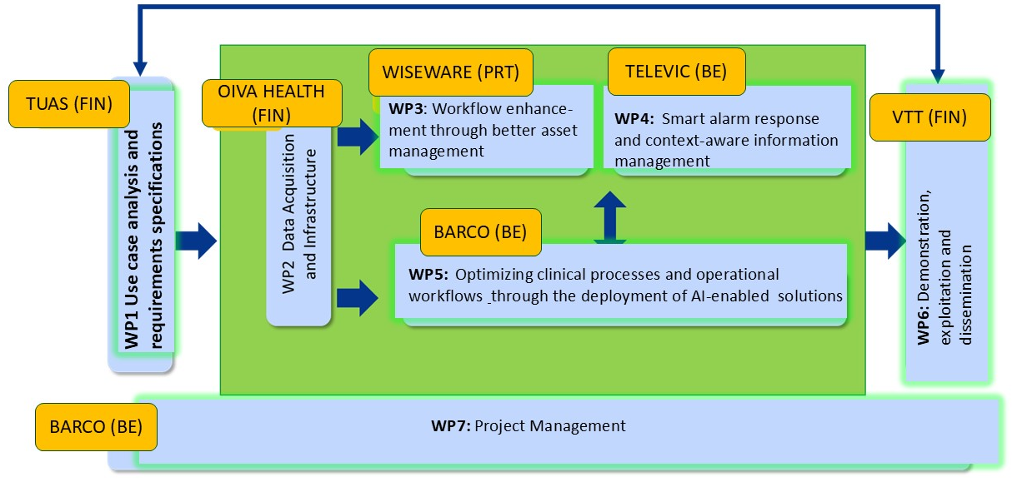
Figure 3: PROFIT WPs structure and lead partner for each WP

Work packages
WP1 - Use Case analysis and requirements specification
The starting point of the project is the analysis of the clinical workflow currently adopted in the use cases selected by the project. It will be based on the available knowledge of the partners, especially the clinically-oriented ones. For each use case, the WP will identify users’ requirements and gaps to be filled in and will explore improvements enabled by innovative technologies.
The use cases analysis will form the basis for the end user acceptance criteria which will be defined in WP6, and will ensure the involvement of relevant stakeholders since the early phase of the project. The requirements will form the basis for the specifications in the technical work packages WP2-5.

WP2 - Data Acquisition and Infrastructure
WP2 will investigate the management of data related to patients as well as hospital staff and infrastructures / assets including a secure and privacy-preserving acquisition, integration, processing, storage, and further exploitation of data. It will define the needs for data processing and storage and the solutions/ tools needed for the application in the use cases and integration into the existing hospital information systems.

WP3 - Workflow enhancement through better asset management
This WP will focus on identifying and setting the hardware and software structure and the enabling technologies that are required for context-aware asset management. Insights will be obtained and AI-based solutions and advanced analytics will be developed to create added value.

WP4 - Smart alarm response and context-aware information management
WP4 will build accurate context representation from aggregated multi-modal data and will provide proactive information. Especially, in the case of alarm handling, the goal is to reason upon that context information to resolve the alarm efficiently and effectively. Based on this context understanding, one can determine what information needs to be provided to which end user, at which moment and in which form. Part of the WP will be devoted to the development of tools for the profiling of patients and healthcare personnel and of AI-enabled solutions for the optimization of tasks assignment based on the skills, experience, workload and preferences of the medical staff.

WP5 - Optimizing clinical processes and operational workflows in hospitals through the deployment of AI-enabled solutions
WP5 will develop solutions capable to facilitate the deployment of new and advanced technologies in the healthcare domain with the final objective of allowing a better quality of care, increased efficiency and a reduction of the physical and cognitive burden on the staff. A specific attention will be devoted to the deployment of AI-enabled solutions and WP5 will develop a secure compute platform where AI algorithms will run in a privacy-preserving and quality-controlled setting. Quality Assessment tools and methods ensuring easier, safe, reliable and regulatory-compliant integration of AI into the clinical practice will be developed.

WP6 - Demonstration, exploitation and dissemination
This WP will integrate the technology building blocks from WP2-5 to demonstrate and validate the innovations against relevant clinical use cases. The demonstrators will show how the technological innovations contribute to simplifying clinical workflows and to enhancing the quality of care; feedback from end-users will be used to evaluate to what extent the project objectives have been achieved. End-user feedback on intermediate demonstrators will be used to update research activities in WP2-5 where needed. The WP includes activities related to dissemination and exploitation aiming at maximizing the impact of the project’s results.

WP7 - Project Management
WP7 will take care of the project management including progress reporting. A Project Management Team consisting of WP leaders and national coordinators will check the progress at least monthly and will meet in person if necessary. At least twice a year a General Assembly meeting with the participation of all partners will be organized to monitor the project’s progress and the achieved results and to discuss future actions. These meetings will take decisions on Change Requests or other important issues, when needed.

Gantt chart
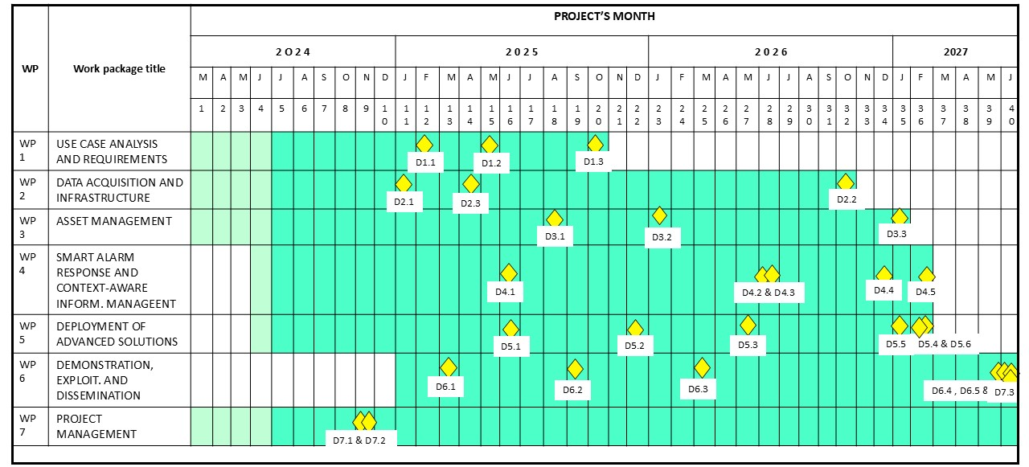

Business opportunities
The PROFIT project proposes solutions for various applications in the healthcare sector:
- AI-enabled solutions for operational efficiency and support to medical professionals;
- Compute platforms and QA frameworks for AI deployment in clinical practice;
- Asset tracking and diagnostic equipment sterilization;
- Clinical alarm management;
- Context-aware information management;
- Digital home care and integrated care;
- New user interfaces and interaction tools (voice-based, voice bots, intuitive dashboards) and integration of voice data into EHR systems;
- AI-aided management of clinical documentation and its enrichment through innovative speech-to-text solutions.

The business opportunities are very promising; here below we report few notes on some of the above mentioned market segments.

- Artificial intelligence in healthcare
The global market of AI-enabled solutions for healthcare applications is expected to grow with an impressive 48% CAGR from 2023 (21 BUS$) to 2029 (148 BUS$).
This expectation is based on the currently poor penetration of AI in healthcare (AI is used only in 5 to 10% of hospitals) and ,on the contrary, the plan of more than 50% of the worldwide hospitals to integrate AI-based solutions in the coming years.
There are still some challenges such as data privacy regulations (GDPR in Europe, HIPAA in U.S.A.) and data security concerns, lack of standards and low level of interoperability, lack of transparency, complexity and costs in the process of getting regulatory approval for AI medical solutions.

- Alarm management and context aware information management
The global alarm management market will reach 5.4 BUS$ in 2028; in the period 2023-2028 a CAGR of 14.5% is expected. The nurse care systems represent the greatest segment.
Analysts expect advances in areas such as the prioritization of the alarms based on the analysis of context, the acquisition of voice-based data, speech-to-text and integration into EHR, AI-assisted generation of clinical data summaries. All these topics are among the topics addressed by the PROFIT project.

- Asset tracking
At a worldwide level, the asset tracking market in the healthcare domain is expected to grow to 92 BUS$ in 2030 with a CAGR of 23% from the 14 BUS$ reported in 2021.
The RFID segment represents the 40% of the market, while the RTLS and the other technologies segments report a share of 30% each.

- Digital home care
The global market is expected to reach a value of 213 BUS$ in 2033 by growing with a CAGR of 29% from the 2023 value of 16.8 BUS$.
Main segments are: remote monitoring & outpatient care, preventive healthcare, personalized services delivery.

- Healthcare consulting services
In the period 2018-2026 the market will grow with a CAGR of 9.8% by reaching 19.6 BUS$ in 2026 (in 2018 a value of 7.5 BUS$ was reported).

The PROFIT consortium brings together multiple partners capable to commercialize the project’s results:

Barco (Belgium) already has a strong presence in the medical market through its visualization solutions and its Nexxis Digital Operating Room solution widely accepted in the surgical market. Through PROFIT, Barco has the opportunity to further extend its product portfolio, by adding a QA framework solution for a safe, reliable and regulatory-compliant deployment of AI algorithms in healthcare. For the company this is very strategic because it means that Barco will go beyond offering a pure visualization solution and enter the business of appliances and deployment platforms for healthcare (AI) algorithms. The product will be combined with a compute platform and this will be more than merely adding a new product.

Televic Healthcare (Belgium) will enhance its AQURA care platform by adding new solutions and services that enable smart alarm response based on contextual data, enriched communication and optimized care workflow for nursing staff. The project’s results in the area of smart alarming and context-aware information management will allow Televic Healthcare to introduce in the hospital market, AQURA 2.0 and will strengthen TELEVIC position in that segment. To profit from the growing market size of clinical alarm management, a smart alarm response solution lowering staff burden will be a key competitive advantage.

Wiseware (Portugal) is a strong player in the RTLS business, developing wearable sensors focused on indoor and outdoor location tracking with real-time human posture analysis (GAIT) already used in healthcare applications. Thanks to PROFIT, Wiseware will improve and extend its portfolio of indoor/outdoor location devices and will enable non-RTLS enabled devices to operate as part of the RTLS ecosystem, e.g., laboratory hyperspectral imaging, vision cameras and battery-less systems to operate without maintenance intervention during the lifetime of the assets to track.

Mediconsult (Finland) is one of the leading providers in Finland of IT solutions for health and social care. As a provider of holistic Health and Social care IT solutions (e.g. the SAGA solution), Mediconsult will be able to offer new automated workflow tools to reduce the burden of healthcare professionals in different patient processes. This will also open new market opportunities abroad.

Oiva Health (Finland) is a market leader in developing and providing digital wellbeing services. Through its cross-European presence, the company provides a user friendly, secure and mission critical platform for the public and private health- and social care sectors and enables all forms of communication between patients and professionals at the hospital and in home care. The PROFIT results will allow Oiva Health to enlarge its offering of out-patient services and realize the digitalization of the patient pathways by integrating hospital’s and home care.

SOLITA (Finland) is a fast-growing Mid-cap digital transformation company with about 1800 professionals and over 200 M€ turnover. Solita strongly focuses on strategic consulting, service design, software development, AI, data, and cloud. Regulated, agile medical software development at Solita is branded RegProof™, whereas the more widely known RegOps methodology is discussed in scientific publications. Solita develops information systems capable of intelligent patient journey orchestration.

https://doi.org/10.1016/j.pmedr.2018.10.008
https://ec.europa.eu/eurostat/statistics-explained/index.php?title=Healthcare_expenditure_statistics
https://www.weforum.org/agenda/2022/01/health-care-nurses-attrition-mental-health-burnout/
https://www.nursingtimes.net/archive/nurses-waste-an-hour-a-shift-finding-equipment-10-02-2009/
https://www.philips.com/a-w/about/news/archive/case-studies/20180315-early-warning-score-reduces-incidence-of-serious-events-in-general-ward.html

