D6.2 Exploitation Reports

Table of Content

1 Objectives 4
2.3 Exploitation Mechanisms 6
2.4 Partner Exploitation Plans 6
3 Outcomes and Impact 8

EXECUTIVE SUMMARY

This deliverable presents the exploitation activities and plans developed within the TiDiT project by all consortium partners. It outlines how the project’s results, tools, and methodologies are being transformed into exploitable assets and commercial offerings. The focus of exploitation within TiDiT is to ensure sustainability beyond the project lifetime through product integration, commercialization, and community building around the Timeline-Driven Digital Twin (DTaaS) platform.

Objectives

The objectives of Deliverable D6.2 were to:
- Identify exploitable results emerging from the TiDiT project.
- Define short-, mid-, and long-term exploitation strategies for each partner.
- Establish a roadmap toward market introduction and industrial adoption.
- Ensure sustainability of the TiDiT platform and its components beyond the project duration.
- Strengthen Europe’s position in digital twin technologies through collaboration and standardization efforts.
All objectives were successfully met, with measurable results in both commercial and collaborative domains.

- Exploitation Framework

The TiDiT exploitation strategy was developed across three complementary levels:

- Partner-level exploitation:
Each partner analyzed its own exploitable outcomes (software components, algorithms, architectures, training materials) and defined specific business plans for integration into existing or new commercial products.

- Consortium-level exploitation:
Common assets such as the TiDiT core platform, APIs, SDK, and reference documentation were identified as shared exploitable results. These form the foundation for a coordinated roadmap toward industrial adoption and community building.

- Open ecosystem and standardization:
TiDiT promotes interoperability and openness through semantic standards (FMI, FMU, SAREF, WoT). The consortium is committed to sustaining and extending the platform under open-source or hybrid models to encourage third-party development and uptake.

2.2 Exploitation Roadmap
Short-Term (0–12 months after project end)
- Public release of the TiDiT core components (APIs, SDK, documentation).
- Launch of pilot extensions in the Smart Manufacturing and Elderly Care domains.
- Organization of demonstration events, webinars, and technical showcases targeting early adopters.
- Establishment of the TiDiT Community Portal to support third-party developers.

Mid-Term (12–24 months)
- Integration of TiDiT components into partners’ commercial portfolios (e.g., HICAMP by INNOVA, SkywaveIoT, BITES digital transformation platforms).
- Commercialization of consultancy and training services for clients adopting digital twin solutions.
- Expansion of the TiDiT Marketplace for add-ons, data analytics modules, and simulation services.
- Publication of anonymized datasets for research reuse and collaboration.







Long-Term (24+ months)
- Formation of a TiDiT Alliance connecting European SMEs, universities, and industry partners.
- Extension of the platform toward new sectors such as energy, logistics, and urban planning.
- Establishment of a self-sustaining business model through subscription-based DTaaS services, certification, and marketplace revenues.

2.3 Exploitation Mechanisms

- DTaaS Commercial Model: Tiered subscription plans (basic, professional, enterprise) allowing clients to access cloud-based digital twin capabilities on demand.
- Consulting and Integration Services: Custom deployments, ontology mapping, and domain-specific extensions offered by consortium partners.
- Training and Certification: Professional courses to ensure adoption and capacity building for industrial and academic users.
- Marketplace for Add-Ons: Revenue-sharing model enabling third-party developers to publish and monetize TiDiT-compatible modules.
- Open-Source Access: Release of selected base components under a permissive license to stimulate innovation and ecosystem growth.

2.4 Partner Exploitation Plans

Caretronic d.o.o. (CRT – WP6 Lead)
Caretronic integrates TiDiT outcomes within its Elderly Care use case, applying digital twin models to streamline healthcare documentation, automate monitoring, and enhance patient safety. Through its international distributor network in over 40 countries, CRT plans to commercialize TiDiT-based modules in collaboration with telecom providers and healthcare institutions. A business model for integrating TiDiT services into CareSense and SeniorCarePro product lines has been defined, ensuring market continuity and revenue generation post-project.

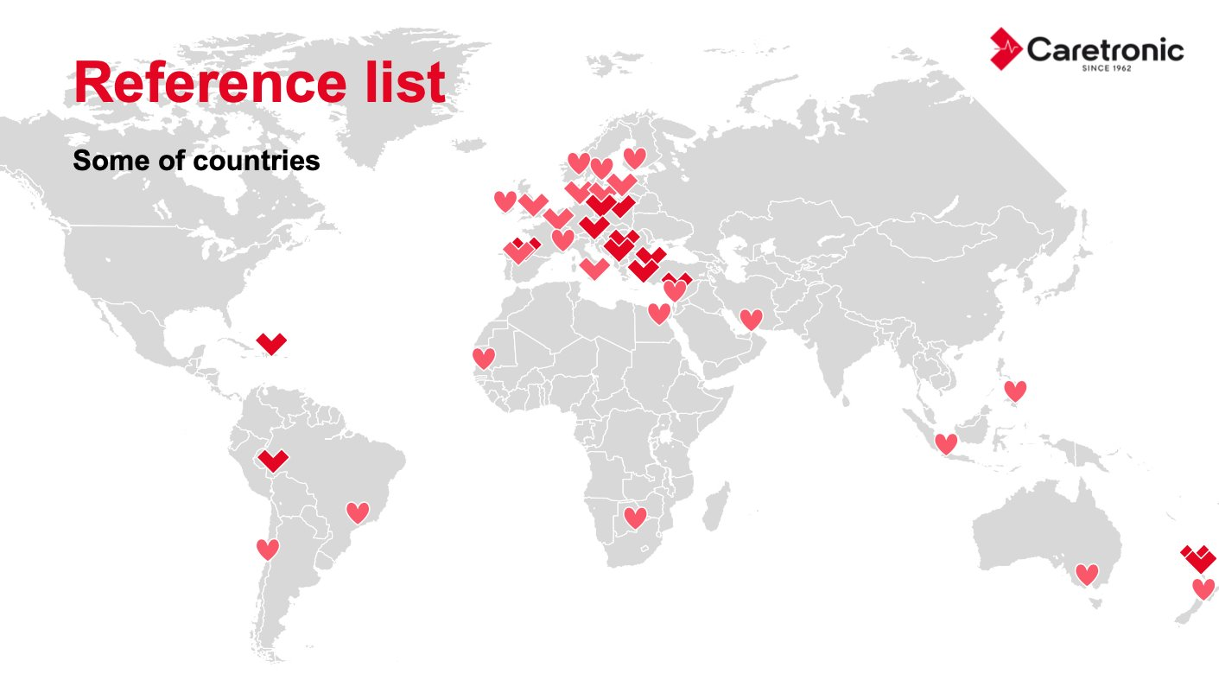

BITES (Turkey)
BITES will integrate TiDiT’s modular DTaaS architecture into its digital transformation portfolio, extending simulation, predictive maintenance, and AI analytics capabilities. The company plans commercial DTaaS offerings leveraging TiDiT’s open-source foundation, focusing on manufacturing, defense, and smart infrastructure sectors. BITES will also adapt TiDiT’s AI and Edge microservices into deployable modules compatible with its proprietary platforms and continue exploiting results through participation in new ITEA and Horizon Europe projects.

INNOVA (Turkey)
INNOVA will exploit TiDiT through its Health Integrated Campus (HICAMP) middleware and smart manufacturing solutions. TiDiT technology will be integrated into predictive maintenance, energy efficiency, and process optimization services. INNOVA also secured a commercial contract with a major telecom operator to deploy TiDiT outcomes in real-world network monitoring scenarios. The company intends to reuse TiDiT as a baseline platform for future EU projects and consultancy services across telecommunications, energy, and healthcare sectors.

Bewell (Italy)
Bewell plans to leverage TiDiT’s timeline-driven digital twin capabilities in its industrial and simulation service offerings, particularly in biomedical and aerospace applications. It will integrate TiDiT modules into its existing simulation frameworks and collaborate with European R&D programs to extend adoption.

Alpata (Turkey)
Alpata focuses on industrial customization of TiDiT modules for smart manufacturing and production optimization. The company will exploit TiDiT’s predictive modeling and residual stress simulation features within its industrial software solutions.

SkywaveIoT (Italy)
SkywaveIoT will use TiDiT to enhance its IoT and analytics platforms, integrating semantic interoperability and predictive modules derived from TiDiT architecture.

Outcomes and Impact
Deliverable D6.2 – Exploitation Reports provides a comprehensive overview of the consortium’s collective and individual strategies for transforming TiDiT project results into sustainable, market-ready products and services. Through the development of a structured exploitation roadmap, the project has successfully bridged the gap between research outcomes and commercial applications. Each partner has defined a clear exploitation pathway, aligning technological achievements with real-world market needs across key domains such as healthcare, manufacturing, defense, and smart infrastructure.
The TiDiT platform, built around the concept of Timeline-Driven Digital Twins (DTaaS), has been strategically positioned for long-term sustainability through a combination of open-source access, modular commercialization, and subscription-based service models. This hybrid exploitation approach enables flexibility in adoption, supports scalability across industries, and promotes the creation of an open European ecosystem for interoperable digital twin solutions.
The consortium’s coordinated exploitation actions have resulted in strengthened technological innovation, cross-domain integration, and market visibility, ensuring that the project’s outcomes will continue to generate impact beyond its lifetime. TiDiT not only supports partner growth but also contributes to broader European objectives in digital transformation, industry 4.0, and smart data-driven decision-making.
Key outcomes and impacts include:
- A comprehensive exploitation roadmap that ensures the long-term sustainability of TiDiT results.
- Integration of TiDiT components into commercial products and services across multiple partners and sectors.
- Increased market readiness for timeline-driven digital twin technologies in healthcare, manufacturing, and defense.
- An established framework for continuous collaboration, training, and standardization, supporting future innovation.
- A significant contribution to Europe’s leadership in the development and adoption of semantic, interoperable digital twin platforms.
Collectively, these achievements demonstrate that TiDiT has evolved beyond a research project into a sustainable innovation ecosystem, capable of driving continued value creation, industrial competitiveness, and technological excellence across Europe and beyond.

