D6.1 Communication Materials and Project Website

Table of Content

1 Objectives 5
2.1 Visual identity and branding 6
2.3 Project website 7
2.4 Maintenance Plan 8
3 Outcomes 9

EXECUTIVE SUMMARY

This deliverable describes the development and launch of the project’s visual identity, communication materials, and official website. These tools provide a coherent and recognizable brand for the project and serve as the primary channels for sharing information with stakeholders, partners, and the wider public.
The overall goal of D6.1 is to ensure consistent project visibility, facilitate knowledge dissemination, and create a strong foundation for future exploitation and stakeholder engagement activities.

Objectives

The objectives of Deliverable D6.1 were fully achieved as planned. The main goals focused on establishing a consistent and professional project identity, ensuring effective communication within the consortium, and enabling public visibility of project activities and results. The outcomes corresponding to each objective are summarized below:
Establish a unified and professional visual identity for the project:
A complete visual identity package was created, including the project logo, color palette, typography, and graphic templates. These elements were applied consistently across all communication materials, ensuring a coherent and recognizable brand image for the project.
Develop core communication materials for use by all partners:
Standardized templates for PowerPoint presentations, Word documents, reports, and posters were developed and distributed to all consortium members. These materials support consistent messaging and professional presentation of the project at events, conferences, and meetings.
Design and launch the official project website:
The official project website was designed, developed, and launched within the planned timeframe. It serves as the central online platform for public information, news, and access to project deliverables. The website is regularly updated with news, partner activities, and dissemination materials.
Enable online dissemination of project updates, results, and public deliverables:
The website, combined with social media channels facilitates continuous dissemination of project results and announcements. Partners regularly contribute updates, ensuring that the broader community and stakeholders are informed about the project’s progress and impact.
Ensure alignment with the communication strategy and visual guidelines:
All materials and communication activities have been developed in accordance with the project’s communication plan and visual identity guide. This ensures consistency across all dissemination channels and reinforces the project’s professional image.

- Implemented Activities

2.1 Visual identity and branding
A strong and consistent visual identity is essential to ensure recognizability and professional presentation of the project in all communication and dissemination activities. During the initial phase of the project, a complete branding package was developed to support both internal and external communication efforts across all partners.

Creation of the project logo and visual style guide:
The project logo was designed to reflect the project’s vision and technological focus. The design process included several iterations and consultations with project partners to ensure alignment with the consortium’s expectations and the overall thematic orientation of the project.
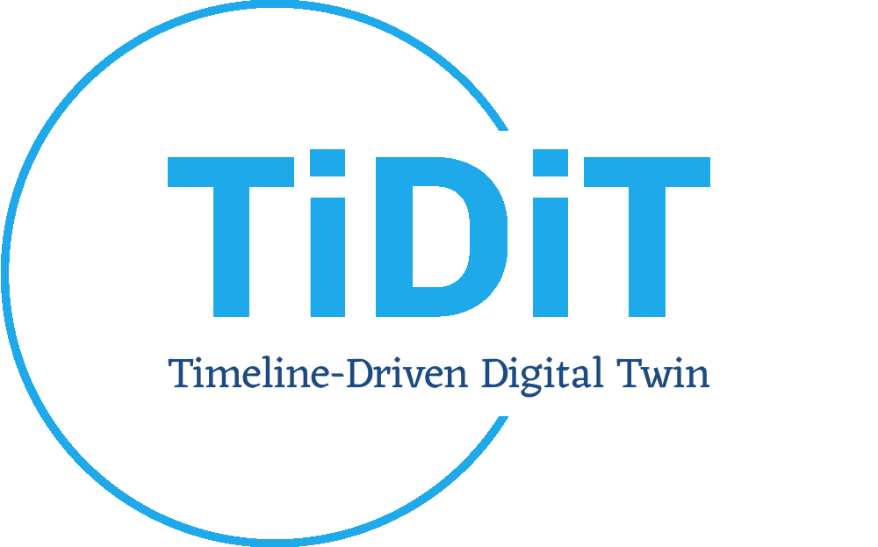
A comprehensive visual style guide was created, defining the use of the logo, project color palette, typography, and layout standards. The guide ensures that all visual materials (print and digital) maintain a uniform appearance and support a professional and coherent image across all dissemination channels.

Preparation of templates for communication materials:
To facilitate consistent communication, standardized templates were prepared for:
- PowerPoint presentations, used in project meetings, conferences, and public events,
- Word document templates, used for reports, deliverables, and letters,
- Poster templates, for events, fairs, and workshops.

These templates incorporate the project logo, color scheme, and partner logos, ensuring that all project-related materials are visually aligned and immediately recognizable. The templates were shared via the project’s shared workspace (e.g., SharePoint or Google Drive) and are actively used by all partners.

Development of a press kit:
A press kit was prepared to support the dissemination of project information to external audiences. The kit includes:
- A high-resolution logo package (color and monochrome versions, raster and vector formats),
- A short standardized project description (for media use and partner websites)
- A one-page project factsheet summarizing key objectives, expected results, and consortium composition.
The press kit enables partners to easily promote the project in their respective communication channels while maintaining a unified and professional presentation.
The established visual identity and branding framework have significantly contributed to the project’s recognizability and professional visibility. The visual assets and templates are actively used in all internal and external communications, ensuring a coherent image of the project throughout its duration.

2.2 Communication Materials
A comprehensive set of communication materials was designed and produced to ensure professional and consistent promotion of the project across all dissemination channels. Digital brochures and flyers were developed to present the project’s objectives, consortium, and expected impact in a clear and visually appealing manner, available in both print-ready and web-optimized formats for easy distribution via email, newsletters, and social media. Unified PowerPoint presentation templates were created for partner use at meetings, conferences, and public events, ensuring visual alignment with the established project branding.
An initial press release and a concise project overview document were prepared to announce the project launch and introduce its goals to external audiences, enabling partners to publish harmonized information on their institutional websites and platforms. To support physical visibility, professional banners and roll-up posters were designed for use at conferences, fairs, and workshops, effectively showcasing the project’s identity and key messages. Collectively, these materials established a coherent communication foundation that enhances project visibility, strengthens stakeholder engagement, and ensures consistent representation across all partners and communication formats.

2.3 Project website

Domain registration and hosting setup: https://tidit.net/

The project website www.tidit.net was designed and developed as a modern, responsive, and multilingual platform, accessible from both desktop and mobile devices to ensure a wide reach and user-friendly experience. The website serves as the central public communication channel for presenting the project’s vision, activities, and outcomes. It features key sections including About the Project, Consortium, Objectives, News & Events, Publications, and Contact, each structured to provide clear and engaging information to different stakeholder groups such as researchers, industry partners, and the general public. The site is integrated with the project’s official social media channels, enabling dynamic sharing of news, events, and updates while ensuring a coherent online presence across multiple platforms. To enhance visibility and search performance, comprehensive SEO optimization was implemented, supported by keyword targeting and metadata configuration. Additionally, analytics tools such as Google Analytics and Matomo were integrated to monitor website traffic, user behavior, and overall outreach effectiveness. The website launch was announced across all partner communication channels — including institutional websites, newsletters, and social media — ensuring immediate visibility and engagement from both project partners and the wider community. It continues to be regularly updated with project milestones, deliverables, and dissemination outputs, providing a living showcase of the project’s progress and impact.

2.4 Maintenance Plan

A structured maintenance plan was established to ensure the long-term functionality, relevance, and accuracy of the project website and its content. The WP6 lead is responsible for coordinating monthly content updates, which include adding news, announcements, and progress reports related to project milestones, dissemination activities, and upcoming events.

All project partners actively contribute by providing relevant materials such as news articles, event participation summaries, publications, and visual content to maintain a dynamic and continuously evolving online presence. This collaborative approach ensures that the website reflects the most recent achievements and remains a reliable communication hub for both stakeholders and the general public.

In addition, technical maintenance, server hosting, and system updates are fully managed by Turkish partners guaranteeing stable operation, security, and compliance with accessibility and data protection requirements. Regular monitoring, backup, and software updates are performed to ensure optimal performance and minimize downtime. This maintenance plan provides a sustainable framework for keeping the project website operational, up-to-date, and aligned with the project’s overall communication and dissemination objectives throughout its lifecycle and beyond.

Outcomes

The implementation of Deliverable D6.1 resulted in several tangible and measurable outcomes that have significantly strengthened the project’s visibility and professional image. A fully functional and publicly accessible project website was successfully developed and launched, serving as the central hub for communication, dissemination, and engagement with stakeholders.
A comprehensive visual identity was created, including the project logo, design guidelines, and branded templates, ensuring a consistent and recognizable presentation across all communication materials and partner activities. A complete set of promotional and dissemination materials—such as brochures, flyers, press releases, banners, and roll-ups—was produced and made available to all consortium members to support outreach and participation in events, conferences, and exhibitions.
Collectively, these efforts have led to enhanced online visibility and broader awareness of the project’s objectives, technological innovations, and consortium activities within the research and industrial communities. The deliverable thus provided a strong foundation for all subsequent communication and dissemination activities under WP6, ensuring that the project is represented consistently, professionally, and effectively across all channels.

