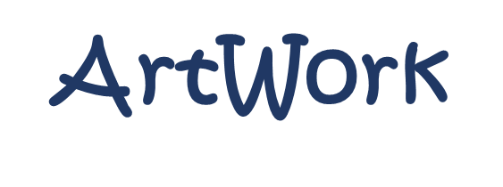
SMART AND CONNECTED WORKER

ITEA 4 – 22019
Work package 2
Smart Digital Twins of Tools, Equipment and Worker

Deliverable 2.3
Database of Smart Digital Workers
Document type  Document version  Document Preparation Date  Classification  Contract Start Date  Contract End Date | : Deliverable  : 1.0  : 29.12.2025  : public  : 2024-03-01  : 2027-02-28


Final approval | Name | Partner
Review Task Level | André Antakli | DFKI
Review WP Level | Mohid | AtlasCopco
Review Board Level | Thomas Bär | DAIMLER

Executive Summary

Content

1 Introduction 2
2 BaSyx-based AAS-Database for Tools 3
2.1.1 Overview 4
2.1.2 Functional description 7
2.1.3 Quick start guide 8

Introduction
In this document, we describe a database implemented with the BaSyx system for maintaining and managing AAS-based digital twins. As an example for workers, we introduce an AAS for a screwdriver.

BaSyx-based AAS-Database for Tools
Screenshot | 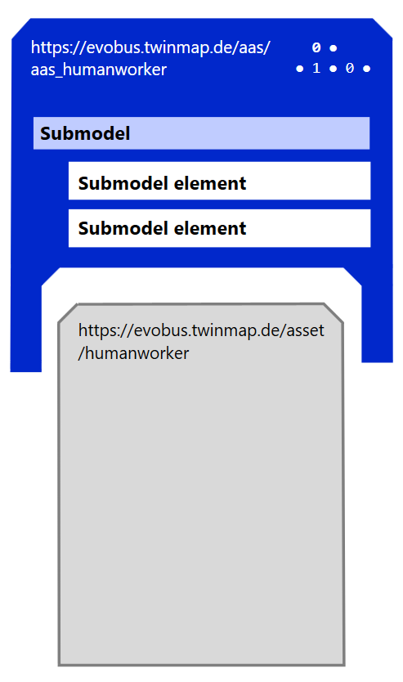
Provider/developer | TWT, DFKI
Contact person | Johannes Iglhaut (TWT), André Antakli (DFKI)
License | - BaSyx Database: MIT  - Worker AAS: (?)  The AAS worker is currently undergoing a standardization process; until then, the digital model for workers may not have been published outside the consortium.
Software type | Service (standalone)
Programming languages | - AAS  - Java  - Python  - C++
Tool web page | - https://wiki.basyx.org/en/latest/index.html  - https://github.com/eclipse-basyx  - https://industrialdigitaltwin.org/en/content-hub/submodels
Source code repository | - https://github.com/eclipse-basyx  - https://industrialdigitaltwin.org/en/  - https://github.com/admin-shell-io/submodel-templates/tree/main/published  - https://github.com/twt-gmbh (place of future publication)
Requirements | 2 GB memory, 3 GB storage space
Target platform | Cross-platform

Overview
Asset Administration Shell Overview: The Asset Administration Shell (AAS) is the standardized digital representation of an asset and forms the core concept of the industrial digital twin as defined and promoted by the Industrial Digital Twin Association. An asset in this context can be a physical object such as a machine, device, component, or plant, but also a non-physical entity such as software, documentation, or services. The AAS provides each asset with a unique, standardized digital identity and acts as the semantic and technical interface between the asset and the digital world, enabling consistent and interoperable communication across systems, organizations, and lifecycle phases. At its foundation, the AAS is based on a technology-independent metamodel that defines the structural elements, relationships, and semantics used to describe an asset digitally. This metamodel ensures that asset data is represented in a uniform way, regardless of the underlying IT systems or vendors. The AAS itself contains identification information for the asset and references all relevant digital content that describes it. Rather than storing all information in an unstructured form, the AAS organizes asset data into so-called submodels. Each submodel represents a specific aspect of the asset, such as nameplate information, technical characteristics, operational parameters, maintenance data, documentation, software information, or lifecycle and sustainability data. This modular approach allows different stakeholders to access exactly the information they need while maintaining semantic consistency.
The IDTA defines detailed specifications that describe how the AAS is structured and how it can be implemented in practice. These specifications include the definition of the metamodel, standardized application programming interfaces for accessing and interacting with AAS instances, rules for semantic data description based on IEC 61360, security concepts for protecting AAS data, and a standardized package format known as AASX. The AASX format enables the complete exchange of an Asset Administration Shell, including its submodels and associated files, in a single portable container. This makes it possible to transfer digital twins easily across company boundaries, engineering tools, and IT platforms. The primary value of the Asset Administration Shell lies in interoperability and lifecycle integration. By providing a common semantic language for asset data, the AAS enables seamless data exchange from engineering and manufacturing through operation, maintenance, and decommissioning. It supports Industry 4.0 use cases such as automated commissioning, condition monitoring, predictive maintenance, digital services, supply chain transparency, and the integration of AI-based applications. Because the AAS standardizes both structure and meaning, systems can interpret asset data automatically without the need for manual mapping or proprietary interfaces.
In summary, the Asset Administration Shell is the standardized digital twin framework that gives assets a consistent digital identity, structures all relevant information in interoperable submodels, and enables secure, lifecycle-wide data exchange. Defined and maintained by the IDTA, it is a key enabler for scalable digitalization, cross-company collaboration, and data-driven value creation in modern industrial ecosystems.
Worker AAS-Example: The AASX file shown in Figure 1 represents a human worker as an asset within an Asset Administration Shell, following AAS metamodel version 3.0. The AAS models the worker as a digital human twin, combining personal, physical, qualification, capability, and ergonomic information with detailed kinematic and spatial data. Unlike a typical technical asset, this AAS focuses strongly on human-related submodels. It includes a detailed skeleton and posture representation, describing joints, limbs, and their spatial positions and orientations using coordinates and quaternions. This allows the worker to be integrated into simulations, ergonomic analyses, or human–machine interaction scenarios. In addition, the AAS defines geometric properties such as bounding boxes, coordinate systems, and length units, which are relevant for layout planning and digital factory models. Beyond physical representation, the AAS also contains personal and organizational information, such as age, nationality, language skills, work history, qualifications, and authorizations. Further submodels describe skills, task experience, preferences, and physical strain limits, enabling use cases like task assignment, workstation matching, capability-based planning, or occupational safety assessments. The worker is therefore modeled as an active, skill-bearing asset rather than a passive resource. Overall, this AASX provides a comprehensive digital twin of a worker, suitable for advanced Industry 4.0 use cases such as human-centered production planning, ergonomic evaluation, skills-based scheduling, and digital workforce management.
Publication Status: The Worker AAS source code has not been published yet, as it is part of the ongoing IDTA standardization process. The repository will be made publicly available once the standard has been officially released. The Code will be published after the finished IDTA standardization process on https://github.com/twt-gmbh

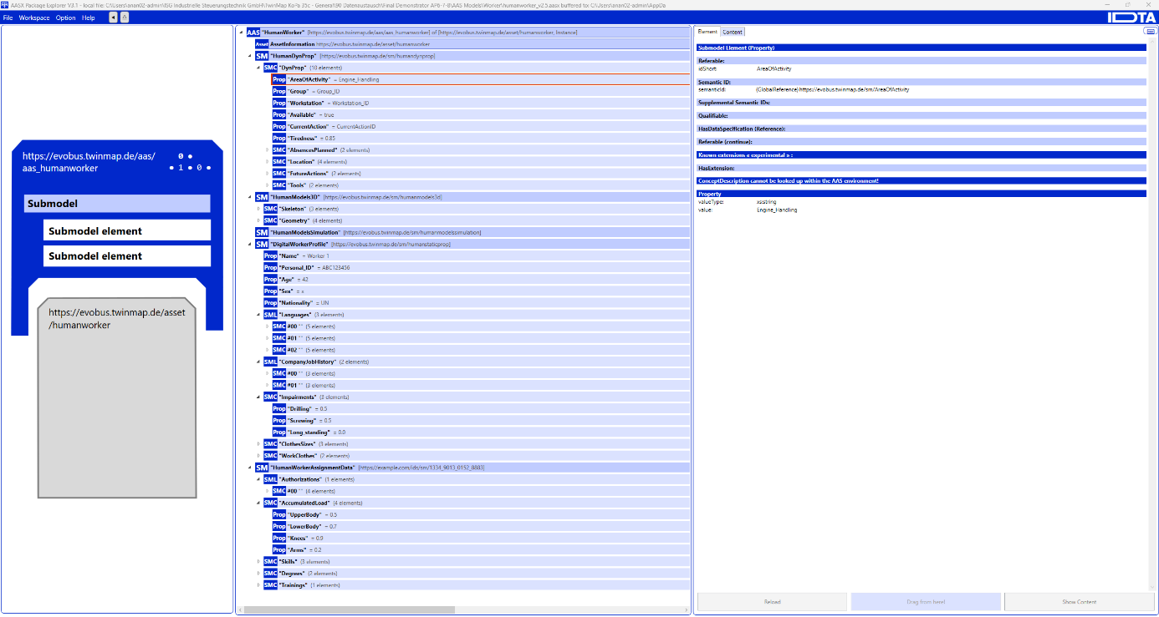
Figure 1: AASX of humanworker
Following, the main properties of said worker shell described using AAS are listed below:
1. Personal and identification properties
- Name: Worker 1
- Personal_ID: ABC123456
- Age: 42
- Sex: x
- Nationality: UN
2. Language skills
German
- Asset_ID: German_ID
- Reading: A2
- Listening: B1
- Speaking: A2
- Writing: A1
English
- Asset_ID: English_ID
- Reading: A1
- Listening: A2
- Speaking: A2
- Writing: A1
French
- Asset_ID: French_ID
- Reading: C2
- Listening: C2
- Speaking: C2
- Writing: C2
3. Employment history
- JobTitle: Maintenance Worker
  - Start: 01-01-1998
  - End: 31-10-2001
- JobTitle: Senior Maintenance Worker
  - Start: 01-11-2001
  - End: 30-06-2008
4. Skills and task capabilities
- Drilling: 0.5
- Screwing: 0.5
- Long_standing: 0.0
5. Anthropometric data
- Torso: 178
- Pants: 36
- Shoe: 43
6. Equipment and personal protective assets
Vest
- Asset_ID: Vest_ID
- State: Lightly Worn
- Received_on: 01/03/2023
- Rental_end: 31/03/2023
Shoes
- Asset_ID: Shoes_ID
- State: New
- Received_on: 15/03/2023
- Rental_end: 19/03/2023
7. Authorizations and certifications
- AuthName: Work_in_HazMat_Room
- Asset_ID: HazMat_room_clearance_ID
- Date_obtained: 01/08/2024
- Date_expires: 31/07/2025
8. Physical strain and ergonomic limits
- UpperBody: 0.5
- LowerBody: 0.7
- Knees: 0.9
- Arms: 0.2
9. Workstation knowledge and preferences
Workstation 1
- Knowledge_level: Skilled
- Count_performed_task: 1234
- Preference_level: 1
Workstation 1 (advanced)
- Knowledge_level: Expert
- Count_performed_task: 10023
- Preference_level: 3
Workstation 3
- Knowledge_level: Skilled
- Count_performed_task: 1234
- Preference_level: 2
10. Education and training
- Asset_ID: MidSchool_ID
  - Date_completed: 31/03/1996
- Asset_ID: Mechanic_ID
  - Date_completed: 31/08/1999
- Asset_ID: Security_ID
  - Date_first_completed: 31/03/1996
  - Data_renewal_due: 28/03/2026
11. Skeleton, posture, and geometry (summary)
- Joint positions (X, Y, Z)
- Joint orientations (X, Y, Z, W quaternions)
- Joint types (e.g. HeadJoint, LeftShoulder, RightElbow, LeftKnee, etc.)
- Parent–child joint relations
- Skeleton_length_unit: m
- BoundingBoxKind: MaxEnvelope
- Representation: PointCloud
- LengthUnit: m

In the interests of standardization and the use cases under consideration, we are focusing on the allocation of workers to workstations in the worker AAS:
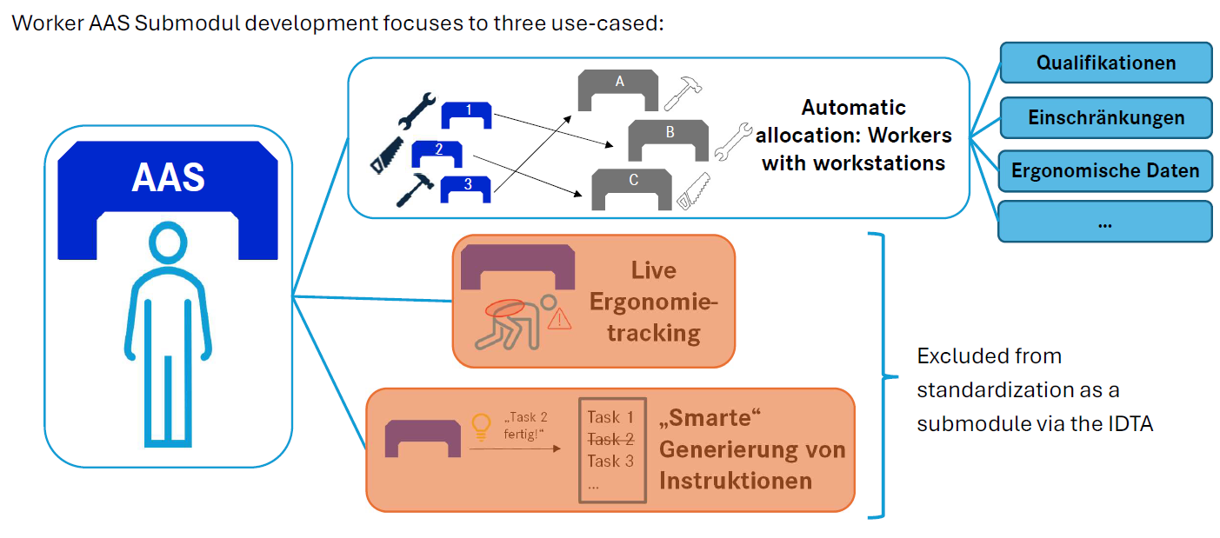
Figure 2: Main focus, worker-workstation-allocatino

The general structure of the AAS can be seen below:
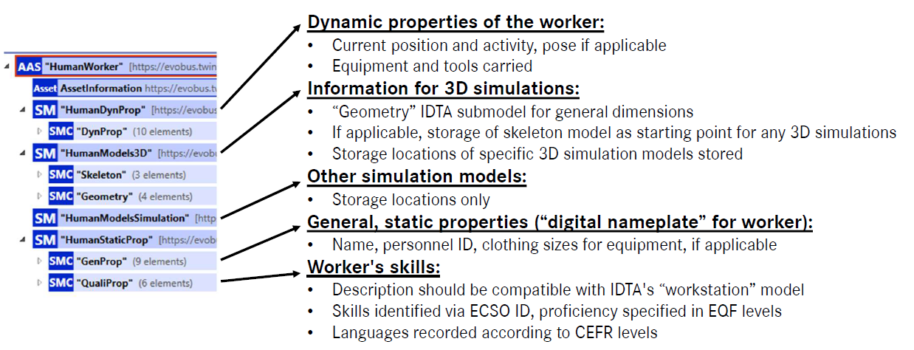
Figure 3: general structure

There are three main property classes of interest: static information about the worker, dynamic information about the worker, and the worker's qualifications, which are particularly important for assigning them to a workstation:

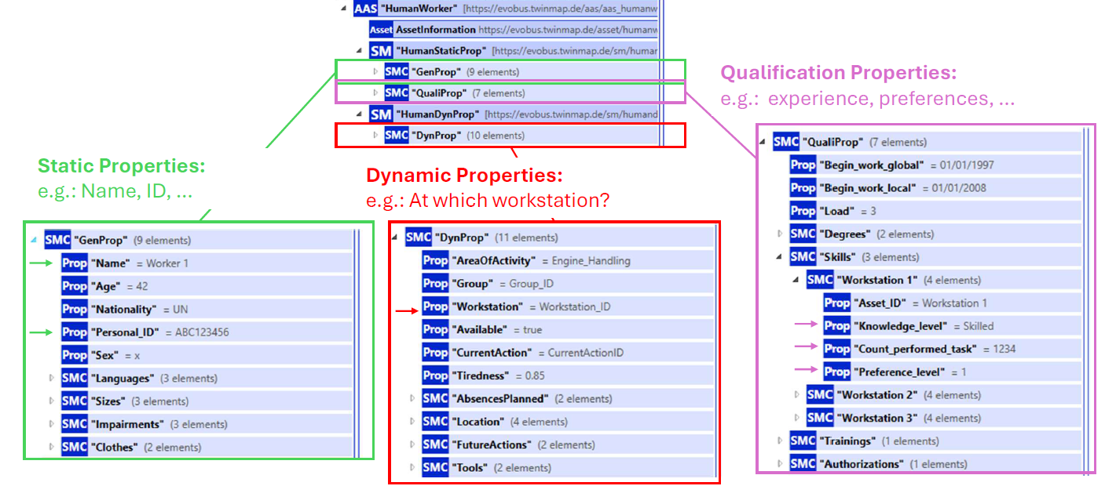
Figure 4: static, dynamic and qualification properties

For assigning workers to workstations, we adhered to the existing, standardized submodel “Worker Workstation Matching Data” (https://industrialdigitaltwin.org/en/wp-content/uploads/sites/2/2024/06/IDTA-02046-1-0_Submodel_WorkstationWorkerMatchingData.pdf):

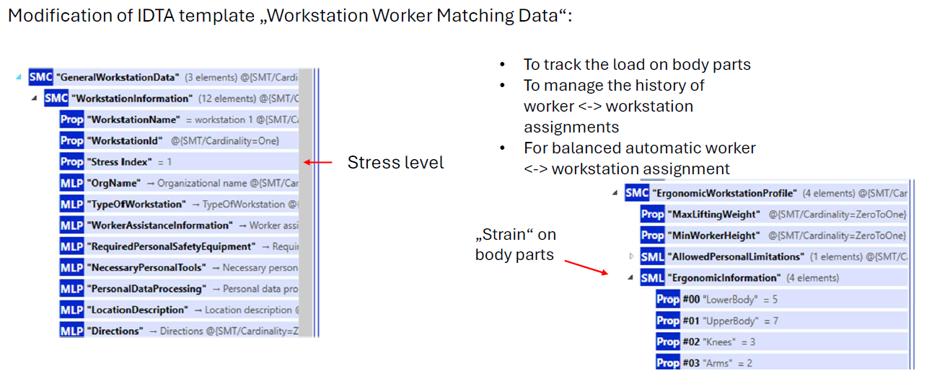
Figure 5: Integration and adaptation of IDTA submodel "Worker Workstation Matching Data”
To this end, adjustments have been and are being made in the course of the standardization process with the IDTA:

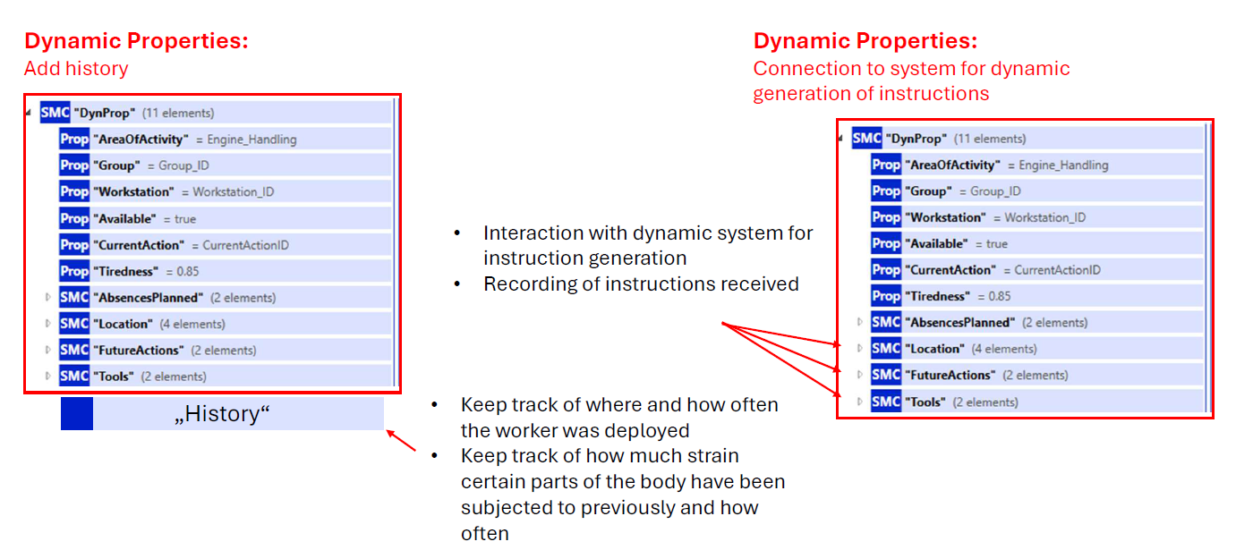
Figure 6: Work in Progress

The kickoff meeting (November 3, 2025) with the IDTA in TWT, where the idea of a worker AAS was presented, received an overwhelmingly positive response. A working group will now be set up, and the worker AAS will then be further refined and submitted for review:
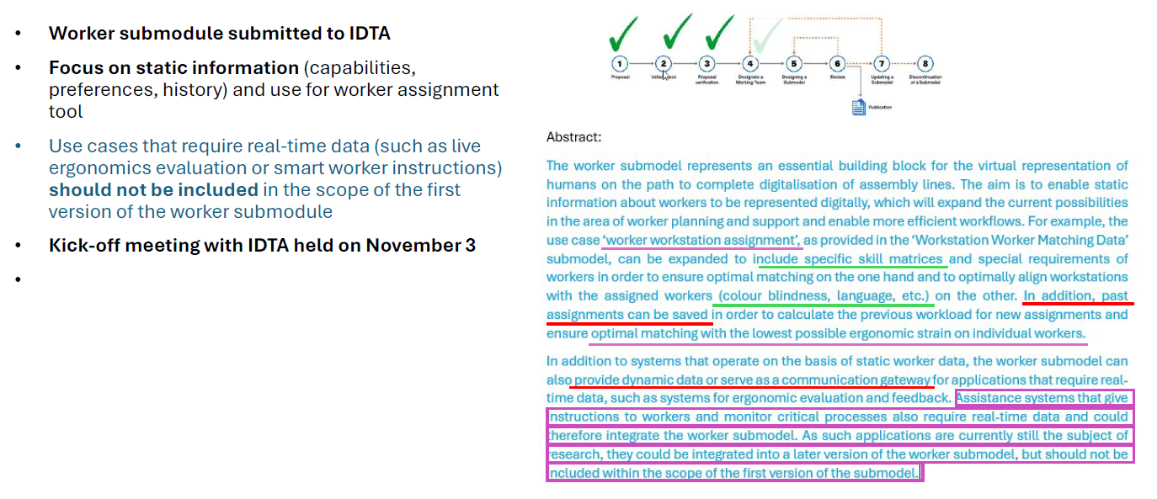
Figure 7: IDTA standardisation progress

To store and manage AAS files, we rely on the BaSyx system, which is an open-source software environment to host AAS files. It is used in ArtWork as our database for digital twins of tools, which is also hosted on Daimler Trucks server.
BaSyx System Overview: Eclipse BaSyx is an open-source middleware framework developed to support the realization of Industry 4.0 concepts in practical industrial environments. Its primary purpose is to enable the standardized digital representation of physical assets and to provide a runtime environment in which these digital representations can be managed, connected, and integrated into larger production systems. BaSyx is built around the concept of the Asset Administration Shell (AAS), which is defined by international standardization bodies as the digital twin of an asset. The motivation behind BaSyx arises from the increasing complexity and variability of modern production systems. Therefore, it allows machines, software systems, and services to communicate in a uniform and interoperable way, by introducing a middleware layer that decouples physical devices from higher-level applications under the use of AAS descriptions of the decoupled physical devices. This middleware provides standardized interfaces for accessing asset data, invoking operations, and discovering available services. Thus, production systems can be reconfigured more easily, devices can be replaced without extensive reprogramming, and new functionalities can be integrated dynamically. At its core, BaSyx follows a service-oriented and modular architecture, consisting of a set of reusable components that can be combined depending on the specific use case. These components can be deployed on embedded devices, industrial PCs, servers, or cloud platforms.
BaSyx Concepts and Architecture: The central concept in BaSyx is the Asset Administration Shell. An AAS represents an asset such as a machine, sensor, software module, or even an entire production line. It contains structured information about the asset, including identification data, technical properties, operational parameters, and offered functions. This information is organized into so-called submodels, each of which describes a specific aspect of the asset, for example its nameplate data, condition monitoring values, or energy consumption. BaSyx provides standardized APIs to access and manipulate AAS instances. These APIs are typically REST-based and follow the specifications defined for the Asset Administration Shell. In addition to the AAS itself, BaSyx includes registries that allow AAS instances and their submodels to be registered and discovered at runtime. From an architectural point of view is BaSyx a layered system: at the lowest level are the physical assets, such as machines and sensors, which may communicate using proprietary or fieldbus protocols; above lies the device or integration layer, where adapters or gateways translate device-specific data into standardized AAS representations; the middleware layer hosts the BaSyx components themselves, including AAS servers, registries, and communication services; on top of this, application-level components such as dashboards, analytics tools, or production planning systems can access the digital twins through standardized interfaces. BaSyx offers software development kits (SDKs) in several programming languages, including Java, C++, .NET, Python, and Rust. These SDKs provide ready-to-use libraries for creating AAS models, implementing servers and clients, and integrating BaSyx functionality into custom applications. BaSyx is also available as a stand-alone Docker container.
For a more detailed description of the BaSyx system, please refer to:
https://wiki.basyx.org/en/latest/content/introduction/basyx_explained.html

Functional description
Eclipse BaSyx is a modular Industry 4.0 middleware framework that implements the Asset Administration Shell (AAS) concept and provides standardized mechanisms for digital asset representation, communication, and integration. The core functional responsibilities of the system include:
- Asset Administration Shell Management: BaSyx provides runtime components for hosting, storing, and exposing Asset Administration Shells and their submodels. Each AAS represents a digital twin of a physical or logical asset and follows standardized AAS meta-models.
- Standardized Data Access and Operations: The system exposes REST-based APIs compliant with AAS specifications, enabling read and write access to properties, invocation of operations, and navigation of submodel structures.
- Submodel Handling: Functional aspects of assets are encapsulated in submodels, allowing modular description of identification data, technical parameters, operational status, and domain-specific information.
- Service and Asset Discovery: BaSyx includes AAS and submodel registries that enable dynamic registration and lookup of digital twins and their endpoints, supporting loosely coupled and reconfigurable system architectures.
- Interoperability and Integration: By adhering to standardized interfaces and data models, BaSyx enables interoperability between heterogeneous devices, software systems, and enterprise applications.
- Multi-Language SDK Support: The system provides software development kits in multiple programming languages, enabling developers to implement custom AAS servers, clients, and integration services.
- Configurable Middleware Deployment: BaSyx components are designed for flexible deployment in containerized, virtualized, or bare-metal environments and can be configured via environment variables to support scalable and automated installations.

Quick start guide
Setting Up Eclipse BaSyx
The setup of Eclipse BaSyx depends on the intended usage scenario, but for most technical evaluations, development environments, and even productive prototypes, a container-based deployment using Docker is the preferred and officially recommended approach. This method ensures reproducibility, simplifies dependency management, and closely resembles real-world industrial deployments.
System Requirements and Preparation: Before deploying BaSyx, the host system must provide a suitable runtime environment. A modern Linux distribution, Windows, or macOS can be used, provided that Docker is supported. The following software components must be installed:
- Docker Engine (version 20.x or newer)
- Docker Compose (v2 recommended)
- Git (optional, but required for source-based development)
- Java Development Kit 11 or newer (only required when building BaSyx components from source)
The installation can be verified using the command line:
service docker start
docker --version
docker compose version
If these commands return valid version numbers, the system is ready for deployment.

Quick Start Docker-Based Running of the BaSyx Environment: The Eclipse BaSyx AAS Environment is a core Eclipse BaSyx component that unifies Asset Administration Shell, Submodel, and Concept Description repositories to enable the creation, management, and access of AAS data within an Industry 4.0 ecosystem. The docker image for the basyx environment which contains all necessairy components to host AAS files can be downloaded from dockerhub and executed using the following prompt:
docker pull eclipsebasyx/aas-environment:2.0.0-SNAPSHOT-7cc2dfdsudo
docker run -p 8081:8081 eclipsebasyx/aas-environment:2.0.0-SNAPSHOT-7cc2dfdsudo
The Eclipse BaSyx AAS Environment acts as an aggregation component that combines the AAS Repository, Submodel Repository, and Concept Description Repository into a single containerized application. It provides the necessary infrastructure to manage and serve Asset Administration Shells, effectively acting as an AAS server for those components.
Key details regarding the AAS Environment:
- Components Included: It combines the AAS Repository, Submodel Repository, and Concept Description Repository.
- Functionality: It enables the creation, management, and retrieval of AAS, Submodels, and Concept Descriptions in one place.
- Implementation: It is available as a Docker image (e.g., eclipsebasyx/aas-environment), making it easy to deploy the server and repositories together.
- Interaction: While it manages repositories, it interacts with them for data access and storage.
After the BaSyx environment is running, we can upload an AASX file with the following cmd:
curl -X POST "http://localhost:8081/upload" -H "accept: */*" -H "Content-Type: multipart/form-data" -F "file=@humanworker_v2.5.aas"
In the example cmd, we are uploading the AAS example previously presented. To access now all shells and submodel we can run the following cmd:
curl http://localhost:8081/shells
curl http://localhost:8081/submodels
Or access it via a web browser like presented below:
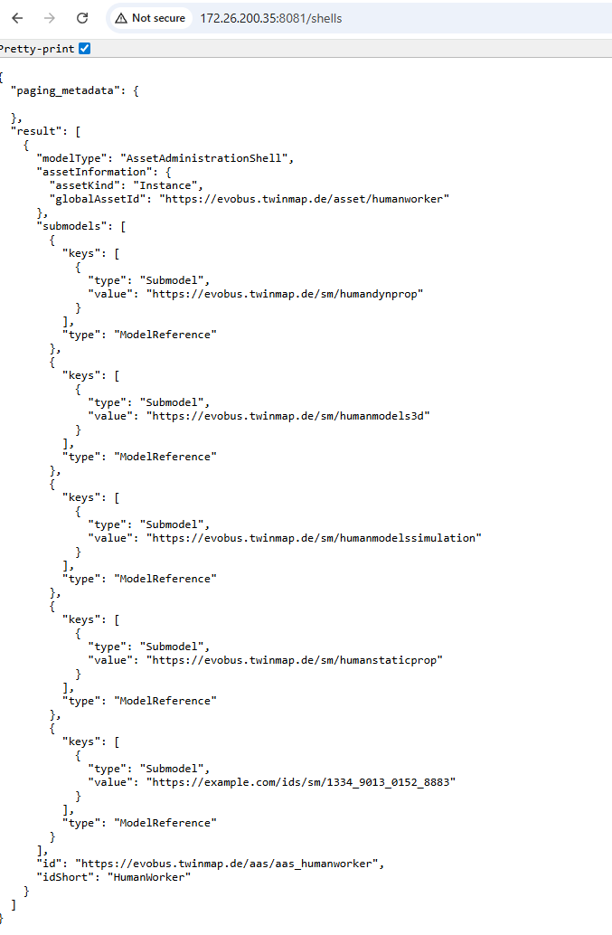
Figure 9: List of all AAS Shells

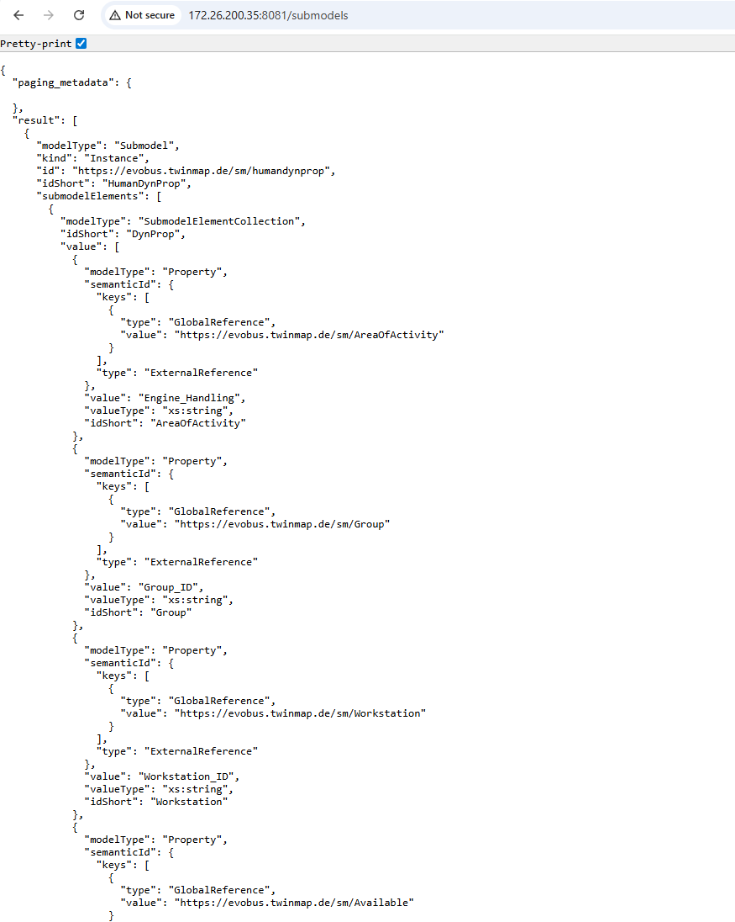
Figure 10: List of all Submodels

To access all REST endpoints of the BaSyx system we can call the root of that server: http://localhost:8081/, providing us with all possible calls via Swagger:
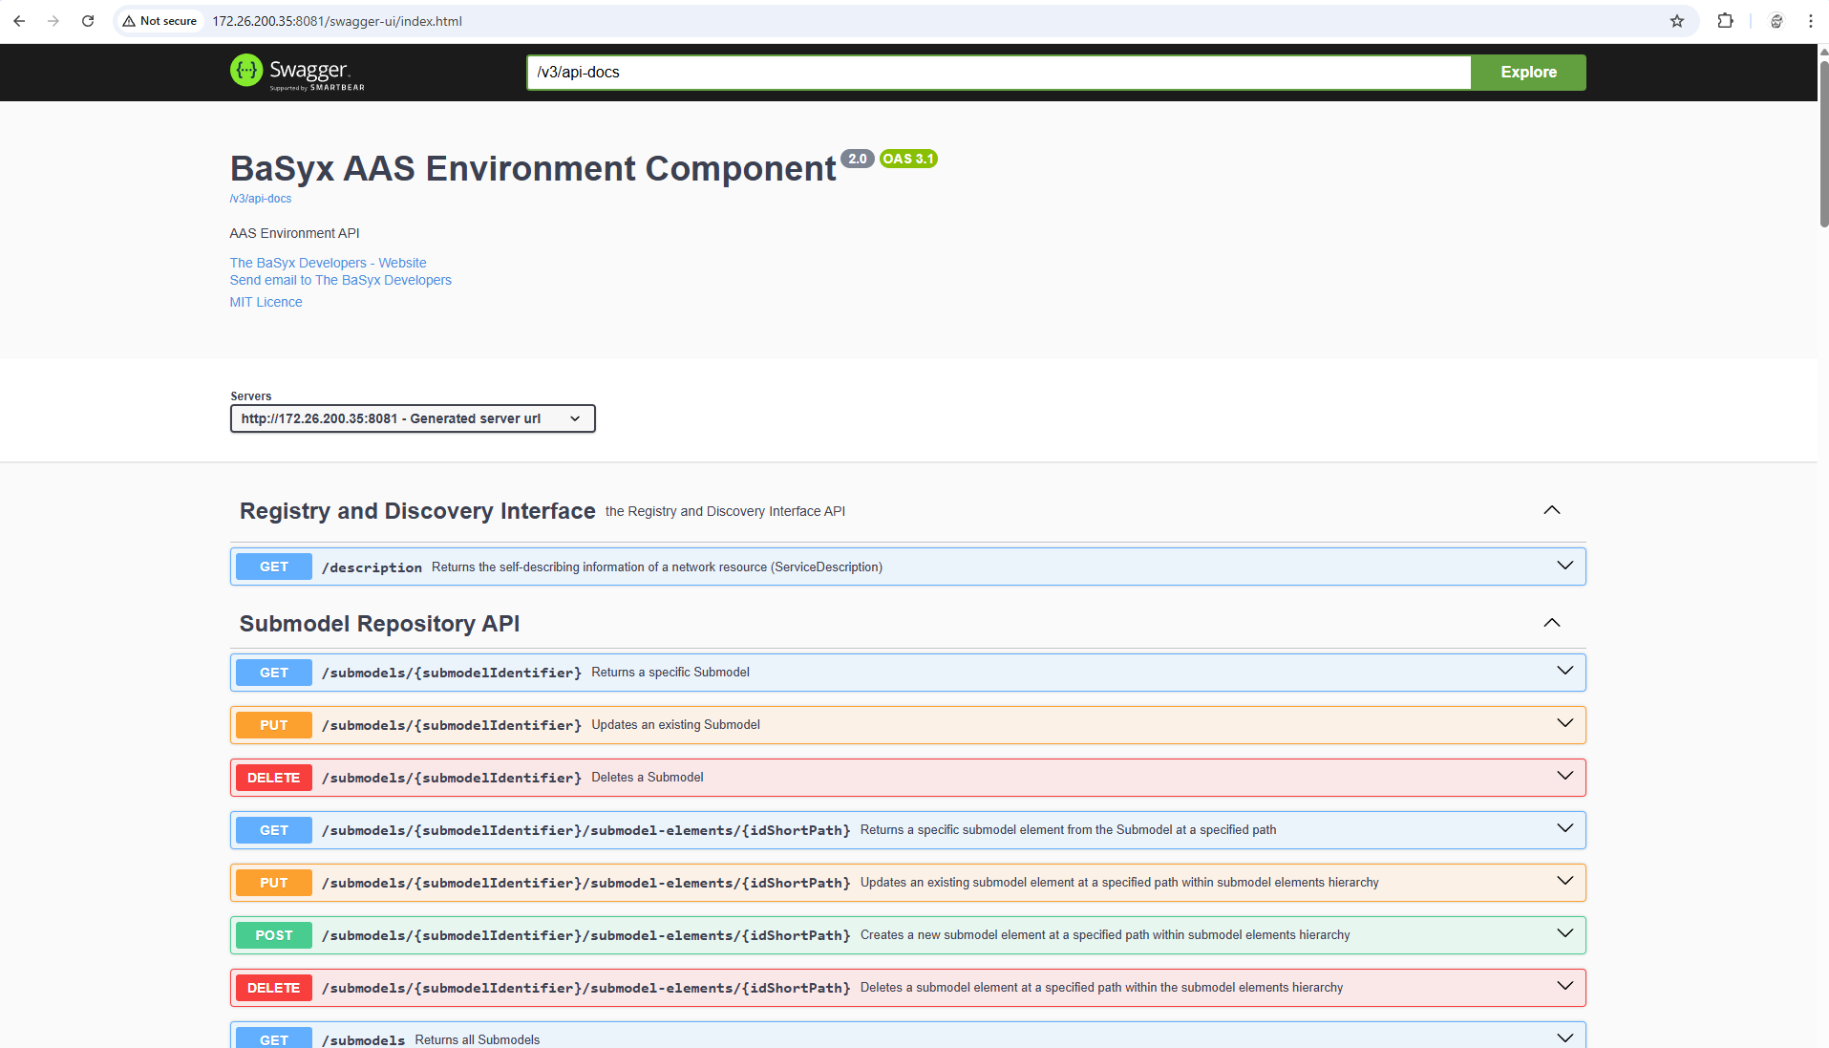

Additional deployment options
Docker-Based Deployment Using Docker Compose: BaSyx provides preconfigured Docker Compose setups that bundle the most important middleware components, including the AAS Environment, registries, and optional infrastructure services such as databases. After obtaining a BaSyx starter configuration (either from the BaSyx website or a prepared repository), the setup process begins by unpacking the configuration archive into a working directory. A typical directory structure looks as follows:
basyx-docker/
├── docker-compose.yml
├── .env
├── aas-env/
├── registry/
└── submodel-registry/
The .env file contains environment variables used by the containers, such as ports, hostnames, and database connection strings. These values can be adjusted to match the local network environment or to avoid port conflicts.
To start the complete BaSyx middleware stack, the following command is executed from the directory containing the docker-compose.yml file:
docker compose up -d
Docker Compose then pulls the required images, creates a dedicated Docker network, and starts all services in detached mode. The status of the running containers can be checked using:
docker compose ps
If all services are listed as “running,” the BaSyx system is operational.

Accessing and Verifying the Running System
Once the containers are running, the BaSyx AAS Environment can be accessed via a web browser or REST client. By default, the web interface is available at:
http://localhost:3000
This interface allows users to browse Asset Administration Shells, inspect submodels, and invoke operations. To verify the REST API directly, a simple HTTP request can be issued using curl:
curl http://localhost:3000/aas
A valid JSON response confirms that the AAS Environment is reachable and functioning correctly.
The AAS Registry and Submodel Registry are typically exposed on separate ports. Their availability can be tested in a similar way:
curl http://localhost:4000/registry
curl http://localhost:4001/submodels

Configuration via Environment Variables
BaSyx components are configured almost exclusively through environment variables, which makes them well suited for containerized and cloud-based deployments. These variables are either defined in the .env file or directly in the docker-compose.yml.
A typical example configuration looks like this:
BASYX_CONTEXT_PORT=3000
BASYX_REGISTRY_PORT=4000
BASYX_SUBMODEL_REGISTRY_PORT=4001
BASYX_MONGODB_CONNECTIONSTRING=mongodb://mongodb:27017
When the containers are started, these variables are injected into the runtime environment and interpreted by the BaSyx services. Changing configuration parameters therefore only requires restarting the containers:
docker compose down
docker compose up -d
No recompilation or image rebuilding is necessary.

Building and Running BaSyx from Source (Java SDK Example)
For development scenarios where custom BaSyx components are required, the system can be built directly from source. The Java SDK is commonly used due to its maturity and extensive feature set.
First, the source code is cloned from the official repository:
git clone https://github.com/eclipse-basyx/basyx-java-sdk.git
cd basyx-java-sdk
The project is then built using Maven:
mvn clean install
This command compiles all modules, runs tests, and installs the resulting artifacts into the local Maven repository. Once the build is complete, individual components such as AAS servers or registries can be started directly from the command line or from within an IDE.
A typical example for starting a BaSyx AAS server looks like this:
java -jar basyx.components/basyx.aas.server/target/basyx-aas-server.jar
Configuration parameters can again be passed as environment variables or JVM arguments.

Logging, Monitoring, and Shutdown
During runtime, container logs can be inspected using Docker commands. For example, to view the logs of the AAS Environment container:
docker compose logs aas-environment
This is particularly useful for debugging startup issues or configuration errors. To stop the entire BaSyx stack in a controlled manner, the following command is used:
docker compose down
This stops and removes all containers while preserving persistent volumes, such as databases, unless explicitly configured otherwise.

