
This document will be treated as strictly confidential. It will only be public to those who have signed the ITEA Declaration of Non-Disclosure.

MEDUSA

DELIVERABLE
D5.1.1 – State of the art on collaborative technology
•••••••••••••••••••••••••••••••••••••••••



Project number: ITEA 10004
Document version no.: 1
Edited by: Mihai Mitrea

ITEA Roadmap domains:
Major: Content & Knowledge

ITEA Roadmap categories:
Major: Interaction
Minor: Network & computing

HISTORY

Document version # | Date | Remarks
V1 | 20/11/2013 | Final version

Table of Contents

1 Introduction 4
2 Current day remote display solutions 5
3 Framework management with respect to collaboration 8
3.1 Software over the Platform 9
3.2 Platform over the Infrastructure 9
3.3 Low level of architectures 9
3.3.1 CompatibleOne over HiPeRT-Cloud by Bull 9
4 Standardized content aggregation 11
4.1 Content Aggregation 11
4.2 Role of Standards 11
4.3 Multimedia Scene-graph Representations 13
5 User interaction technologies 15
6 Collaboration management 16
6.1 Documents editing 16
6.2 Gaming 17
6.3 Social networking 18
6.4 Instant messaging 19
7 Conclusions 20
8 References 21

Introduction

After an Introduction to the remote viewer solutions (Section 2), this document is structured according to the WP5: management of the collaborative framework (Section 3), content aggregation standards (Section 4), user interaction technologies (Section 5) and collaboration management (Section 6). Conclusions are drawn in Section 7.

Current day remote display solutions

These days, all remote display solutions (be they wired or wireless, desktop computer or thin client oriented, Windows or Unix based, etc.) exploit the client-server architecture. Consequently, any remote display technological support can be assessed according to the following three criteria: (1) the interception of the visual content generated by the application at the server side, (2) the compression and the transmission of the content to the client, and (3) the management of the user interactivity (including the transmission of user events from client to server). An additional fourth criterion related to the energy consumption is taken into consideration for mobile thin clients. The study in [CAR 10] brought to light that the energy consumption of a smartphone depends on the network (GSM/Wi-Fi), the CPU, the RAM, the display and the audio. While the last three factors are rather more related to the device and to the actual user behavior, the amount of data transmitted through the network and the CPU activity intrinsically depend on the technology and will be further investigated in our study.

The present section considers the most frequently encountered remote desktop viewers support technologies (X window, NX, VNC, and RDP) for discussion according to these four criteria.

The X window system represents the native remote viewer for all current day desktop Linux applications. The application output, intercepted by an XClient (running on the server), is represented by a rich set of 119 basic graphic primitives describing the X11 protocol. Such X content is transmitted to the XServer (running on the client) by the X11 protocol, which makes no provision for content compression. On the client side, the XServer not only displays the graphical content but also captures the user interactivity by generic Linux OS mechanisms (keyboard/mouse drivers). While ensuring good performance in wired desktop environments, the X window system cannot be directly employed for mobile thin clients, mainly because of its bandwidth and latency requirements; actually, no X window system for thin clients is currently available.

By providing alternative protocols, the NX technology (a proprietary NoMachine solution) is intended to reduce the X11 network consumption and latency. Assuming an X window system is already running locally (the X Client, the X11 protocol and the X Server being all accommodated by the server), an NX proxy intercepts the X11 protocol, compresses it and subsequently transmits the result to the NX agent running on the remote client. Note that no particular user interactivity mechanisms have been developed. Although the experiments showed a good compression rate of the initial X11 content, such a solution is not yet available.

The VNC (Virtual Network Computing) remote viewer also assumes that an X window system is already available locally on the server side and brings new components in order to alleviate bandwidth and CPU constraints. The VNC Server (running on the server) intercepts the X graphical content at the XServer side. It further converts it to raw images (pixel maps) which are subsequently compressed using image compression algorithms and transmitted to the client by using the RFB (Remote FrameBuffer) protocol. On the VNC Client side (running on the client), the visual content composed only of images can be directly displayed. As in the previously discussed cases, the user interactivity is managed by the underling operating system. Several image compression optimizations are currently considered by VNC: TightVNC, TurboVNC, VNC-HEXTILE, VNC-ZRLE, … . For mobile thin clients, VNC-HEXTILE represents nowadays the most effective solution of that kind. Despite completely disregarding semantic information concerning the visual content to be displayed, VNC may be considered today as the most intensively used mobile thin client remote viewer: its myriads of versions for Linux, Android, iOS, RIM and even Windows Mobile can cover more than 87% of the personal smartphones in US [BAN 11].

Microsoft Windows OS provides the RDP (Remote Display Protocol) framework, a proprietary client-server solution for remote displays, available in both desktop and mobile versions. On the server side, the RDP server intercepts the application output through the GDI (Graphical Device Interface) and represents it by a mixture of images, graphics and formatted text. This content is then transmitted using the RDP protocol to the RDP client where it is displayed. In desktop environments, the RemoteFX, an emerging extension of the basic RDP framework, also enables multimedia content transmission. The user interactivity is managed by RDP and/or Windows OS drivers. Although natively designed for the Windows OS, Linux-based RDP servers also emerged in the last months. Nowadays, the RDP clients target about 9% of the US smartphone market [BAN 11] and it is forecasted to have the most important relative growth by 2015 [GAR 12].

The study in [JOV 13] presented MASC, a multimedia oriented remote viewer. The principle consists of representing the graphical content as a real-time interactive multimedia scene-graph. The underlying architecture features novel components for scene-graph creation and management, as well as for user interactivity handling. The experimental setup considers the Linux X windows system and BiFS/LASeR multimedia scene technologies on the server and client sides, respectively. The implemented solution was benchmarked against currently deployed solutions (VNC and Microsoft-RDP), by considering text-editing and www-browsing applications. The quantitative assessments demonstrate: (1) visual quality expressed by seven objective metrics, e.g. PSNR values between 30 and 42dB or SSIM values larger than 0.9999; (2) downlink bandwidth gain factors ranging from 2 to 60; (3) real-time user event management expressed by network roundtrip-time reduction by factors of 4 to 6 and by up-link bandwidth gain factors from 3 to 10; (4) feasible CPU activity, larger than in the RDP case but reduced by a factor of 1.5 with respect to the VNC-HEXTILE.
In practice, the VNC and RDP technological supports are exploited by a large variety of ready to use applications. While an exhaustive list of such applications is practically impossible to be done and is also out of the scope of this document, consider for instance:
- VNC-based applications: Apple Remote Desktop, Cendio ThinLinc, Chicken, ChunkVNC, Crossloop, EchoVNC, Ericom, Goverlan Remote Control, NoMachine NX, iTALC, KRDC, Mac HelpMate, N-central, noVNC, RealVNC, RapidSupport, Remote Desktop Manager, TigerVNC, TightVNC, TurboVNC, UltraVNC, X11vnc;
- RDP-based applications: AnywhereTS, Citrix XenApp, CoRD, DualDesk, Ericom, FreeRDP, NoMachine NX, KRDC, N-central, rdesktop, Remote Desktop Manager, Techinline, xrdp, XP/VS Server.
Moreover, proprietary (undisclosed) remote viewers’ technological support and applications are also available. For instance, TeamViewer exploits NAT (Network Address Translation) for establishing a connection, based on the RFB (VNC) and RDP protocols. GoToMyPC exploits the Citrix ICA (Independent Computing Architecture) proprietary protocol, but also supports VNC (RFB) and RDP. PhoneMyPC exploits its proprietary protocol, without exposing any specification detail. Oracle and Sun Microsystems offer Virtual Desktop Infrastructure (VDI) solution based on the proprietary ALP – protocol (Appliance Link Protocol). Unfortunately, all these solutions are not open for research (undisclosed specification) and development (no source code); consequently, they cannot be objectively benchmarked in our research study.

All these applications may provide additional levels of functionalities, like built-in encryption, file transfer, audio support, multiple sessions, seamless window, NAT pass-through, IpV6 support, video or 3D. The study, reported in the present paper, is placed at the technological support level; consequently, the actual application peculiarities will not be further discussed.
The performances exhibited by the remote display technologies presented above are synoptically illustrated in Figure 1.

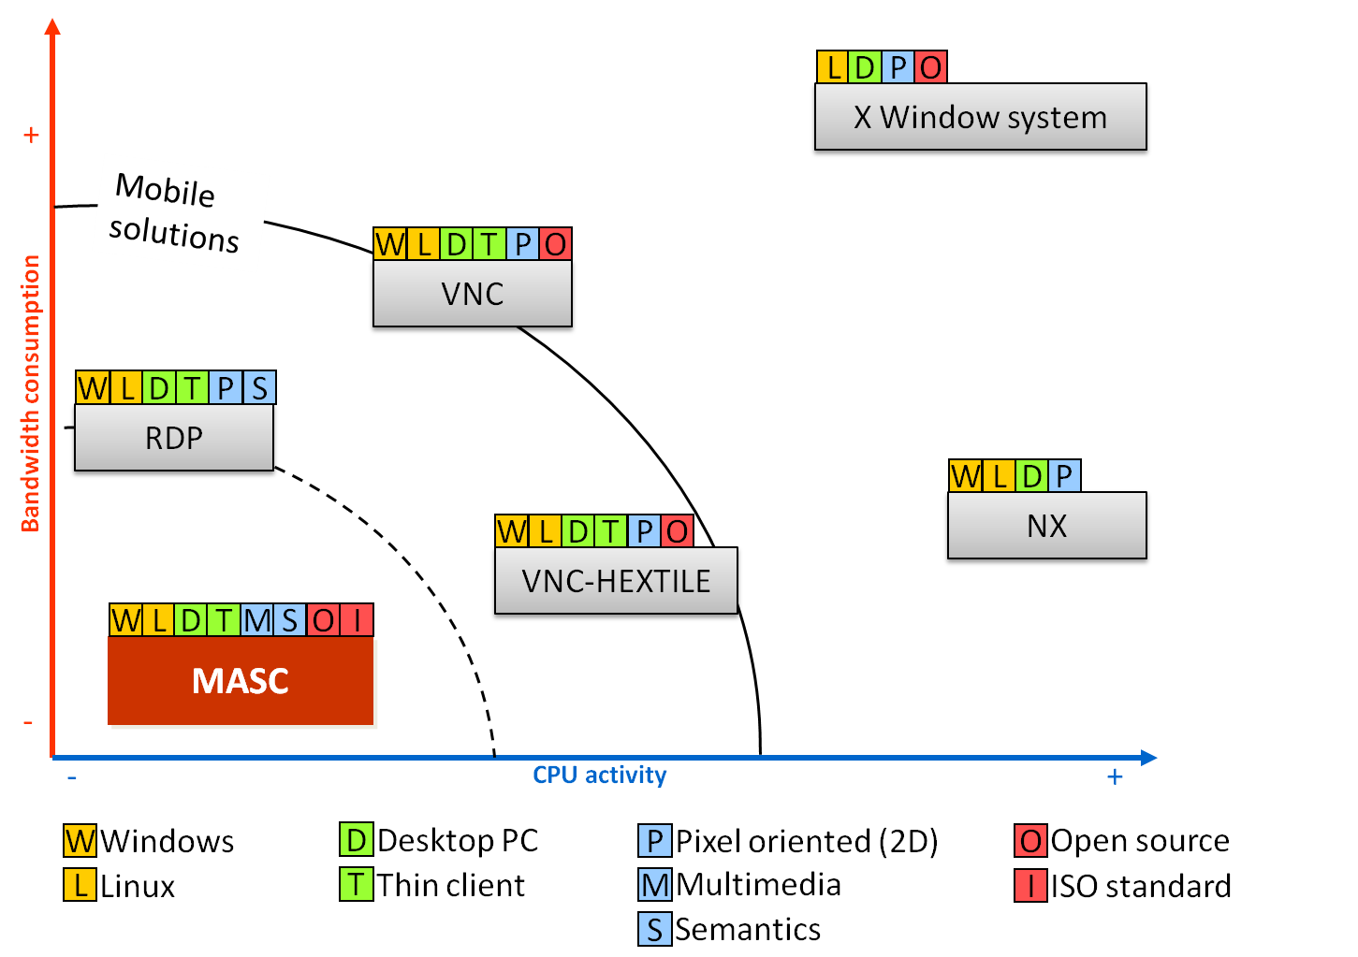
Figure 1. Comparison of the current remote display solutions.

Framework management with respect to collaboration

Section leader: Bull

Contributors: Philips, Technolution, IMT, Prologue

This chapter provides State Of The Art for the abstract, extensible and versatile multiplexing/ demultiplexing interfaces towards the equipment and devices that are integrated within MEDUSA’s collaborative work space. Choices of technology to be used within this task will be imposed equally by the contributing WPs as by the emerging results of the Collaborative management task.

As shown on the figure below Medusa system is a complete cloud stack for supplying software as services to heterogeneous medical stakeholders

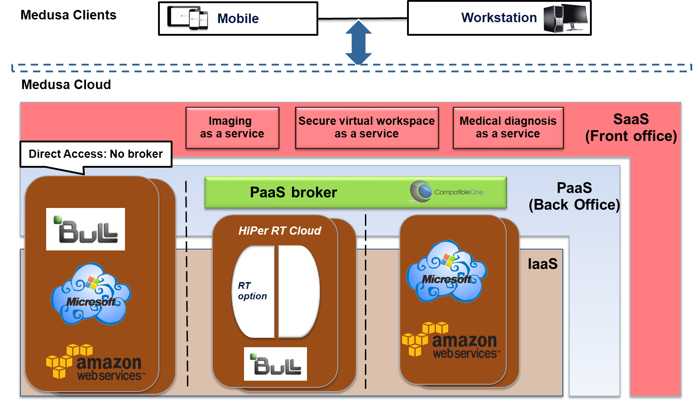
Figure 2: Technical implementation of NIST Reference Architecture for Cloud Computing

This stack would be provided to Medusa clients in accordance with the legal provisions of medical field. The architectural solution retained for building such a system, is based on a layered model inspired from the SOA.

Accordingly, the interfaces for the following interactions should be defined:
- Integration among the layers of the Cloud stack
- Administration
- End users communications.
- Interactions between business applications

Software over the Platform
Medusa supplies the following Software as services to medical stakeholders:
- Advanced image processing
- Secure collaborative workspace
- Decision support
Those coarse grain business services are provided by various partners, which act as Software Providers in Medusa taxonomy.
CompatibleOne platform supports the integration and the cloud provisioning process of these software services within Medusa.
CompatibleOne yet provides Open Cloud Computing Interfaces covering SLA management, Security, Pay per use and billing, Platform requirement, software provisioning, etc.
For all these contributions CompatibleOne is the ideal component for the integration of service-oriented business services.

Platform over the Infrastructure
The architectural framework chosen for Medusa ensures that business services are able to execute on a variety of physical infrastructure. This requires an abstraction component above the infrastructure layer. Once again, CompatibleOne has been selected to fulfill this function, since CompatibleOne offers a simple and unique interface allowing for the description of user cloud computing needs, in terms of resources, and their subsequent provisioning on the most appropriate cloud provider.
Therefore, Platform to Infrastructure integration relies on CompatibleOne interfaces (OCCI).
As a reminder, CompatibleOne yet integrates over Bull HiPeRT-Cloud, Amazon, Azure, CloudSigma, and many other cloud providers.

Low level of architectures

CompatibleOne over HiPeRT-Cloud by Bull
The management system of the HiPeRT-Cloud Platform is comprised of a secure REST API and a Web console running on top of it, and a stack agent, which provides secured access to the managed instances irrespective of whether they are attached to a private or public network. These APIs are protected by the Oauth2 protocol which links back to a central Entitlements Service backend. The HiPeRT-Cloud also includes the delivery of two builtin but independent middleware stacks.
- An HPC Virtual Cluster (HPCVC) based on SLURM (but SGE, IBM LSF, Altair PBS Pro or OAR could be easily supported as well) to run batch-oriented HPC jobs. Synergies are sought after to make the Bullx SCS distribution more flexible in addressing large-scale computing centers and HPC service providers.
- Remote Rendering Virtual Clusters (RRVC) based on open-source remote rendering engines and a very low latency video encoders designed to stream 3D interactive simulations in HD, HPC viewing and gaming scenes. One of these graphic pipelines implemented by ATEME and TSP Artemis embeds very advanced computer graphics assets5. It is planned that CEAList will port and qualify the XLcloud Platform with two of their most demanding interactive simulation apps in 2014. Deploying XRV, the eXtreme Factory remote viewing solution over HiPeRT-Cloud would be pretty straightforward too.
- Realtime capabilities such as Bare Metal deployment of Realtime system over Standard or HPC physical environment.

CompatobleOne provides the glues enabling it to plug above the HiPeRT-Cloud solution.

This Integration Diagram is summarized in the figure below.

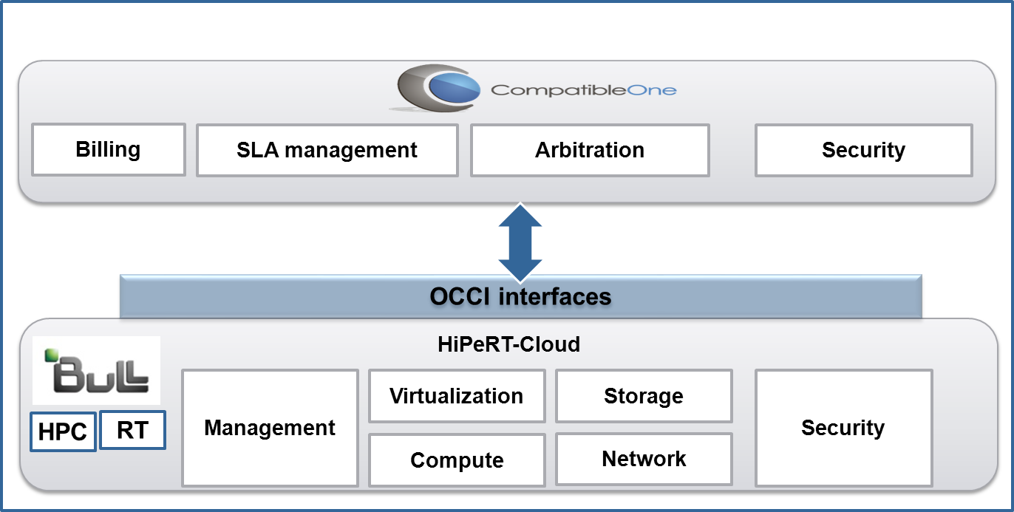
Figure 3: CompatibleOne over HiPert-Cloud by Bull

Standardized content aggregation

Section leader: Sopheon

Contributors: Philips, IMT, Bull, Prologue

Content Aggregation
This task is responsible for identification and handling of the different content types required to be made available for the decision making process. It takes as input heterogeneous industry standard content output and ensures its conformity with various collaborative requirements.

The decision making process in Medusa is supported by the Decision Support System (DSS). The DSS provides real time support to the medical teams for diagnosis and treatment. To do this, the DSS receives real time data from various sources like sensors on the body, (video) images, patient history and annotations or observations from the healthcare professionals. The DSS is connected to these external sources of information through approved APIs.
Some of these sources contain simple data like for example the EHR systems: they contain in general administrative type of data about medication, health condition, etc. They do not aggregate data really. Like the sensors, they deliver in general straight forward data. However, there are also other sources that seriously “aggregate” data on the basis of complex algorithms, specifically in the image comparison and image improvement area of the Medusa system. These systems can calculate the growth of a tumor, and the direction of the growth on the basis of comparing 2 MRI scans, or can calculate the general state of an oncology patient by comparing 2 video images of the face, taken over a period of time. The project is in an too early stage to describe in greater detail the approaches here. For the DSS aggregation we can say more already.

Which data the DSS needs to present scenario based advice, is defined in rules that are laid down in officially approved medical protocols. These rules specify for each data type (parameter) the values it can have and the action that is required if a given value or combination of values occurs. The rules are configured and kept up-to-date as part of a medical protocol deemed to represent the latest insights of evidence-based medicine. So the DSS is also connected to a protocol management system for the creation, management and publication of medical protocols.

The DSS immediately calculates the alerts or notifications to be given to the medical team by continuously aggregating the values that are transmitted by the sources for the parameters agreed in the medical protocol.

Role of Standards
It should be clear that the selection of content types to be monitored and aggregated by the DSS cannot be standardized at a general level, but is a decision taken by healthcare professionals charged with establishing procedures and rule of practice in their organization. This is why it is so important to have a protocol management system for managing and maintaining the medical protocols and rules therein next to the DSS.

Standards only come into play to enable the communication of information between the DSS and systems it connects to. Below is a list of standards that may be relevant for exchanging and aggregating Medusa content types :

Content Type | Standards
Sensor data | ISO/IEEE 11073  Health Informatics - Point-of-care medical device communication ; Personal health device communication  Group of standards for exchange and evaluation of vital signs data between different medical devices and personal health devices (e.g. weighing scales, blood pressure monitors, blood glucose monitors etc.)
Image data | ISO 12052:2006 (DICOM)  Health informatics—Digital imaging and communication in medicine (DICOM)  MPEG standards, see 4.3 below
Patient record data | ISO/CEN EN13606  Health informatics - Electronic Health Record Communication  HL7 v2.x and v3.0

Developments in decision support and protocol management
The development of decision support systems as such is not new in the medical domain. Clinical decision support systems (CDSS) are defined as “typically designed to integrate a medical knowledge base, patient data and an inference engine to generate case specific advice.” (Clinical Decision Support Systems: State of the Art , Agency for Healthcare Research and Quality of the U.S. Department of Health and Human Services, 2009).

However, existing decision support systems differ from the DSS discussed here in the sense that:
- Existing decision support systems are often limited to diagnosis, and when they support treatment it is to warn clinicians about potential problems with drug dosage and/or drug interaction. No system has been designed yet for real-time decision support that makes use of highly sophisticated imaging and monitoring data.
- Existing decision support systems are not linked to a hospital’s medical protocol or guideline management system and medical procedures appear to have a relatively low degree of standardization, therefore it requires substantial time investments of an organisation to adapt a DSS to their own needs

A lot of research is being done in the field of so-called Computer Interpretable Guidelines (CIGs). Various research groups engage in the development of formal languages, methods and tools in order to improve the quality of care. These projects also aim to provide medical teams with a form of automated decision support, however:

- The software tools generally still have research status, there are few commercial products. To the best of our knowledge the currently available systems are not scalable to thousands of protocols.
- The focus is on the formalization of knowledge, not on the integration of real-time data such as images and vital signs.

As to practice, healthcare professionals currently have in the best case seamless access to the relevant protocols which are state-of-the-art, complete and compliant with guideline quality standards. Whether the protocols are available on paper or displayed in electronic format, they constitute a stand-alone source of information. It is up to the clinician to apply the rules laid down in the protocols to real-time patient data and images during the intervention.

Multimedia Scene-graph Representations
Under the framework of MPEG-4 standard, a dedicated multimedia scene description language, called Binary Format for Scene (BiFS) [MPE a], [BAT 99], [BAT 00] is defined. It describes the heterogeneous content of the scene, manages the scene object behavior (e.g. object animation), ensures the timed and conditional updates (e.g. user input/interactivity) and encodes each object by its own coding scheme (video is coded as video, text as text, and graphics as graphics).

The BiFS principles have been further optimized for thin clients and mobile network purposes, thus resulting in a standard called Lightweight Application Scene Representation (LASeR) [MPE b], [DUF 05].

The existing technologies for heterogeneous content representation (BiFS, LASeR, Adobe Flash [ADO], Java [JAV], SMIL/SVG [W3C a], TimedText [W3C b], xHTML [xHTM], see Figure 4) can be benchmarked according to their performances in the areas of binary compression, dynamic updates, streaming and user interactivity management.

Binary compression for multimedia scenes is already offered by several solutions, both on the inside (BiFS and LASeR) and on the outside (Flash and Java) of the MPEG world. On the one hand, LASeR is the only technology specifically developed addressing the needs of mobile thin devices requiring at the same time strong compression and low complexity of decoding. On the other hand, BiFS takes the lead over LASeR by its power of expression and its strong graphics features which can describe 3D scenes. A particular case is represented by the xHTML technology which has no dedicated compression mechanism, but exploits some generic lossless compression algorithms (e.g. gzip) [GZI], [LIU 05].

Dynamic updates allow the server to modify the multimedia scene in a reactive, smooth and continuous way [SON 11]. In this respect, commands permitting scene modifications (object deletion / creation / replacement) in a timely manner [SON 11] should be provided inside the considered technology. This is the case of BiFS, LASeR and Flash. xHTML does not directly allow dynamic updates, but delegates this responsibility to additional technology (e.g. JavaScript).

Streaming refers to the concept of consistently transmitting and presenting media to an end user at a rate determined by the media updating mechanism per se; live streaming refers to the instantaneous delivery of some media created by a live source. BiFS and LASeR are the only binary compressed content representations intrinsically designed to be streamed. In this respect, dedicated mechanisms for individual media encapsulation into a binary format have been standardized and generic transmission protocols are subsequently employed for the corresponding streams. Note that the Flash philosophy does not directly support such a distribution mode: the swf file is generated on the server and then downloaded to the client which cannot change its functionalities. However, inside the swf file, Flash does provide tools for streaming external multimedia contents with their own native support, e.g. a FLV video can be streamed inside the Flash player. A similar approach is followed by xHTML.

Figure 4. Concurrent solutions for heterogeneous content compression, updating and streaming. Power of expression: possibility of describing complex/heterogeneous scenes. Graphics features: visual quality of the displayed content.

User interaction technologies

Section leader: IMT

Contributors: Philips, AMC, Sopheon, Prologue

Nearly all the technologies in Figure 4 are concerned with two well-defined ways for handling user interactivity captured at the scene level: client-side and server-side.

On the one hand, client-side interactivity deals with content manipulation on the end user terminal, where only local scene updates are available: the user events are captured and the scene is correspondingly updated, without contacting the server.

On the other hand, server-side interactivity supposes that the user events are sent to the server by using an up-link channel. MPEG-4 provides two possible solutions for ensuring the server-side interactivity. First, the ECMA script (JavaScript language) [ECM] can be considered in order to enable programmatic access to MPEG-4 objects. In order to achieve server-side interactivity, an AJAX HttpRequest [BRU 06] object is used to send user interactivity information to the server. Such a solution is not only common to BiFS and LASeR, but also to Flash and xHTML. In the particular case of BiFS, a second interactivity mechanism is provided by the ServerCommand which allows the occurrence of a user event to be directly signaled from the scene to the server.

Collaboration management
Section leader: Prologue

Contributors: Philips, AMC, Sopheon, Technolution, Bull, IMT

Nowadays, the collaboration concept is much invoked, yet never addressed, at least not in its general form [JOV 12].

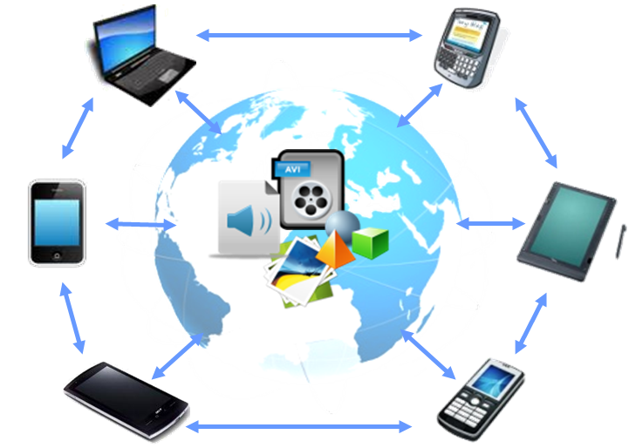
Figure 5. The concept of real-time user collaboration

The collaborative application exploits several methods for simultaneously updating all the connected users:
- Asynchronously: only one user can interact with the multimedia content at one time, thus consuming traffic only generated by one user.
- Pooling: multiple users can interact with the multimedia content at the same time, while the new updates are available to all the users after the application synchronize the content. In this way, the network traffic increases with the number of collaborators, but the interactions from the collaborators are not available in real-time.
- Synchronously: all the users interactions with the multimedia content are available to all of the collaborators in real-time, thus resulting in huge amount of Internet traffic while updating all the users in real-time with the collaboration actions.

Documents editing
With the specification of the Web 2.0 in 2005, new dynamic Internet applications have been introduced, enabling creation of the first collaborative applications. These applications are browser-based documents, written by HyperText Markup Language (HTML) tools. Although claimed to provide simultaneous text editing by all of the connected users, the changes from all the users are actually reflected after the collaborative application performs some periodic data polling policies (e.g. every half-minute). This technology promoted by Google (referred to as Google Docs), was released in February 2007, and is one of the few technologies offering real-time collaboration. In order two or more users to collaborate over one existing document, the Google Docs generate an URL (an Internet address) where the collaborators can access/download the same collaborative application and edit the same document by using an HTML web browser.
Google Docs is restricted to basic and simple text editing functionalities (like typing, color selection, …) and does not allow the user to enjoy the fully functional desktop oriented text editing application, like Microsoft Office Word. Moreover the collaboration is application dependant, forcing the connected users to collaborate only on particular multimedia content and limits them to define their collaboration principles.
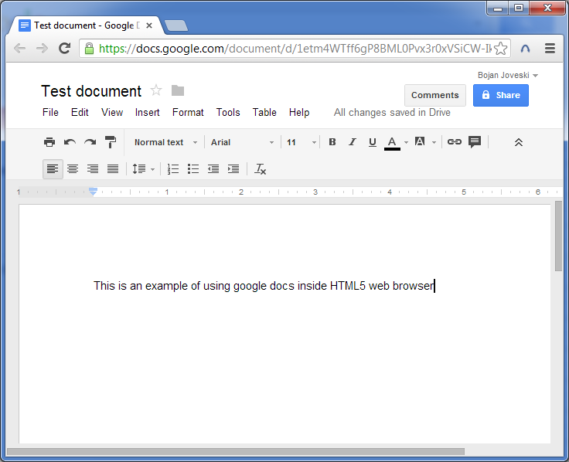
Figure 6. Creating a text document using the Google Docs

In 2009, Google introduced Google Wave, a collaboration environment, eventually to replace email and instant messaging; however, Google renounced this project in 2010, due to insufficient user social networking adoption and HTML limitations.

Gaming
The modern, Internet connected games are always associated to the collaboration principles. They allow the users to play the same game together while not being physically on the same place. In this respect, the users have to install the same application (i.e. the software game itself) on their terminal (PC, Smartphone, …) and to connect to the same collaboration server. Such an approach requires additional hardware resources at the client terminal, which might be an issue in the world of thin clients (limited to I/O resources).
While playing the game, the users actually interact with a local (terminal side) copy of the content while a synchronization process is updating both sides, the server and the connected clients, with the latest information about their actions (position, scene composition, …) [Blizzard, 2012], [Valve, 2012].
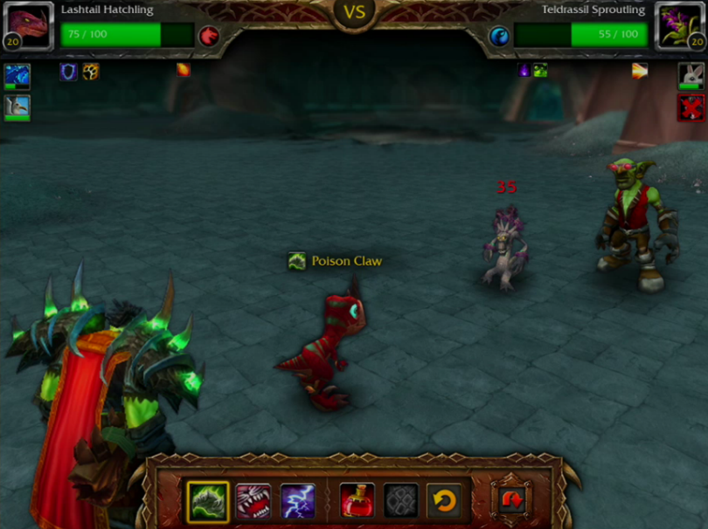
Figure 7 World of Warcraft (WoW) screenshot

Social networking
Social networking provides the communitarian user with the possibility of sharing heterogeneous multimedia content (video, music, journals, blogs, chatting, TV/radio stations, … ). All these contents are usually available at any time and to any user terminal, but each user can access that content individually, without being aware of the other connected user’s actions.
Consider the case of video streaming on YouTube, Figure 8. Generally, thousands of users access the same web page at the same time, in order to see the same video (stored on the server in a given video file). From the technical point of view, a different streaming session is asynchronously allocated to each user, thus allowing him/her to control only his/her own video stream. Consequently, two or more users cannot share the same visual experience at the same time. If one of the users make a pause on the video, this will affects only his video stream, while the rest of the connected users will not be affected.
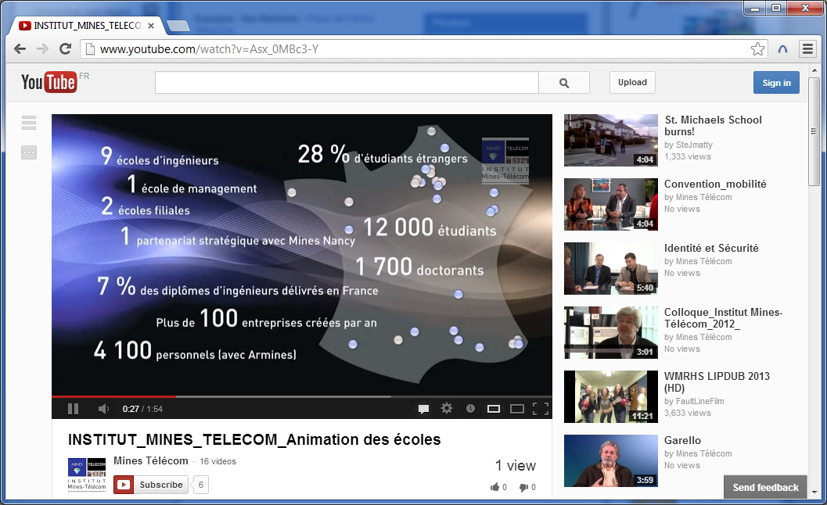
Figure 8. Creating a text document using the Google Docs

The same mechanism governs practically all the multimedia content accessed on Internet via browser: each user can access that content (journals, blogs, chatting, TV/radio stations, … ) based on a unique (none shared) session.

Instant messaging
The principles of exchanging messages trough internet between two or more users is also considered as collaboration. These types of collaborative applications allow two or more connected users to exchange multimedia content (text, images, videos and music) in real-time. The collaborative application captures the multimedia content generated by the user, transfers it to the collaboration server for further distributes it to all connected users. The received multimedia content is in “read only” state: it is not possible to change the received messages or to simultaneously create a new message in collaborative manner (with participation of the other users).
Note that instant messaging is not restricted to text messaging. Actually, video conferencing can be considered nowadays as the most popular type of “chat”, Figure 9, [Skype, 2012], [FaceTime, 2012].
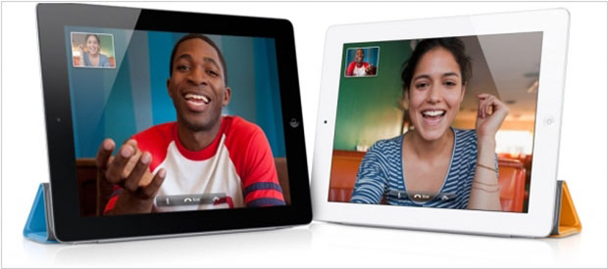
Figure 9. Video conferencing using Skype

Conclusions

Having in view the design, specification and implementation of the MEDUSA virtual collaborative environment, the present State-of-the-art document investigates the existing solutions and trends related to remote displays, cloud management and infrastructure, standardized content aggregation, user interaction and collaboration management.

It was thus brought to light that although no medical collaborative cloud environment exists today, technologies partially supporting the main needs of the targeted MEDUSA framework can be identified.

Consequently, the success of the WP5 research, development and integration tasks is conditioned on the definitions of:
- The medical oriented ontologys related to the cloud and collaboration management;
- The set of semantic constraints on multimedia collaborative & interactive displaying (aggregation, adaptation, transmission).
Work in this respect was/is done under the framework of the MEDUSA WP1, 2 and 6.

References

[BAT 99] S. Battista, F. Casalino, C. Lande, “MPEG-4: A Multimedia Standard for the Third Millennium, Part 1”, IEEE MultiMedia, pp: 74 - 83, January–March 1999
[BAT 00] S. Battista, F. Casalino, C. Lande, “MPEG-4: A Multimedia Standard for the Third Millennium, Part 2”, IEEE MultiMedia, pp:76-84, January–March 2000
[MPE a] MPEG-4 BiFS standard specification, ISO/IEC JTC1/SC29/WG11 14496-11
[MPE b] MPEG-4 LASeR standard specification, ISO/IEC°JTC1/SC29/WG11 14496-20
[DUF 05] J-C. Dufourd, O. Avaro, C. Concolato, ”An MPEG Standard for Rich Media Services”, IEEE MultiMedia, pp: 60-68, October–December 2005
[ADO] Adobe Flash, http://www.adobe.com/
[JAV] The Java Language Specification, http://java.sun.com/docs/books/jls/third_edition/html/j3TOC.html
[W3C a] W3C, Scalable Vector Graphics Specification, http://www.w3.org/TR/2002/WD-SVG12-20021115
[W3C b] W3C, Timed Text Markup Language Specification, http://www.w3.org/TR/ttaf1-dfxp/
[xHTM] xHTML specification, http://www.w3.org/TR/xhtml-basic/
[GZI] GZIP file format specification version 4.3, rfc 1952, http://tools.ietf.org/html/rfc1952
[LIU 05] Z. Liu, Y. Saifullah, M. Greis, S. Sreemanthula, “HTTP Compression Technique”, Wireless Communications and Networking Conference, 2005 IEEE, pp. 2495 - 2500 Vol. 4, New Orleans, USA, March 13-17 2005
[SON 11] J. Song, B.-D. Lee, “Mobile Rich Media Technologies: Current Status and Future Directions”, KSII Transactions on Internet and Information Systems, Vol. 5, No. 2, February 2011
[ECM] Ecma-262, EcmaScript documentation, http://www.ecmascript.org/docs.php
[BRU 06] E.J. Bruno, “Ajax: Asynchronous JavaScript and XML”, Dr. Dobb's Journal, v 31, n 2, February 2006, p 32-35
[CAR 10] Aaron Carroll , Gernot Heiser, “An Analysis of Power Consumption in a Smartphone”, USENIX 2010, June 22–25, 2010
[BAN 11] M. Bannan, D. Kellogg, “All about android”, Nielsen, 2011
[GAR 12] “Forecasts for smartphone operating system sales until 2015”, Gartner, www.rossdawsonblog.com
[JOV 12] B. Joveski, “Semantic multimedia remote viewer for collaborative mobile thin clients”, PhD Thesis, Mines ParisTech, December 2012.
[JOV 13] B. Joveski, M. Mitrea, P. Simoens, I.J. Marshall, F. Prêteux, B. Dhoedt, “Semantic multimedia remote display for mobile thin clients”, Multimedia Systems (MMSJ), vol. 19, no. 1 (February 2013).

