  A platform for the acceleration of go-to market in the ICT-industry |  |  |  |  |  |  |  | Title:  D4.4 Acceleration Content marketing platform  Version : 1.0  Date : 30/11/2016  Pages : 13  Author:  Wim Codenie, Asta Bäck, Päivi Jaring, Justyna Dabrowska, Cristina Ivan  Organisation:  Sirris, VTT, LUT, Siveco
The Accelerate consortium consists of:  AAC Global, Aptual, Beia, Bittium Wireless, Cognistreamer, Commscope Connectivity, F-Secure, Inno-W, Lappeenranta University of Technology, PlanetMedia, Sirris, Siveco, Sivsa, Tobagos, University of Mondragon, Vifib, VTT and Zenjoy |  |  |  |  |  |  |  | Printed on:  14-11-2016
Status: |  |  |  | Confidentiality:
[  [  [ | X | ]  ]  ] | Draft  To be reviewed  Final / Released | [  [  [ | X | ]  ]  ] | Public  Restricted  Confidential |  | - Intended for public use  - Intended for Accelerate consortium only  - Intended for individual partner only
Deliverable ID: D4.4

Title:
Acceleration Content marketing platform

Summary / Contents:

The goal of this deliverable is to give an overview of the actions and experiments that were conducted to spread the results of the Accelerate project to a broader target group. It also describes the Acceleration platform that has been built to connect investors and innovators to support acceleration, and that can be used as a channel to make the project results and learnings available.

© Copyright Accelerate Consortium

History

Version | Date | Author | Partner | Description
0.1 | 06.04.2016 | Wim Codenie | Sirris | First draft
0.3 | 24.06.2016 | Wim Codenie | Sirris | Next version
0.4. | 29.06.2016 | Päivi Jaring, Asta Bäck | VTT | Minor modifications
0.9 | 09.11.2016 | Asta Bäck, Päivi Jaring | VTT | Edited version
1.0 | 30.11.2016 | Cristina Ivan, Päivi Jaring | Siveco, VTT | Platform input + final edits

Table of Contents
1. Context 4
2. Workshops, events, seminars and publications 5
3. The use of accelerators and incubators as a diffusion channel 6
4. The use of social media channels 7
5. Automated startup ecosystem community building 9
6. An acceleration platform 12
6.1 History and technical implementation 12
6.2 Marketing of the platform 16
7. References 18

Context

In the Accelerate project, research was conducted to find a workable model for acceleration. The model was expected to be recognizable for companies and to offers them a practical frame to support them in their acceleration challenges. The result was a four-phased model of acceleration (Figure 1). The model was presented during the review meetings and is result of the research conducted in the other work packages.

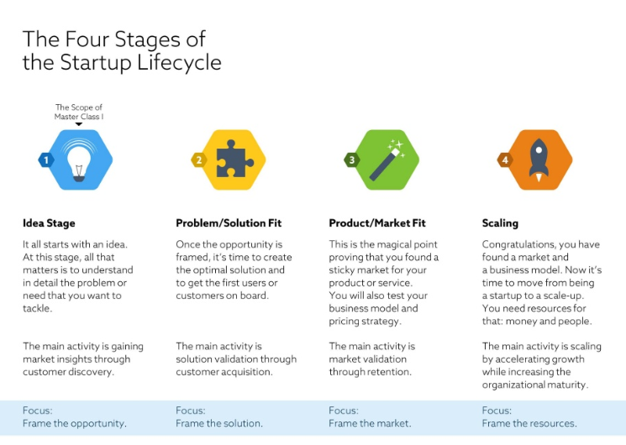

Figure 1. The four phases of acceleration.

A particular challenge was taking the results beyond the consortium. A lot of content has been produced related to the acceleration framework and all the use cases of the project have used it. The goal of this deliverable is to give an overview of the actions and experiments that have been conducted to spread the results to a broader target group.

This deliverable consists of the following five components, which are explained in more detail in this document:
- Content marketing through workshops/events/seminars and publications
- The use of existing accelerators and incubators as a channel for diffusion
- The use of social media channels
- The use of twitter to build in an automatic way a distribution channel for accelerate
- An acceleration platform

Workshops, events, seminars and publications
The accelerate consortium has made several publications and organized several workshops. They are described in detail in a separate deliverable D4.3.

Two conclusions were made:
- Scientific publications are important, mostly to put the topic of acceleration on the research agenda of the research community. Several publications have been published at ISPIM- and other conferences to achieve this.
- For industrial audiences, a dedicated set of material was developed. This material was used to animate workshops with companies.

The most recent workshop was organized using a new Master class concept. The first ITEA Masterclass on Digital Transformation was organized in Stockholm, Sweden on October 19th 2016. The event was organized by Vinnova together with representatives from three ITEA projects: Accelerate, Scalare and Invalue. The event attracted ca. 20 Swedish industrial participants that found the event useful. Four Accelerate partners - Bittium, F-Secure, VTT and Sirris – held presentations at the Masterclass and participated into the discussions on the topic.



Figure 2. The first ever Masterclass was organized in Stockholm in October 2016.

The use of accelerators and incubators as a diffusion channel

A first experiment was conducted to create material about the first phases of acceleration (The Idea stage). This material was made in such a way that accelerators can use it to coach the startups in their local ecosystems (Masterclass, Mohout 2015).

The high number of downloads and views of this material shows that there is high interest by accelerators in this kind of premium content. It is a promising way to distribute results on a larger scale.

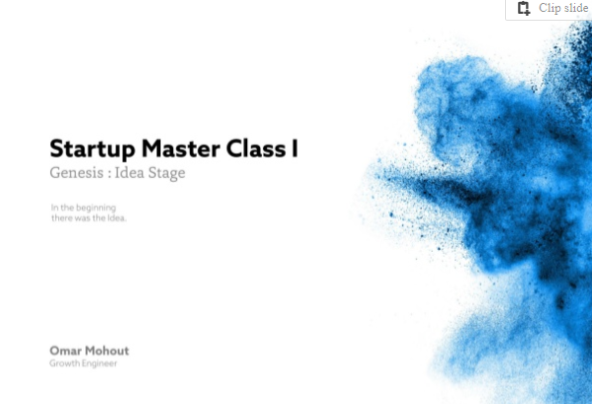

Figure 3. Cover of the Startup Master Class I.

On the regional level, Lappeenranta University of Technology, Finland has been collaborating with the LUTES Entrepreneurial Society and Kora (http://www.thinkkora.com/) to further disseminate the information and the methodologies developed during the Accelerate project. E.g. a Business Acceleration Seminar has been organized in Lappeenranta 2015 with invited speakers from Accelerate consortium for local startups and entrepreneurial community.

The use of social media channels

Material created in the Accelerate project has been distributed in social media channels e.g. on Twitter and Slideshare. The project has maintained its’ own Slideshare account (www.slideshare.net/accelerateproject, see Figure 4 below) that had 43 slide sets in November 2016. They had been viewed ca. 12.800 times in total, which shows that sharing project information publicly via social media is very important in gaining visibility.

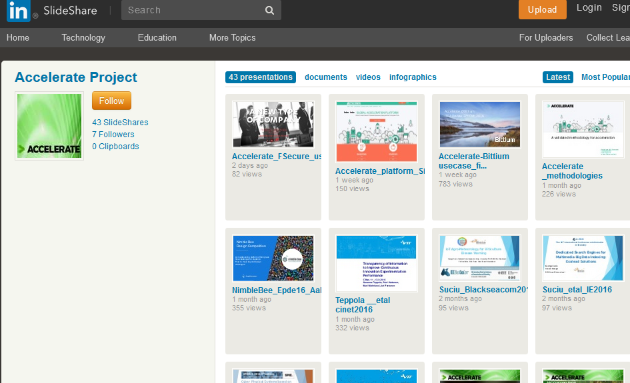

Figure 4. Screencap of Accelerate’s Slideshare-site.

The project manager has informed about news, events and publications via a Twitter account: www.twitter.com/accelerateproj and via the project site: www.accelerateproject.eu.

The ebooks written about the two phases are available at www.slideshare.net/omhout and by November 2016 they have been viewed more than +46.000 times. The third ebook about the third phase will be published at the end of 2016. Building the channels requires a lot of effort, but once the distribution channels have been established, they can be reused.

The conclusion is that for a certain part of the target group social media is an ideal channel to distribute content.

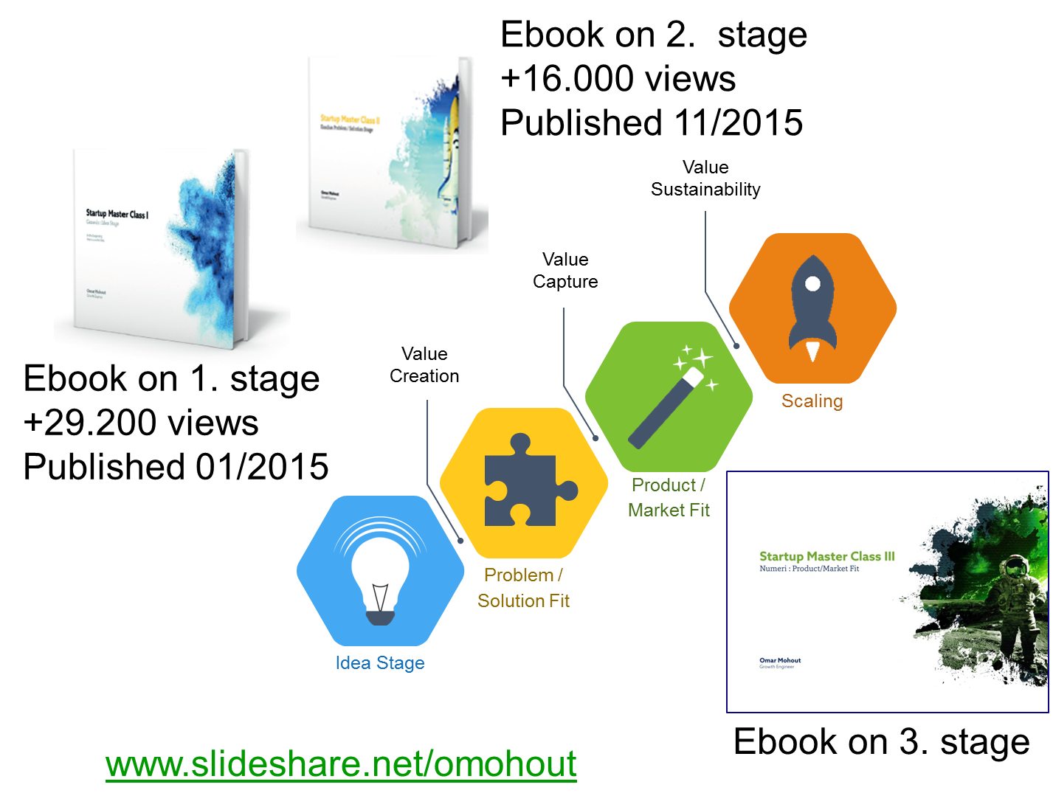
Figure 5. Ebooks on acceleration and their online view.

Automated startup ecosystem community building

An experiment was conducted to evaluate how startup ecosystems and communities can be created using social media. The results of this experiment were presented at ISPIM 2015 (Fiegenbaum & Mohout 2015). A description of the experiment is provided below.

In 2014, an experiment was started in Belgium by launching the #BeTech community on Twitter. Once #BeTech was launched, the community took off, and daily over 400 tweets and retweets are using this hashtag. The growth of the #BeTech community is visualized below.

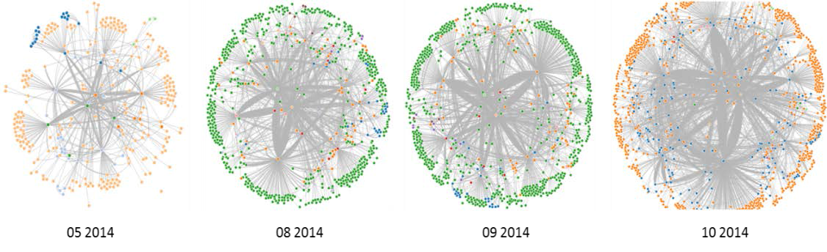
Figure 6. The growth of the “BeTech community on Twitter in 2014

The take-off was very fast: the #BeTech hashtag became an integral part of the Belgian startup community in only 6 months.

The question was raised, whether this could be repeated in other countries. This was not straightforward, as it is impossible to keep manually timely track of all startups. Angellist, Gust and CrunchBase are the most popular startup databases, but they are outdated and incomplete.

However, while it is impossible to search and find all startups, eventually they will emerge on the screen of stakeholders in the local startup ecosystem: acceleration and incubation programs, events and meetups, advisors and mentors, business angels and venture capitalist, IP lawyers and legal advisors, tech media and lean circles. The hypothesis was that by analyzing the activities of the stakeholders in the local ecosystem, the most complete overview could be build.

We selected Twitter as social media for this experiment. Essentially, a platform like Twitter exists for determining what is happening around a certain subject or interest. In other words, it acts as an optimal channel to access, understand or shape a community. Twitter was selected also based on following reasons: it is 1) realtime, 2) public, 3) it connects both people as well as organizations, 4) it has an API (Application Programming Interface) and 5) it is popular with both startups and established technology oriented firms. The examples below show the Twitter accounts for France and Austria linked to the local hash tags.

A Twitter experiment was setup to observe, document and analyze the ecosystems’ growth in an automated way. For the purpose of reinforcing and measuring the stream of data from and about startups, a Twitterbot was set-up for every country. This Twitterbot scans and retweets tweets based on: (1) keywords (in combination with Boolean operators); (2) stakeholders; and (3) community leaders (private messages are filtered out using keywords). The idea was that interested Twitter users are following the Twitterbot for staying up to date of what is happening in their community.





Figure 7. The Twitter accounts of the France and Austria experiments

Experiments were set up in 33 countries in Europe. Social media analytical tools (Leaflet and OpenStreetMap) were used to evaluate the growth of the communities around the hashtag. The social network emerging around the hashtags were studied and analyzed in relation to time and by including the key stakeholders for each country. We look at the speed of ecosystem catching up and adopting a hashtag. Once a certain amount of stakeholders had adopted the hashtag for regular use, we assumed that an ecosystem had been formed, and monitored its growth and integration of newcomers.

By monitoring dedicated hashtags, innovative startups could be automatically scouted and analyzed. In December 2014, we decided to roll it out to all countries in Europe, and as of April 2015, 33 countries were included.

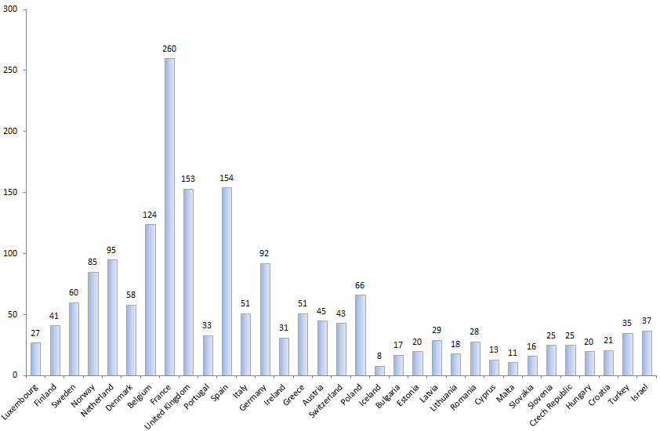
Figure 8. The number of key stakeholders in every country

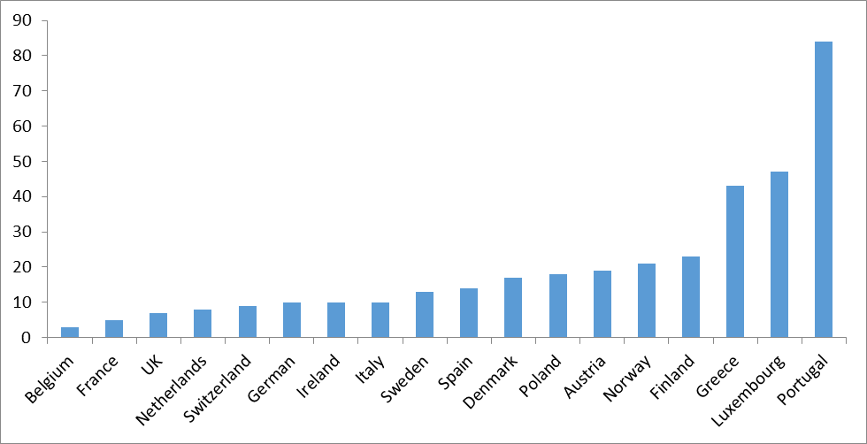
Figure 9. Number of days to reach 100 followers per country

As of 15th of April, 2015, the experiment allowed us to gather the following characteristics of the European startup ecosystems (excluding Albania, Serbia, Montenegro & Bosnia- Herzegovina):
- 33 countries
- 1,792 stakeholders identified
- 596 community and thought leaders identified
- 272 hashtags identified
- More than 200,000 tweets analyzed
- More than 12,000 followers
- Between 2 tweets per day (Malta) and 324 tweets per day (France) in average

The experiment provided insights into the startup and innovation ecosystems in different countries. It lets us identify early new startups and innovations. By combining the data from other regions and countries, trends can be identified, and national and regional differences uncovered.

Acceleration platform
This section describes the development path of the Acceleration platform, its’ technical implementation and marketing activities. Business model aspects of the platform are described in D4.5.

development path and technical implementation

The Global Acceleration Platform aimed to create a solid network of start-ups, investors, and entrepreneurs from different areas of expertise, and help them collaborate in an accessible manner without losing precious time in looking for appropriate partners to foster their project / product or business ideas.
The initial version of the Global Acceleration Platform that was outlined by the Spanish partner Planetmedia was designed to pilot the first dashboard with the scope to provide guidance on the expected values that the KPIs associated to the different methodologies and tools may have in order to reflect the intended progress.

The following consortium partners collaborated to produce the first proof of concept for the platform:
- Planet Media- requirements for the initial version of the Acceleration Platform
- SIVECO Romania- requirements for the final version of the Acceleration Platform, development of both initial and final versions of the Acceleration Platform
- Beia Consult – Hosting of the platform
- VTT - Providing content to the platform

The main components of initial version were:
- A section presenting the most common acceleration challenges – dedicated to including a set of typical common Acceleration Challenges that were structured into the four phases of the acceleration process:
  - Frame the opportunity
  - Frame the solution
  - Frame the market
  - Frame the resources
- A solution Space Section – designed as a component where third party services and product providers would showroom their products and services to any interested company.
- A section presenting all success cases of illustrating the use of methodologies, tools and results offered by Acceleration Platform.
- A functionality dedicated to integration to social networks – a radar like utility collecting opinions and comments from social networks related to acceleration.

The initial version of the platform was extensively improved in terms of design, as agreed at European Consortium level (see Figures 10 and 11).

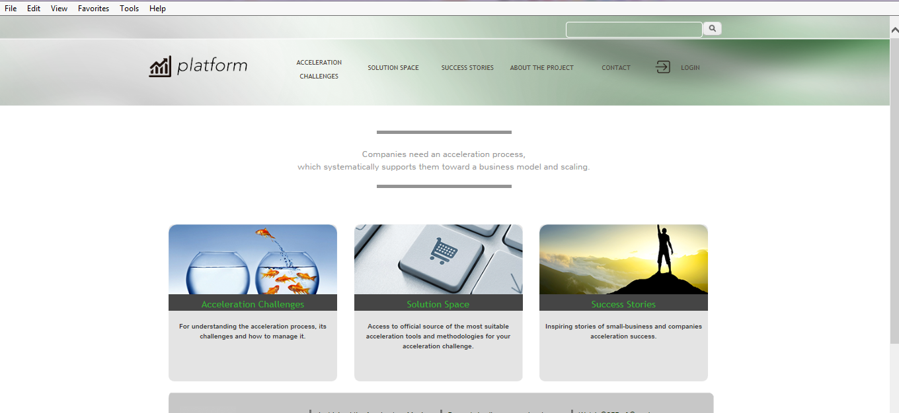

Figure 10. The initial version of the platform.

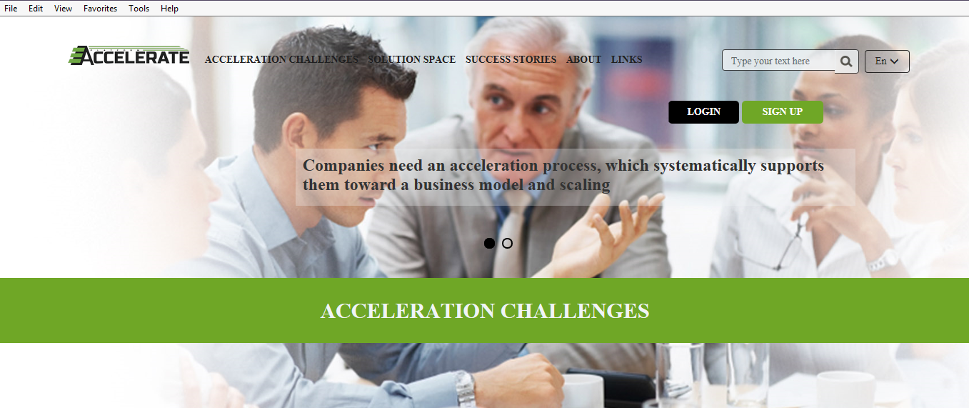
Figure 11. The new version of the platform.

The new functionalities of the Acceleration Platform have been designed to support users in emerging European countries with an innovative platform that allows matching different categories of target users, such as investors and start-ups. Thus, users who are starting up and wish to establish their own business and need financial support to be able to sustain the idea, and funders who wish to invest in a new profitable business, may start beneficial relationships in a fast, safe and effortless manner.

The following aspects were identified as the most important benefits of the Acceleration platform:
- Learn how to accelerate a business or a product, by accessing meaningful information related to the acceleration process
- Access to a database of lessons learnt and other helpful resources
- Access to a collaborative online workspace where passionate entrepreneurs help each other to bring ideas to life
- Access to specialists, investors and consultants with the appropriate knowledge, expertise and financial means to help start-ups launch their project ideas.
- 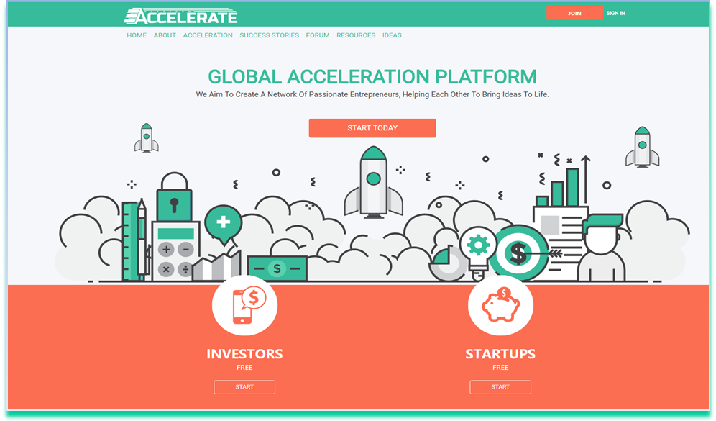
- Figure 12. Homepage of acceleration platform.

The main components of the final version of the Acceleration Platform (see design in Figure 12) are the following:
- Customized profiles for users accessing the private area of the Acceleration Platform, designed on the basis of the users interests; the following profiles are available into the Acceleration Platform:
  - Startup – representing a person, who is prepared to launch a project idea, or a person who already has a company / idea / product, but does not have a partner, or a person who does not have an idea, but wants to start a business. For this role, the following functionalities are available:

    - Create / View / Edit Profile
    - Forum
    - Private messaging
    - Manage private messages
    - Create a project idea
    - Manage the list of project ideas
    - Allow / reject access to private project ideas
  - Investor – representing a person who wants to help talented people, with knowledge and experience and/or financial support to launch a project idea. For this role, the following functionalities are available:
    - Create / View / Edit Profile
    - Forum
    - Private messaging
    - Management of private messages
    - Request access to private information of a project idea
    - Search for project ideas
- An idea publishing system, available for startups, gives them the option to create, publish and manage project / product or business ideas into the platform. The ideas can be private or public. Private means that the idea will be displayed in the listings section of the website with the title and a short description; in order to view all the details an investor will be required to ask permission from the idea owner. The idea owner has the possibility to accept or deny the request.
- A private messaging system for all types of users registered in the private area of the platform.
- Integration with LinkedIn – implemented so that the platform will automatically retrieve details for users who wish to register via LinkedIn, so they are spared from the effort of filling the required data for the profile. Thus, users will find it simple to access the platform by logging in with their existing LinkedIn account details.
- Sections presenting interesting content for the users of the platform related to the overall acceleration process.
- Customized dashboards for users registered to the Acceleration Platform:
  - For startups, with the following structure:
    - the most wanted ideas from the platform by means of requested access to their private information
    - their most viewed ideas
    - new private messages
    - new investors that have joined the platform
  - For investors, with the following structure:
    - the most wanted ideas from the platform by means of requested access to their private information
    - their most viewed ideas
    - new private messages
    - new startups that have joined the platform

Marketing the platform

In order to attract as many users as possible, the consortium will take advantage of the online promotion channels, which are targeted, cost-effective and have measurable results. Online advertising includes email marketing, social media marketing, search engine marketing, mobile marketing and an array of display marketing techniques, such as banner ads, pop-ups, etc.
- The Acceleration platform will be promoted via social and professional networks (mainly through Facebook, Twitter, LinkedIn). For these reason it is crucial for us to establish a strong presence in the social media.
- Another goal is to be ranked at the top in the major search engines, and practice good Search Engine Optimization (SEO) techniques. In that way, anyone searching for the relevant entrepreneurial content will be able to see Accelerate platform as one of the first results of their search.
- Google AdWords for paid advertising will also be used. It is important to convert clicks, so a landing page can be a useful method of increasing the rate of conversion and gaining more customers in the platform.
- Another method is using affiliate marketing, the advantage being that the campaign budget can be dynamic meaning that an affiliated member will be paid only when a conversion is made.
- Besides the online campaigns, the members of the project will continue to promote the platform in meetings, workshops, conferences and other events where disseminating the Accelerate Platform can increase the number of visitors and premium users.
- Viral marketing can play an important role, so it is crucial to have satisfied users who will talk about the Acceleration Platform and its services to their friends and colleagues.
- It is important to build a responsive opt-in email list, which we will use in order to send informative newsletters to entrepreneurs and other interested parties, about new content, ideas, and other services.
To extend the number of platform users, tools like Google Search Console have been included to optimize the search results and improve the way that potential users are directed to our business accelerator.

References
Accelerate’s Slideshare-site: www.slideshare.net/accelerateproject

Fiegenbaum, I., Mohout, O., 2015. Power of Twitter: building innovation radar using social media. The proceedings of the XXVI ISPIM conference, Budapest, Hungary, 14-17 June, 2015

Jaring, P., 2016. Deliverable 4.3 of Accelerate project: Publications, seminars and workshops.

Komi, M., Still, K., Wallin, A., Jaring, P., 2015. Accelerating the innovation process of start-ups - Business incubator and accelerator services in Finland. The proceedings of the XXVI ISPIM conference, Budapest, Hungary, 14-17 June, 2015.

Mohout, O., 2015. Startup Master Class I, Genesis Idea Stage. Available at: http://www.slideshare.net/omohout

Mohout, O., 2015. Startup MasterClass II, Exodus: Problem/Solution Stage, Available at: http://www.slideshare.net/omohout

