Workpackage 1: (Meta)-Modelling
D1.1 v2
State of the art of User Interface Description Languages
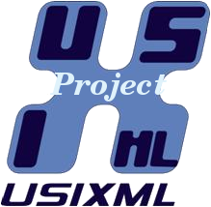 | Project acronym: UsiXML  Project full title: User interface eXtensible Mark-up Language  ITEA label n° 08026

DOCUMENT CONTROL

Deliverable N°: D1.1
Due Date: 09/2010
Delivery Date: 10/2011

Short Description:A user interface description language (UIDL) consists of a specification language that describes various aspects of a user interface under development. A comparative review of some selected user interface description languages is produced in order to analyze how they support the various stages of user interface development life cycle and development goals, such as support for multi-platform, device-independence, modality independence, and content delivery. There has been a long history and tradition to attempt capturing the essence of user interfaces at various levels of abstraction for different purposes, including those of development. The recent return of this effort today gains more attraction, along with the dissemination of XML markup languages, and gives birth to many proposals for various user interface description languages. Consequently, an in-depth analysis of the salient features that make these languages different from each other is desired in order to identify when and where they are appropriate for a specific purpose. The review is conducted based on a systematic analysis grid and some user interfaces implemented with these languages.

Lead Partner: UCL
Contributors: UCL, UJF, PYA, UND, CLM, UPV
Made available to: Public

Rev | Date | Author | Checked by | Internal Approval | Description
0.1 | 01/11/09 | Draft – Josefina Guerrero García, Juan Manuel González Calleros, Jean Vanderdonckt, UCL. | Jean Vanderdonckt, UCL. | Jean Vanderdonckt, UCL. | Initial version
0.1 | /01/10 | Comments integrated from:  Mohamed BOUKHEBOUZE, UND, Jose Vicente Ballester, UPV. | Josefina Guerrero García, Juan Manuel González Calleros, Jean Vanderdonckt, UCL. | Jean Vanderdonckt, UCL. | Summary of comments:  Refer to Review Forms:  D1.1_Review_UND.xls  D1.1_Review_UPV.xls
02 | 03/01/10 | Josefina Guerrero García, Juan Manuel González Calleros, Jean Vanderdonckt, UCL. | Jean Vanderdonckt, UCL. | Jean Vanderdonckt, UCL. | Summary of modifications  Refer to Review Forms:  D1.1_Review_UND.xls  D1.1_Review_UPV.xls
03 | 23/02/11 | Josefina Guerrero García, Juan Manuel González Calleros, Jean Vanderdonckt, UCL. | Jean Vanderdonckt, UCL. | Jean Vanderdonckt, UCL. | Integration of reviewers comments and addition of the following references:  o XWT:  o MariaXML:  o userML:  o XooML

CONTENTS
Pages
Executive Summary 6
DOCUMENTS 6
MANDATORY 6
REFERENCE 6
1. Introduction 6
2. XML-Compliant Languages 7
2.1. Standards 8
2.1.1. Virtual Reality Modeling Language (VRML) 8
2.1.2. Virtual Reality Modeling Language (X3D) 8
2.2. Software Vendors 9
2.2.1. Macromedia Flex Markup Language (MXML) 9
2.2.2. OpenLaszlo 9
2.2.3. Several Interfaces, Single Logic (Sisl) 10
2.2.4. Microsoft Extensible Application Markup Language (XAML) 10
2.2.5. eXtensible User interface Language (XUL) 10
2.3. W3C Recommendations 11
2.3.1. Device Independent Authoring Language (DIAL) 11
2.3.2. Extensible MultiModal Annotation markup language (EMMA) 12
2.3.3. Ink Markup Language (InkML) 12
2.3.4. Voice Extensible Markup Language (VoiceXML) 13
2.3.5. XForms 13
2.4. Interaction Techniques Markup Language (InTml) 14
2.5. eXtensible Interface Scenario Language (XISL) 16
2.6. eXtensible mark-up language for MultiModal interaction with Virtual Reality worlds (XMMVR) 16
3. Analysis on User Interface Description Languages 17
3.1. Dialog and Interface Specification Language (DISL) 17
3.2. Generalized Interface Markup Language (GIML) 17
3.3. Multiple Device Markup Language (MDML) 19
3.4. Renderer-Independent Markup Language (RIML) 21
3.5. Software Engineering for Embedded Systems using a Component-Oriented Approach (SeescoaXML) 21
3.6. Simple Unified Natural Markup Language (SunML) 22
3.7. Maria (MariaXML) 24
3.8. User Interface Markup Language (UIML) 28
3.9. USer Interface eXtensible Markup Language (UsiXML) 28
3.10. Web Service eXperience Language (WSXL) 30
3.11. eXtensible user-Interface Markup Language (XICL) 31
3.12. eXstensible user-Interface Markup Language (XIML) 31
3.13. UserML 32
3.14. XooML 33
4. General Comparison 33
5. Conclusion 35
References 35
Appendix 1. Diagrams 46
Appendix 2. List of UIDLs 52

Executive Summary

DOCUMENTS

MANDATORY
UsiXML FPP V1.0

REFERENCE
D1.1 UsiXML

Introduction
For many years, Human-Computer Interaction (HCI) witnessed a perennial race for the ultimate User Interface (UI) Description Language that would ideally capture the essence of what a UI could be or should be. A UI Description Language (UIDL) consists of a high-level computer language for describing characteristics of interest of a UI with respect to the rest of an interactive application in order to be used during some stages of the UI development life cycle. Such a language involves defining a syntax (i.e. how these characteristics can be expressed in terms of the language) and semantics (i.e., what do these characteristics mean in the real world). It can be considered as a common way to specify a UI independently of any target language (e.g., programming or markup) that would serve to implement this UI.
The issue of UIDL was first raised when it was required to develop a UI like a module of an interactive application rather than merely a series of lines codes. In a second time, the issue was reinforced when the desire appears to model a UI by a set of specifications so as to communicate these specifications and to share them across stakeholders, or to (semi-)automatically generate the code of the UI, as desired in model-based approaches for developing UIs. When a UI was required to be run simultaneously on different computing platforms, this need took shape in some language that would be exchanged from one platform to another without any changes to avoid any extraneous effort.
For some years, the race progressively slept. The wide availability of markup languages and the capability of introducing any language based on XML meta-language, along with the multiplicity of today’s available platforms (e.g., mobile phone, smart phone, pocket PC, handheld PC, Tiqit PC, tablet PC, laptop, traditional PC, and even wall screens) have awaken this race and have exacerbated it to a point where today more than a dozen of UIDLs exist that focus on some of the desired characteristics. To shed light on this proliferation of UIDLs, we conducted a systematic comparison based on an analysis grid and UIs. The paper focuses only on XML-based languages, because XML is a well established standard that is easily extensible and that could work with yet-to-be-invented appliances without many changes. Furthermore, it is declarative and can be use by non-programmers or occasional users.
For the purpose of this survey, we gathered and analyzed as much literature as possible on each UIDL. Then, depending on available tools, we systematically developed a multi-platform or multi-context UI for a simple dictionary so as to identify the capabilities of the UIDL and the ability of this UIDL to be supported by editing, critiquing, analysis tools, and, of course, tools for producing executable UIs, both by compilation/execution and by interpretation.
The remainder of this paper is structured as follows: Section 2 provides an overview of existing UIDLs, including some of the UIDLs that have not been considered for the comparison for different reasons (e.g., their accessibility). Section 3 respectively describes each selected UIDL in the comparison and identifies the main goals pursued by each one. Section 4 defines the comparison criteria used in the comparison analysis and provides the final analysis grid. Section 5 presents the conclusion.

XML-Compliant Languages
In this section, relevant contributions of XML-compliant languages for the definition of UIs are analyzed, based on the available literature and tools. However these languages were not considered for a detailed comparison for one or more of the following characteristics:
- Specificity. The specificity of a language differentiates from general purpose or generic languages from very specific ones. For instance, XISL ((Katsurada, Nakamura, Yamada, & Nitta, 2003) is a very interesting approach but is just specific to multi modal user interfaces.
- Accessibility. The accessibility of the language refers to the available information to analyze it. When the information is totally confidential is impossible to have access to the semantics of the language, this is the case with most of the software vendors (Microsoft, IBM) languages.
- Relatedness. The relatedness characteristic is use to differentiate whether the language is a User Interface Description language (UIDL).
- Standard. The standard property refers to a language that is a standard. Even that these language are very important and relevant in some cases they have one of the previous listed properties. Consequently, they were not considered for the comparison.
In the reminder of this section languages that do not take part of the comparative analysis due to any of the above criteria are quoted.

Standards

Virtual Reality Modeling Language (VRML)
The Virtual Reality Modeling Language (VRML) is neither virtual reality (VR) nor a modeling language (Carey & Bell, 1997). It is not VR as VRML does not require nor precludes immersion, one key aspect a VR. Also, it is not a modeling language as VRML just provides a bare minimum of geometric modeling features, not a robust set. Even that its name maybe does not correspond exactly with its meaning, the purpose of the language have been achieve. In 1995 W3C was planning to use VRML as the standard for the World Wide Web. So, as a W3C recommendation several efforts has been done around the language such as plug-ins to the most used and commercial modeling engines such as: Maya, Max 3D, CAD, among many others. Also some plug-ins has been developed for internet browsers that render VR on the Web.
VRML is not a programming library for application developers. Since VRML is based on the Silicon Graphics Open Inventor toolkit file format. VRML is an extended subset of Open Inventor's file format and does not define an application programmer interface (API), (Carey et al., 2007). Even, that VRML includes scripting language, this is for authors who need more power or integration. VRML followed the evolution of web languages and became a XML-Based language called X3D.

Virtual Reality Modeling Language (X3D)
X3D (Web3D, 2007) is an open standard for 3D content delivery. It is not a programming API. Combines both geometry and runtime behavioral descriptions into a single file that has a number of different file formats available for it, including the XML. It is the next revision of the VRML97 ISO specification, incorporating the latest advances in commercial graphics hardware features as well as architectural improvements based on years of feedback from the VRML97 development community.
Technologies and effort of the W3D consortium tends to use X3D and not VRML anymore. However there is a lot of work to do. Browsers for X3D, such as XJ3D (http://www.xj3d.org/), Dynamic 3D (http://www.3d-online.com/), OpenVRML (http://www.openvrml.org/) or Carina (http://ariadne.iz.net/~entigo/carina/), all of them are under development. Similarly as open source efforts, private companies have developed plug-ins for the internet explorer browser and Mozilla. Another disadvantage of this language is the lack of input devices support; just the mouse and keyboard are supported.
In Figure 15 a simplified version of X3D meta-model is presented. An X3D model is composed of the scene refers to lighting, viewpoints and navigation information. There is a meta-object called X3DNode that can be geometry of anything else, such as: sensors (event handlers), media (audio or video associated to the geometry), and interpolators (animation).

Software Vendors

Macromedia Flex Markup Language (MXML)
The Macromedia Flex Markup Language (MXML) (Adobe, 2009) is a declarative XML-based language used to describe UI layout and behaviors, and ActionScript for the Flex Framework. MXML is used to create client logic for rich extensible UI components for creating rich Internet applications (RIAs), as well as interactive applications.

OpenLaszlo
Open Laszlo (Laszlo 2008) is a XML-based language for is a platform for rich Internet applications. The OpenLaszlo (LZX) system architecture, Figure 1, combines client/server design with web applications. LZX applications are converted into FLASH or DHTML.
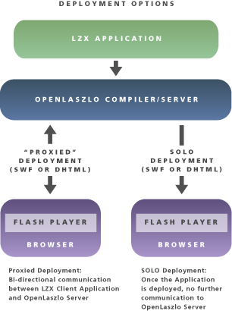
Figure 1: Open Laszlo architecture, source (Laszlo 2008)
OpenLaszlo applications can be made available on the web (Laszlo 2008) in either of two ways: a server is stored locally in the client computer or a compiler. The OpenLaszlo architecture is designed to support multiple device types. Its dynamic layout mechanisms enable simple modifications to such properties as an application's overall size to be intelligently applied by the platform. This simplifies adapting an application to work on screens and devices of different size.

Several Interfaces, Single Logic (Sisl)
The Several Interfaces, Single Logic (Sisl) (Lucent 2000) is a XML-Based language for designing and implementing interactive services with multiple user interfaces. A key idea underlying Sisl is that all user interfaces to a service share the same service logic (Lucent 2000), which provides a high-level abstraction of the service/user interaction. The Sisl implementation supports Java applets, HTML using the Java Servlet API, VoiceXML and the TelePortal platform.

Microsoft Extensible Application Markup Language (XAML)
The Extensible Application Mark-up Language (XAML) (Microsoft 2009) is a markup language for declarative application programming. Windows Presentation Foundation (WPF) implements a XAML loader and provides XAML language support for WPF types to create UIs. In addition, the SDK includes an editing tool called XAMLPad.
XAML from WPF is the XAML variant to specify UIs. XAML syntax uses concrete user interface concepts such as: button, menu item, context menu, textbox. Other concepts related to an application such as: data, control, graphics, security, data binding are also part of the WPF specification.
While XAML is not a UIDL per se but their concepts are of interest for the concrete user interface development.

eXtensible User interface Language (XUL)
The Extensible User Interface Language (XUL) is a Mozilla’s XML-based language for describing window layout. The goal of XUL is to build cross platform applications, making applications easily portable to all of the operating systems on which Mozilla runs.
XUL provides a clear separation among the client application definition and programmatic logic, presentation (”skins” consisting of CSS and images), and language-specific text labels. As a result, the "look and feel” of XUL applications can be altered independently of the application definition and logic.
A UI is described as a set of structured interface elements (windows, menu bar, scrollbar, button ...), along with a predefined list of attributes. Scripts that allow interaction with the user are added. Furthermore, to build cross platform web applications, some bindings can be made between XUL and other technologies introduced by Mozilla:
- the eXtensible Bindings Language (XBL) which is a markup language that defines new elements (methods, content, properties) for XUL widgets;
- Overlays that are XUL files used to describe extra content for the UI;
- XPCOM/ XPConnect that allows the integration of new libraries and
- XPInstall that provides a way to package XUL application. XUL has its focus on window-based graphical user interfaces. This focus is also a limit. XUL is not applicable to interfaces of small mobile devices. Furthermore, there are no abstractions of interaction functionality available.

W3C Recommendations

Device Independent Authoring Language (DIAL)
The Device Independent Authoring Language (DIAL) (W3C 2007a) is a markup language for the filtering and presentation of Web page content available across different delivery contexts. The delivery context is a set of attributes that characterizes the capabilities of the access mechanism, the preferences of the user and other aspects of the context into which a web page is to be delivered, Figure 2. In particular, the capabilities of the device, including the modalities and representations it supports, the characteristics of the network over which delivery occurs, and the preferences of the user will all potentially affect the user experience provided (W3C 2003). The delivery context is composed of the following characteristics (W3C 2007b):
- Device characteristics. Properties such as the physical size of the display, its color capabilities and whether or not it has a pointing device, media types of image that it can display during browsing, the application that is of major interest is the browser on the device.
- Network characteristics. The characteristics of the network in use, for instance, if a device is connected over a low bandwidth network, a more compressed variant of a media resource might be chosen than when a higher bandwidth network is available.
- User preferences. Preferences concerning the way in which information is presented.
- Dynamic characteristics. Characteristics used for adaptation that can be dynamic. They may change while the device is being used to access the Web.
- HTTP request context. HTTP provides headers that are potentially useful in adaptation. The HTTP specification mentions that it is also possible for a server to use any other information from the request, including parameters, in choosing the representation to be returned during server-driven negotiation. While such information does not replace the need for other delivery context, it is certainly a useful source of characteristic values that may not be available elsewhere.

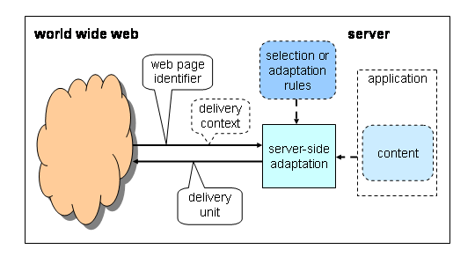
Figure 2: Delivery context, source (W3C 2003).

The selection of the content to be delivered is based on selection rules using the content selection specification. Content Selection for Device Independence is a specification that allows authors to choose between different versions of content for use in different circumstances (W3C 2007b). Adaptation of the UI can be done using CSS files or XHTML methods for content selection. Also rules can be defined in two ways (W3C 2007b):
- Selection: Adaptation by selection involves choosing between different versions of materials according to some set of criteria. Often, selection involves picking one particular variant of a specific resource. For example, several different variants of a particular image might have been prepared to support different delivery contexts.
- Transformation: Adaptation by transformation involves creating a new version of some material according to some set of criteria. Returning to the example of images, there may be situations in which it is not appropriate or not feasible to create all of the required variants. In addition to changes in size and possibly color depth, transformations may also be required to encode and compress the resulting image differently, to suit the requirements of the delivery context.
Finally, web content is mainly described using XHTML tags, the new features added are those related to the device independent (DI) to access the Web using PCs, PDAs, web-enabled phones, and interactive TVs.

Extensible MultiModal Annotation markup language (EMMA)
The Extensible MultiModal Addnotation Markup Language (EMMA) is a W3C markup language used to contain and annotate information automatically extracted from the input of users which manipulate multi modal UIs (W3C, 2008). The language is capable to convey meaning for different types of single input, i.e., text, speech, handwriting and combinations of any previous modalities. These combinations are compliant with the W3C Interaction Framework (Figure 3).

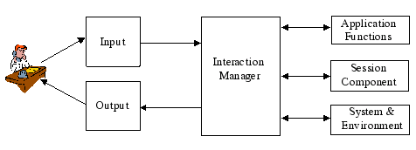
Figure 3 : W3C Multimodal Interaction Framework, Source (Stanciulescu, 2008)
The language is used as a standard data interchange format between components of a multi modal system. EMMA is intended to be automatically generated by interpretation components used to represent the semantics (not directly authored by developers) of the users' inputs. The language does not represent a specification language and does not contain any transformational approach that initiates a progressive development from different models.

Ink Markup Language (InkML)
The ink Markup Language (InkML) (W3C, 2006) is an XML data format for representing digital ink data that is input with an electronic pen or stylus as part of a multimodal system. In the context of the W3C Multimodal Interaction Framework (Figure 3), the markup provides a format for:
- transferring digital ink data between devices and software components
- storing hand-input traces for:
  - Handwriting recognition (including text, mathematics, chemistry)
  - Signature verification
  - Gesture interpretation

Voice Extensible Markup Language (VoiceXML)
VoiceXML holds an interest for our work as it is the only standardized language (W3C, 2004) enabling vocal interaction extensively used in industry applications. Its main goal is to provide web development and content delivery to voice applications, and to free the authors of such applications from low-level programming and resource management. It enables integration of voice services with data services using the traditional client-server paradigm. A voice service is viewed as a sequence of interaction dialogs between a user and an implementation platform. The dialogs are provided by document servers, which may be external to the implementation platform. Document servers maintain overall service logic, perform database and legacy system operations, and produce dialogs. A VoiceXML document specifies each interaction dialog to be conducted by a VoiceXML interpreter. User input affects dialog interpretation and is collected into requests submitted to a document server. The document server replies with another VoiceXML document to continue the user's session with other dialogs.
VoiceXML provides language features to support complex dialogs:
- Output of synthesized speech (text-to-speech)
- Output of audio files
- Recognition of spoken input
- Recognition of DTMF input
- Recording of spoken input
- Telephony features.

XForms
XForms (W3Cc, 2007) separates the presentation from the data, keeping the principle of separation of concepts, allowing reuse and device independence. XForms is not a free-standing document type, but is intended to be integrated into other markup languages, such as XHTML or SVG (W3Cc, 2007). XForms, while designed to be integrated into XHTML, is no longer restricted only to be a part of that language, but may be integrated into any suitable markup language. Further, this characteristic is further illustrated in the Ideal Language (Cantera, Diaz, Rodriguez, 2008).
XForms splits XHTML forms in three models (W3Cc, 2007):
- XForms Model. This element represents a form definition and is used as a container for elements that define the XForms Model. No restriction is placed on how many model elements may exist within a containing document.

- Instance data. Instance data can directly submit the data collected as XML. To connect this instance data with form controls, the ref attributes on the form controls need to be changed to point to the proper part of the instance data, using binding expressions.
- User Interface. An abstract User Interface description is used. Concepts such as: output, input, trigger, submit, range, select, selct1, choice, secret, upload, alert, hint, help, and label. Action Events: message (output), send, rebuild, dispatch, revalidate, setfocus, load, refresh, recalculate, setvalue, reset, toggle, insert, delete, setIndex. Finally, relations: group, switch (case), repeat, bind.

Interaction Techniques Markup Language (InTml)
Interaction Techniques Markup Language (InTml) (Figueroa, Green & Hoover, 2002) is a XML-based language for defining virtual reality (VR) content. A VR application is seen as a dataflow of interconnected filters, which are the building blocks that describe the standard connections for any entity. An entity can be: input or output devices, interaction techniques, object behavior, animations, geometric objects, and other media objects. InTml is a black box for details such as: device description and functionality or object behavior, as these components are coded and just a set of available services (Figueroa et al. 2002). Also, geometry or other media types related to VR objects are produced in any of the available tools for that purpose, such as: Maya, 3D Max, or Blender. InTml is then an integration language for all elements involved in VR applications. It enables the designer to concentrate on the architecture of the application, without dealing with too many details (Figueroa, 2004).
As an example, while dataflow–based languages such as VRML focuses on description of geometry and animation, InTml focuses on the integration of application–specific behavior, object behavior and events from input devices, which is a tedious task in VRML, less complicated actually in X3D. Geometry is something that is described at a lower level, in a loadable format, and InTml refers to it as a reference to an object (Figueroa et al. 2002). The same can be applied to sound or haptic content.
InTml ontology, Figure 4, is composed by two main components: a filter and behavior description. A filter is an abstract building block that represents: any device, interaction technique, behavior, or content in a VR application. Its interface is defined in terms of input and output ports (IPort and OPort), 28 events are handled or defined for them.
The behavior description corresponds to the dialog specification. Objects and device models are independent of implementation. InTml mechanism starts with the specification of the project goals and the definition of the main tasks; everything is documented in InTml documents, which are refined through the process (Figueroa, 2004).

Figure 4: Entities and Relationships of InTML, Source (Figueroa, 2004)

eXtensible Interface Scenario Language (XISL)
XISL (eXtensible Interaction Scenario Language) (Katsurada et al. 2003) is a web-based language that is supported by a tool enabling the development of multi modal UIs based on interaction scenarios between the user and the system. The goal of XISL is to provide a common language supporting Multi Modal interaction that is characterized by three main features:
- Control dialog flow/transition: feature employed from VoiceXML
- Synchronize input/output modalities: feature employed from SMIL
- Modality-extensibility: ensured by XISL.
For this purpose, the language ensures the separation of the content (stored in XML/HTML files) from the interaction (described in XISL documents). This provides advantages in terms of: (1) reusability of the content and/or interaction, (2) improvement of specification’s readability. Moreover, it supports the following types of cooperation between modalities: parallel input/output, sequential input/output, alternative input. The user, system or mixed initiative is supported by XISL for all the compliant devices: (i.e., PCs, mobile phones, PDAs). New devices could also be considered thanks to the use of non strict values of the elements specifying the input/output.

eXtensible mark-up language for MultiModal interaction with Virtual Reality worlds (XMMVR)
The eXtensible mark-up language for MultiModal interaction with Virtual Reality worlds (XMMVR) introduced by (Olmedo, Escudero, & Cardenoso in 2008) as its name indicates is used to specify multi modal (Voice and graphical interaction) with virtual reality. XMMVR is a mark-up language for defining scene, behaviour and interaction where every element in the world or interactive movie is considered an xmmvr element, using the cinematographic movie metaphor (Olmedo et al. 2008). XMMVR is mainly based on VoiceXML for the vocal interaction, VRML for specifying the virtual scene, and ECA rules for the behavior. The XML-schema of the language can be seen in Figure 5.

Figure 5: XMMVR Schema
XMMVR based system is event driven, so that a minimum list of events will have to be defined and it does not exist a time line. An xmmvr element will be formed mainly by the cast of actors, element “cast” and by the sequence of scenes, element “sequence” that marks the passing of the world. Besides we reserve an element “context” for internal use (Olmedo et al. 2008).

Analysis on User Interface Description Languages
In this section, the main contributions of XML-compliant languages for the definition of UIs are analyzed, based on the available literature and tools.

Dialog and Interface Specification Language (DISL)
DISL (Dialog and Interface Specification Language) (DISL) (Schaefer, Steffen, & Wolfgang, 2006) is an UIML (see section 3.8 for more details) subset that extends the language in order to enable generic and modality independent dialog descriptions.
Modifications to UIML mainly concerned the description of generic widgets and improvements to the behavioral aspects. Generic widgets are introduced in order to separate the presentation from the structure and behavior, i.e., mainly to separate user- and device-specific properties and modalities from a modality-independent presentation. The use of generic widget attribute enables to assign each widget to a particular type of functionality it ensures (e.g., command, variable field, text field, etc.). Further, a DISL rendering engine can use this information to create interface components appropriated to the interaction modality (i.e., graphical, vocal) in which the widget will operate.
The global DISL structure consists of an optional head element for Meta information and a collection of templates and interfaces from which one interface is considered to be active at one time. Interfaces are used to describe the dialog structure, style, and behavior, whereas templates only describe structure and style in order to be reusable by other dialog components.
Current implementations of DISL language include media player application for mp3 files on mobile devices with limited resources or players run on PCs but controlled remotely from mobile phones.

Generalized Interface Markup Language (GIML)
The Generalized Interface Markup Language (GIML) is a language used for the generalized Interface Toolkit (GITK), both introduced by (Kost, 2004). GIML is used in this context as an interface descriptor. Following the OMG principles of separation of concerns, GIML splits functionality and presentation. While the functionality is preserved in GIML the UI is derived from XSL files (XSL profiles in Figure 6), which come from user and system profiles. This information is merged with the functional descriptions by using XSLT to form a final interface description. The profile data could come directly from a file−system or from a remote profile server (Kost, 2004). GIML avoids the use of concepts such as "push-button", "scrollbar", whereas GIML uses terms such as "action", "data-entry/value- choice/single/limited". The goal is to use interface patterns in the future. These media neutral identifiers are the foundation for an interface object hierarchy.

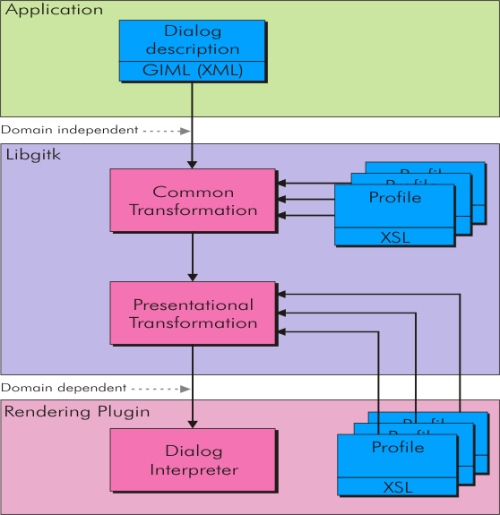
Figure 6: GIML Transformational approach, Source (Kost, 2004)
In Figure 6 the transformational approach based on XSLT transformations is depicted. First a given XSL is applied to the dialog description. The images show that the XML dialog description is provided by the application. Further one can see that additional information comes from "profiles" in the form of XSL stylesheets. These are provided by the core system and the rendering modules. Concepts supported by this language are (Kost, 2004):
- Application: it delivers the functional dialog description and the event handling coded in C, C++, Java or Pearl.
- Wrapper: these components allow the application developer to "freely" choose the preferred language for development, C++, Java or Pearl.
- Core: this component is the only one the application talks to and forms the basic infrastructure, it further manages everything else (plug-ins, transformation pipeline, etc.).
- Transformer plug-ins: these modules provide media neutral transformation (independent of the target domain).
- Renderer plug-ins: these are interpreters which generate and run the final interface two graphical for Web based and for GITK, and a text one for keyboard input.
As GITK can support multiple programming languages and operate the interface on different targets (media) it uses a flexible transformation pipeline and adaptation methods (transformations) are separated from the infrastructure.

Multiple Device Markup Language (MDML)
The Multiple Device Markup Language (MDML) (Johnson & Parekh, 2003) is based on XUL. The specified concepts are the following: navigation, layout and components for a generic GUI. A rule system is defined as well to map specifications to different devices considering the device: memory, display capabilities and internal representation of the data. Although a general representation can be used for all devices, this is sometimes thought to be too simplistic, thus the direction the User Interface framework will follow will produce a different rule set for different devices or perhaps produce different rule sets for the same device.
The architecture, Figure 7, uses Java-based transformation engine. The use of XSLT was found to be too complicated to maintain and even more to reuse as transformation rules where case study dependent. There are four parts in the architecture rule engine, display engine, handler, and code generation. The rule engine will parse the rule file. The display engine will parse the MDML file and handle the layout. The handler will generate a XML file based on the generalized class – class.dtd. The code generation will generate an executable language file. All three parts are Java based applications. The properties file contains specific pieces of information needed by the rule and display engine (Johnson & Parekh, 2003).
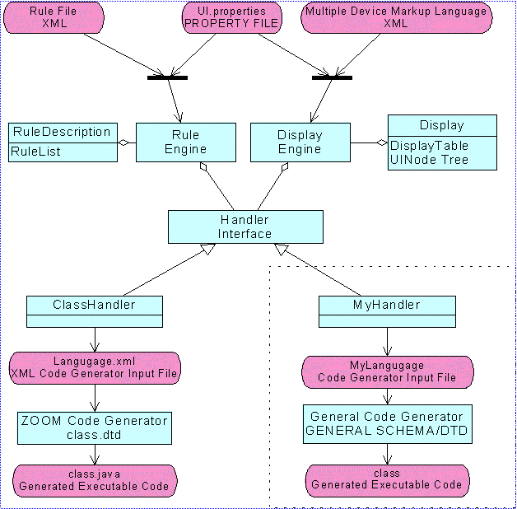
Figure 7: MDML Architecture, source (Johnson et al. 2003)
There are four profiles: desktop, web, mobile and voice. For each profile there are different supported languages or constraints to be considered accordingly to the components of the architecture. All profiles respond differently, Table 1, to the layers of the architecture (Johnson & Parekh, 2003):
- Rule engine. The rule engine is responsible for reading the rule file -- i.e. rule.XML. The rule file has three sections <profile>, <tag>, and <event>. The <profile> tag may contain these tags <import>, <toolkit>, <accessor> and <topfunction>. The <import> tag is used for any imports or includes that must be specified at the beginning of any language file.
- Display engine. The display engine is responsible for reading the initial MDML file into memory and changing layout as desired by the rules. The display engine uses Document Object Model (DOM) to initially capture the MDML file into memory.
- Handler/Code Generation. The handler is general interface that contains access to the rule set and the MDML display object. To produce executable code this project uses the ZOOM Code Generator.

 | Desktop | Web | Mobile (cellular phone and PDA) | Voice
Rule Engine | The <widget> tag must  specify the GUI toolkit mapping |  | PDA substitutes <mouse> for <pen> tags | Nothing especial
Display engine | Maximum set of available widgets displayed |  | Nothing especial | Nothing especial
Code Generation | swing, SWT, .Net (C#, C++, VB) | HTML, XHTML, JSP, .Net | J2ME | VoiceXML
Memory | No constraint | No constraint | Two profiles: less than 2MB memory and those with 2MB or greater memory. | No constraint
Dimensions (screen size) | No constraint | Screen length and width depend on the browser; but usually this is not an issue for display. | MIDlets | Layout in terms of navigation.
Event model | Java Swing based naming | Not specified | Not specified | Not specified
Table 1: MDML profile special characteristics
For Table 1 it can be seen that, depending on the target profile, in some cases there was no information available to fill the table, so the not specified label is used. The memory, dimension and event model are part of the code generation layer. Using this framework requires thinking about design first and code later since the code is automatically generated (Johnson & Parekh, 2003).

Renderer-Independent Markup Language (RIML)
RIML is a markup language based on W3C standards that allows document authoring in a device independent fashion In 2003 the language was presented in a workshop (Demler, Wasmund, Grassel, Spriestersbach, & Ziegert, 2003) but unfortunately the main results of the project, including more details on the language are no longer available. We include this language as being the result of The Consensus European Project, and it is the source of inspiration of an existing vendor language D3ML.
RIML was based on standards such as: XHMTL 2.0 and XFORMS. Special row and column structures are used in RIML to specify content adaptation. Their semantics is enhanced to cover pagination and layout directives in case pagination needs to be done (Demler et al., 2003). Due to the use of XForms RIML is device independent and can be mapped into a XHTML specification according to the target device. It introduced for the first time a mechanism to handle pagination. In this sense it was possible to specify how to display a sequence of elements of the UI. Traditionally displayed in a row, it was possible to displayed in different windows and create navigation button to go from one window to another, forward and backward. The available screen surface was assumed to be too small to display the entire list at once. Pagination was applied resulting in several pages. Besides that, hyperlinks to switch between the pages are included (Demler et al. 2003).
A main design goal for RIML was to simplify authoring with respect to device knowledge (Demler et al. 2003). The presented layout structuring was largely independent of device characteristics. Both, container definitions and nesting, are fully "device independent". Width indications were content related, i.e. device independent. An author specifying the preferred width as the equivalent he would like to see for a container when presented on an unconstrained screen. The minimal value is the one he assumes to make sense for the container content.

Software Engineering for Embedded Systems using a Component-Oriented Approach (SeescoaXML)
Seescoa described in (Luyten, K., Abrams, M., Vanderdonckt, J. & Limbourg, Q., 2004) consists of a suite of models and a mechanism to automatically produce different FUIs at runtime for different computing platforms, possibly equipped with different input/output devices offering various modalities (e.g. a joystick). This system is context-sensitive as it is expressed first in a modality-independent way, and then connected to a specialization for each specific platform. The context-sensitivity of the UI is here focusing on computing platforms variations. An AUI is maintained that contains specifications for the different rendering mechanisms (presentation aspects) and their related behavior (dialog aspects). These specifications are written in a XML-compliant User Interface Description Language (UIDL) that is then transformed into platform-specific specifications using XSLT transformations. These specifications are then connected to a high-level description of input/output devices. A case study is presented that automatically produces three Final UIs at run-time: for HTML in a Web browser, for Java with Abstract Window Toolkit (AWT) on a Java-enabled terminal, and for Java with Swing library. Although the process is straightforward, generated UIs appear to have the same layout of final objects, but coming from the same CIOs.
To produce context-sensitive UIs a translation is performed at the abstract level before going down in the framework for each specific configuration (here restricted to a platform). No concepts or task models are explicitly used in this version. The entry point of this forward engineering approach is therefore located at the level of Abstract UIs. Dygimes (Luyten et al., 2004) is an extended version of Seescoa that adopts the same approach as in Seescoa, except that the AUI is obtained from a CTT task model (Paternò 2000) that is progressively transformed into a priority tree as a starting point for obtaining the AUI.

Simple Unified Natural Markup Language (SunML)
SunML (Picard, Fierstone, Pinna-Dery, & Riveill, 2003.) is an XML language to specify concrete user interfaces that can be mapped to different devices (PC, PDA, voice). The innovation of this language is the capacity to specify dynamically components. SunML is composed of a series of basic concepts to describe the UI that are:
- Element: an element distributes information from the user to the systems. It has a data type (string, integer, float, Boolean). This node is fundamental as it the leaf of the decomposition. Mapping of an element corresponds typically to labels, text fields in the graphical mode and using the vocal channel it could be the action of the system to synthesize text to speech.
- Field: this field is used to recover information from the user. Its functionality is linked with the widget it represents.
- Link: a link refers to the execution of something in particular. Traditionally referred as controls, links can be associated to buttons, menu items, speech recognition grammar. In any case, the use initiates the interaction.
- List: a list groups several elements with the objective of presenting them in a list of values or actions. The element is more complex than the previous ones as it can be composed of other elements.
- Dialog: a dialog is a list that regroups widgets in order to create a dialog among them. The dialog can be mapped to a dialog box full of widgets or a vocal interactive dialog.

Figure 8: SunML Meta-Model, source Picard et al. 2003

This reduced set of elements seems to be not enough but the composition of widgets is used to specify more complex widgets. For instance a list of elements can be mapped to a comboBox or a list of links to a menu.
In SunML it is also possible to encapsulate the style and the content of each widget independent of the others. Two different files are used for that purpose:
- The style can be defined directly using the tag property or store it in a cascade style sheet (CSS) file.
- The content is also stored in a file stored in the client, to avoid excessive data transform from the client and the server.
Figure 9: SunML example, source Picard et al. 2003
Another interesting feature offered in SunML is widget composition, Figure 10. They have some operators on the UI to merge two UI: union (semantically-common widgets), intersection, subtraction, substitution, inclusion. Widgets Merging Language (WML) is the extension used for that purpose.

Figure 10: Union between two interfaces, source Picard et al. 2003

Maria (MariaXML)
(Paternò & Santoro, 2003) introduced a method for producing multiple FUIs for multiple computing platforms at design time. They suggest starting with the task model of the system, then identifying the AUI specifications in terms of its static structure (the presentation model) and dynamic behavior (the dialog model): such abstract specifications are exploited to drive the implementation. This time, the translation from one context of use to another is operated at the highest level: task and concepts. This allows maximal flexibility, to later support multiple variations of the task depending on constraints imposed by the context of use. Here again, the context of use is limited to computing platforms only. The whole process is defined for design time and not for run-time. For instance, there is no embarked model that will be used during the execution of the interactive system, contrarily to the Seescoa approach analyzed in this review. Te resulting language from this effort was called TeresaXML, a UIDL for producing multiple final UIs for multiple computing platforms at design time.
The language evolved in Time and turned into MariaXML (Paternò & Santoro, 2003). This language support dynamic behaviours, events, rich internet applications, multi-target user interfaces, in particular those based on web services. In this way, it is possible to have a UI specified in MariaXML attached to a web service. MariaXML relies on the multi-layer levels of the Cameleon Reference Framework. Thus it describes concepts like: Data objects manipulated by interactors, Events for abstract and concrete UI, Dialogue Model with conditions and CTT operators for event handlers, scripts like Ajax; and dynamic set of user interface elements. All these models are supported by the software Mariae (Maria Environment) using task modelling (using ConcurTaskTrees notation) and UI modelling (MARIA language).
At the AUI level, the tool provides designers with some assistance in refining the specifications for the different computing platforms considered. The AUI is described in terms of Abstract Interaction Objects (AIOs) (Vanderdonckt & Bodart 1993) that are in turn transformed into Concrete Interaction Objects (CIOs) (Vanderdonckt & Bodart 1993) once a specific target has been selected. MariaXML AUI is composed by various Presentations that groups model elements, which are presented to the user at once. The model elements are of two types: Interactor or InteractorComposition. The former represents every type of user interaction object, the latter groups together elements that have a logical relationship. According to its semantics an interactor belongs to one the following subtypes:
- Selection. Allows the user to select one or more values among the elements of a predefined list. It contains the selected value and the information about the list cardinality. According to the number of values that can be selected, the interactor can be a Single Choice or a Multiple Choice.
- Edit. Allows the user to manually edit the object represented by the interactor, which can be text (TextEdit), a number (NumericalEdit), a position (PositionEdit) or a generic object (ObjectEdit).
- Control. Allows the user to switch between presentations (Navigator) or to activate UI functionalities (Activator).
- Onlyoutput. Represents information that is submitted to the user, not affected by user actions. It can be a text a Description that represents different types of media, an Alarm, a Feedback or a generic Object.
The different types of interactor-compositions are:
- Grouping: a generic group of interactor elements.
- Relation: a group where two or more elements are related to each other.
- CompositeDescription: represents a group aimed to present contents through a mixture of Description and Navigator elements.
- Repeater which is used to repeat the content according to data retrieved from a generic data source
MARIA allows describing not only the presentation aspects but also the interactive behaviour. For this purpose it has various features:
- Data Model. The interface definition contains description of the data types that are manipulated by the user interface. The interactors can be bound with elements of the data model, which means that, at runtime, modifying the state of an interactor will change also the value of the bound data element and vice-versa. This mechanism allows the modelling of correlation between UI elements, conditional layout, conditional connections between presentations, input values format. The data model is defined using the standard XML Schema Definition constructs.
- Generic Back End. The interface definition contains a set of ExternalFunctions declarations, which represents functionalities exploited by the UI but implemented by a generic application back-end support (e.g. web services, code libraries, databases etc.). One declaration contains the signature of the external function that specifies its name and its input/output parameters.
- Event Model. Each interactor definition has a number of associated events that allow the specification of UI reaction triggered by the user interaction. Two different classes of events have been identified: the Property Change Events that specify the value change of a property in the UI or in the data model (with an optional precondition), and the Activation Events that can be raised by activators and are intended to specify the execution of some application functionalities (e.g. invoking an external function).
- Dialog Model. The dialog model contains constructs for specifying the dynamic behaviour of a presentation, specifying what events can be triggered at a given time. The dialog expressions are connected using CTT operators in order to define their temporal relationships.
- Continuous update of fields. It is possible to specify that a given field should be periodically updated invoking an external function.
- Dynamic Set of User Interface Elements. The language contains constructs for specifying partial presentation updates (dynamically changing the content of entire groupings) and the possibility to specify a conditional navigation between presentations.
This set of new features allows having already at the abstract level a model of the user interface that is not tied to layout details, but it is complete enough for reasoning on how UI supports both the user interaction and the application back end.
Figure 11 shows the overall class diagram of the AUI meta-model, while Figure 12 shows the possible interactor categories.
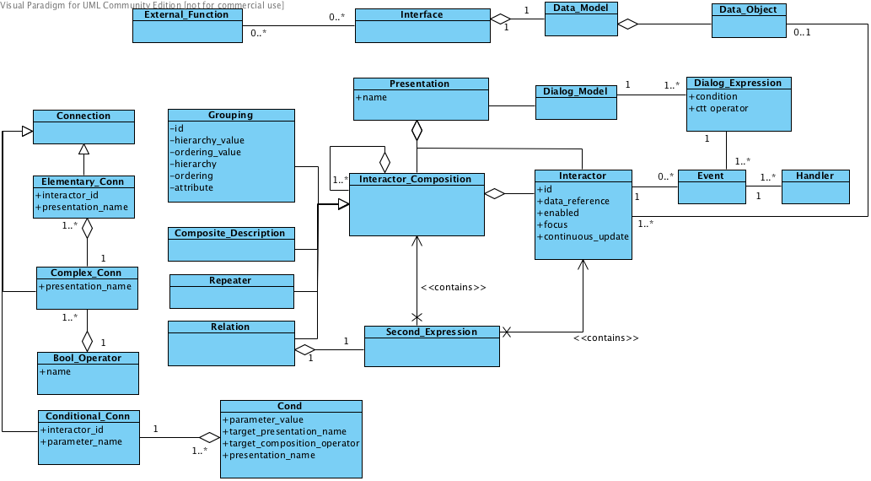
Figure 11: MariaXML AUI Meta-Model
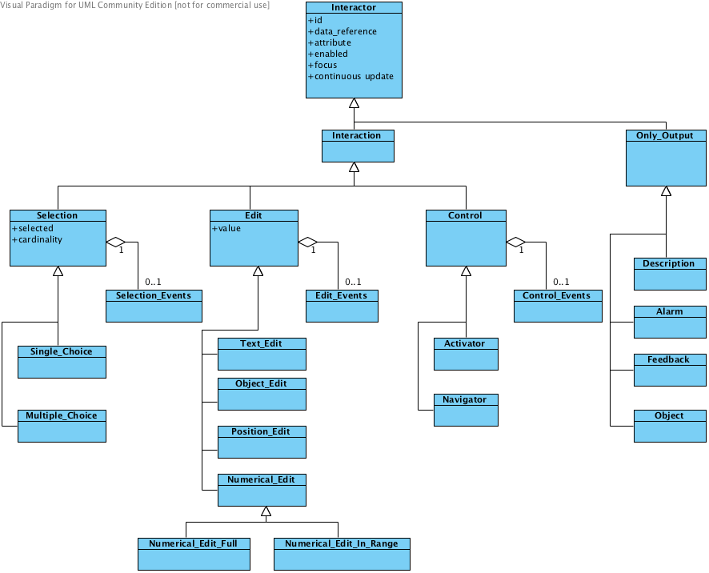
Figure 12: MariaXML Interactor Taxonomy
A Concrete User Interface (CUI) in MARIA provides platform-dependent but implementation language-independent details of a UI. A platform is a set of software and hardware interaction resources that characterize a given set of devices. MARIA currently supports the following platforms:
- Desktop CUIs model graphical interfaces for desktop computers.
- Mobile CUIs model graphical interfaces for mobile devices.
- Multimodal Desktop CUIs model interfaces that combine the graphical and vocal modalities for desktop computers.
- Multimodal Mobile CUIs model interfaces that combine the graphical and vocal modalities for mobile devices.
- Vocal CUIs interfaces with vocal message rendering and speech recognition.
Each platform meta-model is a refinement of the AUI, which specifies how a given abstract interactor can be represented in the current platform. For instance, if we consider the abstract Single Choice interactor, it can be implemented (on a graphical desktop platform) with a radio button, a drop down list or a list box, while on the vocal platform it can be rendered with a list of vocal messages for each option associated to a given keyword.
The same applies for the interactor compositions: in a desktop platform a grouping can be implemented using background colours, borders etc., while in a vocal platform it is possible to use sounds before the first group element. The model definition can be exploited for creating (or deriving with a code generator) final implementations in different target languages. Indeed, it is possible to exploit the same mobile CUI for representing an interface for the iPhone or an Android device.

User Interface Markup Language (UIML)
UIML (Helms, Schaefer, Luyten, Vanderdonckt, Vermeulen & Abrams, 2008) is an XML-based language that provides: (1) a device-independent method to describe a UI, (2) a modality-independent method to specify a UI.
UIML allows describing the appearance, the interaction and the connection of the UI with the application logic. The following four key concepts underlie UIML:
- UIML is a meta-language: UIML defines a small set of tags (e.g., used to describe a part of a UI) that are modality-independent, target platform-independent (e.g., PC, phone) and target language-independent (e.g., Java, VoiceXML). The specification of a UI is done through a toolkit vocabulary that specifies a set of classes of parts and properties of the classes. Different groups of people can define different vocabularies: one group might define a vocabulary whose classes have a 1-to-1 correspondence to UI widgets in a particular language (e.g., Java Swing API), whereas another group might define a vocabulary whose classes match abstractions used by a UI designer
- UIML separates the elements of a UI and identifies: (a) which parts are composing the UI and the presentation style, (b) the content of each part (e.g., text, sounds, images) and binding of content to external resources, (c) the behavior of parts expressed as a set of rules with conditions and actions and (d) the definition of the vocabulary of part classes.
- UIML groups logically the UI in a tree of UI parts that changes over the lifetime of the interface. During the lifetime of a UI the initial tree of parts may dynamically change shape by adding or deleting parts. UIML provides elements to describe the initial tree structure and to dynamically modify the structure.
- UIML allows UI parts and part-trees to be packaged in templates: these templates may then be reused in various interface designs.
To create multiplatform UIs, concept 1 is used to create a vocabulary of part classes (e.g., a class Button) and concept 2 is used to separately define the vocabulary by specifying a mapping of the classes to target languages (e.g., mapping class Button to class java.awt.Button for Java and to the tag <button> for HTML 4.0). To create Multi Modal UIs, a multiplatform UI should be created and then each part is annotated with its mode (e.g., which target platforms uses that part). The behavior section from concept 2 is then used to keep the interface modalities synchronized. For example, it might be defined a UIML part class called Prompt, the mapping of Prompt parts to VoiceXML and HTML, and the behavior that synchronizes a VoiceXML and HTML UI to simultaneously prompt the user for input.

USer Interface eXtensible Markup Language (UsiXML)
The main characteristics of UsiXML:
- UsiXML is structured according to different levels of abstraction defined by the Cameleon reference framework (Calvary, Coutaz, Thevenin, Limbourg, Bouillon, & Vanderdonckt, 2003). The framework represents a reference for classifying UIs supporting a target platform, the AHMI, and a context of use and enables to structure the development life cycle into four levels of abstraction: task and concepts, abstract UI (AUI), concrete UI (CUI) and final UI (FUI). The AHMI development just considers CUI and FUI for the development cycle. Even that not currently used, it might be useful to consider that in UsiXML the identification of the four levels and their hierarchical organization is built upon their independence with respect to the context in which the FUI is used. Thus, the Task and Concepts level is computational-independent, the AUI level is modality-independent (In the cockpit it can be several physical, Vocal, GUI, Tactile) and the CUI level is toolkit-independent.
- UsiXML relies on a transformational approach that progressively moves from the level to the FUI, the running AHMI.
- The transformational methodology of UsiXML allows the modification of the development sub-steps, thus ensuring various alternatives for the existing sub-steps to be explored and/or expanded with new sub-steps. Thus helping in the exploration of different solutions for the final representation of the AHMI and its evaluation in the cognitive model.
- UsiXML has a unique underlying abstract formalism represented under the form of a graph-based syntax.
- UsiXML allows reusing parts of previously specified AHMI in order to develop new applications. This facility is provided by the underlying XML syntax of UsiXML which allows the exchange of any specification. Moreover, the ability to transform these specifications thanks to a set of transformation rules increases their reusability.
- The progressive development of UsiXML levels is based on a transformational approach represented under the form of a graph-based graphical syntax. This syntax proved to be efficient for specifying transformation rules and an appropriate formalism for human understanding.
- UsiXML ensures the independence of modality (Ability to model a UI independent of any modality) thanks to the AUI level which enables the specification of UIs that remains independent of any interaction modality such as physical, graphical, vocal or 3D interaction. This plays a very important role in the context of HUMAN because it allows the design of UIs that are not dependent on the modality of interaction. For instance, currently the autopilot is triggered by pressing physical buttons, and if for any reason a button in a touch screen is used to trigger the autopilot instead of physical buttons then the concretization of the AUI changes. However, the AUI would remain the same as it is still referring.
- UsiXML supports the incorporation of new interaction modalities thanks to the modularity of the framework where each model is defined independently and to the structured character of the models ensured by the underlying graph formalism, thus, it has the property of being extendible to new modalities. The interaction in the AHMI is through direct manipulation of a touch path, if in the future different modalities of interaction are added then they can be added as well to UsiXML without any problem.
- UsiXML is supported by a collection of tools that allow processing its format; it has the property of being machine processable of involved models.
- UsiXML allows cross-toolkit development of interactive application thanks to its common UI description format.

Web Service eXperience Language (WSXL)
The web service experience language (WSXL) by (IBM, 2002) was designed to represent data, presentation and control. Also, as a language for web applications it considers context adaptation that can run in three different modalities:
- Directly using an existing backend application. This application can then be adapted, if desired, and used to serve direct client access or embedded within a remote application
- Local Portal. Two levels of distributors in the application supply chain gain value from the same software service endpoint. The generator provides the same data as in the first case but a local portal uses this input and could add extra data.
WSXL relies on existing standards, Figure 13; in particular, XML based standards such as XPath, XML Events, DOM, XForms and XLink as well as Web Services standards such as SOAP, WSDL and WSFL. Concepts (IBM, 2002) such as:
- WSXLServiceDescription. This portType provides a basic inquiry operation that allows a client to request the WSDL service description document (particularly useful when the service was not discovered through UDDI) and inquire whether or not a particular portType is supported.
- WSXLLifecycle. Lifecycle (indirectly refer to particular instances in subsequent calls) manager for components and collections.
- WSXLProperties. A WSXL component must implement property management operations whereby clients can modify properties at times other than initialization.
- WSXLOutput. Operations related to the markup for the service.

Figure 13: WSXL Meta Model, source IBM (2002).
- Data Component. The WSXL data component is based on the data functionality in XFORMS, and includes both XFORMS model and instance functions. WSXL data components may be connected to data sources external to WSXL applications.
- Presentation component. WSXL presentation components may generate output markup in any target XML language and should indicate which languages may be requested.
- Control Component. The WSXL control component implements portTypes used to manage the arcs binding data components to presentation components, to parse and interpret the XLINK -based control language specification described below, and to implement a processing model that controls the propagation of event notifications in both directions between data and presentation.
WSXL includes an extensible Adaptation Description Language where explicit locations of adaptation points, the permissible operations on adaptation points (e.g. insert, delete, modify), and the constraints on the contents of adaptation (e.g. via an XML Schema) can be specified. The Adaptation Description Language can be used during a post-processing step where the output of a WSXL component can be adapted independently without invoking the component.

eXtensible user-Interface Markup Language (XICL)
The eXtensible user Interface and Component markup Language (XICL) (Sousa & Leite, 2003) is an easy way to develop User Interface Components to Browser-based software. New UI components are created from HTML components and others XICL components. The XICL description is translated into DHTML code.

An XICL documents (Figure 20) is composed by a user INTERFACE description composed by HTML or XICL elements and several COMPONENTS (Structure, Properties, Events and Methods (Sousa et al. 2003). The main contributions that the authors attribute to the language are:
- Reusability, easy to reuse UI components.
- Extensibility, creating new components extending existing ones.
- Abstraction, more powerful components
- Portability, run in the most of browsers
- Standardization, a common language to reuse and to extend components
- Productivity, it should enhance development productivity

eXstensible user-Interface Markup Language (XIML)
The presentation model is written in the eXstensible user-Interface Markup Language (XIML) (Eisenstein, Vanderdonckt & Puerta, 2000; Eisenstein, Vanderdonckt & Puerta, 2001), a language developed by Redwhale Software, derived from XML and able to store the models developed in MIMIC (Puerta, 1996). MIMIC is meta-language that structures and organizes interface models. It divides the interface into model components: user-task, presentation, domain, dialog, user, and design models. The design model contains all the mappings between elements belonging to the other models. The XIML is thus the updated XML version of this previous language.
The XIML language is mainly composed of four types of components: models, elements, attributes and relations between the elements.
Model: we can distinguish two types of models, the interface model and the model components. The first is the root of any XIML document and contains the various sub-models (model components) available in XIML. All the types of models do not have to be present and the same type of model-component can exist several times under the same interface model. The model components (task, domain, user, presentation, dialogue, platform, preferences and the general model) contain information specific to a dimension of the interface.
Element: is information describing a model-component. In the case of presentation elements, it is a unit of information describing the visual appearance of a user interface. Each presentation element may contain other presentation elements (until the simple CIO, i.e. indecomposable). For example a window is a presentation element which can contain the presentation element table which contains itself other presentation elements, etc... A presentation element can refer to an object external to the XIML code, for example an ActiveX control, an image etc... In this case, the attribute location can be used in order to specify a URL where the object could be found.
Attribute: represents a simple unit of declarative information in connection with an interface model, a model-component or an element. It is always necessary to define an attribute for then being able to declare it in a component. The definition of the attribute is composed of the list of its allowed values, the default value of the attribute, its canonical form, documentation (information on what it represents) and of its type.
Relation: defines a link between the elements and/or the models. The element to which the link refers is specified thanks to the reference attribute, containing the identifier to which the object is referred. Any relation must be defined before its use (similarly to attributes). This definition contains the classes allowed in the relation.
The presentation model is composed of several embedded elements, which correspond to the widgets of the UI, and attributes of these elements representing their characteristics (colour, size…). The relations at the presentation level are mainly the links between labels and the widgets that these labels describe. The complete meta-model for the XIML language is shown on Figure 18. Note that such a meta-model was not provided by the XIML consortium itself. Therefore, we recomposed it from the Document Type Definition and from the published articles.

UserML
UserML (Heckmann, 2006) is a UIDL to model users. This approach models are semantically using an OWL ontology, called GUMO, and it is syntactically described using the UserML language. The main concept is the situational statement representing: user model entries, context information or low-level sensor data (Heckmann, 2006). Figure 14 shows the metamodel including the five elements that compose a situational statement.
The Mainpart is an extension of the Resource Definition Framework (RDF) to represent information about the user using the interactive system, including aspects such as range of values and auxiliary to point to other ontologies. The Privacy models keep information about the permissions to share the statement with users. The Explanation model helps to clarify conflicts or problems that the user might confront; it defines the source of the problem, the creator, collect the evidence, the degree of confidence, and the method used to identify the problem. The Administration model describes the role relation of the statement with the organization. The Situation model represents temporal (start, end, durability) and spatial (location and position) aspects of the user action. Each user model is used as information to model context-aware systems in ubiquitous environments targeting mobile, speech, virtual and graphical UIs.
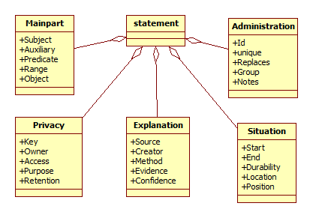
Figure 14: User Meta-Model in UserML

XooML
XooML (Jones, 2011) is language that describes aspects for supporting the development of software tools to collaborate and share documents. There is a XML Schema that is used by three different tools: Plantz (providing information to handle documents and other forms of information exchange), QuickCapture (capturing elements that can be related to information exchange), FreeMindX (mind-mapping). The XooML structure is minimal as it is composed of fragments that served as indivisible grouping of information, establishing a context for the comprehension of a selection amount its constituent associations. Although XooML is not a genuine UIDL it comprises aspects related to UIs that are of relevance when considering the definition of software tools supporting UIDL.

General Comparison
In the two previous sections, a description of the different UIDLs for UI description was given. The purpose of this section is to make a general comparison of all the previously cited languages together in a general overview. Table 2 and Table 3 compare the general properties of the different UIDLs according the six following criteria’s:
- Component models: This criterion gives the aspects of the UI that can be specified in the description of the UIs. The task model is a description of the task to be accomplished by the user, the domain model is a description of the objects the user manipulates, accesses or visualizes through the UIs, the presentation model contains the static representation of the UI and the dialog model holds the conversational aspect of the UI.
- Methodology: Different approaches to specify and model UIs exist:
  - Specification of a UI description for each of the different contexts of use. As a starting point, a UI specification for the context of use considered as representative of most case, the one valid for the context of use considered as the least constrained or finally the one valid for the context of use considered as the most comprehensive is specified. From this starting UI specification, corrective or factoring out decorations (Thevenin, 2001), e.g., to add, remove, or modify any UI description) are applied so that UI specifications can be derived for the different contexts of use.
  - Specification of a generic (or abstract) UI description valid for all the different contexts of use. This generic UI description is then refined to meet the requirements of the different contexts of use.
- Tools: Some of the languages are supported by a tool that helps designer and renders the specification to a specific language and/or platform.
- Supported languages: Specify the programming languages to which the XML-based language can be translated.
- Platforms: Specify the computing platform on which the language can be rendered by execution, interpretation or both.
- Target: A context of use (Souchon, Limbourg & Vanderdonckt, 2002) is made up of three different models: the user model, the environment model (that represents different configuration of the physical conditions in which the application is used) and finally the platform model (represents any property of the platform). This criterion is aimed at indicating which model variation the markup language was designed for (i.e., mono/multi-platform, mono/multi-user or mono/multi-environment).
- Abstraction level: each UIDL may exhibit the capability to express a runnable UI (instance level), one or many models involved in the development of this UI (model level), how these models are built (meta-model level), and what are the fundamental concepts on which this operation is based (meta-meta-model level).
Table 4 compares UIDLs according to the five following criteria:
- Amount of tags: to reach the above level of abstraction, each UIDL manipulates a certain amount of tags, which is also highly depending on the coverage of the concepts.
- Expressivity of the language: This criterion denotes not only the capability of the UIDL to express concepts of the real world, but also the easiness and the usability of manipulating them with the UIDL. If, for a same expressible concept, a first UIDL needs 5 lines of specification and another one, only 2, the latter will be said to be more concise.
- Openness of the language: This criterion informs the designer whether a UIDL sees its concepts or tags fixed or user-modifiable. A UIDL can have a fixed amount of tags while keeping the capability to introduce new concepts that have not been specified in the canonical definition.
- Coverage of concepts: depending on the level of abstraction, each UIDL may introduce some specific vs. generic concepts (e.g., a given presentation model vs. any model, each custom-defined), their properties (e.g., to what extent can a concrete presentation be specified), and their relations.
- Level of usage: depending on the usage of the language we create the following categories: 0 = unknown, 1 = one person, 2 = two or more persons, 3 = one organization, 4 = two or more organizations and 5 = massive usage.
- Publicly available: depending on the availability of the language deep analysis can be done. This category was used to discard many languages that lack on documentation or that is confidential. The possible values are: 0 = no information available, 1 = not available, 2 = poorly available, 3 = moderately available, 4 = completely available and 5 = completely available with meta-models.

Conclusion
Six years from now, a first review of UIDLs was conducted (Souchon and Vanderdonckt, 2003). That work were reviewed and updated accordingly to the progress of those UIDLs, while some works have continue, there were works with not reported update since then. In addition, to that review, new UIDLs that have been reported in the literature and are commercially available were added to this review. For space reason we did not include the complete set of UIDLs but selected those that seems more robust accordingly to the parameters that we evaluate.
There is a plethora of user interface description languages that are widely used, with different goals and different strengths. On one hand we have software vendors UIDLs and, on the other hand, there are free license UIDLs to use; also some of them can support just one platform and others are multiplatform. Some of them (as WSXL or SunML) need a few tags while others (as UsiXML) have a significant amount. Also, some of them are the result of a research project, while some other born in an industry. Considering all those characteristics it might seems hard to pick one from the list. We believe that this choice is more dictated by the goals of the project and the particular needs, even the budget available should be considered as commercial UIDLs are not available for free.
The goal of this work is aimed to help authors to decide what UIDL to use for their projects. We hope this analysis helps in understanding and comparing the components of different UIDLs in a systematic way –their strengths, limitations, and appropriateness for use. There is currently such a large number of UIDLs available that choosing among them can be time consuming and difficult to do, this comparison can assist UI designers in choosing a language suited to their purposes.

References
- Adobe (2009), Flex overview, Adobe Systems Incorporated, Available online: http://www.adobe.com/products/flex/overview/
- Abrams, M., Phanouriou, C., Batongbacal, A.L., Williams, S. & Shuster, J. (1999), UIML: An Appliance-Independent XML User Interface Language. In A. Mendelzon, editor, Proc. of 8th International World-Wide Web Conference WWW’8 (Toronto, May 11-14, 1999), Amsterdam, 1999. Elsevier Science Publishers.
- Arsanjani, A., Chamberlain, D. and et al. (2002), (WSXL) web service experience language version, 2002. Available online: http://www-106.ibm.com/developerworks/library/ws-wsxl2/.
- Demler, G., Wasmund, M., Grassel, G., Spriestersbach, A. & Ziegert, T. (2003), Flexible pagination and layouting for device independent authoring, WWW2003 Emerging Applications for Wireless and Mobile access Workshop.
- IBM (2002), WSXL specification, April 2002, retrieved on January 2nd 2009.
- Luyten, K., Abrams, M., Vanderdonckt, J. & Limbourg, Q. (2004) Developing User Interfaces with XML: Advances on User Interface Description Languages, Satellite workshop of Advanced Visual Interfaces 2004, Gallipoli, Italy.
- Eisenstein J., Vanderdonckt J., Puerta A. (2000), Adapting to Mobile Contexts with User-Interface Modeling, Proc. of 3rd IEEE Workshop on Mobile Computing Systems and Applications WMCSA’2000 (Monterey, 7-8 December 2000), IEEE Press, Los Alamitos, 2000, pp. 83-92.
- Eisenstein J., Vanderdonckt J., Puerta A. (2001), Model-Based User-Interface Development Techniques for Mobile Computing, Proc. of 5th ACM Int. Conf. on Intelligent User Interfaces IUI’2001 (Santa Fe, 14-17 January 2001), Lester, J. (Ed.), ACM Press, New York, 2001, pp. 69-76.
- Figueroa, P., Green, M. & Hoover, H. J. (2002), InTml: A Description Language for VR Applications”. Web3D'02, February 24-28, 2002. Tempe, Arizona, USA.
- Figueroa, P. (2004), Retargeting of Virtual Reality Applications. PH. D. Thesis. University of Alberta Canada.
- Gomes de Sousa, L. & Leite, J. C. (2003), XICL: a language for the user's interfaces development and its components. Proc. of the Latin American conference on Human-computer interaction (Rio de Janeiro, Brazil, August 17 - 20, 2003), ACM Press pages, New York, pp. 191-200.
- Heckmann, D. Ubiquitous User Modelling, Akademische Verlagsgesellschaft Aka GmbH, Berlin, ISBN 3-89838-297-4 and ISBN 1-58603-608-4, 2006.
- Helms, J. Schaefer, R, Luyten, K., Vanderdonckt, J., Vermeulen, J. & Abrams, M. (2008), UIML Version 4.0: Committee Draft, Available online: http://www.oasis-open.org/committees/download.php/28457/uiml-4.0-cd01.pdf
- Johnson, P. D. & Parekh, J. (2003), Multiple Device Markup Language a Rule Approach. SE MS Project & Thesis (SE690), DePaul University.
- Jones, W., XooML: XML in support of many tools working on a single organization of personal information. Proceedings of the iConference 2011 (Seattle , February 8-11, 2011), ACM Press pages, New York, pp. 478-488.
- Katsurada, K., Nakamura, Y., Yamada, H., Nitta, T. (2003), XISL: A Language for Describing Multimodal Interaction Scenarios, Proc. of the 5th International Conference on Multimodal Interfaces ICMI’03 (Vancouver, Canada.
- Kost, S. (2004). Dynamically generated multi-modal application interfaces. Ph.D. Thesis, Technical University of Dresden and Leipzig University of Applied Sciences, Germany.
- Laszlo Systems Inc. (2008), OpenLaszlo Application Developer's Guide, Available online: Available online: http://www.openlaszlo.org/lps4.2/docs/developers/architecture.html
- Lucent (2000), Sisl: Several Interfaces, Single Logic, Lucent Technologies, Available online: http://www.bell-labs.com/user/lalita/sisl-external.html
- Microsoft (2009), XAML, Microsoft Corporation, Available online: http://msdn.microsoft.com/en-us/library/ms747122.aspx
- Olmedo, H., Escudero, D., & Cardenoso, V (2008). A Framework for the Development of Applications Allowing Multimodal Interaction with Virtual Reality Worlds. Communications Proc. 16th International Conference in Central Europe on Computer Graphics, Visualization and Computer Vision'2008 WSCG’2008 (Plzen - Bory, Czech Republic, February 4-7), University of West Bohemia Press, pp. 79-86.
- Paternò, F. (2000), Model-Based Design and Evaluation of Interactive Applications, Springer-Verlag, Berlin.
- Paternò, F. & Santoro, C. (2003), A Unified Method for Designing Interactive Systems Adaptable to Mobile and Stationary Platforms, Interacting with Computers, Elsevier, 15, pp. 349-366.
- Paternò F., Santoro C., Spano L.D., MARIA: A Universal Language for Service-Oriented Applications in Ubiquitous Environments, ACM Transactions on Computer-Human Interaction, Vol.16, N.4, November 2009, pp.19:1-19:30.
- Puerta A.R. (1996), The Mecano Project: Comprehensive and Integrated Support for Model-Based Interface Development, Proc. of 2nd Int. Workshop on Computer-Aided Design of User Interfaces CADUI’96 (Namur, 5-7 June 1996), Presses Universitaires de Namur, 1996, pp. 19-35.
- Picard, E., Fierstone, J., Pinna-Dery, A-M. & M. Riveill (2003). Atelier de composition d'ihm et évaluation du modèle de composants. Livrable l3, RNTL ASPECT, Laboratoire I3S, mai.
- Schaefer, R., Steffen, B., Wolfgang, M., Task Models and Diagrams for User Interface Design, Proc. of 5th International Workshop, TAMODIA'2006 (Hasselt, Belgium, October 2006), Lecture Notes in Computer Science, Vol. 4385, Springer Verlag Berlin, 2006, pp. 39-53
- Souchon, N., Limbourg, Q. & Vanderdonckt, J. (2002), Task modelling in multiple contexts of use. In Proc. of the 9th International Workshop on Design, Specification and Verification of Interactive Systems Workshop DSV-IS’02 (Rostock, June 12-14, 2002).
- Souchon, N., Vanderdonckt, J., A Review of XML-Compliant User Interface Description Languages, Proc. of 10th Int. Conf. on Design, Specification, and Verification of Interactive Systems DSV-IS'2003 (Madeira, 4-6 June 2003), Jorge, J., Nunes, N.J., Falcao e Cunha, J. (Eds.), Lecture Notes in Computer Science, Vol. 2844, Springer-Verlag, Berlin, 2003, pp. 377-391.
- Stanciulescu, A. (2008), A Methodology for Developing Multimodal User Interfaces of Information System, Ph.D. thesis, Université catholique de Louvain, Louvain-la-Neuve, Belgium, 25 June 2008.
- Thevenin, D. (2001), Adaptation En Interaction Homme-Machine : Le Cas de la Plascticité. PhD thesis, Université Joseph Fourier, 21 December 2001.
- Vanderdonckt J., and Bodart F. (1993), Encapsulating knowledge for intelligent automatic interaction objects selection In Ashlund S., Mullet K., Henderson A., Hollnagel E., and White T. (Eds.), Proc. of the ACM Conference on Human Factors in Computing Systems InterCHI'93 (Amsterdam, 24-29 April 1993), ACM Press pages, New York, 1993, pp. 424-429.
- Web3D (2007), X3D International Specification Standards, Web3D Consortium, Available online: http://www.web3d.org/x3d/specifications/x3d/
- W3C (2004), Voice Extensible Markup Language (VoiceXML) Version 2.0, W3C recommendation, 16 March 2004, W3C Consortium. Available online: http://www.w3.org/TR/voicexml20.
- W3C (2003), Device Independence Principles, W3C Working Group Note, 01 September 2003. W3C Consortium. Available online: http://www.w3.org/TR/2003/NOTE-di-princ-20030901/
- W3C (2006), W3C InkML: Digital Ink Markup Language, W3C recommendation, 24 October 2006, W3C consortium. Available online: http://www.w3.org/2002/mmi/ink
- W3C (2007a), Dial: Device Independent Authoring Language, W3C Working Draft, W3C consortium. Available online: http://www.w3.org/TR/dial/
- W3C (2007b), Content Selection Primer 1.0, W3C Working Draft, W3C consortium. Available online: http://www.w3.org/TR/cselection-primer/
- W3C (2007c), XForms 1.0 (Third Edition), W3C recommendation, 29 October 2007, W3C consortium. Available online: http://www.w3.org/TR/2007/REC-xforms-20071029/
- W3C (2008), EMMA: Extensible MultiModal Annotation markup language, W3C Proposed Recommendation, W3C consortium. Available online: http://www.w3.org/TR/emma.

Table 2: UIDLS comparison (First Part)
UIDL | Models | Methodology | Tools | Supported languages | Supported platforms
AUIML | Presentation and dialog | Specification of a generic UI description. The decoration can be done either by the renderer or by the developer | Rendering engine | HTML, DHTML, Java Swing, PalmOS, WML | Handheld and desktop PC
DISL | Presentation, dialog and control | Specification of a generic, platform-independent multimodal UI | Rendering engine | VoiceXML, Java MIDP, Java Swing, Visual C++ | Mobile and limited devices
eNode | Presentation and dialog | Not specified | eNode Secure Sandbox, eNode Object Realizer | Java | Not specified
GIML | Presentation, dialog, and domain | Specification of a generic interface description. | GITK (Generalized Interface Toolkit) | C++, Java, Perl | Not specified
IDEAL | Presentation, dialog, and domain | Specification of a generic UI description | Rendering engine | HTML | Mobile, desktop PC
IMML | Presentation, task, domain, dialog | Specification of a generic UI description | Under construction | Java | Mobile, desktop PC
ISML | Presentation, task, dialog, domain | Specification of a generic UI description | Under construction | Java, Microsoft foundation class, Java swing classes | Desktop PC, 3D screen
MDML | Presentation and dialog | Specification of a generic UI description | ZOOM Code Generator | Java | Mobile, desktop PC
Plastic ML | Presentation, dialog | Specification of a generic UI description | Plastic ML toolkit (for version 1.0) | XHTML, WML, voiceXML | Mobile, desktop PC
SeescoaXML | Task, Presentation, dialog | Specification of a generic UI description | CCOM (BetaVersion 1.0 2002)  PacoSuite MSC Editor | Java AWT, Swing, HTML, java.microedition, applet, VoxML, WML Juggler | Mobile, desktop PC, Palm III
RIML | There is no information | Specification of a generic UI description | There is no information | XHTML, XFORMS, XEvents, WML | Smart phone, pda, Mobile, Desktop Pc
SunML | Presentation, dialog, domain | Specification of a generic UI description | SunML Compiler | Java Swing, voiceXML, HTML, UIML, | Desktop Pc
UIML | Presentation, dialog, domain | Specification of a generic UI description | UIML.net, VoiceXML renderer, WML renderer, VB2UMIL | HTML, Java, C++, VoiceXML, QT, CORBA,  and WML | desktop PC, a handheld device, tv, mobile
WSXL | Presentation, dialog, domain | Specification of a generic UI description | Not specified | HTML | PC, Mobile phone,
XICL | Presentation, dialog, | Specification of a generic UI description | XICL STUDIO | HTML, ECMAScript, CSS e DOM. | desktop PC
XIML | Presentation, task, dialog, domain | Specification of a generic UI description | XIML Schema | HTML, java swing, WLM | Mobile, desktop PC, PDA
XWT | Presentation, context | Specification of a generic UI description | Google Web Toolkit | Java, JQuery | PC, Mobile
UserML | Context | Specification of a generic UI description | UbisWorld, UbisOntology Editor | Java + XForms | PC, Mobile, PDA
TeresaXML | Presentation, task, dialog, domain, context | Specification of a generic UI description | CTTE Tool for task Models  Teresa, Mariae | Markup: Digital TV, VoiceXML, XHTML/SVG, X+V  Programming: C# | DigitalTV, Mobile, Touch-based Smartphone, Vocal, Multimodal X+V
XooMl | Domain | Specification of a generic UI description | Plantz, QuickCapture, FreeMindX | None | None
UsiXML | Presentation, task, dialog, domain | Specification of a generic UI description | SketchiXML, GraphiXML, FlowiXML, FlasiXML, QtkiXML, InterpiXML, | HTML, XHTML, VoiceXML, Java3D, VRML, X3D, XAML, Java, Flash, QTk, WML, XHTML, X+V, C++, | mobile, Pocket PC, interactive kiosk, a wall screen, pda,

Table 3: UIDLS comparison (Second Part)
UIDL | Target | Level | Tags | Expressivity | Openness | Concepts | Organization Type
AUIML | Multi-platform | Model level | No clear information, at least 55 tags | Moderate | No | Date-group, group, actions | Industry
DISL | Multi-platform | Model level | Not specified | Moderate | Not specified | Head element, interface classes (structure, style, behaviour), state, generic widgets | Research
eNode | Not specified | Instance level | Not specified | Low | No | Element types, object realization | Industry
GIML | Multi-platform | Meta-model | 15 tags | High | No | Interface, dialog, widget, objects | Research
IDEAL | Multiplatform | Model level | 127 tags | Moderate | No | Structure, style, content, behaviour, presentation, groups, link, validation, selection, inclusion | Industrial
IMML | Multiplatform (language just specified a CUI) | Model level | 33 tags | Moderate | Yes | Commands, signs, basic interactions | Research
ISML | Multiplatform | Model level | Not specified | Moderate | Not specified | Mappings and constrains, action events, meta-objects, display parts, controller parts, interaction definition | Research
MDML | Multiplatform | Model level | 23 tags | Moderate | Not specified | Rule engine, display engine, handler, code generation | Research
Plastic ML | Multiplatform | Instance level | 20 tags | Moderate | Yes | Not defined | Research
SeescoaXML | Multiplatform | Model level | Not specified | Moderate | No | Component, port, connector, contract, participant, blueprint, instance, scenario, platform, user, device | Research
RIML | Multiplatform | Model level | There is no information | There is no information | No | Dialog, Adaptation, layout, element | Industry
SunML | Multiplatform | Model level | 14 tags | Moderate | No | Element, list, link, dialog, interface, generic events, synchronization | Research
TeresaXML | Multiplatform | Model level | 19 tags | Moderate | No | Mappings, models, , platform, task, input, output | Research
UIML | Multiplatform | Model level | 42 tags | Moderate | Not specified | interconnection of the user interface to business logic, services | Industry
WSXL | Multiplatform | Model level | 12 tags | Moderate | Yes | CUI=XForms, WSDL, Mapping=XLang Workflow=WSFL, Logic=XML event | Industry
XICL | Multiplatform | Model level | Not specified | Moderate | No | Component, structure, script, events, properties, interface | Research
XIML | Multiplatform | Model level | 32 tags | Moderate | Not specified | Mappings, models, sub models, elements, attributes and relations between the elements | Research
XWT | Multiplatform | Model level | Not specified | Moderate | yes | Context= language; location  CUI = presentation (Java), layout, Mapping = Widget morphing; data binding  Dialog = Java + JQuery | Industry
UserML | Multiplatform | Model level | Not specified | Moderate | yes | Context = User (MainPart, Privacy, Explanation, Situation, Administration), Location;  CUI = Mobile, PC, PDA, XForms  Mapping (Match, filter, control) | Research
TeresaXML | Multiplatform | Meta-model | Not specified | Moderate | yes | AUI = Interface, Interactor, Grouping, Connection, dialog expression, composition.  AUI Interactors = selection, edit, control, output  Mappings, models, platform, | Research
XooMl | Multiplatform | Model level | Not specified | Moderate | yes | Domain = Documents, fragments  Mapping= association Attributes | Research
UsiXML | Multiplatform | Meta-model | 118 tags | Moderate | yes | User population, Platform, Environment, Task, Domain,  AUI = hierarchy of abstract containers (ACs) and Abs. Indiv.  Comp. (AICs) and relations  AIC = faceted computing: input, output, control, navigation  Relations = structural, temporal  CUI = hierarchy of concrete interaction objects (CIOs) + behaviour  CIO = graphical / auditory / 3D / hapget  Graphical CIO = containers (window, dialog box,…) or indiv. (check box)  Auditory CIO = form, group, field, value (VoiceXML)  Behaviour = set of ECA rules  Hapget = 3D CIO augmented with haptic parameters | Research

Table 4: UIDLS comparison (Third part)
UIL | Relatedness to UIDL | Standard | Specificity | Publicly available | Level of usage | Weight of the organization behind
DISL | Yes | No | Multimodal UIs for mobile devices | 2 | 3 (Cooperative Computing and Communication Laboratory) | Paderborn University
eNode | Yes | No | Web applications | 2 | 3 | eNode, Inc.
GIML | Yes | No | Multimodal | 3 | 2 | Technical University of Dresden and Leipzig University of Applied Sciences
IDEAL | Yes | No | Multiplatform | 4 | 3 | Telefónica, S.A.
IMML | Yes | No | Multiplatform | 2 | 3 | DIMAp – UFRN
ISML | Yes | No | GUI, multiplatform, multidevice | 2 | 1 | Bournemouth University
MDML | Yes | No | Multiplatform | 4 | 3 | DePaul University
PlasticML | Yes | No | Multiplatform | 3 | 3 | Laboratoire Trigone - CUEEP, Université des Sciences et Technologies de Lille
SeescoaXML | Yes | No | Multiplatform, multidevice, dynamic generation UI | 2 | 3 | Expertise Centre for Digital Media  Limburgs Universitair Centrum
RIML | Yes | No | Mobile devices | 0 | 3 | Industry: SAP Research, IBM Germany, and Nokia Research Center along with CURE, UbiCall, and Fujitsu Invia
SunML | Yes | No | Multiplatform | 4 | 3 | Rainbow team, Nice University
TeresaXML | Yes | No | Multiplatform, multidevice, | 4 | 3 | HCI Group of ISTI-C.N.R.
UIML | Yes | No | Multiplatform | 4 | 3 | Harmonia, Virginia Tech Corporate Research (OASIS)
XICL | Yes | No | multiplatform | 3 | 3 | Federal University of Rio Grande do Norte, Brazil
XIML | Yes | No | multiplatform, multidevice | 4 | 3 | Redwhale Software
WSXL | Yes | No | multiplatform, multidevice | 4 | 3 | IBM
XWT | Yes | No | multiplatform, multidevice Industry | 5 | 5 | Google Inc.
UserML | Yes | No | multiplatform, multidevice, multimodal | 4 | 3 | University of Saarlandes
TeresaXML | Yes | No | Multiplatform, multidevice, | 4 | 3 | HCI Group of ISTI-C.N.R.
XooMl | Yes | No | None | 4 | 2 | University of Washington
UsiXML | Yes | No | multiplatform, multidevice, multimodal | 5 | 4 | UCL

Appendix 1. Diagrams

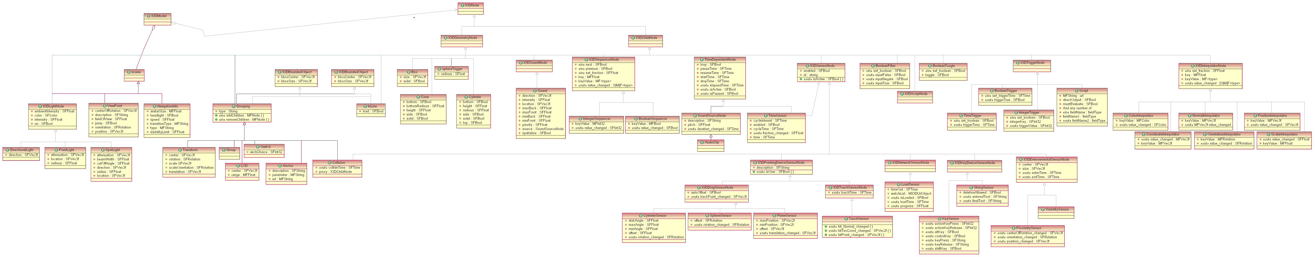

Figure 15: X3D Meta Model, source (Web3D,2007)

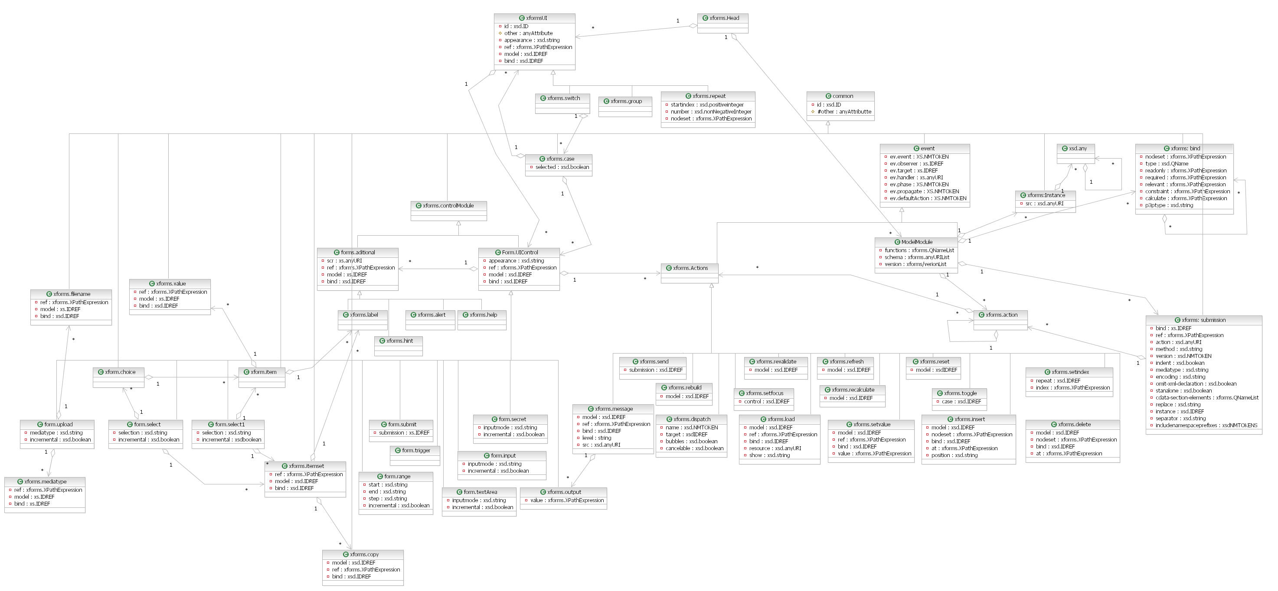
Figure 16: XForms Meta-Model
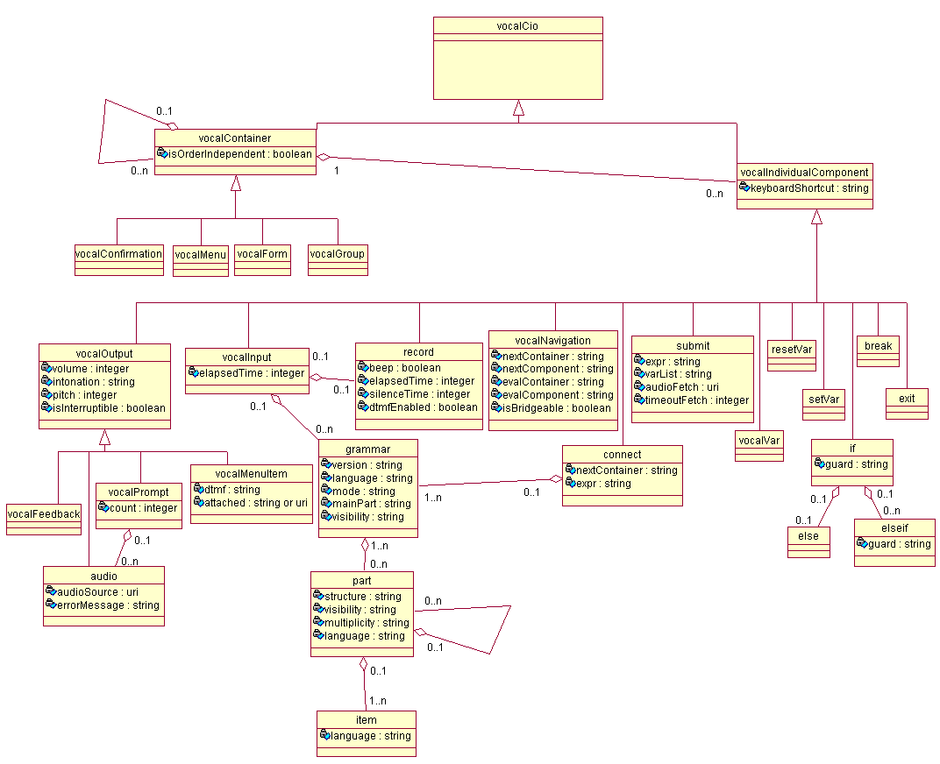
Figure 17: VoiceXML, Source (Stanciulescu, 2008)

Figure 18: The meta-model of XIML
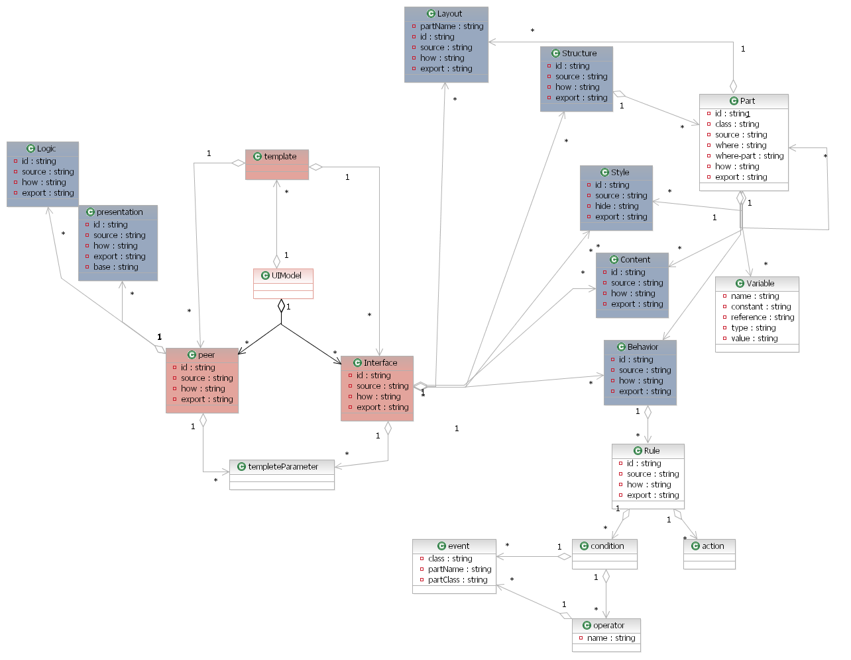
- Figure 19: UIML Meta Model

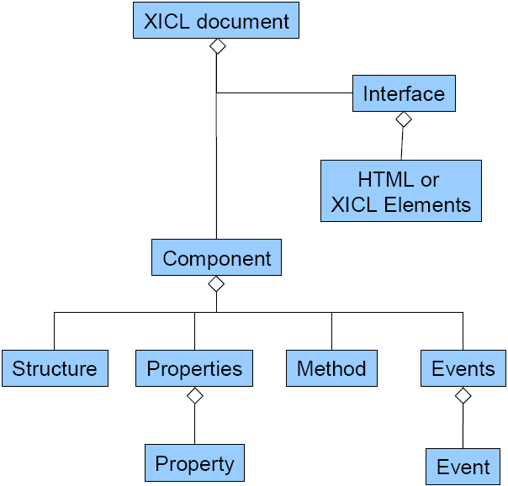
Figure 20: XICL Meta-Model

Appendix 2. List of UIDLs
UsiXML is similar to some extent to the following User Interface Description Languages (UIDLs) and their environments:
- AAIML (Alternate Abstract Interface Markup Language) developed by Trace Center, University of Wisconsin, USA. URL: http://trace.wisc.edu/world/v2/
- AUIL (Abstract User Interface Language) is developed by the Alcatel S.A. URL: http://www.w3.org/2000/10/DIAWorkshop/siebelink.htm
- AUIML (Abstract User Interface Markup Language) is developed by IBM Corp., USA. URL: http://www.ibm.com/developerworks/library/wa-aj-auiml/
- CCXML (Call Control eXtensible Markup Language) is designed to provide telephony call control support for VoiceXML or other dialog systems. URL: http://www.w3.org/TR/ccxml/
- D3ML (Device-Independent MultiModal Mark-up Language) is a language developed in the framework of the SNOW Consortium (Services for NOmadic Workers). URL: http://www.w3.org/2005/06/SNOW_W3C-v1.pdf
- DISL (Dialog and Interface Specification Language) is developed by Cooperative Computing and Communication Laboratory, University of Paderborn, Germany. URL: www.springerlink.com/index/83853515623vu535.pdf
- EMMA (Extensible MultiModal Annotation markup language) is developed by the World Wide Web Consortium. URL: http://www.w3.org/TR/2005/WD-emma-20050916/
- eNode (element Node) is developed by eNode, Inc., USA. URL: http://www.enode.com/x/markup/about.html
- GIML (Generalized Interface Markup Language) is used for interface description in GITK (Generalized Interface Toolkit) project and is developed by Stefan Kost as Ph.D. Thesis at Technical University of Dresden and Leipzig University of Applied Sciences, Germany. URL: http://www.qucosa.de/fileadmin/data/qucosa/documents/1518/1150806179876-4567.pdf
- GladeXML allows dynamic loading of user interfaces from XML descriptions. It is part of the LibGlade library. URL: http://library.gnome.org/devel/libglade/unstable/GladeXML.html

- IDEAL (Interface Description Language?) developed by Telefonica I+D in the context of the MyMobileWeb and MORFEO projects. URL: http://mymobileweb.morfeo-project.org/specs/ideal/
IDS Use of XML (Interaction Design System Use of XML) developed by Honeywell Labs, USA.
IMML (Interactive Message Modeling Language) is a language proposed by Jair Leite to the designers describe an user interface as a message
InkML is designed by the ink subgroup of the Multi Modal Interaction Working Group of W3C
InTml (Interaction Techniques Markup Language) is developed by Departement of Computing Science, University of Alberta, Canada.
3dml (3D Markup Language) is developed by Departement of Computing Science, University of Alberta, Canada.
ISML (Interface Specification Meta-Language) is developed by Simon Crowle in his Ph.D. Thesis at Bournemouth University, UK.
Luxor (XML UI Language Toolkit), Luxor Team
MAWL (The Mother of All Web Languages) is developed by Bell Laboratories, Lucent Technologies.
MDML (Multiple Device Markup Language) is developed by School of Computer Science, Telecommunications and Information Systems, DePaul University, USA.
MPML (Multimodal Presentation Markup Language) is an XML-based language developed to enable the description of multimodal presentation using character agents in easier way.
MRML (Multimedia Retrieval Markup Language) is supported by the Viper Project.
MXML (Macromedia Flex Markup Language) is developed by Macromedia Flex Developer Center.
OpenLaszlo is developed by Laszlo Systems, Inc., USA.
Plastic ML is developed by Trigone Laboratory-CUEEP, Universit? des Sciences et Technologies de Lille, France.
Prado (PHP Rapid Application Development Object-oriented) is an event-driven and component-based framework for PHP 5.
SeescoaXML (Software Engineering for Embedded Systems using a Component-Oriented Approach) is developed by EDM-LUC, Belgium.
RIML (Renderind Independent Markup Language) is supported by Consensus Project.
Sisl (Several Interfaces, Single Logic) is developed by Bell Laboratories, Lucent Technologies.
SSIML (Scene Structure and Integration Modelling Language) is developed by Media Informatics Group, University of Munich, Germany.
SunML (Simple Unified Natural Markup Language) is a language for wirting user interfaces which are device independent.
UIML (User Interface Markup Language) is developed by the UIML Consortium, involving Harmonia, Inc., USA. and Virginia Tech.
VHML (Virtual Human Markup Language) is designed to accommodate the various aspects of Human-Computer Interaction with regards to Facial Animation, Body Animation, Dialogue Manager interaction, Text to Speech production, Emotional Representation plus Hyper and Multi Media information.
VoiceXML (Voice Extensible Markup Language) is designed for creating audio dialogs that feature synthesized speech, digitized audio, recognition of spoken and DTMF key input, recording of spoken input, telephony, and mixed initiative conversations.
VRML (Virtual Reality Modeling Language) allows to create "virtual worlds" networked via the Internet and hyperlinked with the World Wide Web.
XAMJ is developed by XAMJ Working Group as part of SourceForge.net initiative.
XAML (Microsoft Extensible Application Markup Language) developed by Microsoft, Corp., USA.
XDL (XML Interface Description Language) developed by Georgia Institute of Technology.
XICL (extensible markup language for developing user interface and components) is developed by Department of Informatics and Applied Mathematics, Federal University of Rio Grande do Norte, Brazil.
XIML (eXtensible Interface Markup Language) is developed by the XIML Forum, lead by RedWhale Soft. Corp., USA.
XIN-XML language to build and integrate distributed applications.
XISL(eXtensible Interaction Scenario Language) is developed by Toyohashi University of Technology, Nitta Laboratory, Japan.
XMMVR (eXtensible markup language for MultiModal interaction with Virtual Reality worlds) is realated to concepts like: virtual reality, multimodal interaction (graphical and vocal), XML technologies and Java development.
XUL (XML-based User Interface Language) is developed by the Mozilla Fundation

