

ACDC Tools Specifications and Selection

Action | Name | Date | Approbation
Author | Claudine Pelegrin Bomel | 23/07/2012
Approved by | Patrick Schwartz | 09/08/2012
Approved by
Table of contents

1 Abbreviations 4
2 Reference Documents 5
2.1 External Reference 5
3 Executive summary 8
4 State of the art 9
4.1 Video Processing 9
4.1.1 Supported Formats 9
4.1.2 Emerging Standards 10
4.1.3 Video Encoding / Transcoding Algorithms Optimization 15
4.2 Content Delivery 18
4.2.1 IPTV 18
4.2.2 Web TV with Broadband Internet 25
4.2.3 Mobile TV 35
4.3 Cloud Computing for video services 36
4.3.1 Cloud Computing Definition 36
4.3.2 Cloud Standardization 38
4.3.3 General Cloud Tools 38
4.3.4 Distributed processing 39
4.3.5 Distributed semantic content analysis 40

Table of illustrations

Figure 1: MFC Configurations, Side-by-Side (left) and Top-Bottom (right) 2
Figure 2 : IO for CfP Proposals 2
Figure 3 : MFC CfP Anchors. Top-left : SVC, Top-right : FC-MVC, Bottom-left : Simulcast 2
Figure 4: The two-view and three-view test scenarios and the corresponding views to synthesize. 2
Figure 5: Motion Estimation 2
Figure 6: Depth / Disparity Estimation 2
Figure 7: Content Delivery overview 2
Figure 8: IPTV= Internet Protocol TeleVision 2
Figure 9: IPTV architecture example 2
Figure 10: Framing of an IP packet/datagram 2
Figure 11: RTP Protocol headers 2
Figure 12: RTSP Protocol 2
Figure 13: RTSP is an example of a traditional streaming protocol 2
Figure 14: VOD: Unicast streaming 2
Figure 15: Live stream Multicast 2
Figure 16: Multi-screen formats using Broadband Internet and 3GPP streaming technologies 2
Figure 17: Streaming Technology comparison 2
Figure 18: Evolution of Media and communication delivery on Flash platform 2
Figure 19: RTMP packet diagram 2
Figure 20: Matching bandwidth changes to maintain QoS 2
Figure 21: Adaptive streaming is a hybrid media delivery method 2
Figure 22: Detailed process for Adaptive streaming 2
Figure 23: Architecture of HTTP live streaming 2
Figure 24: HTTP Dynamic streaming in Flash Media Server 2
Figure 25: Fragmented DTT Broadcast World in 2011 2
Figure 26: DVB-T2 workflow 2
Figure 27: Architectural overview of the multimedia content analysis platform 2
Figure 28: Available processing capacity values calculated with different load levels and number of CPUs 2
Figure 29: Load levels at different nodes over time 2

Abbreviations

AAC | Advanced Audio Coding
ADSL | Asymmetric Digital Subscriber Line
ADTS | Audio Data Transport Stream
AMR | Adaptive Multi-Rate
AVC | Advanced Video Coding
CAS | Conditional Access System
CDN | Content delivery Network
CPU | Central Processing Unit
CUDA | Compute Unified Device Architecture
DRM | Digital Rights Management
DVB | Digital Video Broadcasting
DVB-H | Digital Video Broadcasting-Handled
DVB-SH | Digital Video Broadcasting - Satellite Handheld
DVB-T | Digital Video Broadcasting – Terrestrial
DVB-T2 | Digital Video Broadcasting – 2nd generation Terrestrial
DVB-TS | Digital Video Broadcast Transport Stream
EPG | Electronic Program ASe
ESG | Electronic Service Guide
FEC | Forward Error Correction
FTP | File Transfer Protocol
GOP | Group Of Picture
GUI | Graphical User Interface
GPGPU | General-Purpose computation on Graphics Processing Units
HD | High Definition
H.264 | Identifier of ITU-T Recommendation ‎[4]
HTTP | Hypertext transfer Protocol
IRD | Integrated Receiver Decoder
IP | Internet Protocol
IPTV | Internet Protocol Television
Mbps | Mega bit per second
MPEG-2 | Moving Picture Experts Group
MPI | Message Passing Interface
NAL | Network Abstraction Layer
NFS | Network File System
NTSC | National Television System Committee
OS | Operating System
OTT | Over The Top
PAT | Program Association Table
PES | Packetized Elementary Stream
PID | Packet IDentifier
PMT | Program Map Table
PSI/SI | Program Specific Information / Specific Information
QOE | Quality Of Experience
QOS | Quality Of Service
RF | Radio Frequence
RTCP | Real-time Transport Control Protocol
RTMP | Real Time Messaging Protocol
RTP | Real-Time Transport Protocol
RTSP | Real Time Streaming Protocol
SD | Standard Definition
SDP | Session description Protocol
SLA | Service Level Agreement
SNMP | Simple Network Management Protocol
SPTS | Single Program Transport Stream
STB | Set-Top Box
TCP | Transmission Control Protocol
TS | Transport Stream
UDP | User Datagram Protocol
URL | Uniform Resource Locator
VC-1 | SMPTE 421M video codec
VOD | Video On Demand

Reference Documents

External Reference

- Pantos, R., W., May “HTTP Live Streaming” draft-pantos-http-live-streaming-06 (Expires: October 2, 2011)
http://tools.ietf.org/html/draft-pantos-http-live-streaming-06

- Technical White Paper, “HTTP Dynamic Streaming on the Adobe Flash Platform”

- Microsoft Silverlight, IIS Smooth Streaming Technical Overview, Alex Zambelli, March 2009

- Schulzrinne, H., et al, "Real Time Streaming Protocol (RTSP)", RFC 2326, April 2008, http://www.ietf.org/rfc/rfc2326.txt

- RTP: A Transport Protocol for Real-Time Applications, July 2003, RFC 3550, http://tools.ietf.org/rfc/rfc3550.txt

- W. Zhu et al., “Multimedia Cloud Computing,” IEEE Signal Processing Magazine, vol.28, n.3, pp. 59-69, 2011

- W.-N. Chen and H.-M. Hang, “H264/AVC motion estimation implmentation on Compute Unified Device Architecture (CUDA),” in Proc. IEEE Int. Multimedia and Expo Conf., 2008, pp. 697–700.

- NVidia, NVidia CUDA Compute Unified Device Architecture Programming Guide. NVidia, July 2008. [Online]. Available: http://www.nvidia.com/object/cuda develop.html

- S. Momcilovic and L. Sousa, “Development and evaluation of scalable video motion estimators on GPU,” in Proc. IEEE Workshop Signal Processing Systems SiPS 2009, 2009, pp. 291–296.

- M. C. Kung, O. C. Au, P. H. W. Wong, and C. H. Liu, “Block based parallel motion estimation using programmable graphics hardware,” in Proc. Int. Conf. Audio, Language and Image Processing ICALIP 2008, 2008, pp. 599–603.

- N.-M. Cheung, X. Fan, O. C. Au, and M.-C. Kung, “Video coding on multicore graphics processors,” IEEE Signal Processing Magazine, vol. 27, no. 2, pp. 79–89, 2010.

- A. Munshi, The OpenCL Specification Version 1.1, Khronos OpenCL Working Group, Septemper 2010. [Online]. Available: http://www.khronos.org/registry/cl/specs/opencl-1.1.pdf

- P. L. Combettes and J.-C. Pesquet, “Proximal splitting methods in signal processing,” in Fixed-Point Algorithms for Inverse Problems in Science and Engineering, Springer-Verlag, New York, 2010.

- O. Veksler, “Stereo correspondence by dynamic programming on a tree,” in IEEE Conference Proceedings of Computer Vision and Pattern Recognition, San Diego, United States, 2005, vol. 2, pp. 384–390.

- V. Kolmogorov and R. Zabih, “Computing visual correspondence with occlusions using graph cuts,” in IEEE International Conference on Computer Vision, Vancouver, BC, Canada, July 2001, vol. 2, pp. 508–515.

- W. Miled, J.-C. Pesquet, and M. Parent, “A convex optimisation approach for depth estimation under illumination variation,” IEEE Transactions on Image Processing, vol. 18, no. 4, pp. 813–830, April 2009.

- Eucalyptus Beginner’s Guide -UEC Edition Ubuntu 10.10 - 23/12/2010

- http://open.eucalyptus.com

- http://opennebula.org

- http://docs.openstack.org/

- Cloud Computing – IUT Nancy- Charlemagne – Année universitaire 2010/2011 - Yohan Parent, Maxime Lemaux, Cyprien Fortina, Hyacinthe Cartiaux

- Introduction to VMware vSphere

- vSphere Ressource Management Guide

- The NIST Definition of Cloud Computing - Version 15, 10-7-09
Authors: Peter Mell and Tim Grance

- https://computing.llnl.gov/tutorial/parallel_comp

- https://openmp.org

- IBM - Anatomy of a cloud storage infrastructure - 30/11/2010

- SNIA - Cloud Storage Reference Model - June2009

- SNIA - Cloud Storage for Cloud Computing - Sept 2009

- SNIA - Managing Data Storage in the Public Cloud – Oct 2009

- SNIA - Storage Mulyi-Tenancy for Cloud Computing – March 2010

- SNIA - Hypervisor Storage Interface for Storage Organisation – June 2010

- SNIA – Implementing, serving and using Cloud Storage – October 2010

- SNIA – CDMI Reference Implementation Developer’s Guide V1.0.1h – April 2011

- SNIA - Cloud Data Management Interface Guide V1.0.1h – 30 mars 2011

- NoSQL databases

- Dynamo : Amazon’s High Available Key-value store

- Bigtable : a distributed storage system for structured data

- Cumulus : an open source storage cloud for sciences

- SNIA - IP Storage Inside White Paper

- SNIA – Shared Storage Model - A framework for describing storage architectures

- http://www.osrg.net/sheepdog/

- http://awsdocs.s3.amazonaws.com/S3/latest/s3-api.pdf

Executive summary
This document is an abstract of the deliverable D2.1 “Tools Specifications and Selection” associated to the Work Package 2 Cloud Infrastructure of the ACDC project, labelled ITEA2 #09008. This abstract contains a deep State of The Art.
As stated in the FPP :
- objective of WP2 is to research and develop a new content delivery infrastructure based on new processing and storage technologies also named “cloud computing”.

- objective of this WP2 deliverable is to specify a selection of tools allowing design independent from the hardware platform (compilers,…) and allowing mapping of the application on multi-CPU / multi- Cores / multi GPU.

State of the art

Video Processing

Supported Formats
ACDC Cloud infrastructure will provide a Video Transcoder / Streamer Software prototype which performs in very performant way on-the-fly and off-line video adaptation and conversion.

It will support wide range videos inputs streams and delivers multiple output streams over a variety of different network protocols.

- Transport Protocols
  - UDP
    - MPEG2-TS,…
  - TCP
    - MPEG2-TS,…
  - RTMP (Adobe specific process)
  - HTTP/HTTPS Progressive download
  - HTTP/HTTPS Streaming
    - Apple HLS,
    - Microsoft Smooth streaming,
    - Adobe HDS,…
  - File Transfer (
    - FTP,
    - SCP,
    - SFTP,…
- Video format
  - Container
All major containers would be supported for input/output formats.
    - avi
    - mp4
    - flv
    - wmv, asf
    - mov
    - mpg
    - ogg/ogv
    - 3gp
  - Video codec
All major formats would be supported for input formats, there might be restrictions for output formats regarding encoding issues (like vp6 and vp7 that might not be useful as output formats)
    - H263
    - mpeg4
    - h264 (AVC with its amendments : SVC and MVC,…)
    - mpeg1video, mpeg2video
    - mjpeg
    - Microsoft specific codecs (wmv1, wmv2, wmv3/VC1)
    - Flash specific codecs (Sorenson, vp6, vp7, vp8)
  - Audio codec
All major formats would be supported for input formats, there might be restrictions for output formats regarding encoding issues (like nellymoser that might not be useful as output formats)
    - aac (mp4), mp3, mp2, mp1
    - amr
    - pcm
    - Flash specific codecs (nellymoser,…)
    - Microsoft specific codecs (wma1, wma2,…)

The major innovations are:
- on-the-fly input Video content analysis allowing media adaptation and conversion in real-time with minimal latency
- Video conversion processing distribution over multiple processing nodes
- Managing distributed cache system avoiding multiple conversion of the same content. This cache will be integrated with Distributed Cloud storage

Emerging Standards
The ACDC Cloud Infrastructure will provide additional transcoding functionalities that matches the forthcoming specifications given by emerging standardization activities. In the following, a brief summary of the major standardization activities that will be addressed in this project.
Among the recent activities related to 3D Video, MPEG has been active, mainly on two subjects : Multiview Frame Compatible Coding (MFC) and 3D Video Coding (3DVC). We will detail the recent activities in each, knowing that these will lead to 3D video coding standards that the partners will want to support in the future.

Multiview Frame Compatible

  - Description of the technology

Multiview Frame Compatible or MFC is a method for delivering stereo 3D video content using more conventional coding tools. It is a stereo coding technique that packs the two views either in a side-by-side or in a over-under (or top-bottom) configuration, as shown in Figure 5.

 | 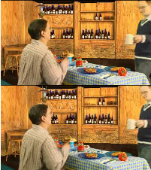
Figure 1: MFC Configurations, Side-by-Side (left) and Top-Bottom (right)
The two views are subsampled before packing, which results in a loss of spatial resolution. Hence, the base layer formed in this way is enhanced by sending one or more enhancement layers, in order to get back to the full resolution per view at the decoder.

  - Draft Call for Proposals

Following the 97th MPEG meeting in Torino in July 2011, a draft Call for Proposals (CfP) has been issued, inviting proponents to submit an MFC based coding scheme, taking into input the two full original left and right views, that should be packed into a frame-compatible signal after some pre-filtering to avoid aliasing. The proposal should output the reconstructed frame-compatible base layer, the reconstructed full-resolution left and right views, and of course the bitstreams generated.

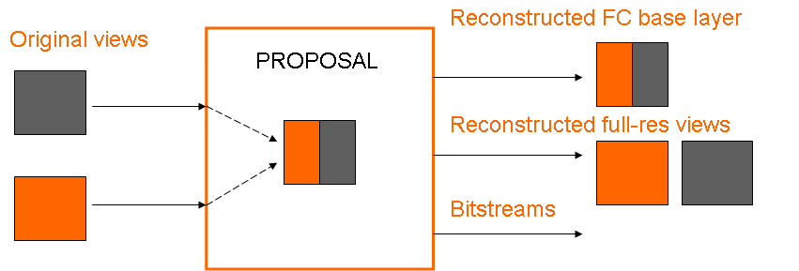

Figure 2 : IO for CfP Proposals

A set of anchors has been considered to evaluate proposals to [1] :

Anchor ID | Name | Description
1 | MVC | MVC applied directly to left and right views. This serves as an upper anchor.
2 | AVC-UP | Up-sampled frame-compatible base layer encoded with AVC. No enhancement layers.
3 | SVC | SVC with frame-compatible base layer and spatial scalability
4 | FC-MVC | MVC with frame-compatible base layer, where enhancement layer contains complementary samples
5 | Simulcast | Simulcast of AVC frame-compatible and 2D-compatible MVC for left/right views. This serves as a lower anchor.

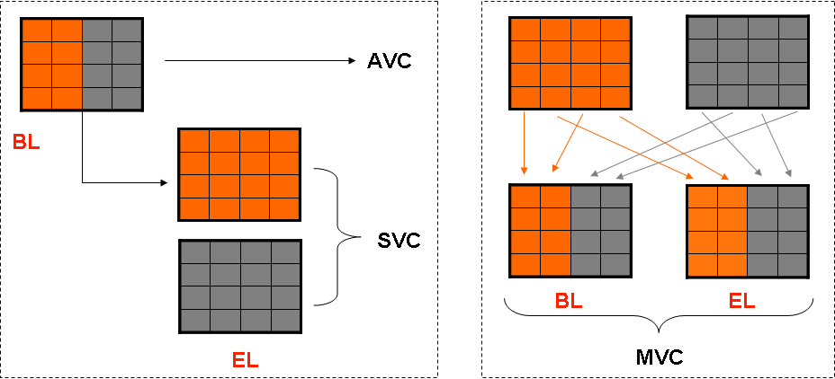
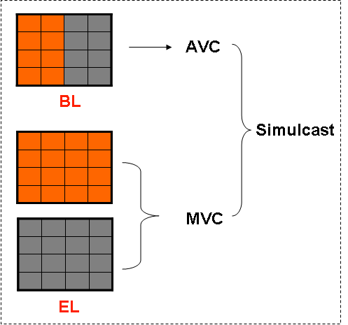

Figure 3 : MFC CfP Anchors. Top-left : SVC, Top-right : FC-MVC, Bottom-left : Simulcast

In addition, the following conditions were established :

- The bit rate required to code the enhancement layer should not be greater than 25% of the one used to code the base layer.
- An open GOP structure shall be used with 3 intermediate pictures : IbBbP…
- IDR (random access points) shall be inserted every 4 seconds, and the intra period shall be equal to 2 seconds.
- Fast motion estimation is allowed.
- Multiple pass encoding and weighted prediction are allowed.
- Fixed QP (per slice type with layer asymmetry) shall be used for the base layer (no rate control). [3]

The evaluation process will be based on both objective measures and subjective viewing. Objective quality evaluation of proposed solutions will be based on BD measures against the anchor encodings. The base layer should be broadcast quality and should not contain appreciable alias products. The PSNR of the upscaled base layer and the full resolution encodings shall be measured against the input full resolution source. [3]

A final Call for Proposals should be issued at the end of the 98th MPEG meeting in Geneva in November 2011, and the consequent evaluation of proposals should be carried out at the 99th MPEG meeting in February 2012.

  - Discussions

- Is the 25% EL rate constraint necessary ? And why isn’t it required for Simulcast anchors ?
- Are the base layer bit rates appropriate for the content ?
- What is the optimal temporal structure ?

3D Video Coding

MPEG issued after the 96th meeting in Geneva in March 2011 a Call for Proposal for 3D Video Coding technologies. The aim is to find a solution with an associated data format and compression technology that enables the rendering of high quality views from an arbitrary number of dense views. The following bullet points go over the general contents of the CfP [4] :

- Proponents shall use texture sequences defined in the CfP with their associated depth maps. No depth maps from other depth estimation algorithms shall be used.

- Proposals will be divided into two categories : AVC-Compatible (forward compatibility with AVC) and HEVC-Compatible (forward compatibility with HEVC, or unconstrained). Each proponent may select to contribute to either one of these categories.

- Two test scenarios will be considered : the two-view test scenario where the input consists of 2 views (left-right), and the three-view scenario where the input consists of 3 views (left-center-right).

- Specific rate points (not to be exceeded) are defined for each sequence (4 per sequence).

- Rendering may be accomplished using a reference view synthesis tool, or a proposed synthesis algorithm that is more appropriate for the proposed data format.

- For the two-view test scenario, a center view will be synthesized. For the three-view test scenario, all 1/16 positions between the left and right views will be synthesized.

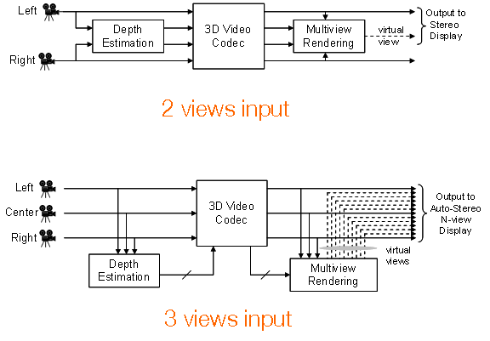
Figure 4: The two-view and three-view test scenarios and the corresponding views to synthesize.

- Anchors include MVC coding of texture and depth data independantly, and HEVC coding of each texture view and each depth view independantly. Anchors follow the same bit rate constraints imposed on proposals.

- Objective results consist of BD-Rate and BD-PSNR measurements compared to anchors.

- Subjective viewing is primordial as no course of action will be taken before the subjective assessment of the reconstructed and synthesized views’ quality. Stereoscopic and autostereoscopic viewing will be considered.

- For the stereoscopic viewing, a stereo pair will be selected. It corresponds, in the 2-view scenario, to one of the original views and the synthesized center view. In the 3-view scenario, two stereo pairs, with equal baseline, will be considered. The first is specified in the CfP and is centered around the middle view, and the second is randomly selected. Unlike the 2-view scenario, in the 3-view scenario, we can have a stereo pair that is entirely composed of synthesized views.

- For the autostereoscopic viewing, 28 views will be selected from the range of available views of the 3-view scenario. They are selected to be confortable to view, and they should provide a sufficent depth range, i.e there’s a sufficiently wide baseline distance between the 1st and the 28th view.

- Finally, submission should contain bitstream files that satisfy the given rate constraints, the reconstructed input views and the synthesized views, the software used to synthesize the views, an excel sheet containing BD measurements, and information about complexity (encoding / decoding time, expected memory usage, specific dependancies…).

Conclusion

In this paragraph, we discussed the primary normalization activities undertaken by MPEG towards the development of new 3D services. The 98th MPEG meeting in Geneva in November 2011 should give us interesting updates since it is an important milestone in 3D video technology development, in which proposals for 3DVC are to be evaluated, and a course plan and a final CfP for MFC are to be issued.

Video Encoding / Transcoding Algorithms Optimization
It is known that the most time and resources consuming part of video encoding algorithms is the motion estimation step. For multi-view sequences, this has also the additional burden of disparity estimation, which makes use of similar tools and therefore suffers from the same drawbacks. The development of efficient video encoding algorithms in the context of a multimedia-aware cloud infrastructure represent a key issue of this project, in order to both take advantage of the huge and varying processing capabilities of a cloud to reduce computation times, and on the other hand improve the accuracy of the encoding processes by using more sophisticated algorithms.
In the state-of-the-art codecs, like H.264/AVC, both motion and disparity estimation, the latter covered by the MVC extension, are accomplished through a recursive estimation, scanning the macroblocks in a raster order and predictively processing them, and being thus highly inefficient for parallel implementations. For this reason, following the current research trends, several original motion and disparity vector field estimation algorithms will be proposed, which have two main additional advantages:
- they provide dense fields, meaning one vector per pixel (instead of one vector per block), providing increased flexibility for representation and transmission, thus improving the overall quality of the encoding,
- the estimation algorithms are enabled for parallelization at multi-core and GPU level, thanks also to the use of recent convex optimization methods (in a set theoretic framework).
As a further advantage, these algorithms will naturally fit the developing framework that will be soon introduced by the future HEVC (High Efficiency Video Coding) standard in video coding.

Motion Estimation Algorithm

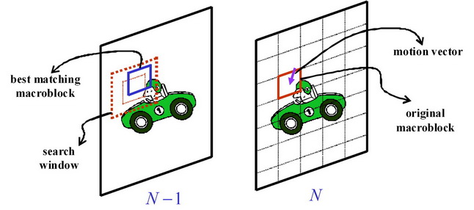
Figure 5: Motion Estimation

Motion estimation represents the foundation of almost all video coding techniques currently available, for which the main idea consists in removing redundancy of video data by describing a sequence of video frames using only a key frame (namely the intra-frame) and some more or less compact information about the motion of the different parts of the scene.
In the great majority of past and current video codecs (from MPEG-1 up to MPEG-4 and H264/AVC), the motion estimation step is, often largely, the most time-consuming, calling for the design of an optimized algorithm for highly data-parallel computational devices/platforms.

Leveraging cloud computing to provide multimedia applications and services over the Internet is a major current challenge. Moreover, as stated in [6], the deployment of a multimedia-aware cloud infrastructure (MEC, Media-Edge Cloud) is necessary to provide a disruptive QoS provisioning. In this project, we first intend to study and develop the parallel implementations of state-of-the-art motion estimation algorithm, having as a constraint the development of a portable and scalable solution, able to adapt to both the heterogeneity and the evolutivity of a cloud. In particular, we focus on data parallel implementations of the full search block matching (FSBM) algorithm, since such approach is naturally suited for this problem, and provide a solution that fits both a general purpose GPU and a multi-core CPU. A few recent works have already dealt with this problem, with exclusive focus on the GPU. In [7] for example, a FSBM algorithm for H.264/AVC motion estimation has been introduced that fits into the Compute Unified Device Architecture (CUDA) [8], while in [9] the problem of scalability of the FSBM algorithm with respect to the number of cores of a GPU is discussed. In \cite{Schwalb2009}, the GPU-oriented parallelization of a motion estimation algorithm based on diamond search has been also proposed. Several works, like [10,11], discuss the GPU parallelization of the RD-optimized motion estimation in H.264/AVC video coding. As an element of novelty, we intend to develop implementations that rely on the [12] framework, as it provides a common API for the execution of programs on systems equipped with different types of computational devices such as multi-core CPUs, GPUs, or other accelerators.

Depth/Disparity Estimation Algorithm

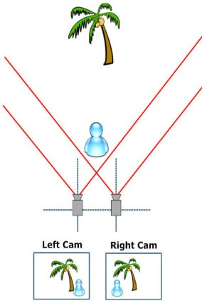
Figure 6: Depth / Disparity Estimation

The recovery of the depth information of a scene from stereo/multi-view images is of fundamental importance in many applications in the video processing domain such as autonomous navigation, 3-D reconstruction and 3-D television. It represents a basic step for the efficient encoding/compression of multi-view/3D videos. For the elementary stereo case, given two images from different viewpoints, a stereo matching method attempts to find corresponding pixels in both images. The disparity map computed from this matching process can then be used to recover the 3-D positions of the scene elements for known camera configurations. Being computationally demanding, disparity estimation can largely take advantage of a suitable algorithm designed for high performance computing infrastructures.

The disparity estimation problem has been extensively studied in computer vision [13]. Traditionally, disparity estimation algorithms are basically classified into two categories: local methods and global ones. Algorithms in the first category, where the disparity at each pixel depends only on intensity values within a local window, perform well in highly textured regions. However, they often produce noisy disparities in textureless regions and fail at occluded areas. These problems can be reduced by using global methods which aim at finding the disparity field that minimizes a global energy function over the entire image. For this purpose, several energy minimization algorithms have been proposed. The most common approaches are dynamic programming [14], graph cuts [15] and variational methods [16]. While dynamic programming and graph cuts methods operate in a discrete manner, variational techniques work in a continuous space. Therefore, they possess the advantage of producing a disparity field with ideally infinite precision. Among these global approaches, it has been shown that variational-based disparity estimation methods are among the most competitive techniques, for their preservation of depth discontinuities. By mainly focusing on dense disparity estimation, the problem will be formulated as a convex optimization problem within a global variational approach. As a major contribution to this project, IT intends to develop a optimized parallel implementation of the resulting disparity estimation algorithm algorithm. This will be achieved, first of all, exploiting the intrinsic parallel nature of the convex optimization framework, which allows us to efficiently solve the estimation problem over feasibility sets determined by multiple parallel constraints that model prior information. This naturally fits the resulting algorithm into the task-parallel programming paradigm, particularly suitable for multi-core devices. Moreover, leveraging GPU will allow the optimized data-parallel implementation of all the low-level processing involved.

Content Delivery
One of ACDC project goal is to research, develop and demonstrate an adaptive content delivery cluster within TV (IPTV, Web TV/Internet TV and Mobile TV), on demand (Video, Entertainment), personal video recording and targeted advertising services over variety of networks to different terminals (STB, PC, Mobile).
This chapter describes the Content Delivery part for a better understanding of all the networks and the technologies that will be involved in ACDC system.
We will present the different Content delivery sub-systems, which allows the provisioning of services through different access networks (IPTV dedicated network using protocols such as UDP, RTP, RTSP, IGMP, Web TV with Broadband internet using streaming protocols such as RTMP, HTTP adaptive streaming and finally Mobile TV networks including 3GPP and Broadcast network with DVB-T2 as this technology should replace DVB-H which is becoming a dead technology) as described in the figure below.

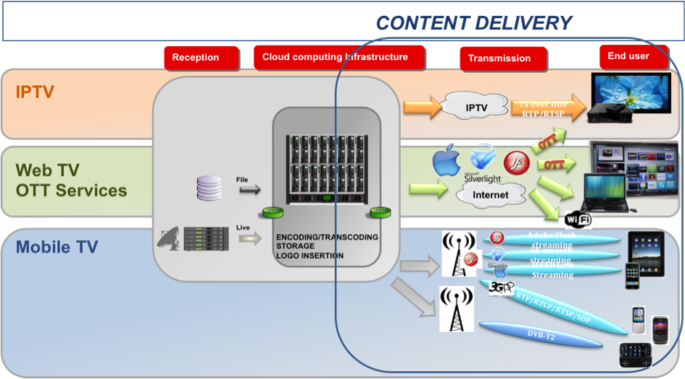
Figure 7: Content Delivery overview

IPTV
Despite the maturing of the enabling technologies, the deployment of IPTV presents many technical challenges to those required to successfully provide these services. IPTV represents the convergence of the broadcast and telecommunications worlds.
The mains points for IPTV content delivery are:
- A need for Set Top box
- Complex service Platform integration
- Multicast distribution for Live TV, Unicast distribution for VoD
- QoS is guaranteed using FEC protection

IPTV overview
In standard broadcast systems all of the normal broadcast channels are delivered to the STB in the home (via Cable, Satellite or Terrestrial). There could be hundreds of channels, all of which are delivered simultaneously. The STB tunes to the desired channel in response to requests from the viewer’s remote control. As a result of this local tuning the channel changes are almost instantaneous. In order to preserve bandwidth over the final link to the house, IPTV systems are designed to deliver only the requested channel to the STB. Note there could be several programs (or channels) delivered to different IP addresses in the same home (i.e. separate STB’s or other IP enabled receivers). In order to change channels, special commands are sent into the Access network requesting a change of channel. There is a complex protocol exchange (using IGMP “Leave” and “Join” commands) associated with this technique. This exchange requires a finite time to complete and the time taken is heavily influenced by transmission delays in the network which in turn has a direct impact on the channel change timings of the system. In essence, in IPTV systems the channel change is made in the network and not on the local STB. While preserving precious last mile bandwidth this approach presents a number of challenges to the scalability and usability of the system. Broadcast TV makes use of IP Multicasts (and IGMP as mentioned) to deliver the programming efficiently through the IP system. A Multicast is designed to allow multiple users simultaneous access to the session. VoD employs unicast IP services using the RTSP control mechanism. At the request of the viewer, the selected programming is located from within the network (from a server) and a unique unicast is setup to deliver the program to the user. This is in effect a private network connection between the server and the viewer’s STB.

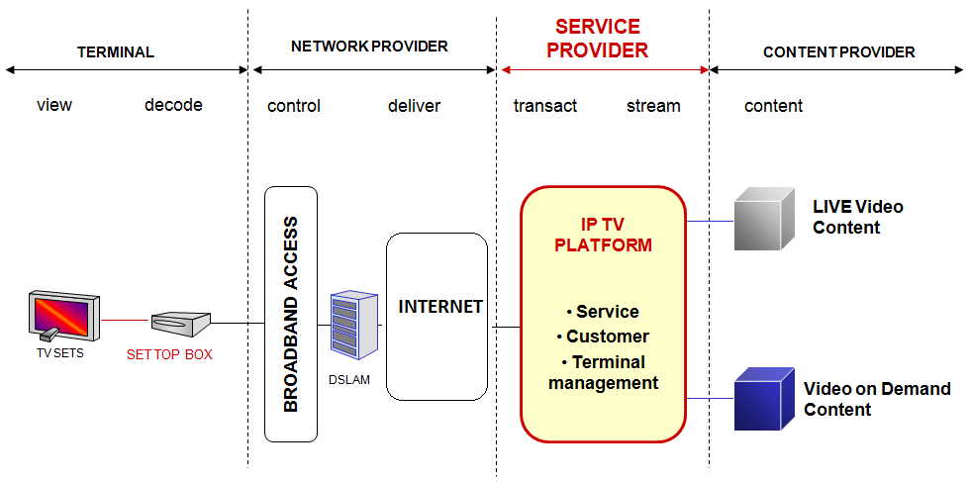
Figure 8: IPTV= Internet Protocol TeleVision

Challenges in Delivering IPTV Services
Video, voice and data are all IP data services, but each has its own Quality of Service (QoS) requirements when being transported across IP networks. In order to be successfully decoded at the STB, the Transport Stream carrying the video needs to arrive at a known and constant bit rate, in sequence with minimal jitter or delay. The requirements for the successful delivery of voice or data are just as important but less stringent than those needed by video. The differing characteristics of these services all contribute to the complexity of designing, deploying and maintaining networks required to deliver high quality services to the consumer. By their very nature, IP networks are “Best Effort” networks initially developed for the transport of data. As a consequence these networks are susceptible to lost or dropped packets as bandwidth becomes scarce and jitter increases. In the vast majority of cases this problem has no significant impact on data services which can cope with packet resends and packets arriving out of order as they get routed along different paths through networks. Video is completely intolerant to the vagaries of a best effort network. QoS (Quality of Service) for video services requires:
1. High availability and sufficient guaranteed bandwidth to allow the successful delivery of the service. Without this, video delivery will be “bursty” which will cause issues at the Set Top Box (STB) which expects its data at a constant bit rate and in the correct sequence.
2. Low transmission delay through the network. This impacts quality of experience as it will impact the response time to requests from the user’s remote control.
3. Low network jitter. Jitter affects the variability of packet arrival through the network. This variability can lead to buffer underand overflows at the receiving equipment (STB). Jitter can impact the way packets are handled at various network elements. If the jitter is too high, packet loss will increase as queuing software tries to load balance traffic at network elements.
4. Low Packet Loss. Lost packets have the greatest impact on the quality of received video and will generally lead to highly visible blocking errors. If lost packets contain I-frame Video, the impact will be more pronounced as the STB has to wait for the next I-frame to arrive to allow it to “reset” itself. This problem is aggravated by the use of H.264 which uses a longer GOP (Group of Pictures) structure (increasing the chances of lost frames) and because of the increased compression ratio each frame contains more information. Consequently, the loss of a single H.264 frame is likely to have a greater impact on the picture quality.

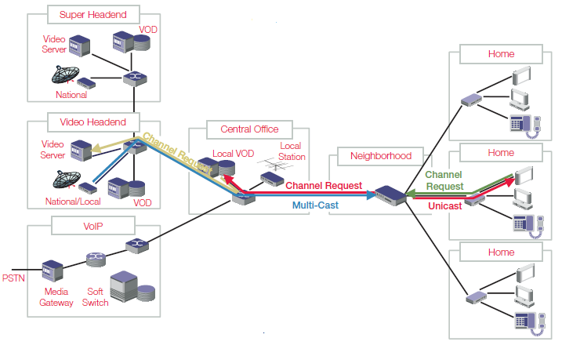
Figure 9: IPTV architecture example

IPTV systems consist of a number of key components (often referred to as the Ecosystem) all of which can have an impact on the QoE and QoS. Some of the most important components are:
Middleware – The software and hardware infrastructure that connects the IPTV components together. It normally includes subscriber-facing EPG, application control, back office/billing, etc.
STB (Set Top Box) – The Consumer Premise Equipment (CPE) used to interface with the user and the IPTV services provided by the network.
Video Encoder/Transcoder/Stream Processor – Responsible for the transformation of an input stream that can be of various formats into a digital compressed stream targeting the CPE.
Core Network Elements – The key elements used to make up the Next Generation core network capable of prioritizing Video, Voice and Data through the network.
Access Network Technologies – Access technologies capable of providing the bandwidth required to deliver TV services to the home or receiving equipment (for example: ADSL2, FTTx, WiMax, DVB-H).
Video Servers – Computer based multi-stream playout devices connected to large storage systems.
CAS/DRM – A Conditional Access System (CAS) allows for the secure delivery of content. Digital Rights Management (DRM) controls subscriber usage of the delivered content (for example: view once, unlimited view during calendar window, etc.).

IPTV video compression technologies
Digital TV systems came to fruition during the ‘90’s and are accessible worldwide across satellite, cable and terrestrial broadcast networks. They use MPEG-2,H264/AVC compression systems that have also been used for early deployment of IPTV by telcos and cable companies. As mentioned earlier, a standard video signal using MPEG-2 encoding uses about 3.75 Mbps of bandwidth over an IP network. A high definition signal may require 12-15 Mbps. So in order to deliver 2 channels of SD encoded TV to a home, almost 8 Mbps bandwidth is required. If xDSL is being used to access the home, it is easy to see why bandwidth is an issue. One way to alleviate bandwidth restrictions is to use new video compression technologies such as H.264/AVC or VC-1. H.264 can offer up to a 50% reduction in bandwidth utilization for the same picture quality compared to existing MPEG-2 compression. Bandwidth is one consideration when selecting the compression technology to be used in the system. However there are a number of other factors that need to be considered. Using MPEG-2 encoding, the average Group of Pictures, or GOP length, the Group of Pictures between I-frames is approximately 12 – 18. Using H.264 encoding, this GOP length could be as long as 300 frames. This makes the video stream even more susceptible to dropped packets, as each H.264 encoded frame effectively contains more information (because of improved compression efficiency), and so losing H.264 frames is likely to have a greater impact on the viewing experience. Beyond technical considerations there are a number of other things to be contemplated such as availability of commercially viable encoders and receivers (STB’s), patent and royalty payments and interoperability with other network components.

Network Protocols
IPTV systems are based on IP transmission protocols such as UDP and RTP, and also signaling protocols such as RTSP and IGMP.
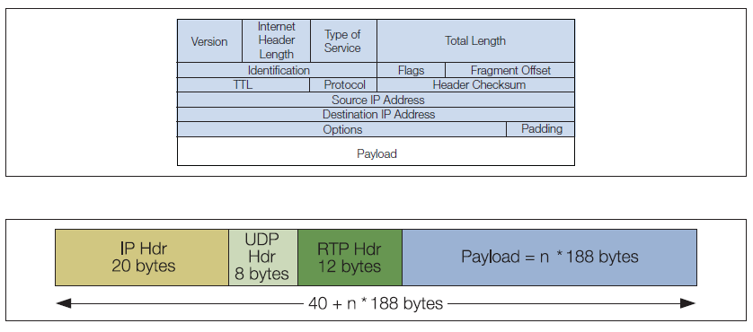
Figure 10: Framing of an IP packet/datagram

UDP Protocol
UDP or User Datagram Protocol is defined in IETF RFC 768 and is one of the core protocols of the IP protocol suite. The term ‘datagram’ or ‘packet’ is used to describe a chunk of IP data. Each IP datagram contains a specific set of fields in a specific order so that any receiver knows how to decode the data stream. Many protocols can be encapsulated within the IP datagram payload. One of its main advantages of UDP is its simplicity that reduces the amount of overhead carried, compared to the amount of data in the payload. The 16 bit length field therefore defines a theoretical limit of 65,527 bytes for the data carried by a single IP/UDP datagram. IP Packet Format shows the framing of an IP packet/datagram. In practice, this UDP packet length means that it can carry up to 7 (188 byte) Transport Stream packets. It is the simplicity of UDP that can cause issues. Its stateless form means there is no way to know whether a sent datagram ever arrives. There is no reliability or flow control guarantees such as are provided by TCP, which can identify lost packets and re-send them as necessary. UDP has been described as a ‘fire and forget’ protocol because it is difficult to discover if a packet has been lost before the subscriber does.

RTP Protocol
RTP [5] or Real Time Protocol is defined by IETF RFC 3550 and IETF RFC 3551 and describes a packet-based format for the delivery of audio and video data. RTP actually consists of two closely linked parts:
Real Time Protocol provides time stamping, sequence numbering, and other mechanisms to take care of timing issues. Through these mechanisms, RTP provides end-to-end transport for real-time data over a network. Use of sequence numbering also enables lost or out of order packets to be identified. Real Time Control Protocol is used to get end-to-end monitoring data, delivery information, and QoS. Although RTP has been designed to be independent of the underlying network protocols, it is most widely employed over UDP. When an encoded video is being carried, the RTP timestamp is derived directly from the 27 MHz sampled clock used by the Program Clock Reference (PCR) carried within the Transport Stream, thus further ensuring good timing synchronization. It is, however, important to note that RTP does not define any mechanisms for recovering from packet loss, but lost packets can be detected as described above. RTP does not provide any multiplexing capability. Rather, each media stream is carried in a separate RTP stream and relies on underlying encapsulation, typically UDP, to provide multiplexing over an IP network. Because of this, there is no need for an explicit de-multiplexer on the client either. Each RTP stream must carry timing information that is used at the client side to synchronize streams when necessary.

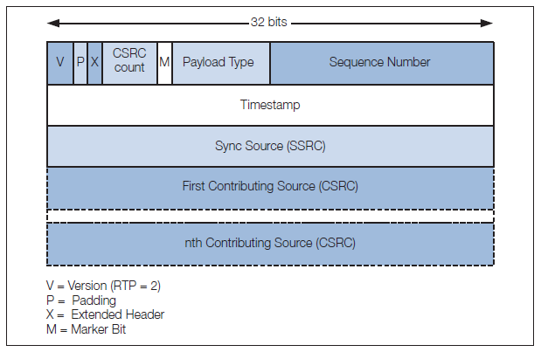
Figure 11: RTP Protocol headers

RTSP Protocol
RTSP or Real Time Streaming Protocol is defined by IETF RFC 2326 and describes a set of VCR like controls for streaming media. Typically, RTSP messages are sent from client to server, although some exceptions exist where the server will send to the client. In IPTV systems, RTSP is used in VoD applications for the consumer(client) to access and control content stored at the VoD servers. VoD is essentially a one-to-one communication established using unicast. Unicast is the exact opposite to broadcast, in which we send information to all users on the network. Unicast allows the VoD service to be requested by and sent to a single user.
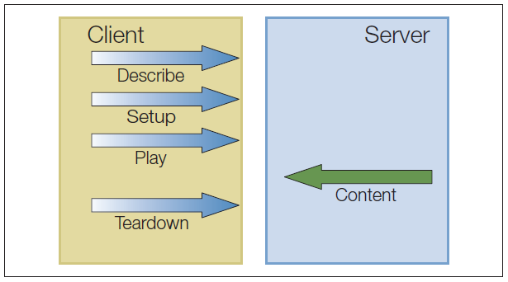
Figure 12: RTSP Protocol

The Real-Time Streaming Protocol establishes and controls either a single or several time-synchronized streams of continuous media such as audio and video. It does not typically deliver the continuous streams itself, although interleaving of the continuous media stream with the control stream is possible. In other words, RTSP acts as a “network remote control” for multimedia servers. After a session between the client and the server has been established, the server begins sending the media as a steady stream of small packets (the format of these packets is known as RTP). The size of a typical RTP packet is 1452 bytes, which means that in a video stream encoded at 1 megabits per second (Mbps), each packet carries approximately 11 milliseconds of video. In RTSP, the packets can be transmitted over either UDP or TCP transports—the latter is preferred when firewalls or proxies block UDP packets, but can also lead to increased latency (TCP packets are re-sent until received).
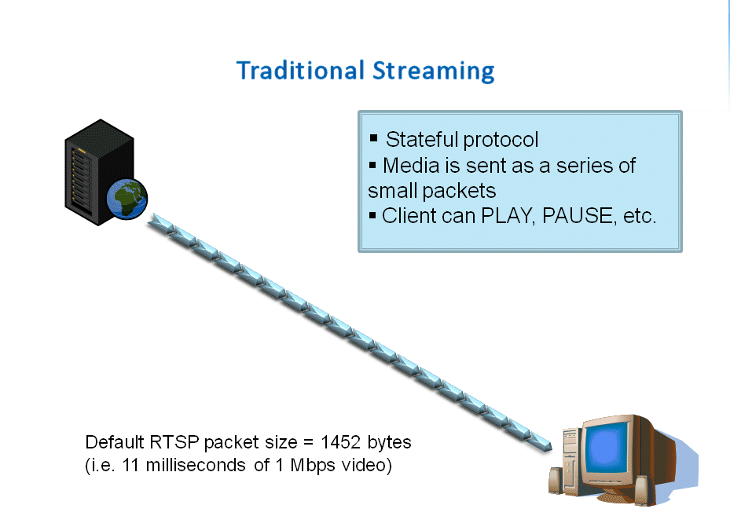

Figure 13: RTSP is an example of a traditional streaming protocol

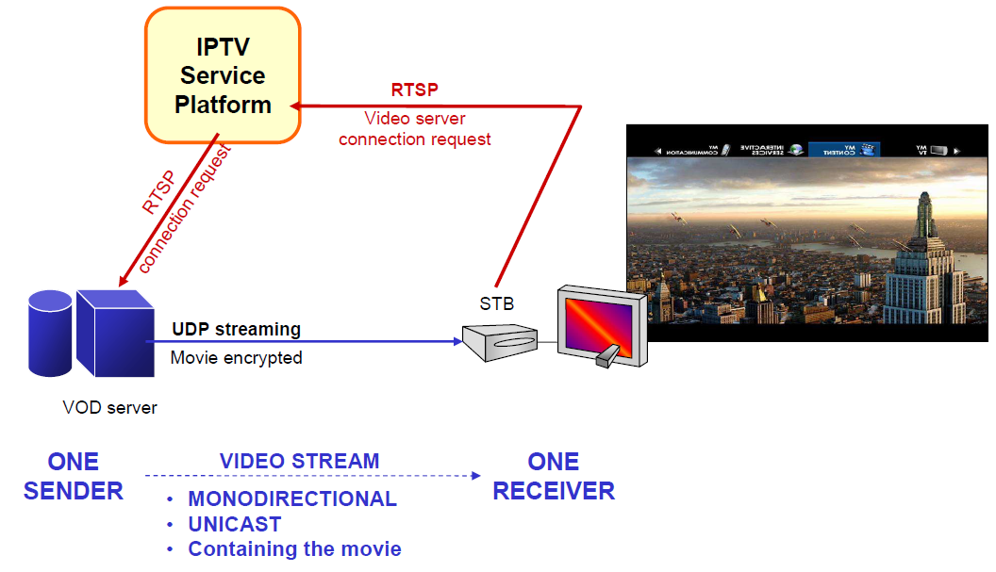
Figure 14: VOD: Unicast streaming

IGMP Protocol
IGMP or Internet Group Management Protocol is defined by several IETF RFCs, the latest version being RFC3376. IP multicasting is defined as the transmission of an IP datagramto a “host group”. This host group is a set of hosts identifiedby a single IP destination address. In an IPTV system, the hostgroup would be a set of subscribers who wish to receive aparticular program.
In practice, what this means is that the transmission systems using IGMP do not send all the content to all the users. Multicasting, using IGMP allows control of which content goes to which users and therefore controls the amount of data being sent across thenetwork at any one time.
IGMP is the protocol used to handle channel changes in an IPTV system. In response to remote control commands, a series of IGMP commands to leave the current multicast and join a different service are issued. The time that it takes to execute these commandshas a direct impact on channel change times. Middleware providers are working on a variety of different schemes to improve channel change response times.

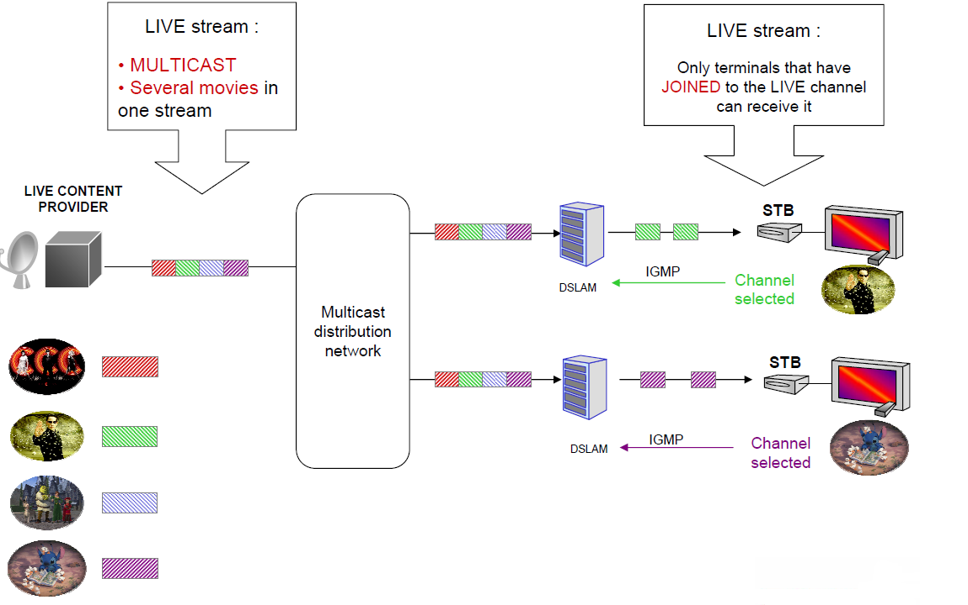
Figure 15: Live stream Multicast

Web TV with Broadband Internet
Web TV using Broadband internet with streaming protocols, RTMP, HTTP progressive download, HTTP adaptive streaming and 3GPP RTP/RTSP streaming protocols is a part of the Content delivery sub-systems.
The mains points for Broadband Internet content delivery (Web TV/OTT) are:
- No receiver investment for operator is needed
  - Any connected screen can receive video streamed over IP
  - FTTH, ADSL, 3G, 4G, WIFI
- Based on Unicast distribution
  - Same network for DATA and video
- QoS is best effort
  - Depends on bandwidth, CDN

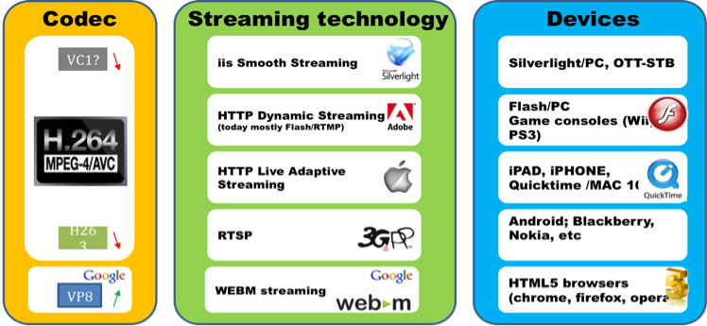
Figure 16: Multi-screen formats using Broadband Internet and 3GPP streaming technologies

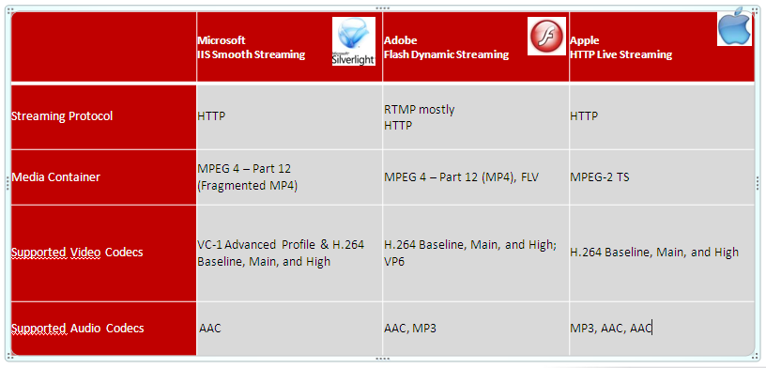
Figure 17: Streaming Technology comparison

RTMP streaming protocol
The Real-Time Messaging Protocol (RTMP) was designed for high-performance transmission of audio, video, and data between Adobe Flash Platform technologies, including Adobe Flash Player and Adobe AIR. RTMP is now available as an open specification to create products and technology that enable delivery of video, audio, and data in the open AMF, SWF, FLV, and F4V formats compatible with Adobe Flash Player.
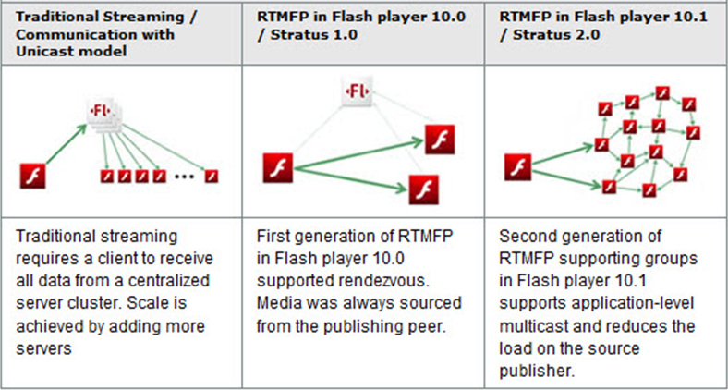
Figure 18: Evolution of Media and communication delivery on Flash platform
RTMP (except RTMFP) is a TCP-based protocol which maintains persistent connections and allows low-latency communication. To deliver streams smoothly and transmit as much information as possible, it splits streams into fragments and their size is negotiated dynamically between the client and server while sometimes it is kept unchanged: the default fragment sizes are 64-bytes for audio data, and 128 bytes for video data and most other data types. Fragments from different streams may then be interleaved, and multiplexed over a single connection. With longer data chunks the protocol thus carries only a one-byte header per fragment, so incurring very little overhead. However, in practice individual fragments are not typically interleaved. Instead, the interleaving and multiplexing is done at the packet level, with RTMP packets across several different active channels being interleaved in such a way as to ensure that each channel meets its bandwidth, latency, and other quality-of-service requirements. Packets interleaved in this fashion are treated as indivisible, and are not interleaved on the fragment level.
The RTMP defines several virtual channels on which packets may be sent and received, and which operate independently of each other. For example, there is a channel for handling RPC requests and responses, a channel for video stream data, a channel for audio stream data, a channel for out-of-band control messages (fragment size negotiation, etc.), and so on. During a typical RTMP session, several channels may be active simultaneously at any given time. When RTMP data is encoded, a packet header is generated. The packet header specifies, amongst other matters, the id of the channel on which it is to be sent, a timestamp of when it was generated (if necessary), and the size of the packet's payload. This header is then followed by the actual payload content of the packet, which is fragmented according to the currently agreed-upon fragment size before it is sent over the connection. The packet header itself is never fragmented, and its size does not count towards the data in the packet's first fragment. In other words, only the actual packet payload (the media data) is subject to fragmentation. At a higher level, the RTMP encapsulates MP3 or AAC audio and FLV1 video multimedia streams, and can make remote procedure calls (RPCs) using the Action Message Format. Any RPC services required are made asynchronously, using a single client/server request/response model, such that real-time communication is not required.
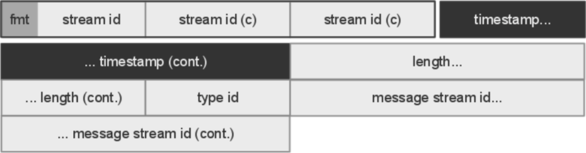
Figure 19: RTMP packet diagram
Packets are sent over a TCP connection which are established first between client and server. They contain a header and a body which, in the case of connection and control commands, is encoded using the Action Message Format (AMF). The header is split into the Basic Header (shown as detached from the rest, in the diagramme) and Chunk Message Header. The Basic Header is the only constant part of the packet and is usually composed of a single composite byte, where the 2 most significant bits are the Chunk Type (fmt) and the rest form the Stream ID. Depending on the value of the former, some fields of the Message Header can be omitted and their value derived from previous packets while depending on the value of the latter, the Basic Header can be extended with 2 extra bytes (as in the case of the diagramme that has 3 bytes in total). The Chunk Message Header contains meta-data information such as the message size (measured in bytes), the Timestamp Delta and Message Type. This last value is a single byte and defines whether the packet is an audio, video, command or "low level" RTMP packet such as an RTMP Ping.

HTTP Streaming protocol
The biggest issue with RTSP is that the protocol or its necessary ports may be blocked by routers or firewall settings, preventing a device from accessing the stream. HTTP Streaming can be used on TCP port 80 or 8080, and traffic to that port is usually allowed through by firewalls, therefore, HTTP Streaming optimization mechanism can be applied if the client is behind a firewall that only allows HTTP traffic.

HTTP Streaming packages media files into fragments that clients can access instantly without downloading the entire file.

With adaptive HTTP streaming, HTTP streaming client can switch dynamically among different streams of varying quality and size during playback. This provides users with the best possible viewing experience their bandwidth and local computer hardware (CPU) can support. Another major goal of dynamic streaming is to make this process smooth and seamless to users, so that if up-scaling or down-scaling the quality of the stream is necessary; it is a smooth and nearly unnoticeable switch without disrupting the continuous playback.

The need for HTTP streaming
With faster-performing client hardware and users with higher bandwidth becoming the norm, the promise of high-definition (HD) video on the web is a reality. HD web video is generally considered larger video starting at 640 × 480 pixel dimensions and increasing up through 720p towards 1080p. The issues facing this trend have been around since the beginning of streaming video. Now, media servers and players can handle streaming HD video in ways that greatly improve the user's experience without the need for them to do anything besides sit back and enjoy high-quality material.

One of the biggest issues facing publishers trying to stream longer duration (longer than five minutes) and higher quality video—especially HD video—is the standard fluctuations of users' Internet connections. This is a standard issue on most networks and can be exacerbated when multi-taskers, wireless network fluctuations, or multiple, simultaneous users sharing a connection are involved.

The end result is a moving target for actual available bandwidth, and this can leave users continually having to rebuffer and wait for their video if the selected stream bandwidth is unsustainable on their network. Dynamic streaming detects fluctuating bandwidth and switches among streams of different bit rates in order to match the content stream to the user's bandwidth.
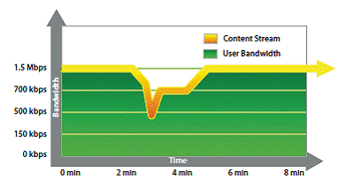
Figure 20: Matching bandwidth changes to maintain QoS
On the other hand, some users may start the stream with low available bandwidth, and then free up more bandwidth after the start of the video. In this scenario, dynamic streaming can offer the ability to up-scale the video quality to a higher level, once again improving the user's experience.

In the past, the alternative was to perform initial or frequent bandwidth detection routines. Although better than nothing, these tests were costly in time and often didn't provide the accuracy needed due to the normal fluctuations and changes in bandwidth. Now, with the dynamic streaming capabilities and Quality of Service (QoS) information available, bandwidth detection tests have lost much of their value.

Another issue that can hinder playback, especially with large-dimension HD video and full-screen playback, can be the user's hardware performance limitations. If the CPU cannot decode the video stream fast enough, it will result in dropped frames, which can adversely affect the smoothness of the user's video display. In this case, using a lower-quality video file would enable less strain on the CPU to decode in synch and maintain performance.

Benefits of adaptive bit rate streaming
Adaptive Bitrate Streaming (or Adaptive Streaming) is a technique used in streaming multimedia over computer networks. While in the past most video streaming technologies utilized streaming protocols such RTSP, today's adaptive streaming technologies are almost exclusively based on HTTP and designed to work efficiently over large distributed HTTP networks such as the Internet.
It works by detecting a user's bandwidth and CPU capacity in real time and adjusting the quality of a video stream accordingly. It requires the use of an encoder which can encode a single source video at multiple bit rates. The player client switches between streaming the different encodings depending on available resources. "The result: very little buffering, fast start time and a good experience for both high-end and low-end connections."

Consumers of streaming media experience the highest quality material when adaptive bit rate streaming is used because the user's network and playback conditions are automatically adapted to at any given time under changing conditions.
The media and entertainment industry are the main beneficiaries of adaptive bit rate streaming. As the video space grows exponentially, content delivery networks and video providers can provide customers with a superior viewing experience. Adaptive bit rate technology requires less encoding which simplifies overall workflow and creates better results.
The use of a CDN to deliver media streaming to an Internet audience is often used, as it allows scalability. The CDN received the stream from the source at its Origin server, then replicates it to many or all of its Edge cache servers. The end-user requests the stream and is redirected to the "closest" Edge server. The use of HTTP-base adaptive streaming allows the Edge server to run a simple HTTP server software, whose licence cost is cheap or free, reducing software licencing cost, compared to costly media server licences (e.g. Adobe Flash Media Streaming Server). The CDN cost for HTTP streaming media is then similar to HTTP web caching CDN cost.

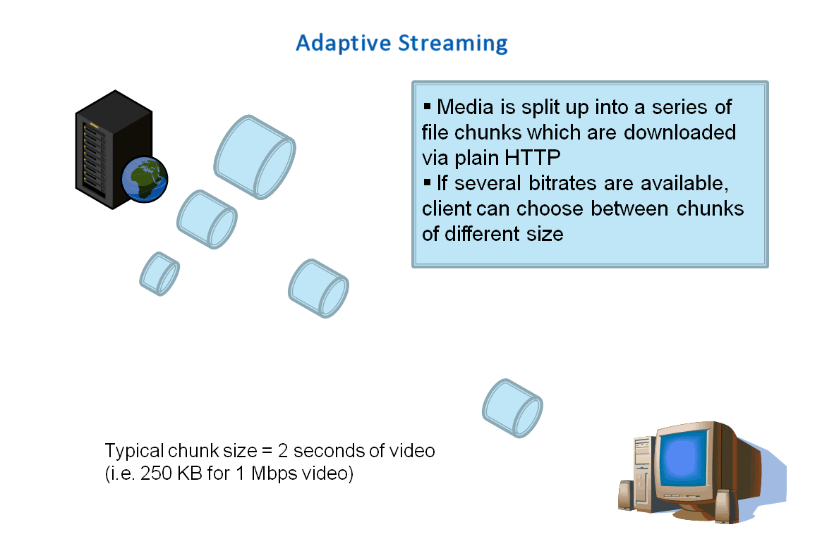
Figure 21: Adaptive streaming is a hybrid media delivery method

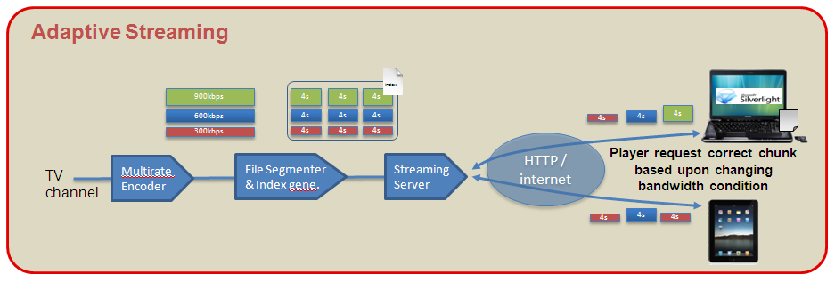
Figure 22: Detailed process for Adaptive streaming

Apple HTTP Live Streaming (for iPhone, iPad, IPod touch, Quicktime, and Safari browser)

HTTP Streaming allows breaking the live contents or stored contents into several chunks/fragments and supplying them in order to the client.

Conceptually, HTTP Live Streaming consists of three parts: the server component, the distribution component, and the client software.

The server component is responsible for taking input streams of media and encoding them digitally, encapsulating them in a format suitable for delivery, and preparing the encapsulated media for distribution.

The distribution component consists of standard web servers. They are responsible for accepting client requests and delivering prepared media and associated resources to the client. For large-scale distribution, edge networks or other content delivery networks can also be used.

The client software is responsible for determining the appropriate media to request, downloading those resources, and then reassembling them so that the media can be presented to the user in a continuous stream.

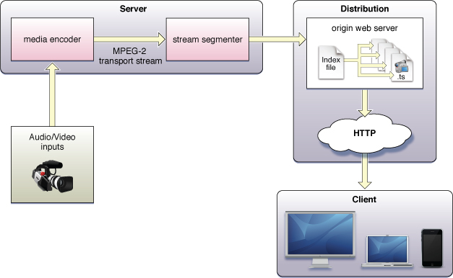
Figure 23: Architecture of HTTP live streaming

Description of server component
The server component can be divided into two components:

- A media encoder, which takes a real-time signal (Input can be live or from a prerecorded source) from an audio-video device, encodes the media (mainly with H264 encoding for video and AAC for audio), and encapsulates it for delivery. Currently, the supported format is MPEG-2 Transport Streams for audio-video, or MPEG elementary streams for audio. The encoder delivers an MPEG-2 Transport Stream over the local network to the stream segmenter.
Audio-only streams can be a series of MPEG elementary audio files formatted as either AAC with ADTS headers or MP3.

- A stream segmenter which reads the Transport Stream from the local network and divides it into a series of small media files of equal duration. Even though each segment is in a separate file, video files are made from a continuous stream which can be reconstructed seamlessly.

The segmenter also creates an index file containing references to the individual media files and metadata. The index file is in .M3U8 format. Each time the segmenter completes a new media file, the index file is updated. The index is used to track the availability and location of the media files. The segmenter may also encrypt each media segment and create a key file as part of the process.

Media segments are saved as .ts files (MPEG-2 streams) and index files are saved as .M3U8 files, an extension of the .m3u format used for MP3 playlists.

Here is a very simple example of an .M3U8 file a segmenter might produce if the entire stream were contained in three unencrypted 10-second media files:

#EXTM3U
#EXT-X-MEDIA-SEQUENCE:0
#EXT-X-TARGETDURATION:10
#EXTINF:10,
http://media.example.com/segment1.ts
#EXTINF:10,
http://media.example.com/segment2.ts
#EXTINF:10,
http://media.example.com/segment3.ts
#EXT-X-ENDLIST

The index file may also contain URLs for encryption key files or alternate index files for different bandwidths. The specification of HTTP Live Streaming is described in [1].

Description of Distribution Components
The distribution system is a web server or a web caching system that delivers the media files and index files to the client over HTTP. No custom server modules are required to deliver the content and typically very little configuration is needed on the web server.
Recommended configuration is typically limited to specifying MIME-type associations for .M3U8 files and .ts files.

File extension | MIME type
.M3U8 | application/x-mpegURL
.ts | video/MP2T

Tuning time-to-live (TTL) values for .M3U8 files may also be necessary to achieve desired caching behavior for downstream web caches, as these files are frequently overwritten, and the latest version should be downloaded for each request.

Description of Client Component
The client software begins by fetching the index file, based on a URL identifying the stream. The index file in turn specifies the location of the available media files, decryption keys, and any alternate streams available. For the selected stream, the client downloads each available media file in sequence. Each file contains a consecutive segment of the stream. Once it has a sufficient amount of data downloaded, the client begins presenting the reassembled stream to the user.
The client is responsible for fetching any decryption keys, authenticating or presenting a user interface to allow authentication, and decrypting media files as needed.
This process continues until the client encounters the #EXT-X-ENDLIST tag in the index file. If no #EXT-X-ENDLIST tag is encountered, the index file is part of an ongoing broadcast. The client loads a new version of the index file periodically. The client looks for new media files and encryption keys in the updated index and adds these URLs to its queue.

Microsoft Smooth Streaming (Delivery to the Silverlight player)
Smooth Streaming [3] is a hybrid delivery method which is based on HTTP progressive download. It relies on HTTP as the transport tool and performs the media download as a long series of very small progressive downloads, rather than one big progressive download. It is one version of what is generically called adaptive streaming, a new and innovative way of streaming media and solving the issues of reliable playback and quality.
The video/audio source is cut into many short segments (“chunks”) and encoded to the desired delivery format. Chunks are typically 2 to 4 seconds long. At the video codec level, this typically means that each chunk is cut along video GOP (Group of Pictures) boundaries (each chunk starts with a key frame) and has no dependencies on past or future chunks/GOPs. This allows each chunk to later be decoded independently from the other chunks, but when collected and played back by the end user it is viewed as an uninterrupted video experience.
The encoded chunks are hosted on a HTTP Web server. A client requests the chunks from the Web server in a linear fashion and downloads them using plain HTTP progressive download. As the chunks are downloaded to the client, the client plays back the sequence of chunks in linear order. Because the chunks are carefully encoded without any gaps or overlaps between them, the chunks play back as a seamless video.
The video/audio source is encoded at multiple bit rates, generating multiple sized chunks for each 2-to-4-seconds of video. The client can now choose between these various chunks that suit its needs best. Web servers usually deliver data as fast as network bandwidth allows. The client can easily estimate user bandwidth and decide to download larger or smaller chunks ahead of time. The size of the playback/download buffer is fully customizable.

The encoders didn't employ any new encoding tricks but merely followed strict encoding guidelines (closed GOP, fixed-length GOP, VC-1 entry point headers, and so on.) which ensured exact frame alignment across the various bit rates of the same video.

A manifest file describes the relationship between media tracks, bitrates and files on the disk.

The rest of the solution consists uploading the chunks to Web servers and then building a Silverlight player that would download the chunks and play them in sequence.

The Smooth Streaming specification defines each chunk/GOP as an MPEG-4 Movie Fragment and stores it within a contiguous MP4 file for easy random access. One MP4 file is expected for each bit rate. When a client requests a specific source time segment from the web server, the server dynamically finds the appropriate Movie Fragment box within the contiguous MP4 file and sends it over the wire as a standalone file, thus ensuring full cacheability downstream.

HTTP Dynamic streaming in Flash Media Server
Most content viewed on a Web site is served over HTTP. Any Web server, such as Apache or Microsoft Internet Information Services (IIS), can deliver Flash Video (FLV or SWF) files. The best reasons to use a Web server with HTTP protocol for hosting Flash Video content are simplicity and cost. If you know how to transfer files to a Web server using a File Transfer Protocol (FTP) client, for example, you can put Flash Video files on a Web site and make the content accessible to visitors. Another advantage of HTTP is cost: Most Web hosting providers offer cheap storage and large transfer quotas that allow you to host numerous media files and serve them to your visitors.

From a site visitor's point of view, one advantage of using HTTP is access. Many corporate networks use firewalls to block specific content from entering. Popular methods of blocking are protocol and port restrictions. Some firewall rules allow only HTTP content served over port 80. Almost all Web servers use port 80 to serve content, but a Web server can be set up to serve HTTP content over custom ports such as 8080, 8081, or 8500. These ports are usually used by test or development servers. Some firewall rules allow only specific MIME types, such as text/html (HTML documents), and common image formats (image/gif, image/jpeg, and image/png). By far, Flash Video served over HTTP on port 80 has the best chance of being viewed by a visitor.

While the Real Time Message Protocol (RTMP) remains the protocol of choice for lowest latency, fastest start, dynamic buffering, and stream encryption, HTTP Dynamic Streaming [2] enables leveraging of existing caching infrastructures (for example, content delivery networks, ISPs, office caching, home networking), and provides tools for integrating content preparation into existing encoding workflows.

Both on-demand and live delivery are supported with HTTP Dynamic Streaming. The content preparation workflow for each is slightly different. On-demand content is prepared through a simple post-encoding step that produces MP4 fragment files along with a manifest file. Live stream delivery requires real-time fragmenting and packaging server that will package a live stream.

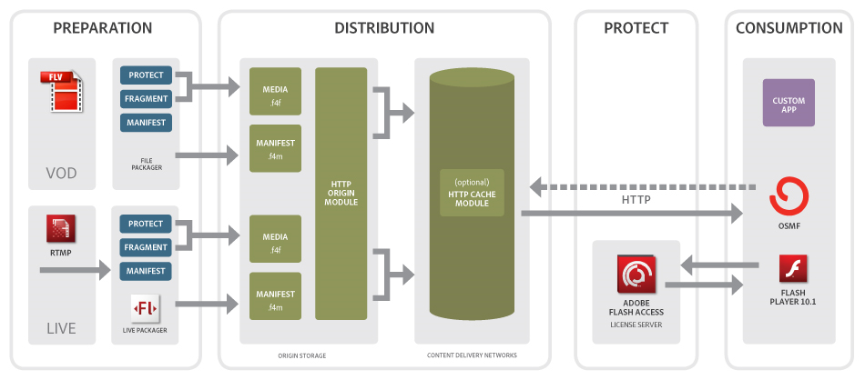
Figure 24: HTTP Dynamic streaming in Flash Media Server
Dynamic streaming is the process of efficiently delivering streaming video to users by dynamically switching among different streams of varying quality and size during playback. This provides users with the best possible viewing experience their bandwidth and local computer hardware (CPU) can support. Another major goal of dynamic streaming is to make this process smooth and seamless to users, so that if up-scaling or down-scaling the quality of the stream is necessary; it is a smooth and nearly unnoticeable switch without disrupting the continuous playback.
Dynamic streaming can provide an optimal solution to network fluctuations and CPU overloading. By continually monitoring key QoS metrics on the client, dynamic streaming can effectively identify when to switch up or down to different-quality streams. The Adobe solution does not require specially encoded files for dynamic streaming, which means existing files already encoded in multiple bit rates can be used.
Dynamic streaming is controlled by the player.
The segmenter needs to:
- Make multiple files: Multiple versions of the same video will be encoded at different bitrates. The player will select the best one according to a user's available bandwidth and CPU load (inferred by counting dropped frames) during playback.
- Give the player a list of the files: The player will need to have a list of the versions that are available, and the bitrates of each. This list will look different depending on which player you're using.
To prepare for dynamic streaming, it is necessary to encode the video at several different bitrates that span the capabilities of the viewers.
When the player loads, it will detect the user's bandwidth & the screen size and choose the appropriate version of the file. The player will continue to measure bandwidth and dropped frames continually during playback, and will react to screen size changes (such as a user going to full-screen viewing).

Mobile TV
Mobile TV networks includes all 3G streaming protocols previously described, and also Broadcast network with DVB-T2. This technology should replace DVB-H which is becoming a dead technology as described in the figure below.
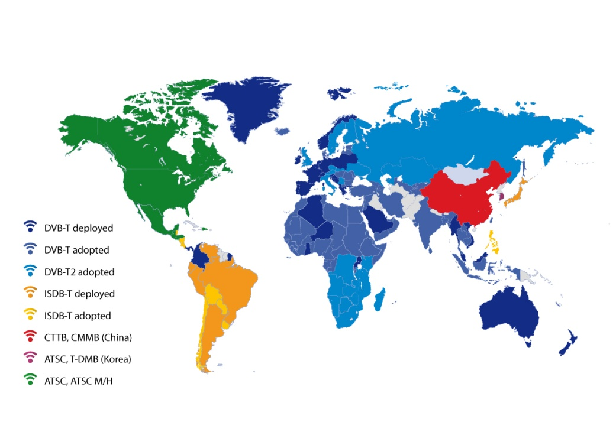
Figure 25: Fragmented DTT Broadcast World in 2011

The DVB-H network was announced to be subject of termination due to low popularity (no terminals available). DVB-H is becoming a dead technology. DVB-T will eventually come back in Europe under the new DVB-T2 standard which incorporate mobile broadcasting capabilities. DVB-T2 is launching in several countries and DVB-T2 should provide the benefits of both DVB-T and DVB-H. In DVB-T2, same transmitter equipment can be used for stationary and mobile reception. The standard for terrestrial digital television (DVB-T) has been defined in 1996 and been deployed first in UK in 1998 and then widely over the Europe. A new standard named DVB-T2 has been defined in 2008 and the first deployment are starting notably in UK.
The purpose of DVB-T2 is to offer
- 30% of robustness improvement
- 30% of additional useful rate (for more HD services)
- 30% of additional coverage area (for larger SFN area)
- A better indoor reception (for mobile reception)
- The capability to have multiple channels with dedicated modulation mode (for mixing handheld and roof antenna reception)
The DVB-T2 standard is a non backward compatible extension of the DVB-T standard but reuse part of its technology (COFDM modulation, protection mechanism,…) but with additional concept
Multi-PLP (Multiple Physical Layer Pipe) allowing transmitting multiple independent channel in the same signal. This concept has been re-use from the DVB-S2 standard.
Figure 26: DVB-T2 workflow

Cloud Computing for video services

Cloud Computing Definition
Born as a result of web technologies, networks and data centers all reaching maturity at about the same time, Cloud computing is first and foremost a distribution model, in the form of pay-as-you-go on-line services, or commoditized and configurable resources such as servers, storage and applications.

The term "cloud" comes from the early days of the Internet where the network was drawn as a cloud, an abstraction of the underlying infrastructure it represents (TCP/IP abstraction and then WWW data abstraction).
The emerging cloud abstracts infrastructure complexities of servers, applications, data, and heterogeneous platforms.

Cloud computing utilizes the network as a means to connect the user to resources that are based in the 'cloud'. With 'cloud computing', clients only require a simple computer, a web browser and a connection to the Internet, in order to make requests to and receive data from the cloud.

Given the wealth of information and the buzz around this topic in the computer press there is not A definition but definitions of what is meant by the term cloud computing. The definitions come from Cloud providers, as well as market trend analysis organisms, specialized press or standardization organisms. We refer to the National Institute of Standards and Technology (NIST) definition [24].

“Cloud computing is a model for enabling convenient, on-demand network access to a shared pool of configurable computing resources (e.g., networks, servers, storage, applications, and services) that can be rapidly provisioned and released with minimal management effort or service provider interaction.”

This cloud model promotes availability and is composed of five essential characteristics, three service models, and four deployment models.

Strength of the Cloud computing model is the abstraction of physical infrastructure components, of resources location and available capacity. Through these abstractions, the cloud is seen as a pool of infinite resources always available. The essential characteristics of a cloud are:

- On-demand self-service. A consumer can provision computing capabilities, as needed automatically without requiring human interaction with each service’s provider.

- Network access. Capabilities are available over the network (internet or intranet in case of private cloud). Capabilities are accessed through standard mechanisms (TCP/IP,SSL, HTTP,….), that promotes use by heterogeneous thin or thick client platforms.

- Resource pooling. The provider’s computing resources (processing, memory, storage network bandwidth, and virtual machines) are pooled to serve multiple consumers using a multi-tenant model, with different physical and virtual resources dynamically assigned and reassigned according to consumer demand.

- Rapid elasticity. Provisioning is rapid and scales out or in based on need.

- Measured Service. Cloud systems automatically control and optimize resource use by leveraging a metering capability at some level of abstraction appropriate to the type of service (e.g., storage, processing, bandwidth, and active user accounts).

The service models depends on the capabilities provided to consumer :

- Software as a Service (SaaS). The capability provided to the consumer is to use the provider’s applications running on cloud infrastructure. The applications are accessible from various client devices through a thin client interface such as a web browser (e.g., web-based email).

- Platform as a Service (PaaS) The capability provided to the consumer is to deploy onto the cloud infrastructure consumer-created or acquired applications created using programming languages and tools supported by the provider. The consumer does not manage or control the underlying cloud infrastructure including network, servers, operating systems, or storage, but has control over the deployed applications and possibly application hosting environment configurations (services Web configuration, database structure, number of servers, loadbalancers,….)

- Infrastructure as a Service (IaaS) The capability provided to the consumer is to provision processing, storage, networks, and other fundamental computing resources where the consumer is able to deploy and run arbitrary software, which can include operating systems and applications. The consumer has control over operating systems, storage, deployed applications on virtual servers.

The deployement models can be :

- Private cloud. The cloud infrastructure is operated solely for an organization. It may be managed by the organization or a third party and may exist on premise or off premise.

- Community cloud. The cloud infrastructure is shared by several organizations and supports a specific community that has shared concerns (e.g., mission, security requirements, policy, and compliance considerations). It may be managed by the organizations or a third party and may exist on premise or off premise.

- Public cloud. The cloud infrastructure is made available to the general public or a large industry group and is owned by an organization selling cloud services.

- Hybrid cloud. The cloud infrastructure is a composition of two or more clouds (private, community, or public) that remain unique entities but are bound together by standardized or proprietary technology that enables data and application portability (e.g., cloud bursting for load-balancing between clouds).

Cloud Standardization
Many organizations should play a role in Cloud standards definition, the most significants are :
- IETF (Internet Engineering Task Force) which works on Internet related concerns including the issue of virtual networks and of security.
- DMTF (Distributed Management Task Force) which has already worked on virtual machines standardization and who is legitimate on management aspects.
- SNIA (Storage Networking Industry Association) which is responsible for all matters relating to the representation of storage in the cloud.
- IEEE (The Institute of Electrical and Electronics Engineers) which has an established role in the standardization of SOA (Service Oriented Architecture) to be an important component for the Cloud.
- OMG (Object Management Group) which is involved in the standardization of Web Services
- W3C (World Wide Web Consortium) which works on standards related to Web
- ETSI (European Telecommunications Standards Institute) which is involved in the field of IaaS and the access to these IaaS resources.
- Open Grid Forum which is working on the provisioning and monitoring of distributed resources and infrastructure services.
- NIST (National Institute of Standards and Technology) which has developed the most commonly used definition of Cloud Computing
In addition to these organizations, we can include initiatives wishing to promote the emergence of open standards:
- Open Cloud Manifesto which promotes interoperability between Cloud Computing Solutions
- Cloud Security Alliance which contributes to a better consideration of safety issues in the Cloud
- Free Cloud Alliance which aims to promote open solutions.
The ACDC project will work synchronizing with the progress that can be made ​​by those organizations.

General Cloud Tools

Apache Tomcat(web server):
Apache Tomcat (or Jakarta Tomcat or simply Tomcat) is an open source servlet container developed by the Apache Software Foundation (ASF). Tomcat implements the Java Servlet and the JavaServer Pages (JSP) specifications from Sun Microsystems, and provides a "pure Java" HTTP web server environment for Java code to run.

Apache CFX (web service):
Apache CXF is an open-source, fully featured Web Services framework. It originated as the combination of two open-source projects: Celtix developed by IONA Technologies (acquired by Progress Software in 2008) and XFire developed by a team hosted at Codehaus. These two projects were combined by people working together at the Apache Software Foundation. The name CXF derives from combining the "Celtix" and "XFire" project names.

Apache Whirr
Apache Whirr is a set of libraries for running cloud services. Whirr is currently in the Apache Incubator. Whirr provides;
- A cloud-neutral way to run services. You don't have to worry about the idiosyncrasies of each provider.
- A common service API. The details of provisioning are particular to the service.
- Smart defaults for services. You can get a properly configured system running quickly, while still being able to override settings as needed.

Apache Pig
Apache Pig is a platform for analyzing large data sets that consists of a high-level language for expressing data analysis programs, coupled with infrastructure for evaluating these programs. The salient property of Pig programs is that their structure is amenable to substantial parallelization, which in turns enables them to handle very large data sets.
At the present time, Pig's infrastructure layer consists of a compiler that produces sequences of Map-Reduce programs, for which large-scale parallel implementations already exist (e.g., the Hadoop subproject). Pig's language layer currently consists of a textual language called Pig Latin, which has the following key properties:
- Ease of programming. It is trivial to achieve parallel execution of simple, "embarrassingly parallel" data analysis tasks. Complex tasks comprised of multiple interrelated data transformations are explicitly encoded as data flow sequences, making them easy to write, understand, and maintain.
- Optimization opportunities. The way in which tasks are encoded permits the system to optimize their execution automatically, allowing the user to focus on semantics rather than efficiency.
- Extensibility. Users can create their own functions to do special-purpose processing.

Apache Web Server
The Apache HTTP Server Project is a collaborative software development effort aimed at creating a robust, commercial-grade, featureful, and freely-available source code implementation of an HTTP (Web) server. The project is jointly managed by a group of volunteers located around the world, using the Internet and the Web to communicate, plan, and develop the server and its related documentation. This project is part of the Apache Software Foundation. In addition, hundreds of users have contributed ideas, code, and documentation to the project.
The Apache HTTP Server Project is an effort to develop and maintain an open-source HTTP server for modern operating systems including UNIX and Windows NT. The goal of this project is to provide a secure, efficient and extensible server that provides HTTP services in sync with the current HTTP standards.

Distributed processing

Apache™ Hadoop™
The Apache™ Hadoop™ software library is a framework that allows for the distributed processing of large data sets across clusters of computers using a simple programming model. It is designed to scale up from single servers to thousands of machines, each offering local computation and storage. Rather than rely on hardware to deliver high-availability, the library itself is designed to detect and handle failures at the application layer, so delivering a highly-available service on top of a cluster of computers, each of which may be prone to failures.
The project includes these subprojects:
* Hadoop Common is a set of utilities including FileSystem, RPC, and serialization libraries.
* Hadoop Distributed File System (HDFS) is a distributed file system designed to run on commodity hardware. HDFS is highly fault-tolerant and is designed to be deployed on low-cost hardware. HDFS provides high throughput access to application data and is suitable for applications that have large data sets.
* Hadoop MapReduce is a software framework for easily writing MapReduce applications which process vast amounts of data (multi-terabyte data-sets) in-parallel on large clusters (thousands of nodes) of commodity hardware in a reliable, fault-tolerant manner.
A MapReduce job usually splits the input data-set into independent chunks which are processed by the map tasks in a completely parallel manner. The framework sorts the outputs of the maps, which are then input to the reduce tasks. Typically both the input and the output of the job are stored in a file-system. The framework takes care of scheduling tasks, monitoring them and re-executes the failed tasks.
For more information visit http://hadoop.apache.org

Apache Mahout
Mahout's goal is to build scalable machine learning libraries. With scalable they mean:
Scalable to reasonably large data sets. Their core algorithms for clustering, classfication and batch based collaborative filtering are implemented on top of Apache Hadoop using the map/reduce paradigm. However they do not restrict contributions to Hadoop based implementations: Contributions that run on a single node or on a non-Hadoop cluster are welcome as well. The core libraries are highly optimized to allow for good performance also for non-distributed algorithms.
Scalable to support various business cases. Mahout is distributed under a commercially friendly Apache Software license.
Scalable community. The goal of Mahout is to build a vibrant, responsive, diverse community to facilitate discussions not only on the project itself but also on potential use cases. Come to the mailing lists to find out more.
Currently Mahout supports mainly four use cases: Recommendation mining takes users' behavior and from that tries to find items users might like. Clustering takes e.g. text documents and groups them into groups of topically related documents. Classification learns from exisiting categorized documents what documents of a specific category look like and is able to assign unlabelled documents to the (hopefully) correct category. Frequent itemset mining takes a set of item groups (terms in a query session, shopping cart content) and identifies, which individual items usually appear together.
http://mahout.apache.org/

Distributed semantic content analysis

Research background on distributed content analysis
The development of automatic methods for analysing multimedia content has been a popular research topic since the early 1990's. Multimedia content analysis (MMCA) is a very complex subject for several reasons. First of all, the multimedia consists of several types of content, such as image, video, audio and text. All of these content types have unique characteristics from the analysis perspective. Furthermore, multimedia content can be interpreted from virtually infinite amount ofviewpoints, ranging from low-level physical properties to high-level semantics. Several research groups have studied methods and algorithms with different aims over the years of research.
Distributed multimedia content analysis is a research field that attempts to apply distributed computing methodologies efficiently to content analysis solutions. Distribution of the analysis methods brings additional complexity over traditional monolithic stand-alone programs, but it also enables implementing larger-scale horizontally scaled systems that facilitate content based analysis for a variety of novel applications. Some of the most recent research on distributed content analysis is introduced below.
Heinzl et al. have developed a service-oriented infrastructure for multimedia applications. Their solution aims to provide development tools for variety of multimedia applications covering video and audio content analysis, audio synthesis and multimedia consumption. The aim of their work was to facilitate easy and rapid implementation of new multimedia applications, making the system dynamically scalable and inventing an efficient way to distribute multimedia data between different networked nodes within the system. Their system uses SOAP protocol for messaging between the services. Business Process Execution Language (BPEL) is utilized for modeling different service compositions and their workflows. Scalability of the system is enabled by dynamically extending the hardware platform in which the system is deployed on. This is accomplished by using cloud computing technologies, namely the Amazon Elastic Compute Cloud (EC2)
[Source: Heinzl S., Seiler D., Juhnke E., Stadelmann T., Ewerth R., Grauer M. & Freisleben B. (2009) A scalable service-oriented architecture for multimedia analysis, synthesis and consumption. Inderscience International Journal of Web and Grid Services, Vol. 5, pp. 219-260.]

Ewerth et al. introduce a distributed solution for detecting cut points from video files. These cut points are used for temporally segmenting a video into disjoint segments called shots. This temporal segmentation is a common task in video content analysis and can be utilized in further analysis phases. The presented architecture is based on grid computing paradigms and it utilizes web services as the implementation technology. These so called grid services are implemented using Globus toolkit, which is an open-source toolkit for building computational grid environments. SOAP protocol is used for communication between nodes in the distributed system.
[Source: Ewerth R., Friese T., Grube M. & Freisleben B. (2004) Grid services for distributed video cut detection. In: Proceedings of the IEEE Sixth International Symposium on Multimedia Software Engineering, pp. 164-168.]

The CASSANDRA framework is a distributed multimedia content analysis system based on a service-oriented design. The system aims to utilize the continuously increasing processing power of the modern networked consumer electronic devices, such as mobile phones and personal computers, for multimedia content analysis. The software architecture facilitates the composition of applications from distributed components. The framework is based on modular structure, where the basic element is called a service unit, each of which provides a certain service to the network and may also use other services itself. All the individual content analysis components are deployed as separate units. Service units have separate control and data streaming interfaces. The control interface is based on Universal Plug and Play (UpnP) framework, while a simplistic TCP/IP solution is used for the data streaming.
[Source: de Lange F., Nesvadba J. & Lukkien J. (2007) CASSANDRA Framework: A Service Oriented Distributed Multimedia Content Analysis Engine. IEEE Eight International Workshop On Image Analysis for Multimedia Interactive Services(WIAMIS'07).]

In [35], Seinstra et al. present a distributed solution for video content analysis. They introduce Parallel-Horus, a cluster programming library that allows developers to implement distributed multimedia applications as fully sequential programs. Parallel-Horus is an extension to Horus, which is a programming library intended for implementing multimedia applications. The driving idea behind Parallel-Horus is to provide a transparent programming model that hides the challenges of distributed programming from its users. The system integrates this transparent programming model with a grid computing execution model based on wide-area multimedia services. The system is based on a client-server architecture and it consists of three logical components: client, service and resource broker. Each component has its own API that allows the initialization, invocation and registration of services.
[Source: Seinstra F., Geusebroek J., Koelma D., Snoek C., Worring M & Smeulders A. (2007) High-performance distributed video content analysis with parallel- horus. IEEE multimedia, vol. 14, no. 4, pp. 64-75.]

Web service composition for semantic content analysis
This chapter describes distributed web service architecture to allow web level scalability for multimedia content analysis. The system was developed in MediaTeam research group at the University of Oulu, Finland. The system is based on service component architecture that manages the orchestration and composition of services using content analysis service units. Content analysis units enrich multimedia metadata via common data model that is built on MPEG-7 content description standard.

The architecture of the multimedia content analysis platform is based on service-oriented design, where the application logic is distributed and accessible through web service interfaces. The system consists of four basic entities: Client software, Content analysis service, Analysis unit(s) and Service registry. A system diagram is shown below. Communication between different nodes uses XML-based SOAP messages that are transported via HTTP protocol. The service interfaces are defined using Web Service Description Language (WSDL).
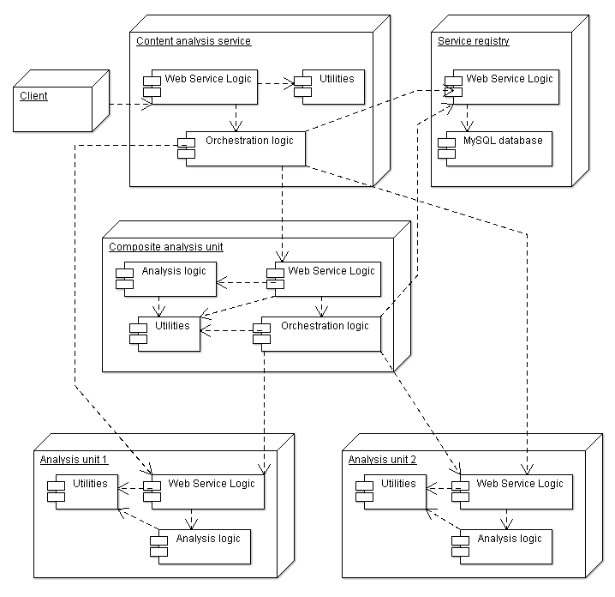
Figure 27: Architectural overview of the multimedia content analysis platform

A client can be any software program that is able to utilize the analysis output provided by the platform. Content analysis service is the control point of the system. It discovers and invokes the analysis units required to fulfill the client's requests. It provides a web service interface to the platform clients, therefore acting as the single entry point to the platform. The analysis units are web services that execute the actual content analysis tasks. Each unit specializes to a specific analysis functionality. The service registry keeps a MySQL database containing information about registered analysis units. It also provides a web service interface for discovering and registering services. Orchestration logic is included in all services that can invoke other services. It provides methods for service discovery, service selection and invocation.

One important feature of the distributed service platform is that a content analysis unit may utilize the results of the other analysis units. In this situation the unit forms a service composition with the other units. The constructed composite unit performs similar operations as the main content analysis service: it discovers, selects and invokes the analysis units that are part of the composition. In situations where a single analysis functionality is invoked by multiple compositions for the same data, redundant invocation is avoided by selecting the analysis unit that is already processing the data.

The platform is also capable of balancing the load between different services in a situation where an analysis unit has been replicated to several nodes. The developed method is more sophisticated than a round-robin method where requests are distributed to the different servers in a circular order. The method balances the load in a resource-aware manner, where the server's current load level and its computational capacity are taken into account. For determining the server load level, the load average reported by unix-based operating systems is used. Based on the load level l and the number of CPU cores in the server N_{CPU} the load balancing method calculates a value that represents the current available processing capacity of the server C. The server with the highest available processing capacity is always selected. Equation 1 defines the formula used in the calculation.

 (1)

If the load level is equal or less than the total number of CPU cores, the processing capacity is calculated by subtracting the load value from the number of CPU cores. This gives a value representing the average number of “free” CPUs in the server. In an overload situation where the load level is higher than the number of CPU cores, the subtraction results in a negative number. In this case, the subtraction result is divided by the number of CPU cores in order to reflect the relative overload of the server. Example values calculated using Eq. 1 can be seen in Figure 28.

Load level | C, N_{CPU} = 2 | C, N_{CPU} = 4 | C, N_{CPU}= 8 | C, N_{CPU=16}
0.5 | 1.5 | 3.5 | 7.5 | 15.5
2 | 0 | 2 | 6 | 14
4 | -1 | 0 | 4 | 12
8 | -3 | -1 | 0 | 8
16 | -7 | -3 | -1 | 0
Figure 28: Available processing capacity values calculated with different load levels and number of CPUs

Experiments with distributed content analysis

Distributed content analysis platform's ability to balance load between replicated service components on different nodes was measured with an analysis task run over a period of time. The purpose of the test was to measure how well the platform was able to balance the load between servers with different performance characteristics and a varying amount of external load.

The test was performed by configuring the content analysis platform with a frontal face detection service, an analysis unit that detects frontal face regions from digital images and videos. The analysis unit was replicated into four different computers and communication within the platform was achieved through web service invocations. Frontal face detection service was selected for this test because it can efficiently utilize the entire processing capacity of the computer it runs on due to its parallelized internal design. The parallelization is particularly effective in analyzing videos.

Test environment consisted of three identical modern desktop PCs and a larger server machine. The desktop PCs were dual core machines with 2 gigabytes of memory. The server machine had two quad core CPUs totaling 8 cores and 24 gigabytes of memory. The computers were connected in the same LAN via a gigabit Ethernet connection. Apache Axis2 was used as the web service engine in the platform services that were running on Apache Tomcat servers.

The test was conducted as a one hour test run where a client application sent analysis requests to the platform requesting face detection for a video file. The requests were sent at random intervals between 15 and 45 seconds in an attempt to simulate a more realistic scenario where the analysis requests would arrive at unpredictable times. The analyzed video file was a 1 minute 35 seconds long MPEG-4/AVC mobile video recording with the resolution of 640*480 pixels. The file size was 32 megabytes. The specifications of the selected video clip were assumed to represent a typical user generated mobile video.

Load levels of the different machines were measured over the time period of the test run. Their development can be seen in Figure 29. The first observation is that the curve representing the load of the server machine is at a much higher level than the curves of the desktop-PCs. The curves representing the desktop-class machines are grouped quite closely together. The dashed lines show the mean load values for each machine. The mean value for the server machine was 11.36 whereas the mean values for the desktop-PCs were very close to each other, 3.51, 3.32 and 3.48 respectively. The average load for the desktop machines was 3.44 which gives 3.3 times higher load for the server machine. Figure 29 shows that the load levels on the server have larger variance than with the desktop computers. This is because the server had other external processes running simultaneously in the background which affected the overall load level.

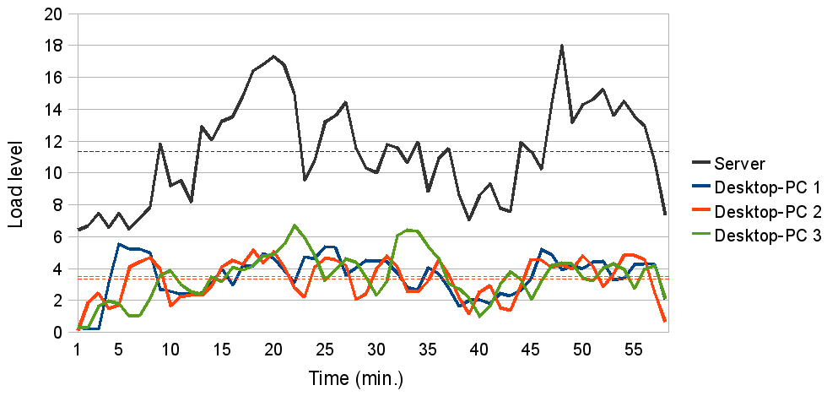
Figure 29: Load levels at different nodes over time
[Source: Rautiainen M, Heikkinen A, Sarvanko J and Ylianttila M (2011) “Distributed Web Service Architecture for Scalable Content Analysis: Semi-automatic Annotation of User Generated Content”, Proc. Grid and Pervasive Computing 2011, LNCS 6646, Oulu, Finland, pp. 158–167]

Distributing content analysis tasks using modern software frameworks
The ACDC project focuses on the cloud computing applications for rich media. This section introduces recent trends in big data research, which is increasingly accommodating to applications of large-scale multimedia data processing and analysis. A new emerging paradigm for distributed processing is MapReduce. It provides an efficient framework for parallelization of computational tasks across independent processing nodes through mapping and reduction of sub-results into final aggregate.

Hadoop – a distributed computing and data storage framework
Apache Hadoop is an open source implementation of distributed computing and data storage frameworks and has been introduced elsewhere in this document. In this section we introduce visual data analysis research that builds upon Apache Hadoop.
White introduced several “big data” studies for computer vision problems and applications. He concluded that Map/Reduce paradigm suits well in several large scale image processing tasks where the focus is on large data sets and their utilization in solving traditional computer vision problems, such as pose estimation, scene completion, geographic estimation, object recognition, pixel-based annotation, one frame motion, object detection, data clustering and image retrieval.
[Source: Brandyn White, Large Scale Image Processing with Hadoop, https://docs.google.com/present/view?id=0AVfpz37UN4jxZGM0a2pudzRfNjVkc3dnczl0Nw&amp;hl=en]
Trease et al. introduce their distributed, multi-core image processing framework that supports data-intensive, high-throughput video analysis. Authors describe how their architecture is mapped into a Hadoop MapReduce framework for transaction parallelism. Applications for their video analysis architecture include: “(1) processing data from many (100s, 1000s, 10,000s+) surveillance cameras, and (2) processing archived video data from repositories or databases.” Their system is designed for large data throughput. The processing speed of their architecture is described “ranging from one DVD per second (5 Gigabytes per second) on Linux clusters to 500 Gigabytes per second (for the PCA analysis on a modern Nvidia GPGPU multi-threaded cluster using only 4 GPGPUs)”.
[Source: Using Transaction Based Parallel Computing to Solve Image Processing and Computational Physics Problems, http://www.chinacloud.cn/upload/2009-04/temp_09042910141363.pdf]
HP Labs demonstrates cloud infrastructure on an image processing application that allows users to transform their images and videos to a cartoon style. Their cloud computing test bed allocates underlying resources dynamically and is able to provision the resources on a computational market where prices vary with demand and users are able to manage their resource allocation based on their budgeted cost.
[HP Labs cloud-computing test bed: VideoToon demo, http://www.hpl.hp.com/open_innovation/cloud_collaboration/cloud_demo_transcript.html]
Wiley et al. demonstrate the utility of Hadoop framework in astronomical image processing. Their challenge is to analyse 60 peta-bytes of sky image data during the years 2015-2025. They demonstrate how Hadoop can be used to create image coadditions by weighting, stacking and mosaicing image intersections taken from multiple telescope outputs. Image coadditions allowed them to obtain ~2 magnitudes increase in point source detection depth over single images.
[Source: Keith Wiley, Andrew Connolly, Simon Krughoff, Jeff Gardner, Magdalena Balazinska, Bill Howe, YongChul Kwon, Yingyi Bu. Astronomical Image Processing with Hadoop, http://adass2010.cfa.harvard.edu/ADASS2010/incl/presentations/O02_4.pdf]

Mahout – a distributed framework for scalable machine learning
Mahout is an Apache project that aims to provide scalable machine learning algorithms and libraries on top of the Hadoop platform. Mahout is a work in progress but it has several analytics algorithms implemented.

Mahout aims at building scalable machine learning libraries for reasonably large data sets. The core algorithms for clustering, classification and batch based collaborative filtering are implemented on top of Apache Hadoop using the map/reduce paradigm. Currently Mahout supports mainly four use cases that are around text document analysis:
- Recommendation mining takes users' behavior and from that tries to find items users might like.
- Clustering takes e.g. text documents and groups them into groups of topically related documents.
- Classification learns from exisiting categorized documents what documents of a specific category look like and is able to assign unlabelled documents to the (hopefully) correct category.
- Frequent itemset mining takes a set of item groups (terms in a query session, shopping cart content) and identifies, which individual items usually appear together

[Source: http://mahout.apache.org/ ]

Mahout adoption in industry
- Adobe AMP uses Mahout's clustering algorithms to increase video consumption by better user targeting. See http://nosql.mypopescu.com/post/2082712431/hbase-and-hadoop-at-adobe
- Amazon's Personalization Platform – See http://www.linkedin.com/groups/Apache-Mahout-2182513
- AOL use Mahout for shopping recommendations. See http://www.slideshare.net/kryton/the-data-layer
- Booz Allen Hamilton uses Mahout's clustering algorithms. See http://www.slideshare.net/ydn/3-biometric-hadoopsummit2010
- Buzzlogic uses Mahout's clustering algorithms to improve ad targeting
- Cull.tv uses modified Mahout algorithms for content recommendations
- DataMine Lab uses Mahout's recommendation and clustering algorithms to improve our clients' ad targeting.
- Drupal users Mahout to provide open source content recommendation solutions.
- Foursquare uses Mahout to help develop predictive analytics.
- InfoGlutton uses Mahout's clustering and classification for various consulting projects.
- Kauli, one of Japanese Adnetwork, uses Mahout's clustering to handle clickstream data for predicting audience's interests and intents.
- Mendeley uses Mahout internally to test collaborative filtering algorithms and as part of their work on EU and JISC-funded research collaborations.
- Mippin uses Mahout's collaborative filtering engine to recommend news feeds
- NewsCred uses Mahout to generate clusters of news articles and to surface the important stories of the day
- SpeedDate.com uses Mahout's collaborative filtering engine to recommend member profiles
- Yahoo! Mail uses Mahout's Frequent Pattern Set Mining. See http://www.slideshare.net/hadoopusergroup/mail-antispam
- 365Media uses Mahout's Classification and Collaborative Filtering algorithms in its Real-time system named UPTIME and 365Media/Social

Mahout adoption in Academia
- Dicode project uses Mahout's clustering and classification algorithms on top of Hbase.
- The course Large Scale Data Analysis and Data Mining at TU Berlin uses Mahout to teach students about the parallelization of data mining problems with Hadoop and Map/Reduce
- Mahout is used at Carnegie Mellon University, as a comparable platform to GraphLab.
- The ROBUST project, co-funded by the European Commission, employs Mahout in the large scale analysis of online community data.
- Mahout is used for research and data processing at Nagoya Institute of Technology, in the context of a large-scale citizen participation platform project, funded by the Ministry of Interior of Japan.
- Several researches within Digital Enterprise Research Institute NUI Galway use Mahout for e.g. topic mining and modelling of large corpora.

[Source: https://cwiki.apache.org/MAHOUT/powered-by-mahout.html]

According to above information, Mahout’s analytic toolsets have been widely used in content recommendation services and systems based on web documents. Mahout does not directly support analytics of multimedia data, but obviously the tools for machine learning can be adopted to multimedia content analysis as long as the mapping for feature extraction from multimedia data is provided. One significant challenge lies in how the processing of linear data (in case of time-continuous multimedia) will be distributed for feature extraction.

Mahout in practice
Mahout co-founder Ingersoll introduces how Mahout can be used to cluster documents, make recommendations and organize content. Mahout provides tools, models and interfaces to process data for various applications.

Content recommendation:
- DataModel: Storage for Users, Items, and Preferences
- UserSimilarity: Interface defining the similarity between two users
- ItemSimilarity: Interface defining the similarity between two items
- Recommender: Interface for providing recommendations
- UserNeighborhood: Interface for computing a neighborhood of similar users that can then be used by the Recommenders
Content clustering:
- Canopy: A fast clustering algorithm often used to create initial seeds for other clustering algorithms.
- k-Means (and fuzzy k-Means): Clusters items into k clusters based on the distance the items are from the centroid, or center, of the previous iteration.
- Mean-Shift: Algorithm that does not require any a priori knowledge about the number of clusters and can produce arbitrarily shaped clusters.
- Dirichlet: Clusters based on the mixing of many probabilistic models giving it the advantage that it doesn't need to commit to a particular view of the clusters prematurely.
Content classification:
- (complementary) Naïve Bayes
- Random forest decision tree based classifier
[Sources: http://www.ibm.com/developerworks/java/library/j-mahout/ and http://mahout.apache.org/]

On the performance and cost of using Mahout for recommendations
Some benchmarks have been made to estimate the cost and overhead of creating distributed recommendations using Wikipedia article-article associations with following results:
“The input is 1058MB as a text file, and contains, 130M article-article associations, from 5.7M articles to 3.8M distinct articles ("users" and "items", respectively). I estimate cost based on Amazon's North-American small Linux-based instance pricing of $0.085/hour. I ran on a dual-core laptop with plenty of RAM, allowing 1GB per worker...
In this run, I run recommendations for all 5.7M "users". You can certainly run for any subset of all users of course….
…This implies a cost of $0.01 (or about 8 instance-minutes) per 1,000 user recommendations. That's not bad if, say, you want to update recs for you site's 100,000 daily active users for a dollar.... it is about 8x more computing than would be needed by a non-distributed implementation if you could fit the whole data set into a very large instance's memory, which is still possible at this scale but needs a pretty big instance. That's a very apples-to-oranges comparison of course; different algorithms, entirely different environments. This is about the amount of overhead I'd expect from distributing – interesting to note how non-trivial it is.”
Based on above and the prices of May 27, 2010, it was estimated that the cost of computing recommendations for 100000 daily users was one dollar (per Amazon cloud computing prices at that time).
[Source: https://cwiki.apache.org/confluence/display/MAHOUT/Mahout+Benchmarks]

