ITEA Press release
EXPLAIN brings explainable, trustworthy and human-centred AI to industry
16 September 2025, Estoril (Portugal) - During the ITEA Award of Excellence ceremony at the ITEA PO Days, the ITEA Award of Excellence for Innovation was handed over to the ITEA project EXPLAIN. This recognition celebrates the project’s pioneering work in bringing explainable, trustworthy and human-centred artificial intelligence (AI) to the heart of industrial operations, ensuring safer, smarter and more sustainable decision-making across the process industries.
Despite the growing potential of AI, industrial adoption has often been held back by a lack of trust. Black-box algorithms and abstract explanations leave potential users uncertain, which reduces the likelihood of AI insights being implemented. EXPLAIN addressed this issue by making AI models more transparent and tailored to real-world needs, enabling domain experts to understand, interact with and improve machine learning (ML) systems.
Trustworthy AI through collaboration and feedback
To bridge the gap between industrial expertise and AI capabilities, EXPLAIN developed an interactive, explainable machine-learning lifecycle for the user-centric design of AI solutions and the early involvement of domain experts in the development process. This is enriched with interactive explanations and continuous human feedback. This novel approach was supported by an MLOps infrastructure designed to run efficiently on local, energy-saving hardware. It not only fosters collaboration between ML developers and software engineers, but also ensures that AI solutions evolve alongside user input.
Eight real-world use-cases guided the development of the project’s key frameworks. From anomaly detection and vibration monitoring to visual inspection and operator support in flotation processes, each use-case was analysed by domain experts to identify specific needs for explainability and feedback. These insights informed a modular architecture comprising:
- An explainer framework, linking industrial problems to appropriate explanation strategies
- A feedback framework, enabling a continuous improvement loop based on real-world observations
The overall result is an XAI conceptual framework and guidelines based on real-world cases, thereby aligning human needs with ML design and explanation strategies.
Guidance on how to get started with XAI
EXPLAIN has delivered structured guidance on how to get started with XAI within companies and its innovations have already produced tangible outcomes. Four prototypes have reached TRL6 or higher, with some already moving into commercial use. Viking Analytics has launched a vibration monitoring solution that helps users prioritise machine maintenance based on understandable AI outputs. Meanwhile, Prodrive is using EXPLAIN’s visual product inspection tool internally, allowing non-experts to implement AI-based inspection systems quickly and affordably.
Beyond its technical contributions, EXPLAIN generated 70 dissemination outputs, including scientific papers, workshops and conferences. A practical guidebook, ‘Explainable AI, Explained: Human-Centric Design for Process Industries’, is released, offering best practices for the human-centric design of AI in the process industries.
"By involving industrial domain experts throughout the machine-learning lifecycle with a modern, collaborative approach, the EXPLAIN project has delivered tangible results for Boliden. Although this approach is often discussed within the industrial AI domain, few have demonstrated how to execute it effectively. The EXPLAIN project has paved a new way, and we’re excited to carry the insights into the future."
- Rasmus Tammia, Program Manager at use-case provider Boliden
Building the future of industrial AI
With partners representing more than USD 100 billion in market share, EXPLAIN has laid the groundwork for long-term impact. Plans are already underway to explore the use of generative AI for even more intuitive human-AI interaction. In Germany, partners are launching a productisation pilot, moving EXPLAIN from a prototype to a market-ready solution.

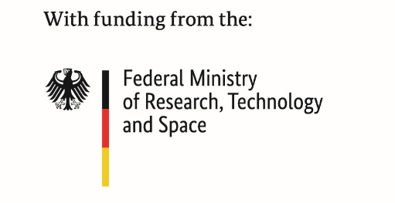
This project has received funding from:

Note for editors, not for publication

For interview requests, questions and additional information about EXPLAIN and ITEA, please contact:
EXPLAIN Contact person ITEA Contact person
Ruben Hühnerbein (Project leader ABB Germany) Régis Cazenave (ITEA Vice-chairman)
ruben.huehnerbein@de.abb.com regis.cazenave@itea4.org

EXPLAIN project partners
https://itea4.org/project/explain.html

About ITEA
ITEA is the Eureka Cluster on software innovation, enabling a large international community to collaborate in funded projects that turn innovative ideas into new businesses, jobs, economic growth and benefits for society.
https://itea4.org

