ITEA Press release
  - IML4E simplifies and scales AI adoption for European industry
16 September 2025, Estoril (Portugal) - During the ITEA Award of Excellence ceremony, the ITEA project IML4E was honoured with the ITEA Award of Excellence for Standardisation. IML4E is increasing the accessibility of artificial intelligence (AI) and machine learning (ML) automation by delivering MLOps tools, methodologies, and a platform for developing and maintaining AI/ML solutions. With ETSI, the project is actively contributing to standardisation efforts while embracing an open-source philosophy. This strategic approach boosts the scalability, automation, and practical adoption of MLOps, laying the groundwork for a platform with Europe-wide impact.
Setting the standard for industrial-grade MLOps
While the promise of AI and ML is well-understood, many companies still face critical barriers when trying to apply these technologies within existing industrial-grade software development processes.
IML4E aims to leverage MLOps’ capabilities and has developed a three-layer framework – platform, technology, and methodology – which provides everything needed to support MLOps adoption at any maturity level. The Operations Support System (OSS) platform, an open, portable and cloud-agnostic environment, gives companies a ready-to-use foundation for the creation and execution of ML/AI services. Meanwhile, tools like the innovative SAGED error detection tool, the MLOps testing methodology and an MLOps maturity assessment help organisations monitor data quality and make informed decisions on how to improve in light of the current maturity and expansion goal.
Under the coordination of Fraunhofer FOKUS, IML4E is undertaking standardisation efforts with ETSI MTS and further integrating the project’s results into the consortium’s industrial applications to improve their competitive advantage.
Transforming practice across sectors
By offering foundational technologies and methodologies for MLOps, IML4E serves as an innovation enabler that allows companies to focus on their core business with enhanced capabilities. This brings different benefits to different industrial stakeholders. For example, Granlund used IML4E’s tools to reduce the data requirements for training building energy models from 24 months to just 1-6 months, while Basware dramatically scaled its SmartPDF invoice processing service from 300,000 to 4 million invoices per month with increased accuracy and reduced training time. These achievements reflect the adaptability of IML4E’s framework across sectors and its value for various stakeholders, from smart service providers and MLOps tool developers to consultancy firms.
“IML4E has been a game-changer for Basware, enabling us to scale our SmartPDF AI invoice processing more than tenfold with higher accuracy and efficiency. By combining cutting-edge research with advanced MLOps practices, we have increased automation, reduced training times, and strengthened customer trust – creating direct impact on revenue and laying a strong foundation for future AI-driven growth.”
- Timo Sinisalmi, R&D Director at Basware Oy
Looking ahead
IML4E’s work is especially timely as Europe prepares for the broader adoption of AI under the new EU AI Act and increasing demand for governance, ethical oversight and sustainability. As AI systems grow more complex and energy-intensive, IML4E is already looking ahead. Through the follow-up ITEA projects ELFMo and Excellent-AI, partners are working on the responsible and energy-efficient use of large language and foundational models.

Thanks to its open-source outputs, strong focus on industry needs, and commitment to best practices, IML4E has created not just a toolkit but a foundation for building Europe’s leadership in responsible, standardised and scalable AI. The ITEA Award of Excellence for Standardisation is a well-deserved recognition of the project’s impact.

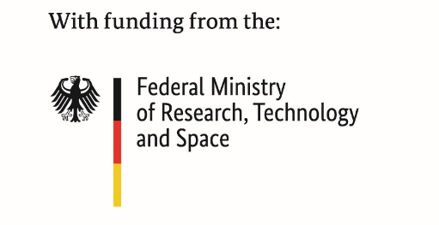
This project has received funding from:
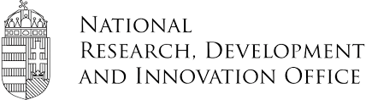


Note for editors, not for publication

For interview requests, questions and additional information about IML4E and ITEA, please contact:
IML4E Contact person ITEA Contact person
Jürgen Großmann (Project leader Fraunhofer FOKUS) Régis Cazenave (ITEA Vice-chairman)
juergen.grossmann@fokus.fraunhofer.de regis.cazenave@itea4.org

IML4E project partners
https://itea4.org/project/IML4E.html

About ITEA
ITEA is the Eureka Cluster on software innovation, enabling a large international community to collaborate in funded projects that turn innovative ideas into new businesses, jobs, economic growth and benefits for society.
https://itea4.org

